v0.08 – 17 Mar 2010

PHYSICAL ASSETS MANAGEMENT

DOMAIN MODEL
The following figure illustrates the domain model applicable to the management of physical assets in the context of the IUfA UUIS.

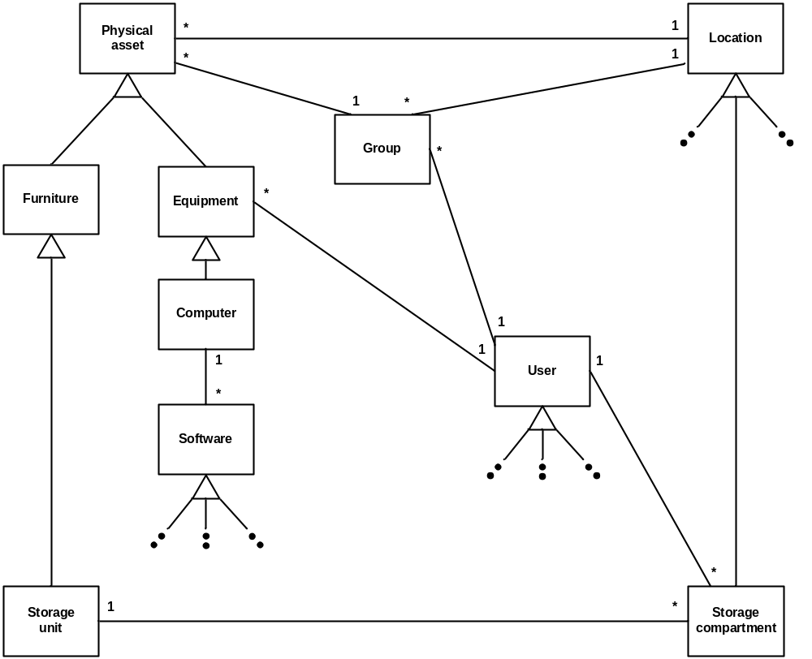
Figure 1 Physical assets management – Domain model

The capability to manage (add, view, update, etc) physical assets is limited to Faculty users (Role 2) with Manage physical assets permission (for assets owned by their faculty only). University users (Role 3) with Manage physical assets permission have the capability to manage assets from all faculties.
Physical assets are defined as furniture (including storage unit) and equipment (including computer).
The physical assets management functionality allows the user to:
- Add, Search, View, Update (including location) physical assets inventory records;
- Assign a location to a physical asset;
- Assign an equipment to a user;
- Assign a storage compartment to a user;
- Create groups of physical assets
- View, update and delete groups of physical assets;
- Assign a location to a group; and
- Assign a group to a user.

USE CASES
The following figure provides the Physical assets management use case diagram.

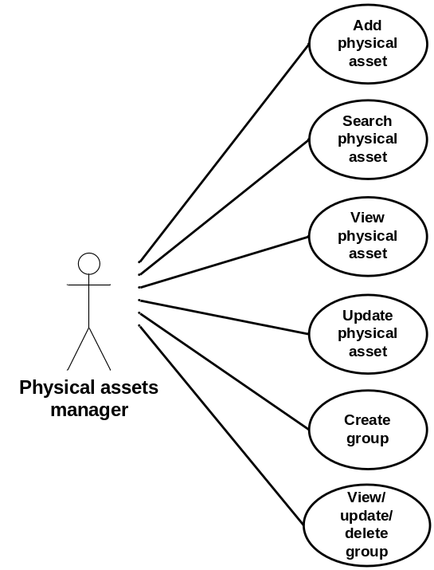
Figure 2 Physical assets management – Use case diagram

The following paragraphs provide the detailed description for each use case.

Add physical asset
Role: Physical assets manager (Role 2), Physical assets manager (Role 3);
Pre-conditions:
- Authenticated session; and
- Faculty or University user with Manage physical assets permission;
Steps:
- The physical assets manager selects the Add asset button under the Physical assets tab (accessible from all system pages);
- The system displays the Add asset page;
- The physical assets manager provides the following information:
- Barcode (mandatory) – the barcode is to be provided by the physical asset manager at the time of creation of the asset based on the stamp that he will affix to the physical asset;
- Owner (mandatory) – Faculty;
- Purchase requisition number;
- Purchase order number;
- Legacy code;
- Date purchased;
- Warranty expiration;
- Location;
- Category (mandatory) – radio button with choices Furniture and Equipment;
- Manufacturer;
- Model;
- Furniture description (if applicable):
  - Furniture type (mandatory) from Classroom front desk, Classroom desk, Classroom chair, Classroom desk/chair unit, Lab bench, Lab stool, Lab chair, Office Desk, Office chair, Office bookshelf, Table and Storage unit;
  - Dimension;
  - Color; and
  - Finish;
  - Additional fields specific to furniture type Storage unit:
    - Storage unit type from Locker, Filing cabinet and Shelving unit;
    - Number of compartments (mandatory), and:
      - Compartment #1 user;
      - Compartment #2 user;
      - …
      - Compartment #N user;
- Equipment description (if applicable):
  - Equipment type (mandatory) from Computer, Screen, Keyboard, Mouse, Printer, Telephone, Photocopier, Projector, Screen, Amplifier, Microphone and Speaker;
  - Serial number;
  - Equipment assigned user;
  - Additional fields specific to equipment type Computer:
    - Computer type from Tower, Laptop and Server;
    - Processor;
    - MAC address;
    - Hard drive capacity;
    - Non-volatile memory; and
    - Volatile memory;
- The physical assets manager selects the Submit button;
- The system:
  - If one or more mandatory field is missing displays a message indicating the missing information and requesting the physical assets manager to provide it; and/or
  - In the case where the Physical Asset Manager is a Faculty user, if the specified Faculty differs from the Faculty in his profile, displays a message indicating the discrepancy;
    - The physical assets manager selects the Return button; and
    - The system displays the Add asset page with current information;
- The system displays a message with the information provided by the physical assets manager requesting confirmation:
  - The physical assets manager selects the Confirm button; or
  - The physical assets manager selects the Return button;
    - The system displays the Add asset page with current information;
- The system:
  - Assigns the physical asset a unique identification number (asset ID);
  - Sets the physical asset status to In-stock;
  - Adds the physical asset to the database including asset ID, barcode, owner, legacy code, date purchased, warranty expiration, manufacturer, model, category and all furniture or equipment description fields, whichever is applicable; and
  - Displays a message to the physical assets manager with the asset ID;
    - The physical assets manager selects the Return button;
Post-conditions:
- The system displays the Add asset page with all fields cleared; and
- The new asset record is stored in the database;
Exceptions:
- The physical assets manager cancels the physical asset addition by selecting the Cancel button from the Add asset page:
  - The system displays the original system page (from which the Physical assets tab was accessed); and
  - The system does not store any information associated with the physical asset addition;
- A database error is encountered:
  - The system displays an error message.

Search physical asset
Role: Physical assets manager (Role 2), Physical assets manager (Role 3);
Pre-conditions:
- Authenticated session; and
- Faculty or University user with Manage physical assets permission;
Steps:
- The physical assets manager selects the Search asset button under the Physical assets tab (accessible from all system pages);
- The system displays the Search asset page;
- The physical assets manager provides the following (all optional) search information:
- Asset ID;
- Barcode;
- Owner – Faculty;
- Purchase requisition number;
- Purchase order number;
- Legacy code;
- Date purchased date range;
- Warranty expiration date range;
- Location;
- Group ID;
- Manufacturer;
- Model;
- Category – checkbox with choices Furniture and Equipment;
- Furniture type(s) – checkbox with choices Classroom front desk, Classroom desk, Classroom chair, Classroom desk/chair unit, Lab bench, Lab stool, Lab chair, Office Desk, Office chair, Office bookshelf, Table and Storage unit;
- Storage unit type(s) – checkbox with choices Locker, Filing cabinet and Shelving unit;
- Equipment type(s) – checkbox with choices Computer, Screen, Keyboard, Mouse, Printer, Telephone, Photocopier, Projector, Screen, Amplifier, Microphone and Speaker;
- Equipment serial number;
- Equipment assigned user;
- Computer type(s) – checkbox with choices Tower, Laptop and Server;
- MAC address;
- Hard drive capacity range in Gbytes;
- Non-volatile memory range in Mbytes; and
- Volatile memory range in Mbytes;
- Status(s) – checkbox with choices In-stock, Assigned, Damaged, In-repair, Lost and Retired;
- The physical assets manager selects the Search button;
- The system builds the query based on the selected parameters and issues it to the database to perform. In the case the Physical Asset Manager is a Faculty user, the search is limited to the Faculty in his profile, regardless of the above choice;
- The system displays the Search results page with the list of physical asset records returned by the query with:
  - Asset ID;
  - Barcode;
  - Category;
  - Location;
  - Manufacturer;
  - Model;
  - Furniture type (if applicable);
  - Equipment type (if applicable);
  - Equipment assigned user; and
  - Status;
Post-condition: The system displays the Search results page;
Exceptions:
- The physical assets manager cancels the search by selecting the Return button from the Search asset page:
  - The system displays the original system page (from which the Physical assets tab was accessed);
- The physical assets manager triggers a modified search by selecting the Modify search button from the Search results page:
  - The system displays the Search asset page with the last input value for all search information fields;
- The physical assets manager triggers a new search by selecting the New search button from the Search results page:
  - The system displays the Search asset page with all search information fields cleared;
- The physical assets manager clears all search information fields by selecting the Clear search parameters button from the Search asset page:
  - The system displays the Search asset page with all search information fields cleared;
- The query does not return any result:
  - The system displays a “No results found” message;
- A database error is encountered:
  - The system displays an error message.

View physical asset
Role: Physical assets manager (Role 2), Physical assets manager (Role 3);
Pre-condition: The system displays the Search results page with successful query results;
Steps:
- The physical assets manager selects a specific physical asset using a radio button;
- The physical assets manager selects the View asset button;
- The system displays the Asset details page with:
  - Asset ID;
  - Barcode;
  - Owner – Faculty;
  - Purchase requisition number;
  - Purchase order number;
  - Legacy code if applicable;
  - Date purchased;
  - Warranty expiration;
  - Location;
  - Group ID;
  - Manufacturer;
  - Model;
  - Category;
  - Furniture description (if applicable):
    - Furniture type;
    - Dimension;
    - Color; and
    - Finish;
    - Additional fields specific to furniture type Storage unit (if applicable):
      - Storage unit type;
      - Number of compartments, and:
        - Compartment #1 user;
        - Compartment #2 user;
        - …
        - Compartment #N user;
  - Equipment description (if applicable):
    - Equipment type;
    - Serial number;
    - Equipment assigned user;
    - Additional fields specific to equipment type Computer (if applicable):
      - Computer type;
      - Processor;
      - MAC address;
      - Hard drive capacity;
      - Non-volatile memory; and
      - Volatile memory;
  - Status;
Post-condition: The system displays the Asset details page;
Exceptions:
- The physical assets manager returns to the Search results page by selecting the Return button from the Asset details page:
  - The system displays the Search results page with the results from the last query;
- A database error is encountered:
  - The system displays an error message.

Update physical asset
Role: Physical assets manager (Role 2), Physical assets manager (Role 3);
Pre-condition: The system displays the Asset details page;
Steps:
- The physical assets manager selects the Update physical asset button;
- The system displays the Edit physical asset page with:
- Un-editable fields:
    - Asset ID;
    - Barcode;
    - Purchase requisition number;
    - Purchase order number;
    - Manufacturer;
    - Model;
    - Category;
    - Furniture type if applicable;
    - Storage unit type if applicable;
    - Equipment type if applicable;
    - Equipment serial number if applicable;
    - Computer type if applicable;
- Editable fields:
    - Legacy code;
    - Owner – Faculty; Note: Editing of this field is limited to Physical Asset Manager (Role 3);
    - Date purchased;
    - Warranty expiration;
    - Location;
    - Status from In-stock, Assigned, Damaged, In-repair, Lost and Retired;
    - Furniture dimension if applicable;
    - Furniture color if applicable;
    - Furniture finish if applicable;
    - If applicable:
      - Compartment #1 user;
      - Compartment #2 user;
      - …
      - Compartment #N user;
    - Equipment assigned user;
    - Computer processor if applicable;
    - Computer MAC address if applicable;
    - Computer hard drive capacity if applicable;
    - Computer non-volatile memory if applicable; and
    - Computer volatile memory if applicable;
- The physical assets manager edits/updates the above fields as applicable;

- The physical assets manager selects the Submit button;
- The system displays a message with the information provided by the physical assets manager requesting confirmation:
  - The physical assets manager selects the Confirm button; or
  - The physical assets manager selects the Return button;
    - The system displays the Update physical asset page with current information;
- The system:
  - Updates the physical asset database entry with the applicable changes;
Post-conditions:
- The system displays the Asset details page with updated information; and
- The updated physical asset record is stored in the database;
Exceptions:
- The user cancels the update by selecting the Cancel button from the Edit physical asset page:
  - The system displays the Asset details page; and
  - The system does not store any updated information;
- A database error is encountered:
  - The system displays an error message.

Create group
Role: Physical assets manager (Role 2), Physical assets manager (Role 3);
Pre-conditions:
- Authenticated session; and
- Faculty or University user with Manage physical assets permission;
Steps:
- The physical assets manager selects the Create group button under the Physical assets tab (accessible from all system pages);
- The system displays the Create group page;
- The physical assets manager provides the following information:
- Group assets (one mandatory):
  - Asset #1 – Asset ID;
  - Asset #2 – Asset ID;
  - …
  - Asset #N – Asset ID;
- Group location;
- Group assigned user;
- The physical assets manager selects the Submit button;
- The system:
  - If the submitted group does not contain at least one asset, displays a message and requests the physical assets manager to provide a minimum of one asset; and/or
  - In the case where the Physical Asset Manager is a Faculty user, if one or more of the specified asset belongs to a different Faculty than the Faculty in his profile, displays a message indicating the discrepancy;
    - The physical assets manager selects the Return button; and
    - The system displays the Create group page with current information;
- The system displays a message with the information provided by the physical assets manager requesting confirmation:
  - The physical assets manager selects the Confirm button; or
  - The physical assets manager selects the Return button;
    - The system displays the Create group page with current information;
- The system:
  - Assigns the group a unique identification number (group ID);
  - Adds the group to the database including group ID, asset ID(s), location if provided and assigned user if provided;
  - Updates the record for every individual asset of the group with, if provided, the group location;
  - Updates the record for every individual asset of the group with, if provided, the group assigned user;
  - Displays a message to the physical assets manager with the group ID;
    - The physical assets manager selects the Return button;
Post-conditions:
- The system displays the Create group page with all fields cleared;
- The new group record is stored in the database; and
- The updated physical asset records are stored in the database;
Exceptions:
- The physical assets manager cancels the group creation by selecting the Cancel button from the Create group page:
  - The system displays the original system page (from which the Physical asset tab was accessed); and
  - The system does not store any information associated with the group creation;
- A database error is encountered:
  - The system displays an error message.

View/update/delete group
Role: Physical assets manager (Role 2), Physical assets manager (Role 3);
Pre-conditions:
- Authenticated session; and
- Faculty or University user with Manage physical assets permission;
Steps:
- The physical assets manager selects the View/update/delete group button under the Physical assets tab (accessible from all system pages);
- The system displays the Retrieve group page;
- The physical assets manager provides the group ID;
- The physical assets manager selects the Retrieve button;
- The system builds the query and issues to the database to perform;
- The system displays the Group details page with (all editable):
- Group assets:
  - Asset #1 – Asset ID;
  - Asset #2 – Asset ID;
  - …
  - Asset #N – Asset ID;
- Group location; and
- Group assigned user;
- The physical assets manager edits/updates the above fields as applicable;
- The physical assets manager selects the Submit button;
- The system, in the case where the Physical Asset Manager is a Faculty user, if one or more of the specified asset belongs to a different Faculty than the Faculty in his profile, displays a message indicating the discrepancy;
    - The physical assets manager selects the Return button; and
    - The system displays the Group details page with current information;
- The system displays a message with the information provided by the physical assets manager requesting confirmation:
  - The physical assets manager selects the Confirm button; or
  - The physical assets manager selects the Return button;
    - The system displays the Group details page with current information;
- If the updated group contains at least one asset, the system:
  - Updates the group database entry with the applicable change(s);
  - Updates the record for every individual asset of the group with, if updated, the group location;
  - Updates the record for every individual asset of the group with, if updated, the group assigned user;
  - Displays a message to the physical assets manager with the group ID;
    - The physical assets manager selects the Return button;
- If the updated group does not contain at least one asset, the system:
  - Deletes the group database entry;
  - Leaves intact (location and assigned user) the record for every individual asset previously of the group;
  - Displays a message to the physical assets manager with the group ID;
    - The physical assets manager selects the Return button;
Post-conditions:
- The system displays the Retrieve group page;
- The updated group record and the updated physical asset records are stored in the database; or
- The group database entry is deleted and the physical asset records are left intact;
Exceptions:
- The physical asset manager cancel the retrieval by selecting the Cancel button from the Retrieve group page;
  - The system displays the original system page (from which the Physical assets tab was accessed);
- The physical assets manager returns to the Retrieve group page by selecting the Return button from the Group details page:
  - The system displays the Retrieve group page;
- The query does not return any result:
  - The system displays a “No results found message”;
  - The physical assets manager selects the Return button;
  - The system displays the Retrieve group page;
- A database error is encountered:
  - The system displays an error message.

FUNCTIONAL REQUIREMENTS

Add physical asset
- The system shall allow Faculty users with Manage physical assets permission to add physical assets to the inventory;
- The system shall assist a user, through structured dialogs, to describe the added physical asset, including barcode, owner (faculty), purchase requisition number, purchase order number, legacy code, date purchased, warranty expiration, location, manufacturer, model, category from furniture and equipment, furniture description if applicable (furniture type, dimension, color and finish), storage unit description if applicable (type, number of compartments and assigned users), equipment description if applicable (equipment type, serial number and equipment assigned user) and computer description if applicable (computer type, processor, MAC address, hard drive capacity, non-volatile memory and volatile memory).
- The system shall, prior to proceeding with the add physical asset operation, display the physical asset related information and request a confirmation from the user.
- The system shall, in the event where no barcode, owner, category, furniture type (if applicable), number of compartments (if applicable) and/or equipment type (if applicable) are provided, display a message to the user and withhold from performing the add physical asset operation.
- The system shall, in the case where the Physical Asset Manager is a Faculty user, if the specified Faculty differs from the Faculty in his profile, display a message to the user and withhold from performing the add physical asset operation.
- The system shall allow a user to cancel an add physical asset operation.
- The system shall, upon performing the add physical asset operation, create and store a physical asset record with unique ID number, status reflecting its added state and user provided information.
- The system shall, upon successfully completing the add physical asset operation, display a message to the user including the physical asset record unique ID number.

Search physical asset
- The system shall allow Faculty users with Manage physical assets permission to search physical assets.
- The system shall assist a user, through structured dialogs, to specify search criteria, including physical asset unique ID number, barcode, owner(s), purchase requisition number, purchase order number, legacy code, date purchased date range, warranty expiration date range, location, manufacturer, model, category, furniture type(s), storage unit type(s), equipment type(s), equipment serial number, equipment assigned user, computer type(s), MAC address, hard drive capacity range in Gbytes, non-volatile memory range in Mbytes, volatile memory range in Mbytes and status(s).
- The system shall allow a user to clear search criteria.
- The system shall, in the case where the Physical Asset Manager is a Faculty user, limit the search results to the Faculty in his profile.
- The system shall display the results of a physical asset search including, for each returned result, physical asset unique ID number, barcode, manufacturer, model, category, location, furniture type (if applicable), equipment type (if applicable), equipment assigned user and status.
- The system shall, upon returning no results for a physical asset search, display a message to the user.
- The system shall allow a user to cancel a physical asset search.
- The system shall allow a user to modify the search criteria of a previously executed physical asset search.

View physical asset
- The system shall allow Faculty users with Manage physical assets permission to select a physical asset for viewing.
- The system shall display the physical asset details including physical asset unique ID number, barcode, owner, purchase requisition number, purchase order number, legacy code, date purchased, warranty expiration, location, manufacturer, model, category, furniture description if applicable (furniture type, dimension, color and finish), storage unit description if applicable (type, number of compartments and assigned users), equipment description if applicable (equipment type, serial number and equipment assigned user), computer description if applicable (computer type, processor, MAC address, hard drive capacity, non-volatile memory and volatile memory) and status.

Update physical asset
- The system shall allow Faculty users with Manage physical assets permission to update a physical asset record.
- The system shall allow the user to update a physical asset record including legacy code, owner, date purchased, warranty expiration, location, status from In-stock, Assigned, Damaged, In-repair, Lost and Retired, furniture dimension (if applicable), furniture color (if applicable), furniture finish (if applicable), compartment #1 to compartment #N assigned user (if applicable), equipment assigned user (if applicable), computer processor (if applicable), computer MAC address (if applicable), computer hard drive capacity (if applicable), computer non-volatile memory (if applicable) and computer volatile memory (if applicable).
- The system shall limit the editing of the owner field to user with Physical Asset Manager (Role 3);
- The system shall, prior to performing the update physical asset record operation, display the update information and request a confirmation from the user.
- The system shall allow a user to cancel an update physical asset record operation.
- The system shall, following confirmation from the user, modify the physical asset record to include user provided update information.

Create group
- The system shall allow Faculty users with Manage physical assets permission to group one or more physical assets under a unique group identifier.
- The system shall allow a user to specify the location and assigned user of a group.
- The system shall, in the event where no asset is provided, display a message to the user and withhold from performing the create group operation.
- The system shall, in the case where the Physical Asset Manager is a Faculty user, if one or more of the specified asset belongs to a different Faculty than the Faculty in his profile, display a message to the user and withhold from performing the create group operation.
- The system shall, prior to performing the create group operation, display the group information and request a confirmation from the user.
- The system shall allow a user to cancel a create group operation.
- The system shall, upon performing the create group operation, create and store a group record with unique ID number, asset ID number(s), location and assigned user.
- The system shall, upon performing the create group operation, update the record for every individual asset in the group with, if provided, the group location and assigned user.
- The system shall, upon successfully completing the create group operation, display a message to the user including the group unique ID number.

View/update/delete group
- The system shall allow Faculty users with Manage physical assets permission to view, update and delete group records.
- The system shall allow the user to update a physical asset record including asset ID(s), location and assigned user.
- The system shall, in the case where the Physical Asset Manager is a Faculty user, if one or more of the specified asset belongs to a different Faculty than the Faculty in his profile, display a message to the user and withhold from performing the group update operation.
- The system shall, prior to performing the group update operation, display the update information and request a confirmation from the user.
- The system shall allow a user to cancel a group update operation.
- The system shall, upon update of a group (i.e. update information contains at least one asset), modify the group record to include user provided update information and update the record for every individual asset in the group with, if provided, the group location and assigned user.
- The system shall, upon deletion of a group (i.e. update information does not contain at least one asset), delete the group database entry and leave intact (location and assigned user) the record for every individual asset previously of the group.
- The system shall, upon successfully completing the group update operation, display a message to the user including the group unique ID number.

DATA DICTIONARY
The following figure provides the Physical assets management E/R diagram.

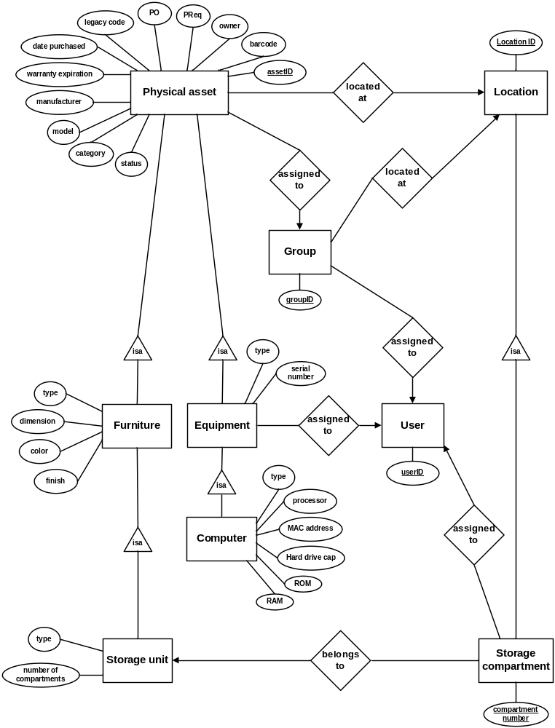
Figure 3 Physical assets management – E/R diagram

The following table provides the data dictionary for the Physical asset entity.

field | type | null | default | comment
assetID | int | No |  | Auto increment
barcode | varChar(32) | No
owner | varChar(128) | No
PReq | varChar(32) | No
PO | varChar(32) | No
legacyCode | varChar(32) | Yes | Null
datePurchased | Date | Yes | Null
warrantyExpiration | Date | Yes | Null
manufacturer | varChar(128) | Yes | Null
model | varChar(128) | Yes | Null
category | varChar(32) | Yes | Null
status | varChar(32) | No | “In-stock”
Table 1 Entity Physical asset – Data dictionary

The following table provides the data dictionary for the Furniture entity.

field | type | null | default | comment
type | varChar(32) | Yes
dimension | varChar(32) | Yes
color | varChar(32) | Yes
finish | varChar(32) | Yes
Table 2 Entity Furniture – Data dictionary

The following table provides the data dictionary for the Storage unit entity.

field | type | null | default | comment
type | varChar(32) | Yes
nOfCompartments | int | No | 1
Table 3 Entity Storage unit – Data dictionary

The following table provides the data dictionary for the Equipment entity.

field | type | null | default | comment
type | varChar(32) | Yes
serialNumber | varChar(32) | Yes
Table 4 Entity Equipment – Data dictionary

The following table provides the data dictionary for the Computer entity.

field | type | null | default | comment
type | varChar(32) | Yes
processor | varChar(32) | Yes
MACAddress | varChar(32) | Yes
hardDriveCap | varChar(32) | Yes
ROM | varChar(32) | Yes
RAM | varChar(32) | Yes
Table 5 Entity Computer – Data dictionary

The following table provides the data dictionary for the Storage compartment entity.

field | type | null | default | comment
compartmentNumber | int | No
Table 5 Entity Storage compartment – Data dictionary

STATE DIAGRAMS

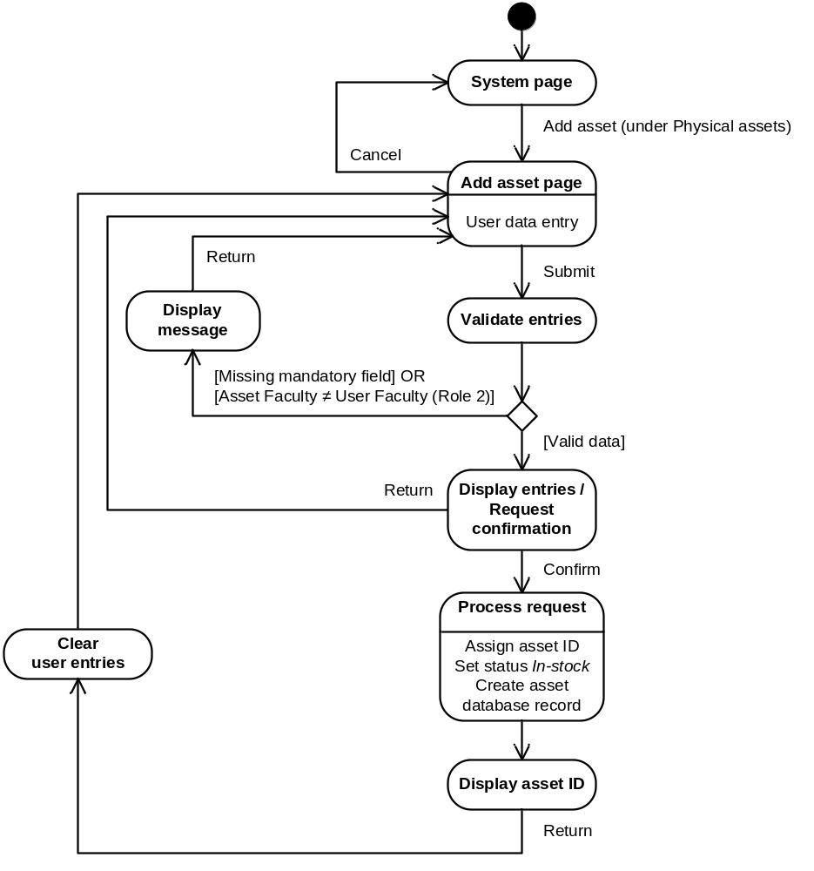
Figure 5 Add physical asset – State diagram

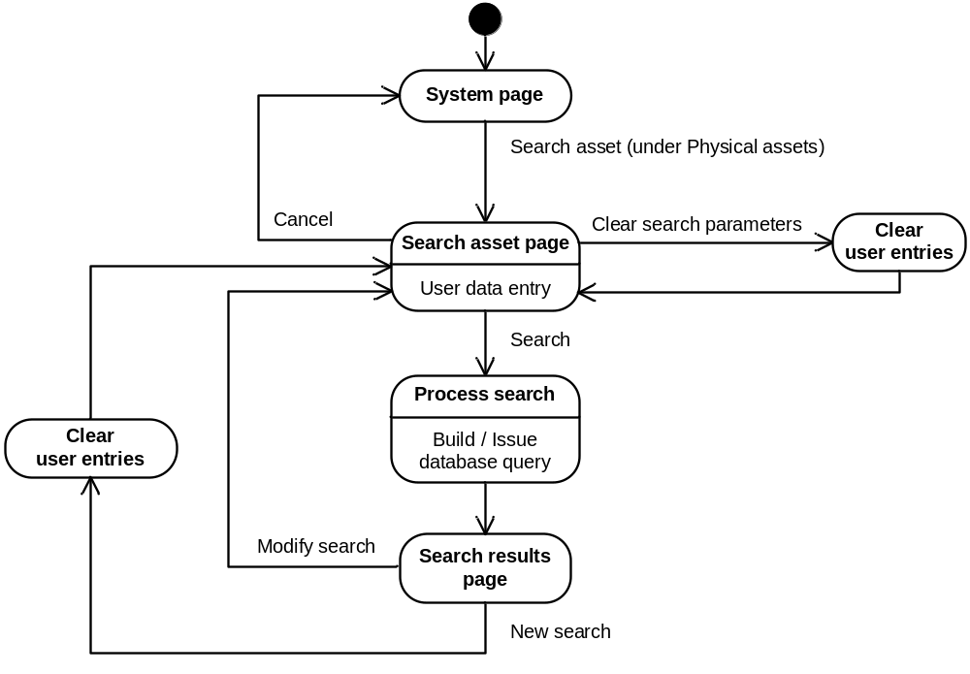
Figure 6 Search physical asset – State diagram

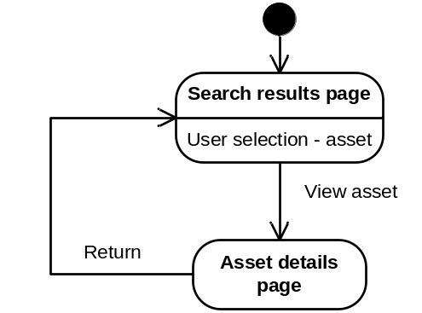
Figure 7 View physical asset – State diagram

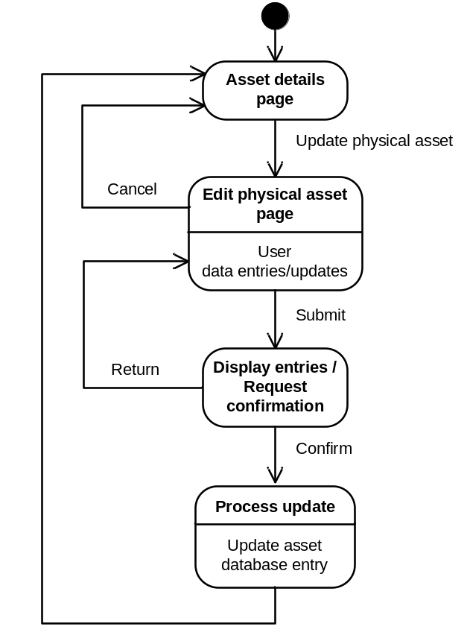
Figure 8 Update physical asset – State diagram

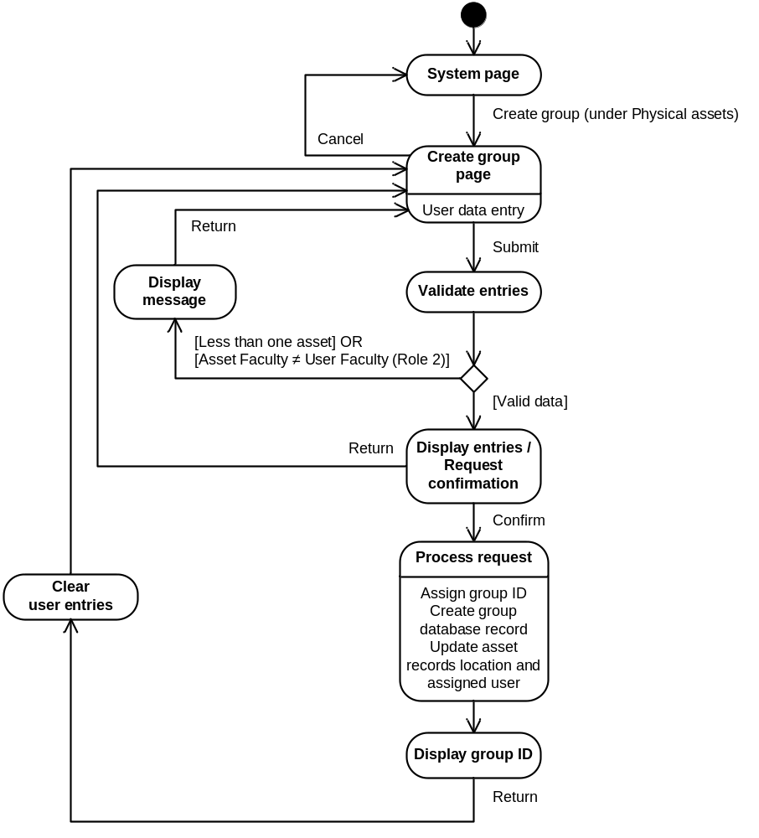
Figure 9 Create group – State diagram

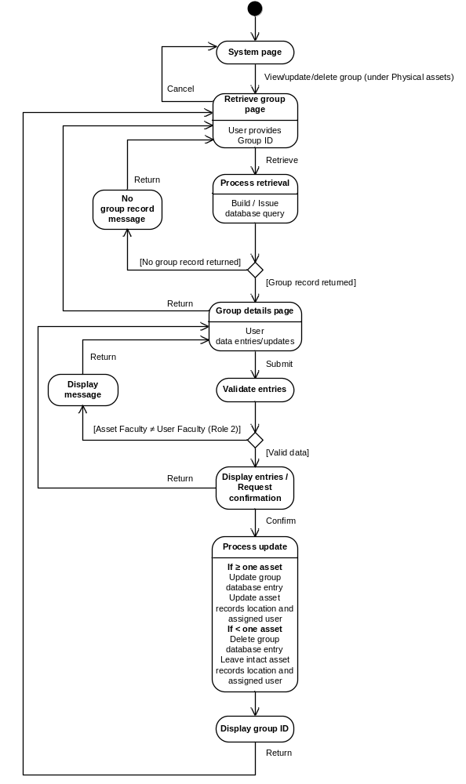
Figure 9 View/update/delete group – State diagram

