v0.08 – 21 Feb ’10 – R.T.

PROBLEM REPORTING/TRACKING

DOMAIN MODEL

Business logic – workflow
The following figure illustrates the workflow applicable to the reporting and tracking of problems in the context of the IUfA UUIS.
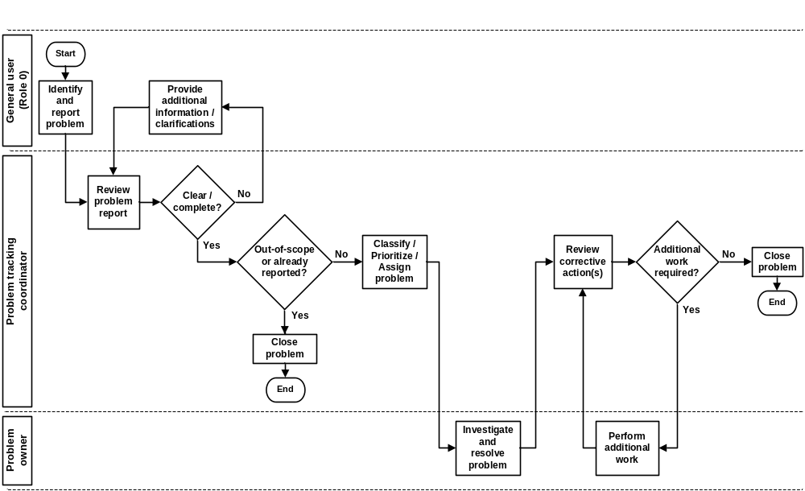
Figure 1 Problem reporting/tracking – Workflow

All General users (Role 0) of the IUfA UUIS have the capability to report problems.
Following the reporting of a problem, the Problem tracking coordinator will review the problem report and:
- Request, as required, additional information / clarifications from the originator to ensure clarity and completion;
- Determine if the problem report is within the scope of the problem management service, otherwise reject the problem;
- Verify that the problem is not a duplication of an already reported problem, otherwise close the problem and provide rationale; and
- Appropriately classify the problem based on its nature, specify its level of urgency and assign the problem to the appropriate individual with due date.
The Problem owner will investigate the problem and take appropriate the appropriate actions to provide its resolution.
Following the resolution of a problem, the Problem tracking coordinator will review the corrective action(s) and:
- Request, as required, the Problem owner to perform additional work; and
- Close the problem.

Class diagram
The following figure provides the Problem reporting/tracking class diagram.

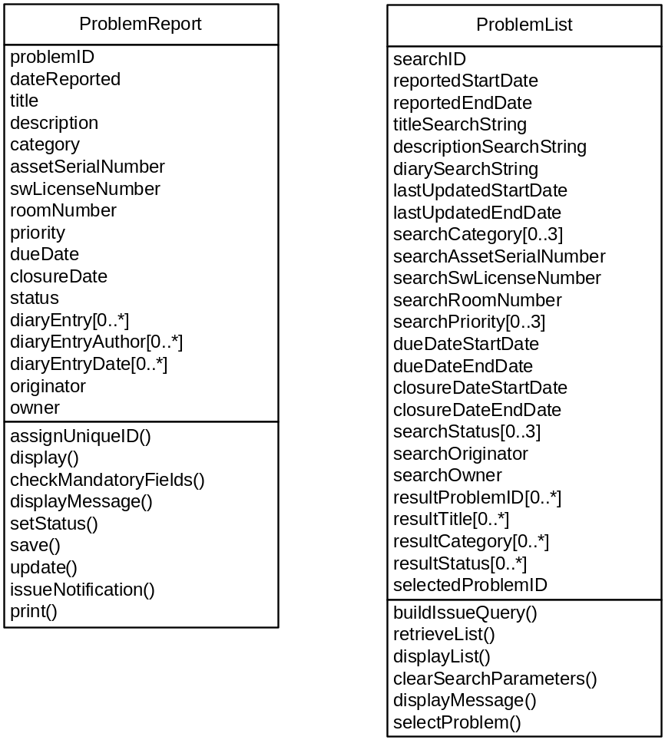
Figure 2 Problem reporting/tracking – Class diagram

USE CASES
The following figure provides the Problem reporting/tracking use case diagram.

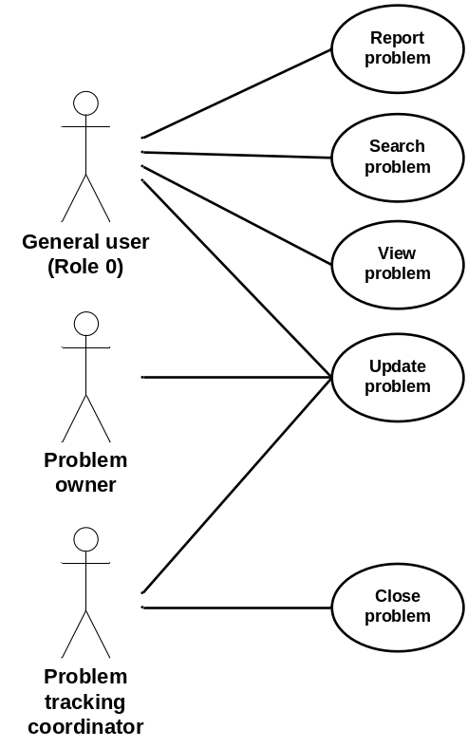
Figure 3 Problem reporting/tracking – Use case diagram

The following paragraphs provide the detailed description for each use case.

Report problem
Role: General users (Role 0);
Pre-condition: Authenticated session;
Steps:
- The user selects the Report problem button under the Problem tab (accessible from all system pages);
- The system displays the Report problem page;
- The user provides the following information:
- Title – short text (mandatory field);
- Description – long text (mandatory field);
- Category – radio button with choices Physical asset, Software or Facility; and
- Physical asset serial number – drop-down list with the system inventory of physical assets;
- SW license number – drop-down list with the system inventory of SW licenses;
- Room number – drop-down list with the system inventory of facility rooms;
- The user selects the Submit button;
- The system, if one or more mandatory field is missing, displays a message indicating the missing information and requesting the user to provide it:
  - The user selects the Return button; and
  - The system displays the Report problem page with current information;
- The system displays a message with the user provided information and requesting the user to confirm the submission:
  - The user selects the Confirm button; or
  - The user selects the Return button;
    - The system displays the Report problem page with current information;
- The system:
  - Assigns the reported problem a unique identification number (problem ID);
  - Sets the problem status to Reported;
  - Adds the problem report to the database including problem ID, originator, user provided information, status and date reported;
  - Displays a message to the user with the problem ID;
    - The user selects the Return button;
  - Issues a problem report notification to the originator and the Problem tracking coordinator with problem ID, status and date reported;
Post-conditions:
- The system displays the system page from which the Problem tab was accessed;
- The new problem report is stored in the database; and
- A problem report notification is routed to the originator and the Problem tracking coordinator;
Exceptions:
- The user cancels the request by selecting the Cancel button from the Report problem page:
  - The system displays the original system page (from which the Problem tab was accessed); and
  - The system does not store any information associated with the cancelled problem report;
- A database error is encountered:
  - The system displays an error message.

Search problem
Role: General users (Role 0);
Pre-condition: Authenticated session;
Steps:
- The user selects the Search problem button under the Problem tab (accessible from all system pages);
- The system displays the Search problem page;
- The user provides the following (all optional) search information:
- Problem ID(s) – drop-down list with problem ID from the system;
- Date reported range;
- Title search string – short text;
- Description search string – short text;
- Diary search string – short text;
- Last updated date range;
- Category(s) – checkbox with choices Physical asset, Software and Facility;
- Physical asset serial number(s) – drop-down list with the system inventory of physical assets;
- SW license number(s) – drop-down list with the system inventory of SW licenses;
- Room number(s) – drop-down list with the system inventory of facility rooms;
- Priority(s) – checkbox with choices High, Medium and Low;
- Due date range;
- Closure date range;
- Status(s) – checkbox with choices Reported, In-work and Closed;
- Originator(s) – drop-down list with the system users;
- Owner(s) – drop-down list with the system users;
- The user selects the Search button;
- The system builds the query based on the selected parameters (AND) and issues it to the database to perform;
- The system displays the Search results page with the list of problem reports returned by the query with:
  - Problem ID;
  - Title;
  - Category; and
  - Status;
Post-condition: The system displays the Search results page;
Exceptions:
- The user cancels the search by selecting the Return button from the Search problem page:
  - The system displays the original system page (from which the Problem tab was accessed);
- The user triggers a modified search by selecting the Modify search button from the Search results page:
  - The system displays the Search problem page with the last input value for all search information fields;
- The user triggers a new search by selecting the New search button from the Search results page:
  - The system displays the Search problem page with all search information fields cleared;
- The user clears all search information fields by selecting the Clear search parameters button from the Search problem page:
  - The system displays the Search problem page with all search information fields cleared;
- The query does not return any result:
  - The system displays a “No results found” message;
- A database error is encountered:
  - The system displays an error message.

View problem
Role: General users (Role 0);
Pre-condition: The system displays the Search results page with successful query results;
Steps:
- The user selects a specific problem using a radio button;
- The user selects the View problem button;
- The system displays the Problem details page with:
- Problem ID;
- Date reported:
- Title;
- Description;
- Category;
- Physical asset serial number if applicable;
- SW license number if applicable;
- Room number if applicable;
- Priority;
- Due date;
- Closure date;
- Status;
- All diary entries with author and date;
- Originator; and
- Owner;
Post-condition: The system displays the Problem details page;
Exceptions:
- The user returns to the Search results page by selecting the Return button from the Search Problem details page:
  - The system displays the Search results page with the results from the last query;
- The user request a print-out of the problem detailed information by selecting the Print button from the Problem details page:
  - The system prints the problem detailed information report;
- A database error is encountered:
  - The system displays an error message.

Update problem
Role: General users (Role 0), Problem tracking coordinator and Problem owner;
Pre-condition: The system displays the Problem details page;
Steps:
- The user selects the Update problem button;
- If the user is the Problem tracking coordinator, the system displays the Update problem page with:
- Un-editable fields:
    - Problem ID;
    - Date reported:
    - Title;
    - Description;
    - Originator;
    - All previous diary entries with author and date;
- Editable fields:
    - Category;
    - Physical asset serial number;
    - SW license number;
    - Room number;
    - Priority;
    - Due date;
    - Status;
    - Owner; and
    - Diary entry (mandatory);
- If the user is not the Problem tracking coordinator, the system displays the Update problem page with:
  - All above fields set as un-editable except Diary entry (mandatory);
- The user edits/updates the above fields as applicable;
- The user selects the Submit button;
- The system, if no diary entry has been provided, displays a message indicating the missing information and requesting the user to provide it:
  - The user selects the Return button; and
  - The system displays the Update problem page with current information;
- The system displays a message with the user provided information and requesting the user to confirm the submission:
  - The user selects the Confirm button; or
  - The user selects the Return button;
    - The system displays the Update problem page with current information;
- The system:
  - Updates the problem report database entry with the diary entry and applicable changes;
  - Displays a message to the user with the problem ID;
    - The user selects the Return button;
  - Issues a problem update notification to the user, the originator, the Problem tracking coordinator and the owner with problem ID, status and date of update;
Post-conditions:
- The system displays the Problem details page with updated information;
- The updated problem report is stored in the database; and
- A problem update notification is routed to the originator, the Problem tracking coordinator and the owner;
Exceptions:
- The user cancels the update by selecting the Cancel button from the Update problem page:
  - The system displays the Problem details page; and
  - The system does not store any updated information;
- A database error is encountered:
  - The system displays an error message.

Close problem
Role: Problem tracking coordinator;
Pre-condition: The system displays the Problem details page;
Steps:
- The user selects the Close problem button;
- The system displays the Close problem page with:
- Un-editable fields:
    - Problem ID;
    - Title;
- Editable fields:
    - Diary entry (mandatory);
- The user provides a diary entry;
- The user selects the Submit button;
- The system, if no diary entry has been provided, displays a message indicating the missing information and requesting the user to provide it:
  - The user selects the Return button; and
  - The system displays the Close problem page;
- The system displays a message with the user provided information and requesting the user to confirm the submission:
  - The user selects the Confirm button; or
  - The user selects the Return button;
- The system displays the Update problem page with current information;
- The system:
  - Sets the problem status to Closed;
  - Updates the problem report database entry with the diary entry, status change and closure date;
  - Displays a message to the user with the problem ID;
- The user selects the Return button;
- Issues a problem closure notification to the originator, the Problem tracking coordinator and the owner with problem ID, status and closure date;
Post-conditions:
- The system displays the Problem details page with updated information;
- The updated/closed problem report is stored in the database; and
- A problem closure notification is routed to the originator, the Problem tracking coordinator and the owner;
Exceptions:
- The user cancels the closure by selecting the Cancel button from the Close problem page:
  - The system displays the Problem details page; and
  - The system does not store any updated information;
- A database error is encountered:
  - The system displays an error message.

FUNCTIONAL REQUIREMENTS

Report problem
- The system shall allow users to report problems.
- The system shall assist a user, through structured dialogs, to describe the reported problem, including title, description, category from Physical asset, Software and Facility, physical asset serial number (if applicable), SW license number (if applicable) and room number (if applicable).
- The system shall, prior to proceeding with the submit problem operation, display the problem related information including title, description, category, physical asset serial number (if applicable), SW license number (if applicable) and room number (if applicable) and request a confirmation from the user.
- The system shall, in the event where no title and/or description are provided, display a message to the user and withhold from performing the submit problem operation.
- The system shall allow a user to cancel a submit problem operation.
- The system shall, upon performing the submit problem operation, create and store a problem report record with unique identification number, originator, title, description, category, physical asset serial number (if applicable), SW license number (if applicable), room number (if applicable), status reflecting its reported state and date reported.
- The system shall, upon successfully completing the submit problem operation, display a message to the user including the problem report record unique identification number.
- The system shall, upon successfully completing the report problem operation, issue an e-mail notification to the user and the Problem tracking coordinator including unique identification number and date reported.

Search problem
- The system shall allow users to search problem reports.
- The system shall assist a user, through structured dialogs, to specify search criteria, including problem unique identification number, date reported range, title search string, description search string, diary search string, last updated date range, category, physical asset serial number(s), SW license number(s), room number(s), priority(s), due date range, closure date range, status(s), originator(s) and owner(s).
- The system shall allow a user to clear search criteria.
- The system shall display the results of a problem report search including, for each returned result, problem unique identification number, title, category, and status.
- The system shall, upon returning no results for a problem report search, display a message to the user.
- The system shall allow a user to cancel a problem report search.
- The system shall allow a user to modify the search criteria of a previously executed problem report search.

View problem
- The system shall allow users to select a problem report for viewing.
- The system shall display the problem report details including problem unique identification number, date reported, title, description, category, physical asset serial number (if applicable), SW license number (if applicable), room number (if applicable), priority, due date, closure date, status, diary entries with date, originator and owner.
- The system shall allow a user to print the problem report details.

Update/Close problem
- The system shall allow users to add a diary entry to a problem report.
- The system shall allow the Problem tracking coordinator to update a problem report including category, physical asset serial number, SW license serial number, room number, priority, due date, status and owner.
- The system shall, prior to performing the update problem operation, display the update information and request a confirmation from the user.
- The system shall, in the event where no diary entry is provided, display a message to the user and withhold from performing the update problem operation.
- The system shall allow a user to cancel an update problem operation.
- The system shall, following confirmation from the user, modify the problem report record to include user provided update information including user identification and date of update.
- The system shall, upon successfully completing the update problem operation, issue an e-mail notification to the user, the Problem tracking coordinator, the originator and the owner including unique identification number and date updated.
- The system shall allow the Problem tracking coordinator to update a problem report for closure.

DATA DICTIONARY
The following figure provides the Problem reporting/tracking E/R diagram.

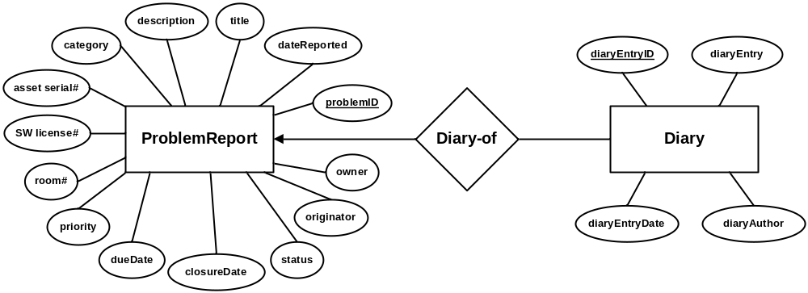
Figure 4 Problem reporting/tracking – E/R diagram

The following table provides the data dictionary for the ProblemReport entity.

field | type | null | default | comment
problemID | int | No |  | Auto increment
dateReported | date | No | Timestamp
title | varChar(32) | No
description | varChar(255) | No
category | varChar(15) | Yes | Null
assetSerialNbr | varChar(15) | Yes | Null
swSerialNbr | varChar(15) | Yes | Null
roomNbr | varChar(15) | Yes | Null
priority | varChar(7) | Yes | Null
dueDate | date | Yes | Null
closureDate | date | Yes | Null
status | varChar(15) | No | “Reported”
originator | varChar(15) | No
owner | varChar(15) | Yes | Null
Table 1 Entity ProblemReport – Data dictionary

The following table provides the data dictionary for the Diary entity.

field | type | null | default | comment
diaryEntryID | int | No |  | Auto increment
diaryEntry | varChar(255) | No
diaryAuthor | varChar(15) | No
diaryEntryDate | date | No | Timestamp
Table 2 Entity ProblemReport – Data dictionary

