v0.03 – 18 Mar ’10 – R.T.

REQUESTS

ACTIVITY DIAGRAM
The following figure provides the activity diagram applicable to the management of requests in the context of the IUfA UUIS.
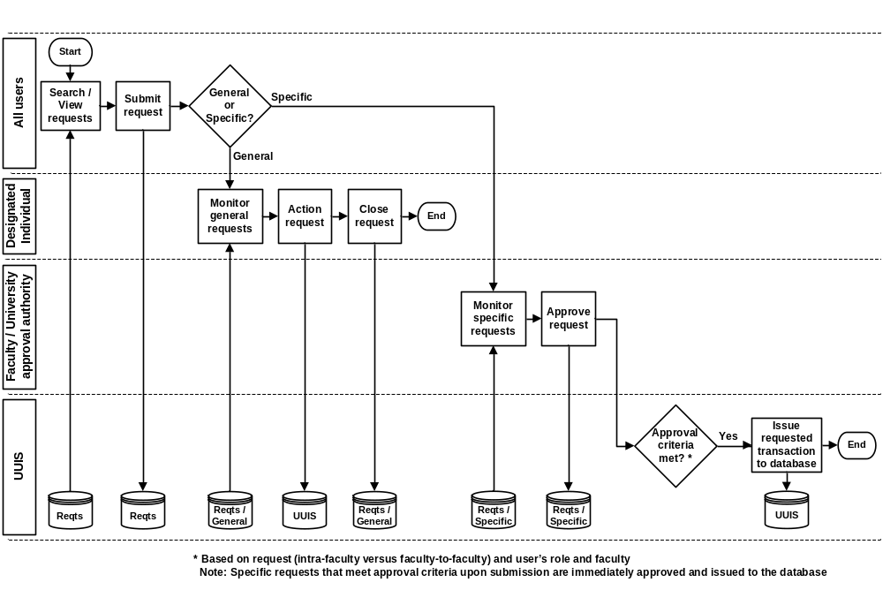
Figure 1 Requests – Activity diagram

All users of the IUfA UUIS have the capability to submit requests.
The IUfA UUIS supports two types of requests, general and specific.
General requests are broken into two categories:
  - Administrative request; and
  - Technical request.
General administrative requests are used to report problems such as:
- Malfunctioning physical asset;
- Broken physical asset; and
- Lost physical asset.
General technical requests are used to report problems involving IT such as:
- Malfunctioning computer component;
- Broken computer component;
- Malfunctioning network;
- Malfunctioning software;
- Request software installation; and
- Request a modification to one’s user profile.
General requests will be monitored by a Role 3 designated individual (one for administrative requests and one for technical requests) who will take the appropriate action and close the request (and provide a closure note).

The IUfA UUIS supports the five categories of specific requests listed below:
- Move asset to location;
- Move group to location;
- Assign equipment to user;
- Assign storage compartment to user; and
- Assign group to user.
Specific requests that involve an intra-faculty transaction only (e.g. asset from a faculty assigned to a user of that faculty) require approval at the faculty level.
Specific requests that involve a faculty to faculty transaction (e.g. asset from a faculty assigned to a user from another faculty) require approval at the university level.

Users can browse all requests and their status at their level and below for their department. Level 0 users can only browse their own requests.

USE CASES
The following figure provides the Requests use case diagram.

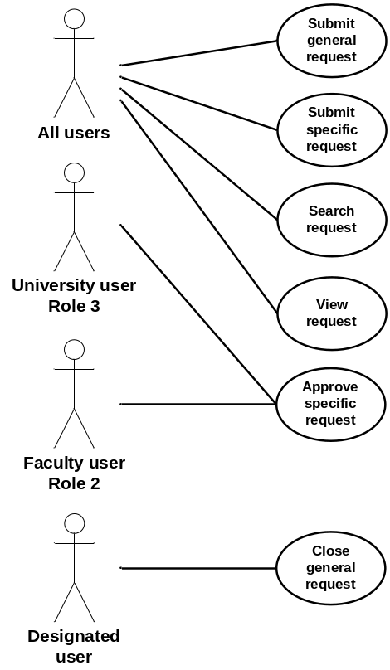
Figure 2 Requests – Use case diagram

The following paragraphs provide the detailed description for each use case.

Submit general request
Role: All users;
Pre-condition: Authenticated session;
Steps:
- The user selects the Submit general request button under the Requests tab (accessible from all system pages);
- The system displays the Submit general request page;
- The user provides the following information:
  - Category – radio button with choices General administrative or General technical; and
  - Description;
- The user selects the Submit button;
- The system, if a description is not provided, displays a message and requests the user to provide it:
  - The user selects the Return button; and
  - The system displays the Submit general request page with current information;
- The system:
  - Assigns the request a unique identification number (request ID);
  - Sets the request status to Pending;
  - Adds the request to the database including request ID, category, description, status, originator username, faculty, department and level;
  - Displays a message to the user with the request ID;
    - The user selects the Return button;
Post-conditions:
- The system displays the system page from which the Requests tab was accessed; and
- The new request is stored in the database;
Exceptions:
- The user cancels the request by selecting the Cancel button from the Submit general request page:
  - The system displays the original system page (from which the Requests tab was accessed); and
  - The system does not store any information associated with the cancelled request;
- A database error is encountered:
  - The system displays an error message.

Submit specific request
Role: All users;
Pre-condition: Authenticated session;
Steps:
- The user selects the Submit specific request button under the Requests tab (accessible from all system pages);
- The system displays the Submit specific request page;
- The user selects one of the following choices (radio button) and provides the applicable (mandatory) information:
  - Move asset to location:
    - Barcode; and
    - Location;
  - Move group to location:
    - Group ID; and
    - Location;
  - Assign equipment to user:
    - Barcode; and
    - Username;
  - Assign storage compartment to user:
    - Barcode;
    - Compartment number; and
    - Username;
  - Assign group to user:
    - Group ID; and
    - Username;
- The user selects the Submit button;
- The system, if one or more mandatory field is missing, displays a message indicating the missing information and requesting the user to provide it:
  - The user selects the Return button; and
  - The system displays the Submit specific request page with current information;
- The system:
  - Assigns the request a unique identification number (request ID);
  - If the specific request:
    - Involves an intra-faculty transaction only (e.g. asset from a faculty assigned to a user of that faculty) and if the user holds Role 2 from that faculty or Role 3; OR
    - Involves a faculty to faculty transaction (e.g. asset from a faculty assigned to a user from another faculty) and the user holds Role 3;
      - The system sets the request status to Approved;
      - The system issues the transaction implied by the request to the database;
    - Otherwise:
      - The system sets the request status to Pending;
  - Adds the request to the database including request ID, category (Move asset to location, Move group to location, Assign equipment to user, Assign storage compartment to user or Assign group to user as applicable), barcode, location, group ID, username, compartment number, status, originator username, faculty, department and level;
  - Displays a message to the user with the request ID and status;
    - The user selects the Return button;
Post-conditions:
- The system displays the system page from which the Requests tab was accessed; and
- The new request is stored in the database;
Exceptions:
- The user cancels the request by selecting the Cancel button from the Submit specific request page:
  - The system displays the original system page (from which the Requests tab was accessed); and
  - The system does not store any information associated with the cancelled request;
- A database error is encountered:
  - The system displays an error message.

Search request
Role: All users;
Pre-condition: Authenticated session;
Steps:
- The user selects the Search request button under the Requests tab (accessible from all system pages);
- The system displays the Search request page;
- The user provides the following (all optional) search information:
- Request ID;
- Category(s) – checkbox with choices General administrative, General technical, Move asset to location, Move group to location, Assign equipment to user, Assign storage compartment to user and Assign group to user;
- Description search string – short text;
- Status(s) – checkbox with choices Pending, Closed and Approved;
- Barcode;
- Location;
- Group ID;
- Username;
- Originator username;
- Originator faculty;
- Originator department;
- Originator level;
- Compartment number; and
- Closure note search string – short text;
- The user selects the Search button;
- The system builds the query based on the selected parameters and issues it to the database to perform:
  - If the user has Role 0, the returned results are limited to those for which he is the originator;
  - If the user has Role 1 and above, the returned results are limited to those for which Originator level is equal or lower than the user’s role AND Originator department is the same as the user’s;
- The system displays the Search results page with the list of requests returned by the query with:
  - Request ID;
  - Category; and
  - Status;
Post-condition: The system displays the Search results page;
Exceptions:
- The user cancels the search by selecting the Return button from the Search request page:
  - The system displays the original system page (from which the Requests tab was accessed);
- The user triggers a modified search by selecting the Modify search button from the Search results page:
  - The system displays the Search request page with the last input value for all search information fields;
- The user triggers a new search by selecting the New search button from the Search results page:
  - The system displays the Search request page with all search information fields cleared;
- The user clears all search information fields by selecting the Clear search parameters button from the Search request page:
  - The system displays the Search request page with all search information fields cleared;
- The query does not return any result:
  - The system displays a “No results found” message;
- A database error is encountered:
  - The system displays an error message.

View request
Role: All users;
Pre-condition: The system displays the Search results page with successful query results;
Steps:
- The user selects a specific request using a radio button;
- The user selects the View request button;
- The system displays the Request details page with:
  - Request ID;
  - Category;
  - Description;
  - Status;
  - Barcode;
  - Location;
  - Group ID;
  - Username;
  - Originator username;
  - Originator faculty;
  - Originator department;
  - Originator level;
  - Compartment number; and
  - Closure note;
Post-condition: The system displays the Request details page;
Exceptions:
- The user returns to the Search results page by selecting the Return button from the Request details page:
  - The system displays the Search results page with the results from the last query;
- A database error is encountered:
  - The system displays an error message.

Close general request
Role: Designated user;
Pre-condition: The system displays the Request details page for a request of category General administrative or General technical;
Steps:
- The user selects the Close general request button;
- The system displays the Close general request page;
- The user provides the following (mandatory) information:
    - Closure note;
- The user selects the Submit button;
- The system, if no closure note has been provided, displays a message indicating the missing information and requesting the user to provide it:
  - The user selects the Return button; and
  - The system displays the Close general request page;
- The system, if the user is the designated user:
  - Sets the problem status to Closed;
  - Updates the request database entry with the closure note and status change;
  - Displays a message to the user with the request ID and status;
    - The user selects the Return button;
Post-conditions:
- The system displays the Request details page with updated information; and
- The closed request is stored in the database;
Exceptions:
- The user cancels the closure by selecting the Cancel button from the Close general request page:
  - The system displays the Request details page; and
  - The system does not store any updated information;
- Upon submission, if the user is not the designated user, the system:
  - Does not store any updated information;
  - Displays a message to the user stating he is not authorized to perform the operation;
    - The user selects the Return button;
  - The system displays the Request details page with previous information;
- A database error is encountered:
  - The system displays an error message.

Approve specific request
Role: Role 2 user with matching faculty or Role 3 user;
Pre-condition: The system displays the Request details page for a request of category Move asset to location, Move group to location, Assign equipment to user, Assign storage compartment to user or Assign group to user;
Steps:
- The user selects the Approve specific request button;
- If the specific request:
  - Involves an intra-faculty transaction only (e.g. asset from a faculty assigned to a user of that faculty) and if the user holds Role 2 from that faculty or Role 3; OR
  - Involves a faculty to faculty transaction (e.g. asset from a faculty assigned to a user from another faculty) and the user holds Role 3;
    - The system sets the request status to Approved;
    - The system issues the transaction implied by the request to the database;
    - Updates the request database entry with status change; and
    - Displays a message to the user with the request ID and status;
      - The user selects the Return button;
Post-conditions:
- The system displays the Request details page with updated information; and
- The closed request is stored in the database;
Exceptions:
- Upon approval, if the specific request:
  - Involves an intra-faculty transaction only (e.g. asset from a faculty assigned to a user of that faculty) and if the user does not hold Role 2 from that faculty or Role 3; OR
  - Involves a faculty to faculty transaction (e.g. asset from a faculty assigned to a user from another faculty) and the user does not hold Role 3;
    - The system does not store any updated information;
    - Displays a message to the user stating he is not authorized to perform the operation;
      - The user selects the Return button;
    - The system displays the Request details page with previous information;
- A database error is encountered:
  - The system displays an error message.

FUNCTIONAL REQUIREMENTS

Submit general request
- The system shall allow users to submit general requests.
- The system shall assist a user, through structured dialogs, to describe the general request, including category from General administrative and General technical, and description.
- The system shall, prior to proceeding with the submit request operation, display the problem related information including category and description and request a confirmation from the user.
- The system shall, in the event where no description is provided, display a message to the user and withhold from performing the Submit general request operation.
- The system shall allow a user to cancel a Submit general request operation.
- The system shall, upon performing the Submit general request operation, create and store a request record with unique identification number, category, description, status set to Pending, originator name, faculty, department and level.
- The system shall, upon successfully completing the Submit general request operation, display a message to the user including the request unique identification number.

Submit specific request
- The system shall allow users to submit specific requests.
- The system shall assist a user, through structured dialogs, to describe the specific request, including category (mandatory data) from Move asset to location (barcode and location), Move group to location (Group ID and location), Assign equipment to user (barcode and username), Assign storage compartment to user (barcode, compartment number and username), and Assign group to user (Group ID and username).
- The system shall, if one or more mandatory field is missing, display a message to the user and withhold from performing the Submit specific request operation.
- The system shall allow a user to cancel a Submit specific request operation.
- The system shall, upon performing the Submit specific request operation, if the request approval criterion is met (involves an intra-faculty transaction only (e.g. asset from a faculty assigned to a user of that faculty) and if the user holds Role 2 from that faculty or Role 3; OR involves a faculty to faculty transaction (e.g. asset from a faculty assigned to a user from another faculty) and the user holds Role 3), issue the requested transaction to the database.
- The system shall, upon performing the Submit specific request operation, create and store a request record with unique identification number, category, user provided data, status set to Pending or Approved as applicable, originator name, faculty, department and level.
- The system shall, upon successfully completing the Submit specific request operation, display a message to the user including the request unique identification number and status.

Search request
- The system shall allow users to search requests.
- The system shall assist a user, through structured dialogs, to specify search criteria, including request ID, category(s), description search string, status(s), barcode, location, group ID, username, originator username, faculty, department and level, compartment number and closure note search string.
- The system shall allow a user to clear search criteria.
- The system shall display the results of a request search including, for each returned result, request unique identification number, category, and status.
- The system shall limit the returned results to:
  - If the user has Role 0, those for which he is the originator;
  - If the user has Role 1 and above, those for which Originator level is equal or lower than the user’s role AND Originator department is the same as the user’s.
- The system shall, upon returning no results for a request search, display a message to the user.
- The system shall allow a user to cancel a request search.
- The system shall allow a user to modify the search criteria of a previously executed request search.

View request
- The system shall allow users to select a request for viewing.
- The system shall display the request details including request ID, category, description, status, barcode, location, group ID, username, originator username, faculty, department and level, compartment number and closure note.

Close general request
- The system shall allow a designated user to close a general request.
- The system shall assist a user, through structured dialogs, to provide a closure note.
- The system shall, if a closure note is not provided, display a message to the user and withhold from performing the Close general request operation.
- The system shall allow a user to cancel a Close general request operation.
- The system shall, upon performing a Close general request operation, if the user is a designated user, update the request record including status set to Closed and closure note.
- The system shall, upon successfully performing a Close general request operation, display a message to the user with request ID and status.
- The system shall, upon attempting a Close general request operation, if the user is not a designated user, display a message to the user stating he is not authorized to perform the operation.

Approve specific request
- The system shall allow a Role 2 user with faculty matching that of all the elements of a request and a Role 3 user to approve a specific request.
- The system shall, upon performing the Approve specific request operation, if the request approval criterion is met (involves an intra-faculty transaction only (e.g. asset from a faculty assigned to a user of that faculty) and if the user holds Role 2 from that faculty or Role 3; OR involves a faculty to faculty transaction (e.g. asset from a faculty assigned to a user from another faculty) and the user holds Role 3), issue the requested transaction to the database.
- The system shall, upon successfully performing an Approve specific request operation, update the request record including status set to Approved.
- The system shall, upon successfully performing Approve specific request operation, display a message to the user with request ID and status.
- The system shall, upon attempting a Close general request operation, if the request approval criterion is met, display a message to the user stating he is not authorized to perform the operation.

DATA DICTIONARY
The following figure provides the Requests E/R diagram.

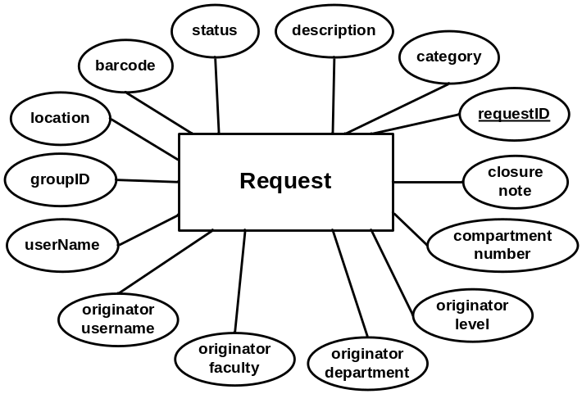
Figure 3 Requests – E/R diagram

The following table provides the data dictionary for the Request entity.

field | type | null | default | comment
requestID | int | No |  | Auto increment
category | varChar(32) | No
description | varChar(1024) | Yes | Null
status | varChar(32) | No | “Pending”
barcode | varChar(32) | Yes | Null
location | varChar(32) | Yes | Null
groupID | int | Yes | Null
userName | varChar(32) | Yes | Null
originatorUserName | varChar(32) | No
originatorFaculty | varChar(128) | Yes | Null
originatorDepartment | varChar(128) | No
originatorLevel | varChar(32) | No
compartmentNumber | int | Yes | Null
closureNote | varChar(256) | Yes | Null | 1..n
Table 1 Entity Request – Data dictionary

STATE DIAGRAMS

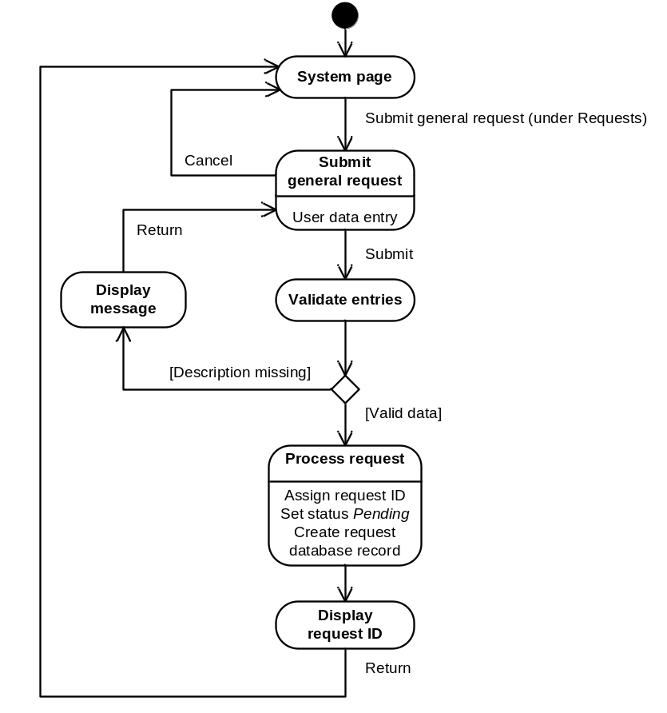
Figure 4 Submit general request – State diagram

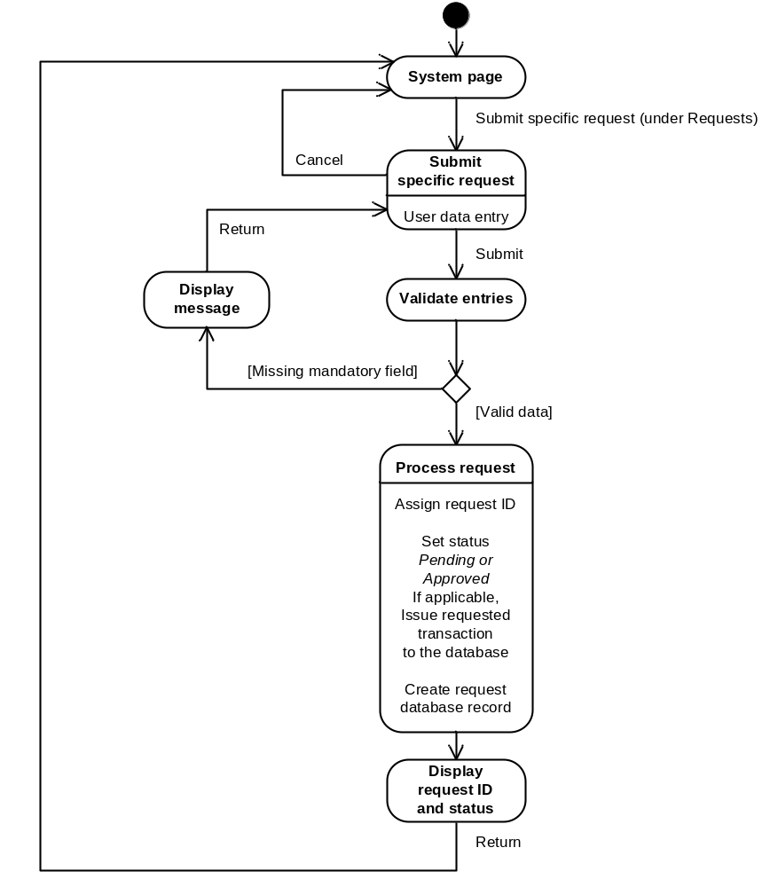
Figure 5 Submit specific request – State diagram

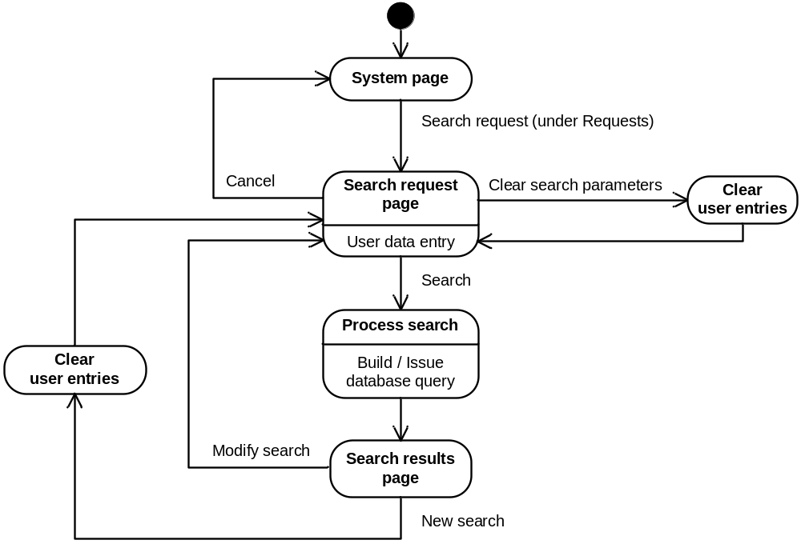
Figure 6 Search request – State diagram

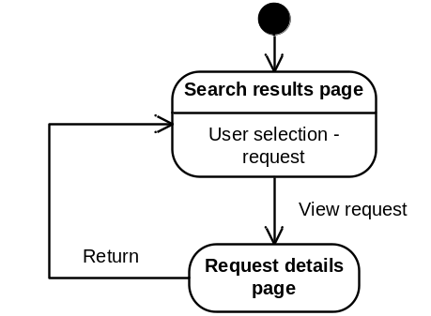
Figure 7 View request – State diagram

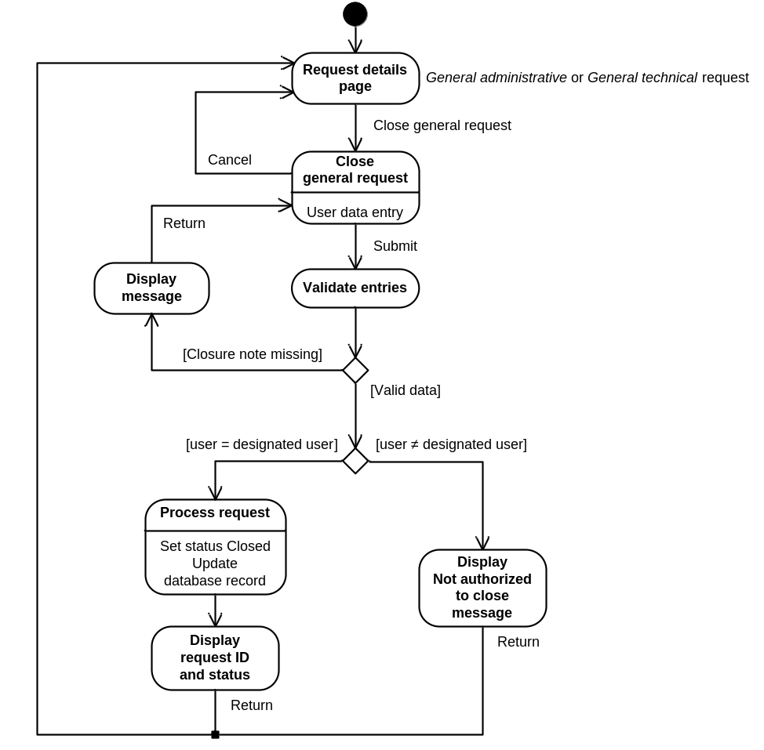
Figure 8 Close general request – State diagram

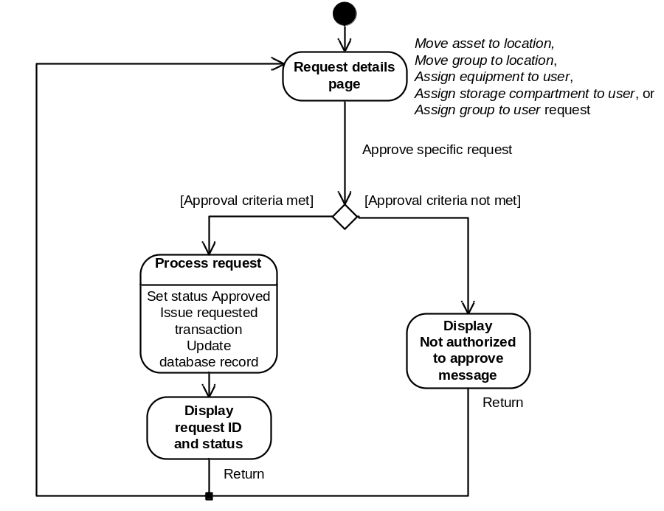
Figure 9 Approve specific request – State diagram

