v0.04 – 1 Mar ’10 – R.T.

REQUESTS / APPROVALS / WORK ORDERS

DOMAIN MODEL

Activity diagram
The following three figures provide the activity diagram applicable to the management of requests, approvals and work orders in the context of the IUfA UUIS.
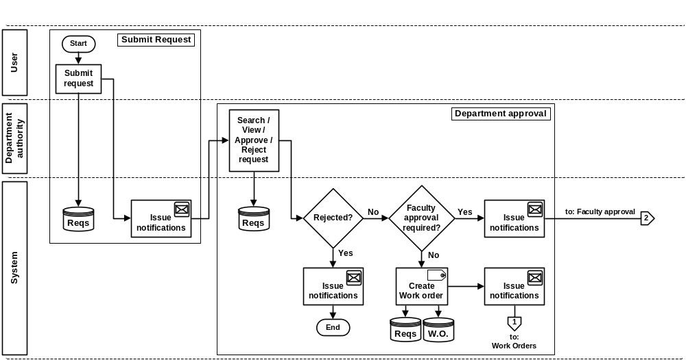
Figure 1 Requests/Approvals/Work Orders – Activity diagram (1 of 3)

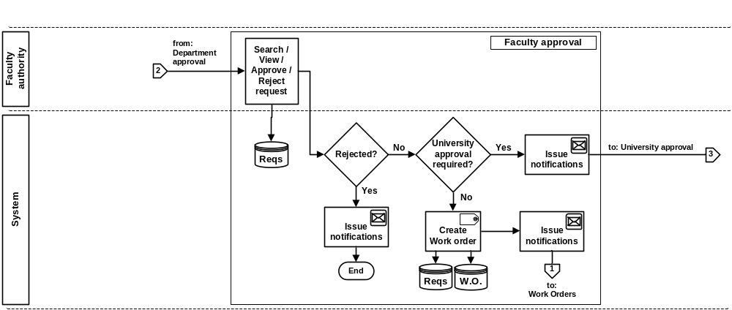
Figure 2 Requests/Approvals/Work Orders – Activity diagram (2 of 3)
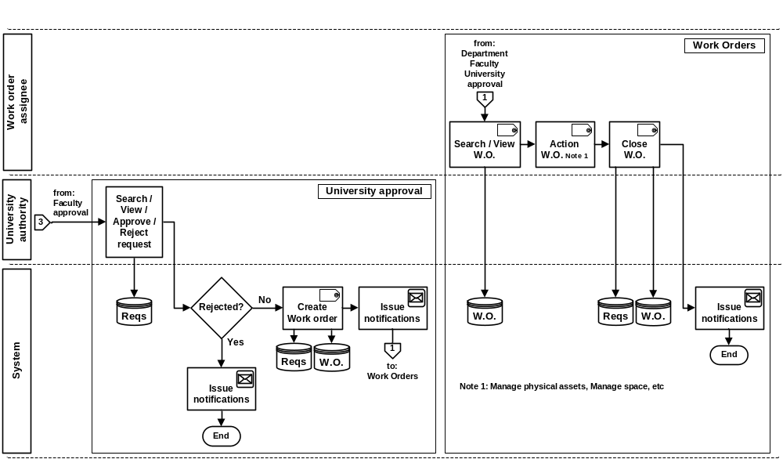
Figure 3 Requests/Approvals/Work Orders – Activity diagram (3 of 3)

All General users (Role 0) of the IUfA UUIS have the capability to submit requests.
Following the submission of a request, the Department authority will review and make a decision to approve or reject the request.
Requests, based on their nature (asset type and requested action), may require subsequent approval from the Faculty authority and the University authority.
Following the sign-off of the last approval, a work order is created and assigned based on the nature of the request (asset type and requested action).
The Work order assignee will take the appropriate action, which includes the modification of system records for the applicable asset (using system functionality such as Manage physical asset, Manage space, etc), and close the work order.

Class diagram
The following figure provides the Requests/Approvals/Work Orders class diagram.

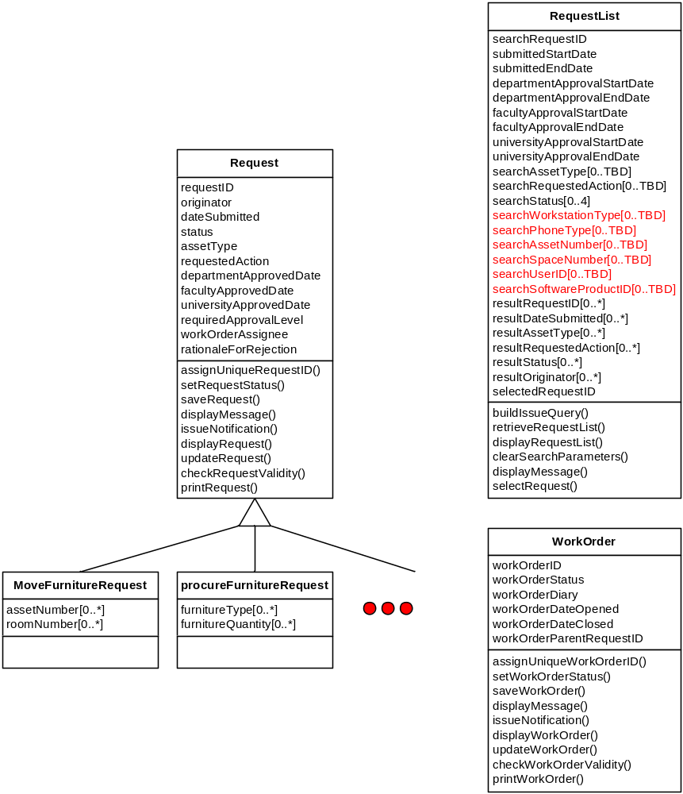
Figure 4 Requests/Approvals/Work Orders – Class diagram

USE CASES
The following figure provides the Requests/Approvals/Work Orders use case diagram.

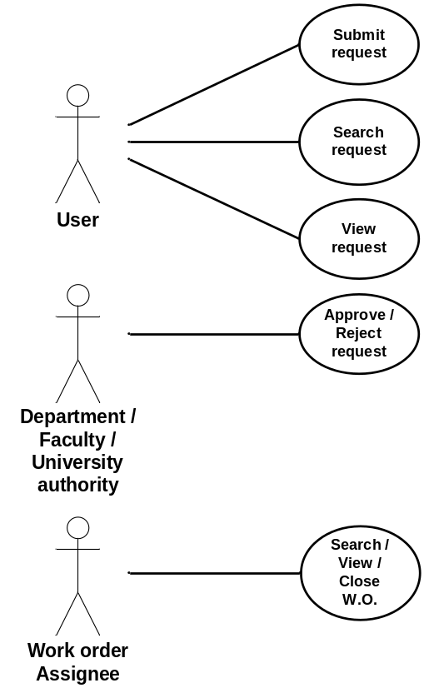
Figure 5 Requests/Approvals/Work Orders – Use case diagram

The following paragraphs provide the detailed description for each use case.

Submit request
Role: General users (Role 0);
Pre-condition: Authenticated session;
Steps:
- The user selects the Submit request button under the Request tab (accessible from all system pages);
- The system displays the Submit request page;
- The user provides applicable information as per Table 1 below;
- The user selects the Submit button;
- The system, if the request information is incomplete (missing applicable data element(s) as per Table 1 below) or if the request information implies multiple requests (Note: a submitted request is expected to be limited to a single action on a single asset type, i.e. be limited to a single cell of Table 1 below), displays a message to the user:
  - The user selects the Return button; and
  - The system displays the Submit request page with current information;
- The system displays a message with the user provided information and requesting the user to confirm the submission:
  - The user selects the Confirm button; or
  - The user selects the Return button;
    - The system displays the Submit request page with current information;
- The system:
  - Assigns the submitted request a unique identification number (request ID);
  - Sets the request status to Submitted;
  - Adds the request to the database including request ID, originator, user provided information, status and date submitted;
  - Displays a message to the user with the request ID;
    - The user selects the Return button;
  - Issues a request notification to the originator and the Department authority with request ID, status and date reported;
Post-conditions:
- The system displays the system page from which the Request tab was accessed;
- The new request is stored in the database; and
- A request notification is routed to the originator and the Department authority;
Exceptions:
- The user cancels the request by selecting the Cancel button from the Submit request page:
  - The system displays the original system page (from which the Request tab was accessed); and
  - The system does not store any information associated with the cancelled request;
- A database error is encountered:
  - The system displays an error message.

The following table provides applicable fields for the submission of requests. Each row applies to a specific asset type. Each column applies to a requested action. Each cell provides the data elements applicable to the asset type/requested action pair.
A request is limited to a single action on a single asset type, i.e. limited to a single cell of Table 1 below.

 | Move | procure | Dispose | assign | Install /  un-install
Space | - | - | - | - | -
Room (key) | N/A | N/A | N/A | User ID(s) | N/A
Cubicle / Work space | N/A | N/A | N/A | User ID | N/A
Locker (key) | N/A | N/A | N/A | User ID | N/A
Drawer (key) | N/A | N/A | N/A | User ID | N/A
Furniture | - | - | - | - | -
Asset  (Desk, Chair, Bookshelf, Cabinet) | Asset#(s) /  Space#(s) | Type(s) /  Qty ea. | Asset#(s) | Type(s) /  Space#(s) | N/A
Equipment | - | - | - | - | -
Workstation  (PC-KB-Mouse-Screen) | Asset#(s) /  Space#(s) | Type(s) /  Qty ea. | Asset#(s) | Asset#(s) /  UserID(s) | Type(s) /  Space#(s)
Phone | Asset#(s) /  Space#(s) | Type(s) /  Qty ea. | Asset#(s) | Asset#(s) /  UserID(s) | Type(s) /  Space#(s)
Software | - | - | - | - | -
Licence | - | Product ID(s) | - | Product ID(s) /  User ID(s) | Product ID(s) /  Workstation asset#(s)
Table 1 Request – Applicable data elements

Search request
Role: General users (Role 0);
Pre-condition: Authenticated session;
Steps:
- The user selects the Search requests button under the Request tab (accessible from all system pages);
- The system displays the Search requests page;
- The user provides the following (all optional) search information:
- Request ID(s) – drop-down list with request IDs from the system;
- Date submitted range;
- Department approval date range;
- Faculty approval date range;
- University approval date range;
- Asset type(s) – drop-down list;
- Requested action(s) – drop-down list;
- Status(s) – checkbox with choices Submitted, Awaiting Faculty approval, Awaiting University approval, Approved and Rejected;
- Workstation type(s);
- Phone types(s);
- Asset number(s);
- Space number(s);
- User ID(s);
- Software product ID(s); and
- Originator(s) – drop-down list with the system users;
- The user selects the Search button;
- The system builds the query based on the selected parameters and issues it to the database to perform;
- The system displays the Search requests results page with the list of requests returned by the query with:
  - Request ID;
  - Date submitted;
  - Asset type;
  - Requested action;
  - Status; and
  - Originator.
Post-condition: The system displays the Search requests results page;
Exceptions:
- The user cancels the search by selecting the Return button from the Search requests page:
  - The system displays the original system page (from which the Request tab was accessed);
- The user triggers a modified search by selecting the Modify search button from the Search requests results page:
  - The system displays the Search requests page with the last input value for all search information fields;
- The user triggers a new search by selecting the New search button from the Search requests results page:
  - The system displays the Search requests page with all search information fields cleared;
- The user clears all search information fields by selecting the Clear search parameters button from the Search requests page:
  - The system displays the Search requests page with all search information fields cleared;
- The query does not return any result:
  - The system displays a “No results found” message;
- A database error is encountered:
  - The system displays an error message.

View request
Role: General users (Role 0);
Pre-condition: The system displays the Search requests results page with successful query results;
Steps:
- The user selects a specific request using a radio button;
- The user selects the View request button;
- The system displays the Request details page with:
- Request ID;
- Date submitted:
- Department approval/rejection date if applicable;
- Faculty approval/rejection date if applicable;
- University approval/rejection date if applicable;
- Asset type;
- Requested action;
- Status;
- Originator; and
- Data elements applicable to the asset type/requested action pair as per Table 1 above.
Post-condition: The system displays the Request details page;
Exceptions:
- The user returns to the Search request results page by selecting the Return button from the Request details page:
  - The system displays the Search requests results page with the results from the last query;
- The user request a print-out of the request detailed information by selecting the Print button from the Request details page:
  - The system prints the request detailed information report;
- A database error is encountered:
  - The system displays an error message.

Approve/Reject request
Role: Department authority, Faculty authority and University authority;
Pre-condition: The system displays the Request details page;
Steps:
- The system displays either the Department approval button (and Reject button), the Faculty approval button (and Reject button), the University approval button (and Reject button) or no approval button based on:
  - Request required approval level per Table 2 below;
  - State of the request per the workflow of Figure 1, Figure 2 and Figure 3 (Department approval, Faculty approval and University approval); and
  - User profile (Department authority, Faculty authority, University authority or none);
- If applicable, the Department authority:
  - Selects the Department approval button:
    - If the request required approval level per Table 2 is Department:
      - The system sets the request status to Approved and creates a work order with unique Work order ID, parent request ID, status Opened and date; and
      - The system issues a notification to the originator, the Department authority and the Work order assignee (see note 1) with work order ID, status Open and date;
    - If the request required approval level per Table 2 is Faculty or University:
      - The system sets the request status to Awaiting Faculty approval; and
      - The system issues a notification to the originator, the Department authority and the Faculty authority with request ID, status and date;
  - Selects the Reject button and provides a rationale for rejection;
    - The system sets the request status to Rejected; and
    - The system issues a notification to the originator and the Department authority with request ID, status and date;
- If applicable, the Faculty authority:
  - Selects the Faculty approval button:
    - If the request required approval level per Table 2 is Faculty:
      - The system sets the request status to Approved and creates a work order with unique Work order ID, parent request ID, status Open and date; and
      - The system issues a notification to the originator, the Department authority, the Faculty authority and the Work order assignee (see note 1) with work order ID, status open and date;
    - If the request required approval level per Table 2 is University:
      - The system sets the request status to Awaiting University approval; and
      - The system issues a notification to the originator, the Department authority, the Faculty authority and the University authority with request ID, status and date;
  - Selects the Reject button and provides a rationale for rejection;
    - The system sets the request status to Rejected; and
    - The system issues a notification to the originator, the Department authority and the Faculty authority with request ID, status and date;
- If applicable, the University authority:
  - Selects the University approval button:
    - The system sets the request status to Approved and creates a work order with unique Work order ID, parent request ID, status Open and date; and
    - The system issues a notification to the originator, the Department authority, the Faculty authority and the Work order assignee (see note 1) with work order ID, status open and date;
  - Selects the Reject button and provides a rationale for rejection;
    - The system sets the request status to Rejected; and
    - The system issues a notification to the originator, the Department authority, the Faculty authority and the University authority with request ID, status and date;
- The system, if no rationale for rejection entry has been provided, displays a message indicating the missing information and requesting the user to provide it:
  - The user selects the Return button; and
  - The system displays the Request details page with current information;
- The system updates the request database entry with the applicable change(s);
- The system displays the Request details page with updated information;
Post-conditions:
- The system displays the Request details page with updated information;
- The updated problem report is stored in the database;
- If applicable a work order is stored in the database; and
- A notification is routed to the originator, the Department authority, the Faculty authority, the University authority and the work order assignee, as applicable;
Exceptions:
- The user returns to the Search request results page by selecting the Return button from the Request details page:
  - The system displays the Search requests results page with the results from the last query;
- A database error is encountered:
  - The system displays an error message.

Note 1: The work order assignee is pre-determined on the basis of the asset type/requested action pair.

The following table provides the approval level applicable to each asset type/requested action pair.

 | Move | procure | Dispose | assign | Install /  un-install
Space | - | - | - | - | -
Room (key) | N/A | N/A | N/A | University | N/A
Cubicle / Work space | N/A | N/A | N/A | Faculty | N/A
Locker (key) | N/A | N/A | N/A | Department | N/A
Drawer (key) | N/A | N/A | N/A | Department | N/A
Furniture | - | - | - | - | -
Asset  (Desk, Chair, Bookshelf, Cabinet) | Department | Faculty | Faculty | Department | N/A
Equipment | - | - | - | - | -
Workstation  (PC-KB-Mouse-Screen) | Department | Faculty | Faculty | N/A | Department
Phone | Department | Faculty | Faculty | N/A | Department
Software | - | - | - | - | -
Licence | - | Faculty | - | Department | Department
Table 2 Request – Required approval level

Search/View/Close Work order
Role: Work order assignee
Pre-condition: Authenticated session;
Steps:
- The user selects the Work order tab (accessible from all system pages);
- The system displays the Search work order page;
- The user provides the Work order ID;
- The user selects the Search button;
- The system builds the query and issues it to the database to perform;
- The system displays the Work order details page with:
  - Work order ID;
  - Date opened;
  - Date closed if applicable;
  - Status;
  - Parent request ID;
- Parent request asset type;
- Parent request requested action; and
  - Parent request data elements applicable to the asset type/requested action pair as per Table 1 above.
- The system displays the Close work order button based on user profile (work order assignee for asset type/requested action pair).
- If applicable, the work order assignee:
  - Selects the Close work order button and provides a diary entry:
    - The system sets the work order status to Closed; and
    - The system issues a notification to the parent request originator, the Work order assignee, the Department authority, the Faculty authority if applicable and the University authority if applicable with work order ID, status Closed, diary entry and date;
- The system, if no diary entry has been provided, displays a message indicating the missing information and requesting the user to provide it:
  - The user selects the Return button; and
  - The system displays the Work order details page with current information;
- The system updates the work order database entry with the applicable change(s);
- The system displays the Work order details page with updated information;
Post-condition:
- The system displays the Work order details page;
- If applicable, the closed work order is stored in the database; and
- If applicable, a notification is routed to the parent request originator, the Work order assignee, the Department authority, the Faculty authority if applicable and the University authority if applicable.
Exceptions:
- The user cancels the search by selecting the Return button from the Search work order page:
  - The system displays the original system page (from which the Request tab was accessed);
- The user returns to the Search work order page by selecting the Return button from the Work order details page:
  - The system displays the Search work order page;
- The user request a print-out of the request detailed information by selecting the Print button from the Work order details page:
  - The system prints the work order detailed information report;
- The query does not return any result:
  - The system displays a “No results found” message;
- A database error is encountered:
  - The system displays an error message.

FUNCTIONAL REQUIREMENTS

Submit request
- The system shall allow users to submit requests.
- The system shall assist a user, through structured dialogs, to provide the data elements associated with the submitted request as per Table 1.
- The system shall, prior to proceeding with the submit request operation, display the submitted request user-provided data elements and request a confirmation from the user.
- The system shall, in the event where the submitted request is incomplete (missing field(s) as per Table 1) or if the request information implies multiple requests (exceeding a single cell as per Table 1), display a message to the user and withhold from performing the submit problem operation.
- The system shall allow a user to cancel a submit request operation.
- The system shall, upon performing the submit problem operation, create and store a request record with unique identification number, originator, date submitted, status reflecting its submitted state, asset type, requested action and data elements associated with the submitted request as per Table 1.
- The system shall, upon successfully completing the submit problem operation, display a message to the user including the request unique identification number.
- The system shall, upon successfully completing the report problem operation, issue an e-mail notification to the originator and the Department authority including unique identification number and date submitted.

Search request
- The system shall allow users to search requests.
- The system shall assist a user, through structured dialogs, to specify search criteria, including request unique identification number(s), date submitted range, Department approval date range, Faculty approval date range, University approval date range, asset type(s), requested action(s), status(s), workstation type(s), phone type(s), asset number(s), space number(s), user ID(s), software product ID(s) and originator(s).
- The system shall allow a user to clear search criteria.
- The system shall display the results of a request search including, for each returned result, request unique identification number, date submitted, asset type, requested action, status and originator.
- The system shall, upon returning no results for a request search, display a message to the user.
- The system shall allow a user to cancel a request search.
- The system shall allow a user to modify the search criteria of a previously executed request search.

View request
- The system shall allow users to select a request for viewing.
- The system shall display the request details including problem unique identification number, date submitted, Department approval/rejection date if applicable, Faculty approval/rejection date if applicable, University approval/rejection date if applicable, Asset type, Requested action, Status, Originator and data elements applicable to the asset type/requested action pair as per Table 1 above.
- The system shall allow a user to print the request details.

Approve/Reject request
- TBD

Search/View/Close Work order
- The system shall allow users to search a work order based on is unique identification number.
- The system shall display the work order details including work order unique identification number, date opened, date closed if applicable, status, parent request ID, parent request asset type, parent request requested action and data elements applicable to the parent request asset type/requested action pair as per Table 1.
- The system shall, upon returning no results for a work order search, display a message to the user.
- The system shall allow a user to cancel a work order search.
- The system shall allow a user, based on his user profile, to close a work order for which he is he work order assignee.
- The system shall, in the event where no diary entry is provided in the context of a close work order operation, display a message to the user and withhold from performing the close work order operation.
- The system shall, upon successfully completing the close work order operation, issue an e-mail notification to the parent request originator, the work order assignee, the Department authority, the Faculty authority if applicable, the University authority if applicable with work order ID, status Closed, diary entry and date.
- The system shall allow a user to print the work order details.

DATA DICTIONARY
The following figure provides the Requests/Approvals/Work Orders E/R diagram.

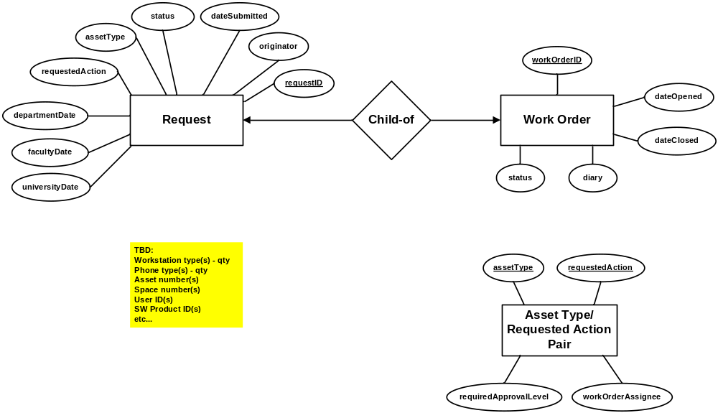
Figure 2 Requests/Approvals/Work Orders – E/R diagram

The following table provides the data dictionary for the Request entity.

field | type | null | default | comment
requestID | int | No |  | Auto increment
originator | varChar(15) | No
dateSubmitted | date | No |  | Timestamp
status | varChar(30) | No | “Submitted”
assetType | enum | No
requestedAction | enum | No
departmentDate | date | Yes | Null | Timestamp
facultyDate | date | Yes | Null | Timestamp
universityDate | date | Yes | Null | Timestamp
Table 2 Entity Request – Data dictionary

The following table provides the data dictionary for the Work Order entity.

field | type | null | default | comment
workOrderID | int | No |  | Auto increment
diary | varChar(255) | No
status | varChar(8) | No | “Open”
dateOpened | date | No |  | Timestamp
dateClosed | date | Yes | Null | Timestamp
Table 3 Entity Work order – Data dictionary

The following table provides the data dictionary for the Asset Type/Requested Action Pair entity.

field | type | null | default | comment
assetType | enum | No
requestedAction | enum | No
requiredApprovalLevel | varChar(12) | No
workOrderAssignee | date | No
Table 3 Entity Asset Type/Requested Action Pair – Data dictionary

