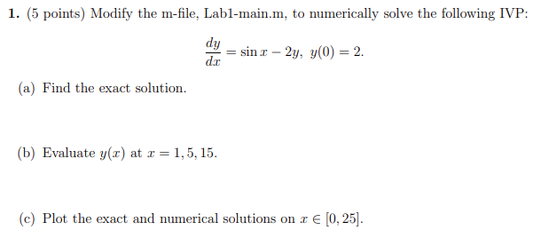
a) y(x) = (2sin(x)-cos(x)/5) + (11/5)e^(-2x)
b)
y_exact = @(x) (2*sin(x) - cos(x))/5 + (11/5)*exp(-2*x);
x_vals = [1 5 15];
y_vals = y_exact(x_vals)
c)
f = @(x, y) sin(x) - 2*y;
[x_num, y_num] = ode45(f, [0 25], 2);

% Exact
x_exact = linspace(0, 25, 200);
y_exact_vals = y_exact(x_exact);

% Plot
plot(x_num, y_num, 'ro', x_exact, y_exact_vals, 'b-', 'LineWidth', 1.5)
xlabel('x')
ylabel('y')
legend('Numerical (ode45)', 'Exact')
title('Comparison of Exact and Numerical Solutions')
grid on
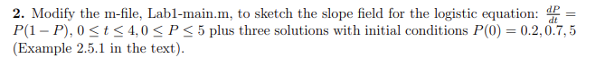

% Slope field for problem 2
[t, P] = meshgrid(0:0.5:4, 0:0.2:5);
dP = P .* (1 - P);
quiver(t, P, ones(size(t)), dP, 'r')
xlabel('t'), ylabel('P')
title('Slope field for logistic equation')
hold on

% Numerical solutions for this goofy problem
f = @(t, P) P .* (1 - P);
P0 = [0.2 0.7 5];
for i = 1:length(P0)
[t_num, P_num] = ode45(f, [0 4], P0(i));
plot(t_num, P_num, 'LineWidth', 1.5)
end
legend('Slope field', 'P(0)=0.2', 'P(0)=0.7', 'P(0)=5')
grid on

