**Lab 4 Submission**

**Data Wrangler Script and Screenshot: CMSC**



**Data Wrangler Script and Screenshot: World Cup 1**













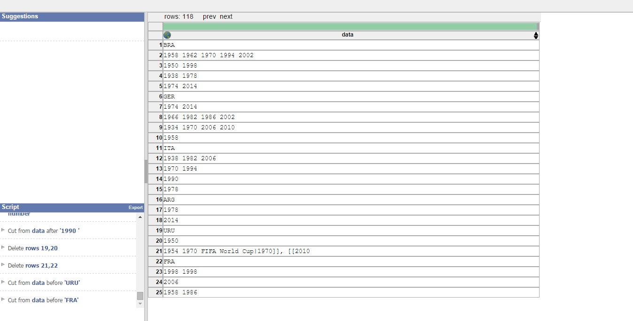

**Data Wrangler Script and Screenshot: World Cup 2**

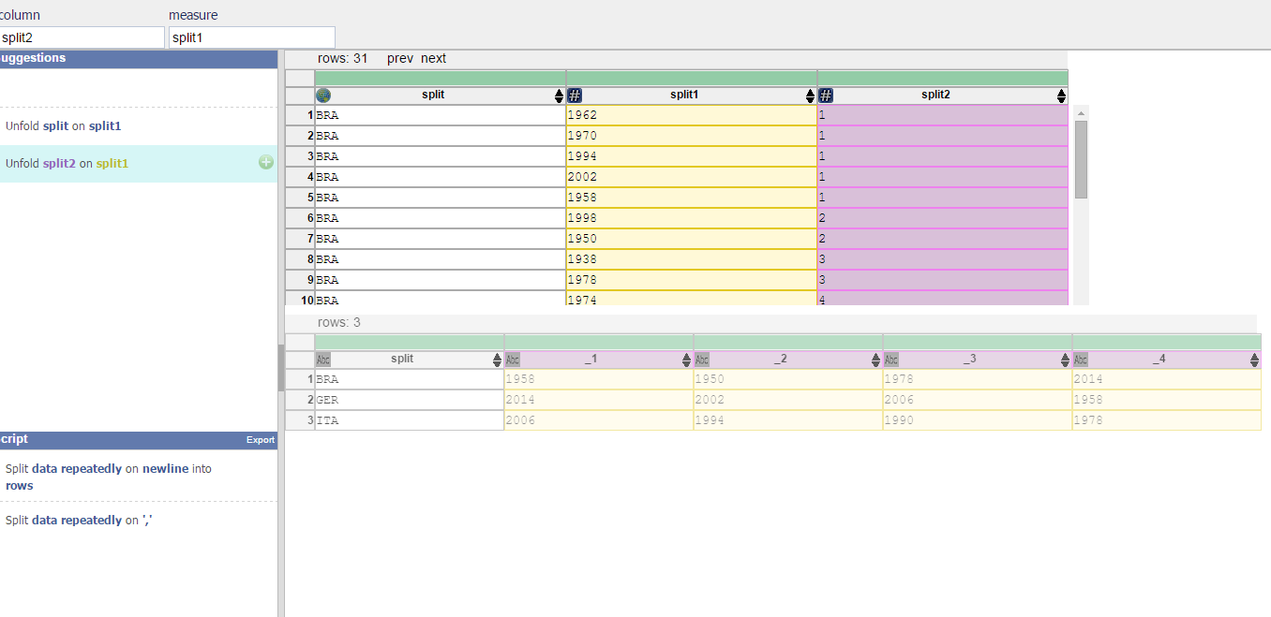

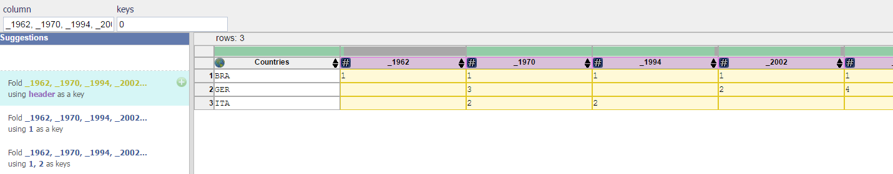

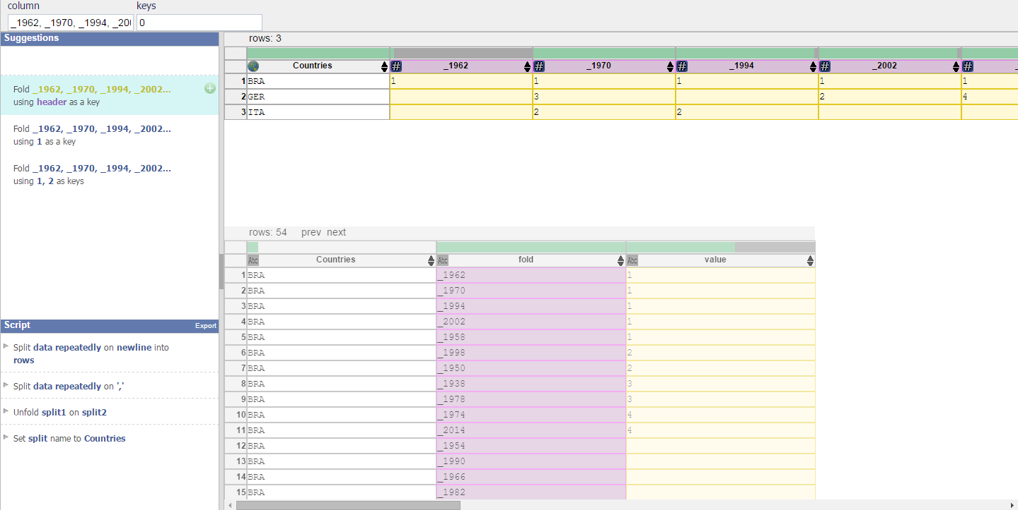

**UNIX Tools Command: CMSC**

cat cmsc.txt | awk -F'[ ,\)]' 'BEGIN {print "Course No.,\tSection No.\tInstructor\tSeats\tOpen\tWaitlist\tDays Time\t\t\tBldg.\tRoom No."} /^CMSC[0-9][0-9][0-9]$/ {print $1;} /^[0-9][0-9][0-9][0-9]$/ {print "\t\t", $0;} /^[-A-Za-z]+( [-A-Za-z]+)$*/ {print "\t\t\t\t", $0;} /^Seats \(Total: [0-9]+, Open: [0-9]+, Waitlist: [0-9]+\)$/ {print "\t\t\t\t\t\t", $3, "\t", $6, "\t", $9;} /^[MWFTuh]+ [0-9]+:[0-9]+/ {print "\t\t\t\t\t\t\t\t\t\t", $1, " ", $2, $3, $4;} /^[A-Z]+ [0-9][0-9][0-9][0-9]$/ {print "\t\t\t\t\t\t\t\t\t\t\t\t\t\t", $1, "\t", $3;}' | less

Or to try another way of formatting (still looks ugly though...)

cat cmsc.txt | awk -F'[ ,\)]' 'BEGIN {print "Course No.,\tSection No.\tInstructor\t\tSeats\t\t\tOpen\t\t\tWaitlist\tDays Time\t\t\tBldg.\tRoom No."} /^CMSC[0-9][0-9][0-9]$/ {course = $1;} /^[0-9][0-9][0-9][0-9]$/ {section = $0;} /^[-A-Za-z]+( [-A-Za-z]+)$*/ {instr = $0;} /^Seats \(Total: [0-9]+, Open: [0-9]+, Waitlist: [0-9]+\)$/ {seats = $3; open = $6; waitlist = $9;} /^[MWFTuh]+ [0-9]+:[0-9]+/ {days = $1; time1 = $2; time2 = $3; time3 = $4;} /^[A-Z]+ [0-9][0-9][0-9][0-9]$/ {bldg = $1; room = $3; print course, "\t", section, "\t\t", instr, "\t\t", seats, "\t\t\t", open, "\t\t\t", waitlist, "\t\t\t\t", days, "\t\t\t\t\t", time1, "\t\t\t\t\t", time2, "\t\t\t\t\t", time3;}' | less

**UNIX Tools Command: World Cup 1**

cat worldcup.txt | sed 's/FIFA//g' | sed 's/[\{\}\|\(\)]//g' | sed 's/fb//g' | sed 's/style=\"background:#fff68f\"//g' | sed 's/<sup>//g' | sed 's/<\/sup>//g' | sed 's/\[\[#[0-9].\]\]//g' | sed 's/style=white-space:nowrap//g' | awk -F'[, \[]' 'BEGIN {place = 0;} /[A-Z][A-Z][A-Z]/ {coun = $1;} /[0-9] \[\[([0-9][0-9][0-9][0-9])*/ { if (place == 4) place = 1; else place = place + 1; if (length($4) != 0) print coun, $4, place; if (length($11) != 0) print coun, $11, place; if (length($18) != 0) print coun, $18, place; if (length($25) != 0) print coun, $25, place; if (length($32) != 0) print coun, $32, place;}' | less

**Python Script: CMSC**

See cmsc.py for source code

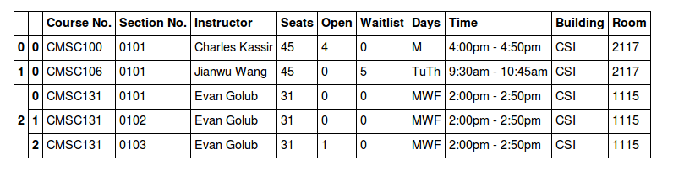

**Python Script: World Cup 1**

See worldcup.py for source code

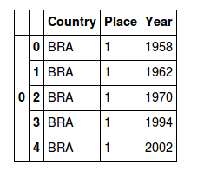

**Python Script: World Cup 2**

See worldcup.py for source code (last few lines in the file are for World Cup 2)

