Tour (10020.ir)

Tour section are dependant on :

* Country module
* State module
* City module
* Hotel module
* Vendor module
* Airlines module
* Tour module
* B2C module

## Country Module

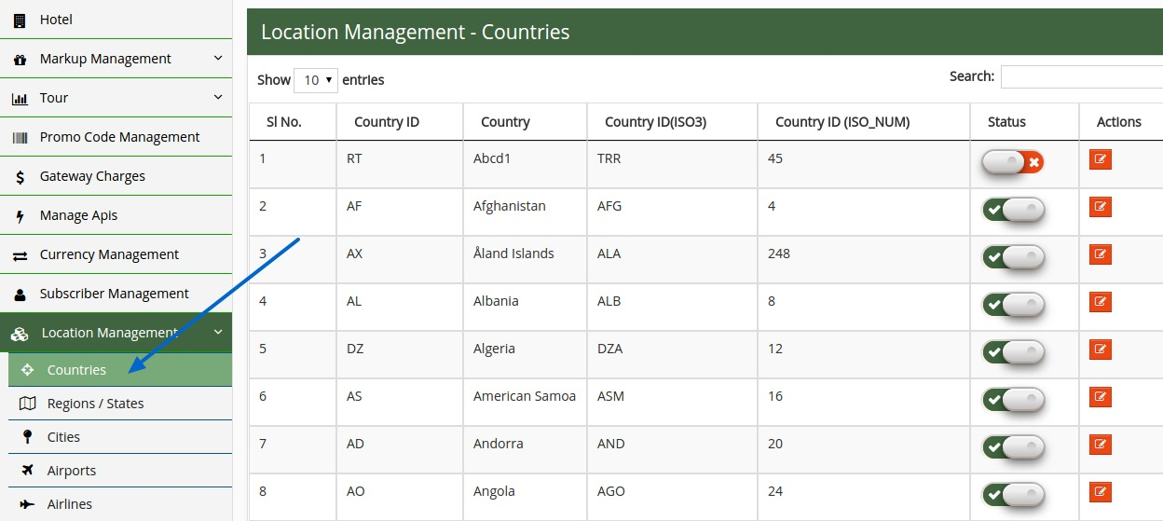

this is the country module. We have already defined appx all countries. You can update here.

## State/Region Module

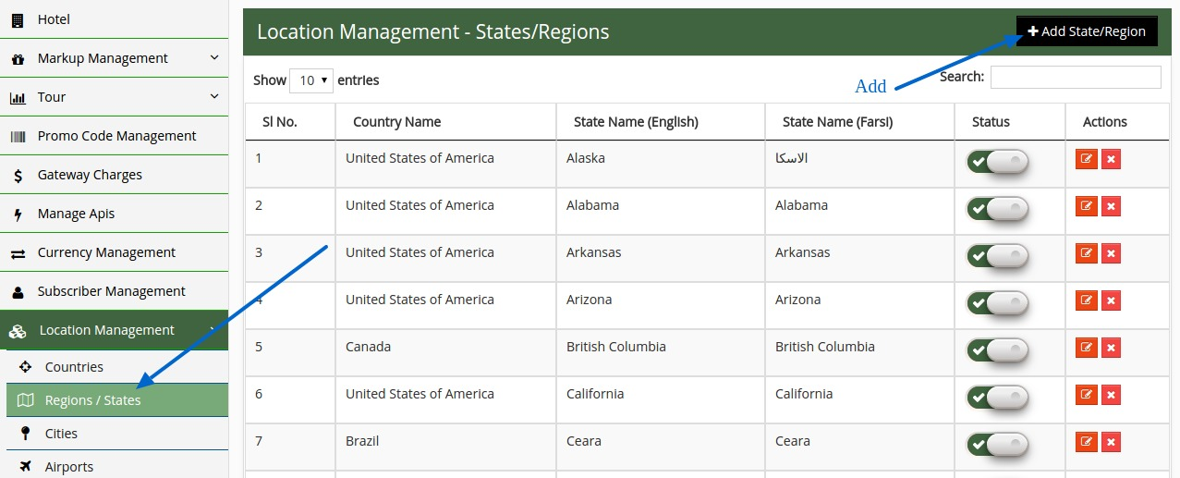

similarly state or region module here. In this section you can manage the states.

## Cities Module

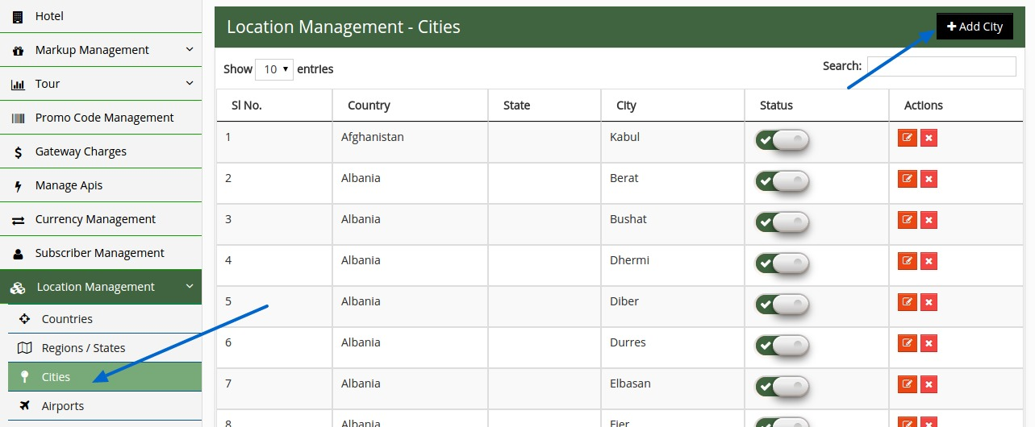

in this city module you can add,edit or delete the cities.

## Hotel Module

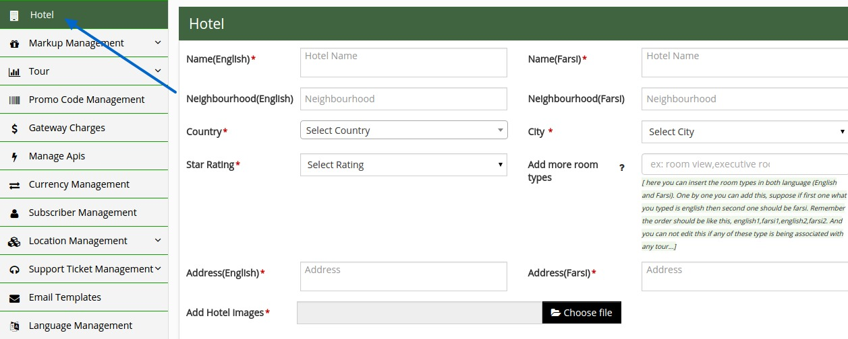

Here admin user can add,edit,delete the hotel.

* you can not delete the hotel if it is included with any tour.

*adding room types : -

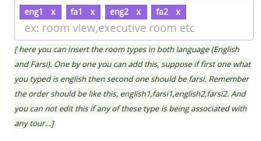

One by one (English, Farsi) you have to add this, suppose if first one what you typed is english then second one should be Farsi. Remember the order should be like this, english1,farsi1,english2,farsi2. And you can not edit this if any of these type is being associated with any tour...

## Vendor Module

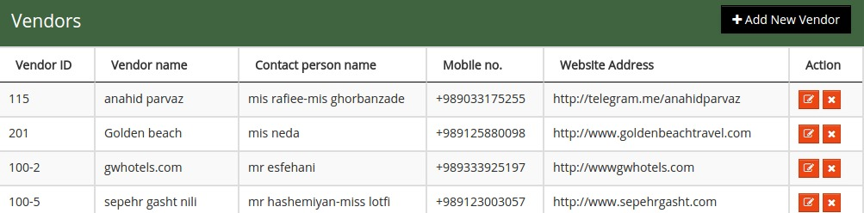

In this section user can manage (add, edit, delete) the vendors.

## Tour airlines Module

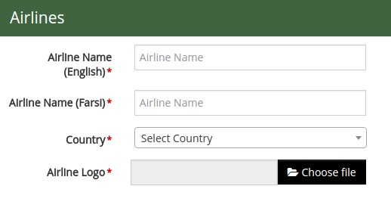

Here country wise you can add airlines. * marked fields are mendatory.

## Tour Module

This is the section where you can define the tour.

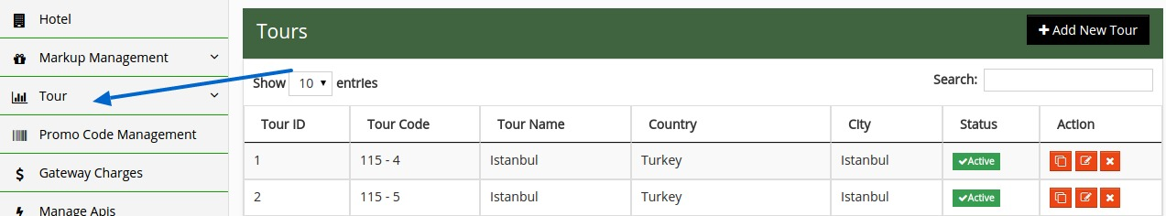

To add the new tour you have to click the “+ Add New Tour” button

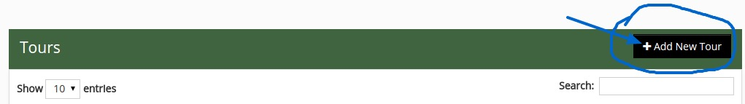

after clicking this it will redirect you to tour setup page where you have to fill up the all mandatory fields to define a tour.

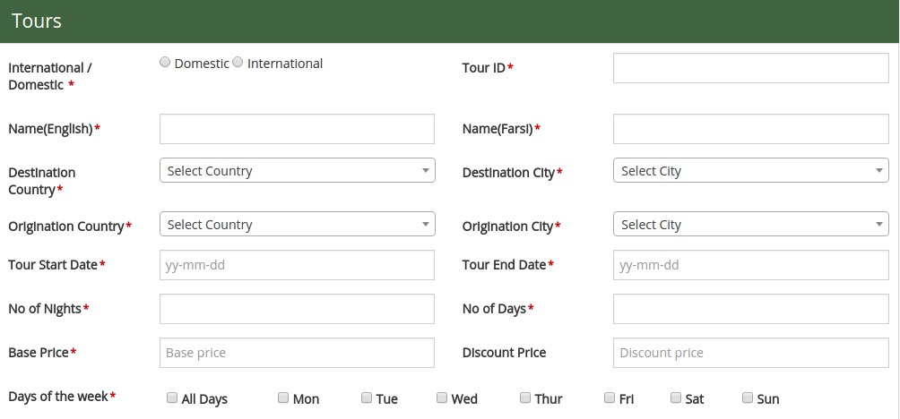

All price sections are there , so you can modify the price of a particular day in a particular hotel also.

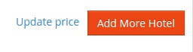

Clicking the "Update price" button it will redirect to the "update master price" page where you can modify the hotel room price date/day wise.

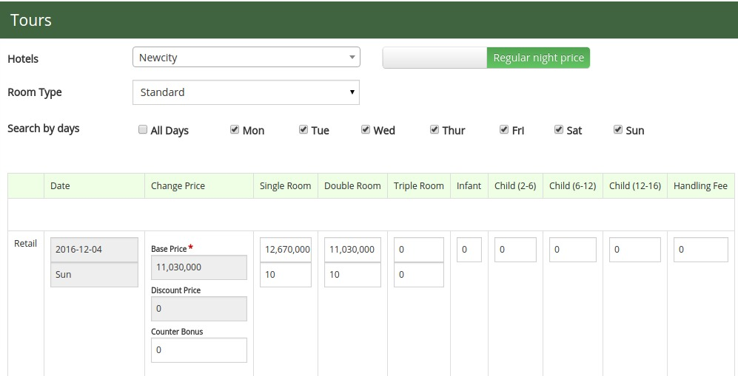

## B2C Module

In this section you can manage (add/edit/delete) the b2c users.

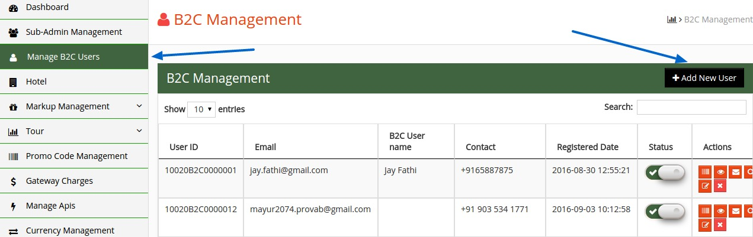

This is the listing page. You can add more b2c user by clicking the “+Add New User” button.

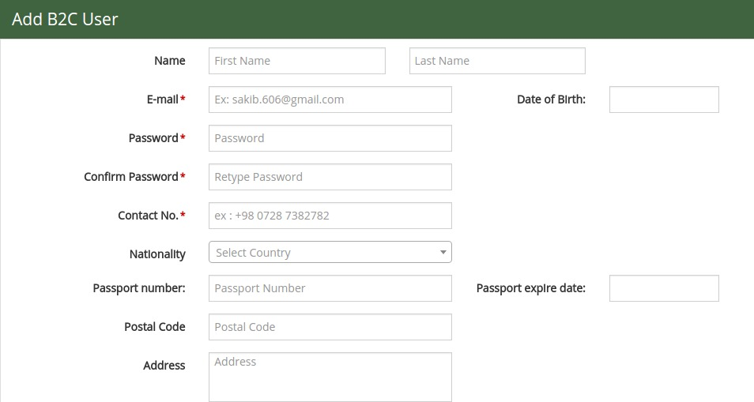

Here you can define the b2c user.