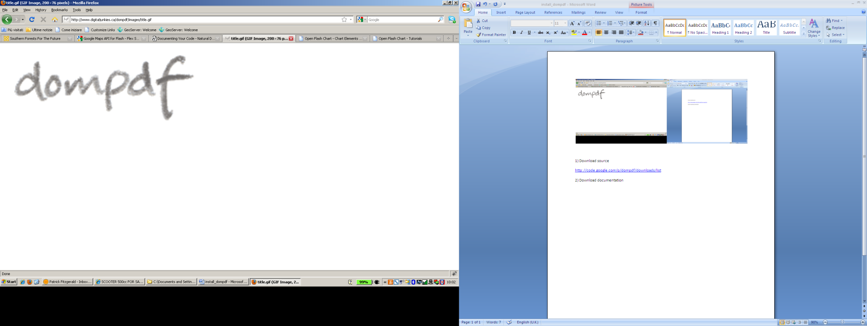

<http://www.digitaljunkies.ca/dompdf/index.php>

1) Install

1.1) Download source

<http://code.google.com/p/dompdf/downloads/list>

1.2) Download documentation

<http://www.digitaljunkies.ca/dompdf/downloads.php>

* Online API documentation

<http://www.digitaljunkies.ca/dompdf/doc/>

2) Upload Files to Server

2.1) Change ‘lib/fonts’ write permissions to chmod 777

* + $ chmod 1777 lib/fonts

3) Enable GD2 in PHP for CSS background-images

3.1) Run apt-get to install

* $ sudo apt-get install php5-gd

3.1) Restart Apache

* $ sudo /etc/init.d/apache2 restart

3) Test Demos on Server

<http://dompdf.server.location/dompdf/www/examples.php>

4) Include New fonts

4.1) To use ‘load_font.php’ script requires the update of the **DOMPDF_LIB_DIR** variable in the ‘dompdf_config.inc.php’ file to point to the default dompdf TTF2PT1 install folder

* + Default install: ‘dompdf/lib/ttf2ufm/ttf2ufm-src’

4.2) Use load_font.php to install and upload new font libraries

* + Default fonts: Helvetica, Times New Roman, Courier & Zapf-Dingbats

5) Configuration

5.1) To enable remote images

* + Change **DOMPDF_ENABLE_REMOTE** to **true**

5.2) To enable images larger than 96 dpi

* + i.e. 300. Change **DOMPDF_DPI** to ‘**300’**