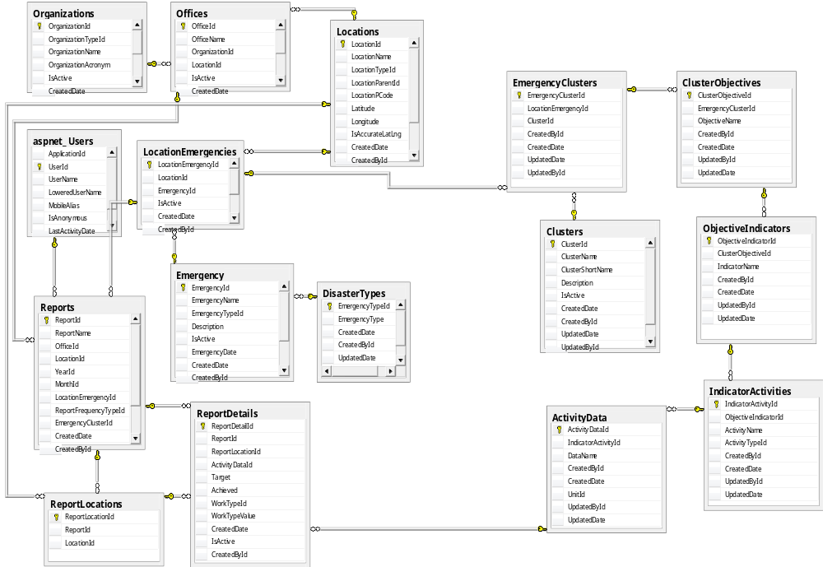
This system is to record 3W information. It is very simple data entry program which only records Target given and Achieved by implementing partner(field worker). Please look following screen shot for the data entry.

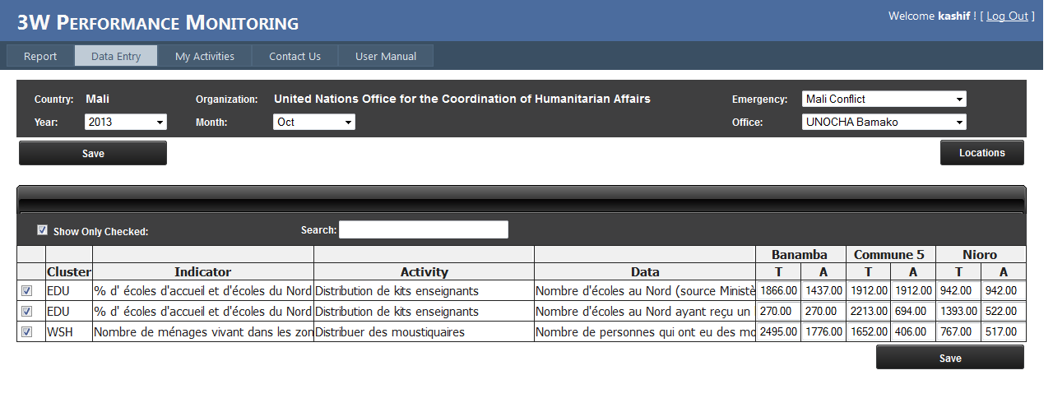
The db design is one to many in most of the tables. Like Clusters -> Indicators->Activities->Data has one to many relations.
Brief description of important tables:
Locations: This table has all the locations. This table is self-joined so all administration locations will be in one table.
Emergency: This table will have emergency and its type. Like ‘Flash floods 2011 Pakistan’, ‘Earthquake Haiti’ etc.
LocationEmergencies: This table will join ‘Emergency’ and ‘Locations’.
Organizations: Has all the UN agencies, iNGOs, NGOs, Gov organizations.
Offices: One organization can have more than one offices at one location so it is to record the information that in which office or the organization user is working.
Clusters: All clusters.
EmergencyClusters: In this table we will record the information that which clusters are activated in a particular emergency.
Following tables will have the information about indicators which clusters define for each emergency:
ClustersObjectives: This table is where we will start record information of objectives defined by a cluster for a particular emergency.
ObjectiveIndicators: This is where we will record the indicators of objectives.
IndicatorActivities: Activities of a particular indicator.
ActivityData: Data of an activity (actual work of Implementing Partner).
Reports: The main table of IP report (Actually it is not report; this is the first table where user will record its information about given targets and achieved targets against each ActivityData).
ReportLocations: Each IP can work on one or more than one locations so it is to record information that where IP has worked.
ReportDetils: Details of each report.

There are other supporting tables like aspnet_Roles, ActivityTypes etc.

