DEVELOPMENT OF A COUPLED VOF-DEM SOLVER FOR MULTIPHASE FLUID FLOW IN OPENFOAM

by
¹Md Asfiqur Rahman, Graduate Student
Phone: (803) 239-9844 / Email: mr112@email.sc.edu

¹Yi Wang, Ph.D., Professor
Phone: (803) 777-2252 / Email: yiwang@cec.sc.edu

¹Department of Mechanical Engineering
University of South Carolina
300 Main Street, Columbia, SC 29208

Abstract:
This study presents the development of a coupled Volume of Fluid (VOF)-Discrete Element Method (DEM) solver, DPMInterFoam, within the open-source OpenFOAM framework for three-phase (gas-liquid-solid) systems. The solver utilizes the Volume of Fluid (VOF) method to accurately capture the gas-liquid interface, combined with the Discrete Element Method (DEM) to resolve particle dynamics through a fully coupled Eulerian-Lagrangian formulation. DPMInterFoam is first verified using a three-dimensional dam break benchmark case. Notably, the numerical results exhibit excellent agreement with reference data. The solver is further evaluated through simulations of particle migration and drainage behavior under multiphase flow in a perforated domain for various particle volume fractions, along with a comparison with OpenFOAM’s default MPPICInterFoam solver. Numerical analyses confirm that DPMInterFoam produces physically coherent results for particle distribution and hydrodynamics across the dilute and dense regimes. While MPPICInterFoam offers better computational efficiency in the dilute regime, unphysical particle-particle overlaps in the dense regime lead to biased hydrodynamic results. Overall, DPMInterFoam can be used as an open-source computational tool to model real-world multiphase flow and particle-interaction scenarios accurately.

Keywords: Lagrangian-Eulerian approach, Multiphase (gas-liquid-solid) flow simulation, Particle migration and drainage, Flow in porous medium, DPMInterFoam, MPPICInterFoam

NOMENCLATURE:
$$ω$$ | Angular velocity | $$p$$ | Pressure
$$A$$ | Acceleration | $$x$$ | Position
$$k$$ | Curvature | $$∅$$ | Probability distribution function
$$ρ$$ | Density | $$Re$$ | Reynolds number
d | Diameter | $$σ$$ | Surface tension constant
$$h^{*}$$ | Dimensionless remaining height | $$τ$$ | Stress tensor
$$t^{*}$$ | Dimensionless time | $$T$$ | Torque
$$x^{*}$$ | Dimensionless front location | t | Time
g | Gravitational force | $$α$$ | Phase Fraction
$$F$$ | Inertial resistance vector | $$ε$$ | Volume fraction
$$m$$ | Mass | $$u$$ | Velocity
$$I$$ | Moment of inertia | $$D$$ | Viscous resistance vector
$$β$$ | Momentum exchange coefficient | V | Volume

ABBREVIATIONS:
CFD | Computational Fluid Dynamics
DEM | Discrete Element Method
MPPIC | Multiphase Particle-In-Cell
VOF | Volume of Fluid

SUBSCRIPTS:
c | Contact
f | Fluid
g | Gas
l | Liquid
p | Particle
pf | Particle-fluid interaction term

- INTRODUCTION
The study of multiphase flows, which involves the interaction of gas, liquid, and solid phases, is pivotal for a wide range of scientific and engineering domains. This multiphase flow technique has broad applications across numerous sectors such as petroleum industry (oil and gas processing, petroleum production), chemical engineering (fluidized bed reactor), waste water treatment ( sedimentation, separation processes), aerospace propulsion (combustion systems), pharmaceutical and medical fields (drug delivery systems, blood flow in arteries, and fluid dynamics within the respiratory system) [1]. These diverse applications highlight the importance of accurately simulating multiphase flows to optimize system performance and ensure operational reliability across industries.
To effectively harness the potential of multiphase flows, it is crucial to examine the complex interactions among gas, liquid, and solid phases. These interactions are not only fundamental to the understanding of multiphase systems but also play a critical role in enhancing the efficiency and performance of processes across various industries. Consequently, a comprehensive understanding of gas-liquid-solid interactions is essential to optimize the design and operation of industrial processes [2]. Considering the complexity and importance of multiphase flow interactions in various industrial applications, traditional experimental approaches often face limitations due to high costs, time constraints, and potential safety hazards. As a result, researchers increasingly turn to alternative methods to study this intricate system [3]. In this context, numerical simulation emerges as a powerful tool, offering a cost-effective, time-efficient, and safer means to explore and understand industrially significant flow phenomena [3]. Given its benefits, numerical simulation has become increasingly prominent for accurately capturing the dynamics of multiphase flows over the decades. However, being complex by nature, a three-phase flow poses significant challenges due to the distinct physical properties and behaviors of each phase, requiring sophisticated modeling techniques to capture their dynamics accurately [1][2][3].
Within the scope of modeling gas-liquid-solid systems, the two most widely used frames of reference in numerical simulation are the Eulerian-Eulerian and Eulerian-Lagrangian [4][5]. Both approaches use volume-averaged Navier-Stokes equations for the fluid phases, with the primary difference in the treatment of the solid phase. In the Eulerian-Eulerian approach, the solid phase is treated as a continuum to reduce computational cost, with particle tracking insignificant. However, it also has a few drawbacks, including the need for constitutive laws for granular flow, complexity in particle size distributions [5], and susceptibility to numerical diffusion [6]. On the other hand, the Eulerian-Lagrangian method tracks the movement of each particle by solving Newton’s law of motion. Here, small time steps are required to resolve particle-particle and particle-wall collisions. These collisions are modeled using either a soft-sphere or a hard-sphere method, both of which result in a high computational cost. Within the Eulerian-Lagrangian framework, the Discrete Element Method (DEM) coupled with Computational Fluid Dynamics (CFD) is a popular and successful method because it combines well-established CFD with the discrete dynamics of a granular particle cloud. Importantly, the particle–particle and particle–wall contact forces are solved by springs, dashpots, and sliders while the trajectory of each particle is tracked by Newton’s law of motion. Moreover, the momentum transfer around the particles is computed by summing the drag, lift, and momentum forces acting on them. This method is capable of handling particles not only significantly larger than the grid size but also of different sizes.
Building on the Eulerian–Lagrangian approaches, numerous commercial and open-source CFD and DEM computational tools have been developed for various research and engineering applications. Open-source tools, such as OpenFOAM, have gained significant traction due to their ease of customization and a broader user and developer community for contributions, which also motivates the present study. The subsequent sections present a comprehensive literature review focused on studies conducted particularly using OpenFOAM. Special attention is given to two prominent methods within this framework: DEM and the Multiphase Particle-in-Cell (MPPIC) coupled with the CFD for multiphase flow. This literature review will outline key findings and advancements in these areas, setting the stage for a deeper understanding of their application in modeling multiphase flows. Tsuji et al. [7] initiated the use of CFD-DEM in numerical simulations of fluidized beds. Sun et al. [8] introduced a novel approach for solving gas-liquid-solid interactions using the VOF (volume of fluid)-DEM method, where the fluid phase was modeled by the VOF method and the particle phase by DEM. In their study, numerical results were validated against experimental data. Following validation, additional multiphase scenarios, including sedimentation and surface tracking, were explored to assess the model's broader applicability. Li et al. [9] extended the research study of Sun et al. by considering mass, capillary, and drag forces along with the VOF-DEM model. Their upgraded model was also validated by evaluating the three-phase dam break case presented by Sun et al. Pozzetti et al. [3] followed a similar approach to Sun et al. and adopted a dual-grid approach to resolve bulk-scale information from the fine-scale by considering a range of fields (chemical, environmental, process engineering) that value different length scales. Park et al. [10] used the VOF-DEM method to determine the effect of particle density on the locations of the water and particle fronts. In their study, the particle density was found not to affect waterfront location. However, the velocity of the particle front location changed inversely along with particle density. Moreover, a classification of front location regimes was introduced based on particle density. Nian et al. [11] implemented an extended coupled CFD-DEM method to optimize the formation of landslide dams, focusing on gas-liquid-solid phase coupling. The method, implemented to enhance computational efficiency, was also verified through simulations, including single-particle sedimentation and three-phase dam-break scenarios. It was then applied to model the evolution of landslide dams with varying kinematic properties of landslide and river flow. Washino et al. [12] focused on developing a scaled-up particle model for simulating three-phase (gas-liquid-solid) flows to reduce computational cost by accounting for phase interaction forces, which were scaled up using continuum assumptions for particulate flow. An enhanced interface-capturing method using a color function was introduced in their study for improved interface smoothness. Additionally, diffusion-based coarse-graining is applied to maintain adequate spatial resolution in CFD despite increased particle sizes. It was claimed that their method could maintain accuracy for phase behavior. Vångö et al. [13] applied the VOF-DEM method to a porous medium within a multiphase densely packed bed of particles by considering particles of identical sizes, and Jing et al. [14] discussed the process of applying VOF-DEM for solving a three-phase flow case along with multi-size particles altogether by taking into account an additional advection equation. Notably, the literature survey indicates that OpenFOAM is a powerful open-source framework for multiphase flow simulations. Several researchers have developed customized solvers within the OpenFOAM environment by extending its existing libraries for coupled fluid-particle simulations that consider multiphase flow. However, most of these developments are not publicly available for continual research and development. Therefore, given the limitations, developing and sharing a high-fidelity VOF-DEM solver within OpenFOAM is essential for the multiphase modeling community, particularly from the perspective of reproducible, extensible research.
Another significant, yet cost-effective (computational) method, particle-in-cell (PIC), has been utilized since the 1960s [15]. The multiphase particle-in-cell (MPPIC), an extension of the original PIC method, was developed in the mid-1990s for a one-dimensional method and then extended to two and three dimensions in recent years [15][16]. The model has been rigorously improved by including a collision model, damping oscillation due to non-elastic collision, return-to-isotropy in the collision source term, and contact force variation initiated by relative motions from diverse particle sizes and densities [17]. In this numerical method, particle dynamics is traced by solving a Liouville equation for the particle distribution function, which is completely different from the DEM described earlier [15]. The implementation of a coupled VOF-MPPIC solver for particle-fluid multiphase flow systems was discussed by Kumar et al. [18], who conducted Large Eddy Simulation (LES) to analyze particle flow dynamics in a hydrocyclone with an air core, employing four sub-grid-scale models. A particle stress model is utilized in the MPPIC method to compute collision force on individual particles as a spatial gradient, which appreciably reduces computational cost while maintaining simulation accuracy even with larger time steps [19]. Snider [15] emphasized the utilization of MPPIC for dense particle flow and presented numerical results for sedimentation and particle jet flow. Karimipour et al. [20] evaluated the MPPIC approach for modeling the bubbling behavior in a fluidized bed of Geldart A particles, using different mesh sizes and drag models. The results, compared with established correlations and experimental data, demonstrated that the MPPIC method has strong predictive capability without requiring modifications to the drag model. Jiane et al. [21] investigated a circulating fluidized bed with six cyclone separators. Liao et al. [22] utilized the VOF-MPPIC coupled method to analyze bubble coalescence and breakup in a slurry to understand the effect of particles and their corresponding properties. Ranjbari et al. [1] employed a similar method to simulate three-phase flow and investigate the effect of particles on pressure drop and void fraction in gas-liquid flows with slug and plug flow patterns by validating their work with Lockhart and Martinelli's correlations. Fatehifar et al. [23] simulated the encapsulation process of particles into liquid droplets produced by a high-throughput flow-focusing microfluidic device.
According to the literature review, a wide range of studies have employed CFD-DEM and MPPIC approaches to model two-phase (gas-solid) systems. Similarly, VOF-DEM and VOF-MPPIC methods are utilized to simulate three-phase (gas-liquid-solid) flow. These efforts have yielded valuable insights into phenomena such as gasification [1][2][5], sedimentation [8][9][15], circulating [1][19], and bubbling [20][24] within fluidized beds. However, there remains a notable scarcity of analysis concerning three-phase flow modeling. First, although OpenFOAM provides a framework for multiphase flow simulations, the absence of a built-in VOF-DEM solver significantly limits its utility for multiphase flow research. Second, a direct, comprehensive comparison between VOF-DEM and VOF-MPPIC solvers in OpenFOAM for three-phase multiphase flows is also needed, especially in contexts where precise characterization of particle bed height, spatial distribution, and migration dynamics is critical. Additionally, most existing studies have concentrated solely on a simple cuboid/rectangular domain [1]~[20][22][24]; the effectiveness and challenges of these Lagrangian-Eulerian solvers in perforated domains have yet to be thoroughly investigated to find out the effect of particle volume fraction on particle migration/drainage. Third, most importantly, there are no adequate resources to guide such numerical model development, particularly in parameter configuration for particle clouds and in maintaining stability throughout the simulation within a three-phase system, which poses challenges for understanding and effectively implementing these complex modeling processes.
This study presents several salient contributions to the advancement of three-phase (gas-liquid-solid) modeling within the OpenFOAM framework, aiming to extend its applicability to a broader user community. These include: (1) the development of DPMInterFoam, a coupled VOF-DEM solver for three-phase flow, to address the need for a built-in VOF-DEM solver in OpenFOAM; (2) a quantitative comparison between our DPMInterFoam and the default MPPICInterFoam solver in OpenFOAM for three-phase numerical cases, analyzing the impact of particle distribution on drainage/migration and overall hydrodynamics in a perforated domain, and assessing the computational performance of both methods; (3) the establishment of criteria for selecting the most appropriate solver based on particle density and distribution; and (4) sharing of the DPMInterFoam solver as an open-source resource for other researchers, along with a comprehensive implementation scripting guide (https://github.com/iMSEL-USC/DPMInterFOAM.git).
The paper is organized as follows: governing equations utilized by our DPMInterFoam solver are described in Section 2. Section 3 describes the numerical simulation process. Section 4 presents a numerical case study of a three-phase dam break, and its published data is used to verify the DPMInterFoam solver. Then, a perforated case study is presented in Section 5, which compares results from DPMInterFoam and MPPICInterFoam solvers and discusses particle drainage/migration across various numerical scenarios in dilute and dense regimes. Finally, the paper concludes with a summary of scientific findings and the insights obtained from the numerical modeling. It is important to note that the MPPICInterFoam solver was employed in this study solely for comparison purposes.

- GOVERNING EQUATIONS
To solve multiphase flow involving gas, liquid, and solid, this study considers the DPMInterFoam solver. This solver follows a coupled Eulerian-Lagrangian approach, where the fluid phase (i.e., gas and liquid) and solid phase (i.e., particles/fines) are treated using Eulerian and Lagrangian approaches, respectively.
Eulerian phase
The Eulerian phase is modeled by the Navier–Stokes equations, which are solved for flow dynamics of two incompressible, isothermal, and immiscible fluids, i.e., gas and liquid, coupled with the VOF method for accurate interface tracking. The continuity equation for incompressible fluid is [3][8][9]
$$\frac{∂ε_{f}}{∂t}+∇∙\left(ε_{f}u_{f}\right)=0$$ | (1)
where $ε_{f}$ represents the void fractions, the fraction of the cell volume occupied by fluid, with $ε_{f}+ε_{p}=1$. Within the fluid, $α_{l}$ and $α_{g}$ are the liquid and gas saturations, with $α_{g}+α_{l}=1$, where l and g subscripts denote the quantities of the liquid and the gas phase, respectively [35]. $u_{f}$ is the velocity field, calculated as the weighted average of corresponding liquid and gas velocities.
The momentum equation can be expressed as [8]
$$\frac{∂\left(ε_{f}ρ_{f}u_{f}\right)}{∂t}+∇∙\left(ε_{f}ρ_{f}u_{f}u_{f}\right)=-ε_{f}∇p+ε_{f}ρ_{f}g+ ∇∙\left(ε_{f}τ_{f}\right)+f_{σ}-F_{fp}$$ | (2)
where, $p$, $g$, $τ_{f}$, $f_{σ}$, and $F_{fp}$ denote pressure, vector of gravity acceleration, fluid stress tensor, surface tension force, and fluid-particle interaction force, respectively. In the OpenFOAM implementation, the reduced pressure $p_{rgh}$ is solved, where $p_{rgh}=p-ρ_{f}gh$and $gh$ is the gravitational potential. The density of fluid $ρ_{f}$ is calculated considering each fluid phase as follows
$$ρ_{f}= α_{l}ρ_{l}+\left(1-α_{l}\right)ρ_{g}$$ | (3)
where l and g subscripts, again, denote the quantities of the liquid and the gas phase, and $α_{l}$ is the volume fraction of liquid, which ranges between 0 and 1. The values correspond to liquid ($α_{l}=1)$, gas ($α_{l}=0$), and liquid-gas interface ($0<α_{l}<1$).
The surface tension $f_{σ}$is defined by the continuum surface force (CSF) model as
$$f_{σ}= σk∇α_{l}$$ | (4)
where $σ$ is a surface tension constant. $k$ is the curvature, calculated from the expression
$$k=-∇∙\left(\frac{∇α_{l}}{\left|∇α_{l}\right|}\right)$$ | (5)
The phase fraction equation given by the VOF method is [3][8][9]:
$$\frac{∂{(ε_{f}α_{l}}_{ })}{∂t}+∇∙ε_{f}\left[u_{f}{{α_{l}}_{ }}_{ }+u_{r}\left(1-{α_{l}}_{ }\right){α_{l}}_{ }\right]=0$$ | (6)
where the average velocity for the liquid-gas mixture $u_{f}$ and the relative velocity $u_{r}$are [31]
$$u_{f}=α_{l}u_{l}+\left(1-α_{l}\right)u_{g}$$ | (7)
$$u_{r}= u_{l} - u_{g}$$ | (8)
where $u_{l}$ and $u_{g}$ represent the velocity field of liquid and gas, respectively.
Lagrangian phase
The governing equations for the Lagrangian phase are described in equations (9)-(18). The movement and transitional and rotational motion of a particle immersed in a multiphase fluid is governed by Newton’s second law [32].
$$m_{p}\frac{du_{p}}{dt}=F_{c}+m_{p}g+F_{s}+F_{pf}$$ | (9)
$$I_{p} \frac{dω}{dt}=T_{c}$$ | (10)
where, $m_{p}$, $u_{p}$, $F_{c}$, $F_{s}$ and $F_{pf}$ represent particle mass, velocity, contact force, volume of particle, pressure, interface-gradient force, particle-fluid interaction force. Moreover, $I_{p}$, $ω$, and $T_{c}$ denote the particle moment of inertia, angular velocity, and torque due to the contact force, respectively.
The particle-fluid interaction force depends on drag, pressure gradient, viscous, Basset, and lift forces [32]. However, in gas-liquid, considering only the particle collision and inter-particle contact are major forces, $F_{pf}$ can be defined as
$$F_{pf}=F_{d}+F_{∇p}$$ | (11)
The right side of the equation (11) contains a drag force $F_{d}$ and pressure gradient $F_{∇p}$ caused by motions of immersed particles in fluid. Here, $F_{d}$ is a function of particle volume fraction $ε_{p}$, volume $V_{p}$, interface momentum exchange coefficient $β$, and the velocity of the fluid and particle [32][38]. Therefore, the drag force can be defined as
$$F_{d}=\frac{V_{p}β}{ε_{p}}(u_{f}-u_{p})$$ | (12)
$$ε_{p}= \frac{1}{V_{c}}\sum_{∀∈c}{V_{p}}$$ | (13)
where $V_{c}$ is the volume of a cell and subscript $c$ stands for a cell. The interface momentum exchange coefficient for the dense regime $(ε_{f}<0.8)$ is obtained by the Ergun equation [34] while, for dilute regimes ($ε_{f}>0.8$), it has been proposed by Wen and Yu [35].
$$β=\left\{\begin{matrix}150 \frac{ε_{p}^{2}μ_{f}}{ε_{f}d^{2}}+1.75\frac{ε_{p}ρ_{f}}{d} \left|u_{f}-u_{p}\right| ε_{f}<0.8 \\ \frac{3}{4}C_{d}\frac{ε_{f}ε_{p}ρ_{f}}{d}\left|u_{f}-u_{p}\right|ε_{f}^{-2.65} ε_{f}>0.8 \end{matrix}\right.$$ | (14)
where, $C_{d}$ is the drag coefficient, and $d$ defines the diameter of a particle. It is important to note that the fluid and particle volume fractions satisfy the relation $ε_{f}+ε_{p}=1$. The drag coefficient and Reynolds number of particles can be calculated by Eqs. (15) and (16), respectively [9][40].
$$C_{d}=\left\{\begin{matrix}\frac{24}{Re_{p}}\left(1+0.15\left(Re_{p}^{0.687}\right)\right) \\ 0.44\end{matrix}\right.\begin{matrix}; Re_{p}<1000 \\ ; Re_{p}≥1000\end{matrix}$$ | (15)

$$Re_{p}=\frac{d_{p}ρ_{f}\left|u_{f}-u_{p}\right|}{μ_{f}}$$ | (16)
Here, the Reynolds number of particles, diameter of the particle, and fluid viscosity are, respectively, denoted by $Re_{p}$, $d_{p}$, and $μ_{f}$. Moreover, the pressure gradient and interface-gradient force can be defined as
$$F_{∇p}=-V_{p}∇p$$ | (17)
$F_{s}=Cm_{p} ∇\left[\left(1-{α_{l}}_{ }\right){α_{l}}_{ }\right]; C=-10$ | (18)

- NUMERICAL SIMULATION PROCESS
This section delves into the process of developing the VOF-DEM solver and performing numerical simulations, highlighting the fundamental steps of model preparation.
Figure 1 presents the algorithmic flow diagram of our coupled VOF-DEM solver (DPMInterFoam), which is designed to simulate fluid–solid interactions involving two immiscible fluids (gas and liquid) and a discrete solid particle phase. The solver consists of three main modules: DEM, fluid–particle interaction, and CFD. Each module operates through a series of steps that are numbered in the order of overall execution, as illustrated in Figure 1. Moreover, the OpenFOAM scripts for velocity and pressure fields solved by this coupled solver are presented in the Appendix (Figure A. 1 and Figure A. 2).
The process begins in the DEM module along with specified initial and boundary conditions, where particles are subjected to fluid forces from the surrounding fluid (step 1 in Figure 1). The contact forces between particles and between particles and walls are computed using established contact mechanics models. These combined forces are then used to solve Newton’s law of motion (step 3), allowing the solver to update the velocities and displacements (step 4) of each particle.
Once the DEM iteration is complete, the solver proceeds to the fluid–particle interaction phase. In this stage (step 6), the local porosity field is calculated by volume-averaging the spatial distribution of particles within each cell. These quantities are then mapped to the fluid mesh and passed to the CFD module (step 7).
The CFD module, based on the VOF method, first solves the VOF transport equation to capture the interface between the two immiscible fluids (step 7). Subsequently, the momentum equation is solved, incorporating source terms obtained from the DEM coupling. To ensure mass conservation, the pressure field is corrected using the continuity equation, and the fluid velocity field is then updated (step 10). A convergence check is then performed (step 11): if the fluid equations have not yet converged, the CFD loop continues by returning to step 7. Once convergence is achieved, the updated fluid properties are returned for momentum exchange between the fluid and solid phases, which are computed by assembling interaction forces such as drag and pressure gradient effects (step 12). Finally, these quantities reached the DEM module (step 1), completing the coupling cycle.
This coupled algorithm ensures two-way data exchange between the Eulerian fluid solver and the Lagrangian particle solver at each numerical time step. As a result, it enables accurate simulation of complex multiphase systems that involve interfacial dynamics, particle migration, and fluid-induced particle transport in porous or free-surface environments.
After the development of the coupled solver, it is employed to solve three-phase numerical simulations within the OpenFOAM framework. The simulation cases consist of three steps:
- Pre-process:
Pre-processing consists of the early steps required for preparing numerical simulations. The process begins with selecting required files for core directories such as 0, constant, and system. Given the focus of this study, a concise discussion of the OpenFOAM dictionary, particularly for particle cloud configuration, is provided here. The constant directory holds essential data defining domain properties that remain constant throughout the simulation. Along with subdirectories like polyMesh for mesh data, files specifying turbulenceProperties, transportProperties, and gravitational acceleration (g), it also requires two additional files (e.g., kinematicCloudPositions and kinematicCloudProperties) to include and control discrete particle clouds. The kinematicCloudPositions file contains the data of the initial positions of discrete particles. This file is particularly important in simulations, where particles are injected by the manual injection model or by precise initial placement. Moreover, the kinematicCloudProperties file is the most essential file for configuring and controlling the behavior of discrete particles in numerical simulation.
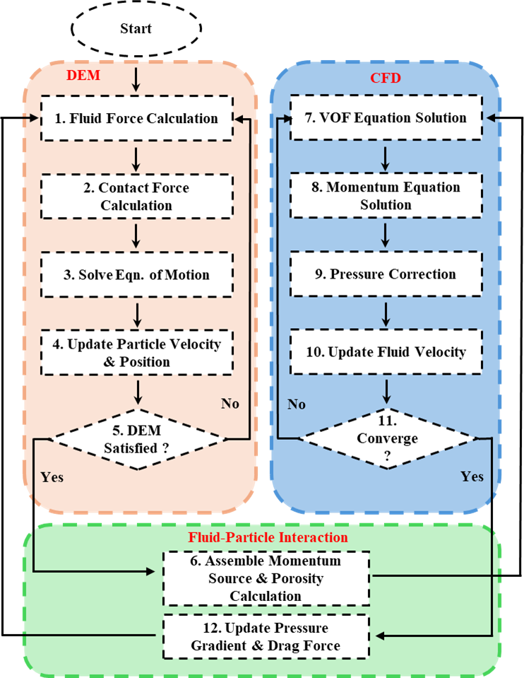
Figure 1. DPMInterFoam solver algorithm chart
It defines a wide range of parameters, including the physical properties of particles (density, elastic modulus, Poisson’s ratio and diameter), injection models (specifying starting and end time of injection, number of particles, parcels, initial velocity of particles, etc.), dispersion models (describing how particles will spread within the fluid), and interaction models (detailing how particles will interact with the continuous phase and each other). By meticulously configuring these properties, kinematicCloudProperties enables precise modeling of particle dynamics, which is essential for accurately representing particle migration in multiphase flows, such as sediment transport, bubble dynamics, and related processes. This detailed setup ensures realistic particle behavior within the fluid domain, offering valuable insights into complex phenomena involving discrete particles.
After configuring the dictionary files, the numerical simulation process for the validation case study begins with geometry creation, background meshing, integration of geometry into the computational domain, and specification of boundary conditions. For the perforated domain case in Section 5, a geometry featuring circular holes (perforated structure) is initially modeled using SolidWorks. Subsequently, background meshing is performed in OpenFOAM. The geometry created in SolidWorks is then imported into the computational domain via OpenFOAM's snappyHexMesh utility. Mesh adjustments and refinements are carried out to capture structural details accurately. Additionally, a face zone is defined at the top of the computational domain to serve as an inlet for water injection.
- Particle packing and migration:
After preprocessing, numerical simulations are performed to model particle packing within the computational domain. Given that particle migration is a key aspect of this numerical analysis, relevant particle properties, such as size, density, collision characteristics, and injection parameters, are explicitly defined in OpenFOAM's kinematicCloudProperties dictionary.
Particle injection and settling in a numerical simulation are carefully defined and can be divided into multiple steps depending on the analysis type. In this paper, for example, the validation case is handled in a single stage: particles are injected by manualInjectionModel, and the resulting particle column is then swept away by the water column. In contrast, the perforated domain case involves a multiple-stage process: particle injection, settlement, and selection. These individual processes are described in detail in the corresponding sections below (see Section 5).
- Post-processing:
After completing the numerical simulations, the results are visualized in the ParaView application. Particle data is rendered using the glyph filter, which displays particles as spheres and enables visualization of additional parameters such as velocity, size, or concentration. For further analysis, numerical data from the simulations is extracted and processed in MATLAB.

- VALIDATION CASE
A three-dimensional air-filled domain, along with the water and particle column, is modeled utilizing our DPMInterFoam solver to compare the obtained results with previous research work [3][8][9], thereby validating the developed solver.
  - Computational Domain
Sun et al. [8] have presented an ideal benchmark study for three-phase (gas-liquid-solid) flow, namely three-phase dam break. In their study, the numerical case study is modeled and solved using the VOF-DEM solver, which is similar to our DPMInterFoam solver and accounts for particle-particle collisions and interphase capture of two immiscible fluids (air and water). Moreover, their numerical results were also validated against experimental data. This specific case provides comprehensive numerical and experimental data, making it well-suited for validating our DPMInterFoam solver developed in this study. Since our study primarily emphasizes numerical work, the validation process begins by comparing results from DPMInterFoam with the numerical outcomes reported by Sun et al. [8]. Subsequently, these results are also compared to those obtained using the MPPICInterFoam solver. This case study also serves to identify optimal parameters for setting up the perforated domain analysis discussed in the subsequent section.
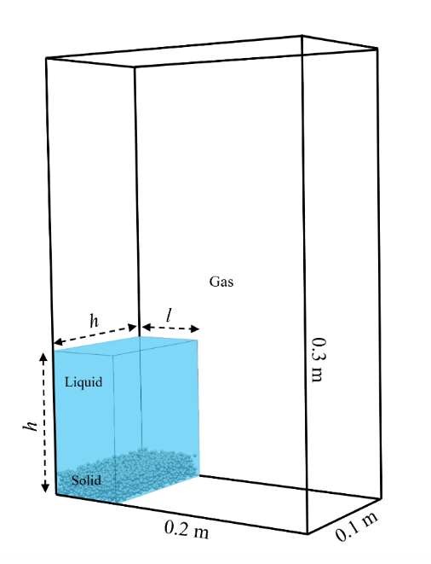
Figure 2. The setup of the three-phase (gas-liquid-solid) dam break case
Following their work, a three-dimensional rectangular domain is generated using blockMesh with dimensions of 0.2 m (length), 0.1 m (width), and 0.3 m (height). The computational domain is discretized into small, uniform cells measuring 0.005 m each, for a total of 48,000 cells. In the next step, No-slip boundary conditions are applied at the horizontal and vertical walls, including the top boundary, in accordance with the reference case presented by Sun et al. [8].
Following the mesh and boundary condition setup, the setFields dictionary in OpenFOAM is used to define the initial water column within a specific region of the domain, and the OpenFOAM script is given in the Appendix (Figure A. 3(a)). The water column is initialized with a length of $l=0.05 m$, while its height and width are each set to $h=2l$. Figure 2 shows the domain dimensions and primary state of gas-liquid-solid phases. After completing all these necessary pre-processing steps for numerical simulation, randomly generated coordinates of 3,883 particles (glass beads) are provided to the KinematicCloudPositions dictionary to inject and create the particle column. Figure A. 3(b) in Appendix shows some examples of the randomly generated coordinates, while Figure A. 3(c) illustrates the injection model configuration utilized in this case study to create the particle column. The particles are injected without initial velocities to maintain their stability within the water column. The details of the particle properties, along with other required parameters, are listed in Table 1. Note that parameters for OpenFOAM’s default solver, MPPICInterFoam, are also included for comparison. The parameters utilized for defining collision models between particle-particle and particle-wall are also illustrated in Figure A. 4 in the Appendix.

Table 1: Parameters used in the three-phase dam break case
 | Properties | Unit | Values | Source
General Parameters | Size of container | m | 0.2 x 0.1 x 0.3 | [8]
General Parameters | Number cells | - | 40 x 20 x 60 | [8]
General Parameters | Liquid density | kgm⁻³ | 1000 | [8]
General Parameters | Liquid viscosity | Pa·s | 1 x 10⁻³ | [8]
General Parameters | Fluid density | kgm⁻³ | 1 | [8]
General Parameters | Fluid viscosity | Pa·s | 1 x 10⁻⁵ | [8]
General Parameters | Number of parcels | - | 3883 | [8]
General Parameters | Particle diameter | m | 0.0027 | [8]
General Parameters | Particle density | kgm⁻³ | 2500 | [8]
General Parameters | Gravity | ms⁻² | 0, -9.8, 0 | [8]
General Parameters | Restitution coefficient | - | 0.9 | [8]
General Parameters | Friction coefficient | - | 0.3 | [8]
DPMInterFoam | Spring constant | N/m | 1000 | [8]
DPMInterFoam | Young’s modulus | MPa | 64 x 10³ | [32]
DPMInterFoam | Poisson’s ratio | - | 0.2 | [32]
DPMInterFoam | Coefficient of restitution: particle-particle | - | 0.2 | [33]
DPMInterFoam | Coefficient of restitution: particle-wall | - | 0.2 | [33]
DPMInterFoam | Coefficient of friction: particle-particle | - | 0.35 | [33]
DPMInterFoam | Coefficient of friction: particle-wall | - | 0.6 | [33]
DPMInterFoam | Collision resolution step | - | 12 | [33]
MPPICInterFoam | $$α_{cp}$$ | - | 0.64 | 0.5 ~ 0.7 [15]
MPPICInterFoam | $$p_{p}$$ | Pa | 10 | 5 ~ 100 [15]
MPPICInterFoam | $$β$$ | - | 2 | $2≤β≤5$ [15]
MPPICInterFoam | $$ϵ$$ | - | 1 x 10⁻⁷ | [15]
MPPICInterFoam | Packing model | - | Explicit | [15]
MPPICInterFoam | Particle stress model | - | Harris-Crighton | [15]

It is essential to note that all parameters are derived from the reference case reported by Sun et al. to ensure the consistency of the validation study. However, due to a few pieces of missing information in the original reference, additional parameters are sourced from other relevant studies. In Table 1, the general parameters listed are common to both solvers in the first row, while solver-specific parameters, such as DPMInterFoam in the second row and MPPICInterFoam in the third row, are provided separately based on the specific requirements of each solver. Additionally, the packing model utilized for MPPICInterFoam is presented in the Appendix (Figure A. 5).
  - Results and Discussion
The numerical results of the validation case obtained with our DPMInterFoam are evaluated both qualitatively and quantitatively by comparing them with those reported by Sun et al. The primary water column, presented in Figure 2, collapses under gravity upon release, generating a wave that propagates horizontally along the bottom surface of the computational domain. To assess the accuracy of the simulation, the position of the advancing waterfront is tracked at various time instances and compared with the dimensionless time $t^{*}$, front location $x^{*}$, and column’s remaining height $h^{*}$, according to definitions provided in the reference study. These dimensionless variables are used to compare our simulation outcomes with benchmark data and ensure the fidelity of the numerical model. The mathematical definitions of dimensionless time, front location, and height are presented as follows:
$$t^{*}=t\sqrt{2g∕l}$$ | (19)
$$x^{*}=x∕l$$ | (20)
$$h^{*}=h∕l$$ | (21)
where, $x$ is the front position vector and $h$ is the water column remaining height.
In the reference study by Sun et al. [8], the authors compared the normalized front position of water, based on equations (19)-(21), between three-phase and two-phase dam break scenarios using numerical simulations. The results obtained from our DPMInterFoam solver in the present study are compared against the data series extracted from [8] for validation, which are considered as ground truth, as shown in Figure 3. In the figure, the normalized positions of the water wave front are plotted against dimensionless times. The numerical data in the reference [8] is indicated by black squares connected with a black line, while the data obtained by DPMInterFoam is represented in red crosses with a red solid line, respectively. It is evident from the analysis that the numerical result of DPMInterFoam aligns precisely with the ground truth data, which indicates that the numerical model configuration and selected parameters are correct. Then, the data of the normalized positions of the water wave front from the MPPICInterFoam solver is plotted, i.e., green solid line with asterisk markers, in the same plot for comparison. Through quantitative comparison in Figure 3, all three data series show a similar trend of increasing normalized position with dimensionless time, indicating strong agreement with the reference data. Notably, the overlap of the red and black markers further validates the accuracy and robustness of the developed DPMInterFoam solver.
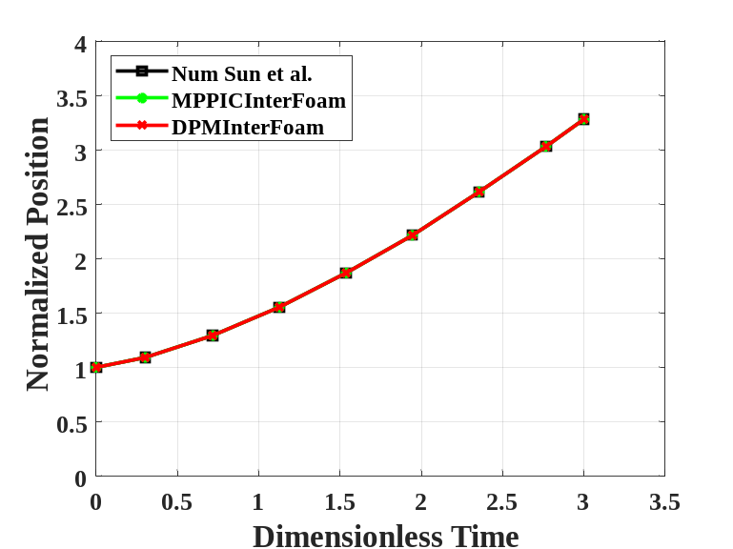
Figure 3. Comparison of numerical results for the three-phase dam break case

Figure 4 illustrates visual comparison of water waves’ front positions along with particle velocity magnitude at different time instances, obtained from both solvers. The left column, Figure 4(a), represents numerical results of MPPICInterFoam, while the right column, Figure 4(b), shows the corresponding results from DPMInterFoam. Simulations from both solvers are shown at three distinct time instances: 0, 0.1, and 0.2 seconds, allowing for a side-by-side visual assessment of wave propagation and particle dynamics over time.
The top row of Figure 4 shows the initial state of the water and particle column before release for both solvers. In the middle row, corresponding to 0.1 seconds, the water column from both solvers collapsed under the influence of gravitational force, advancing approximately halfway across the domain while entraining the particles. Analyzing the particle velocity magnitude for the DPMInterFoam solver reveals that the sweeping particles reach maximum velocity at the leading edge of the wave, with magnitudes gradually decreasing toward the opposite flow direction. Finally, in the bottom row of Figure 4(b) for DPMInterFoam, the water has spread further along the floor, and the wave front continues to propagate, reaching the far end of the container at 0.2 seconds. The MPPICInterFoam results show the wave front at a comparable position, with a similar velocity distribution. Despite the overall agreement, some differences in the spreading patterns between the two solvers are evident. These differences are attributed to the distinct approaches each solver uses to handle particle clouds, reflecting solver-specific modeling characteristics.

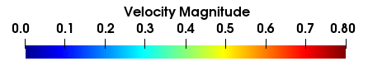
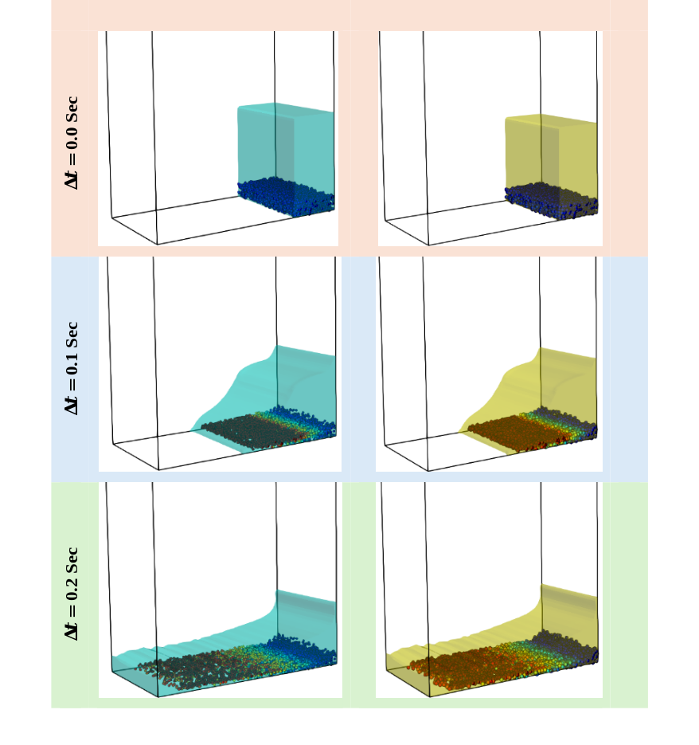
 | (a) | (b)
Figure 4. Comparison of three-phase dam break results: (a) MPPICInterFoam and (b) DPMInterFoam
Following the comparison of numerical results, the computational performance of both solvers is also evaluated for the three-phase dam break case. The study is performed on a workstation equipped with an Intel Xeon 6238R CPU (56 cores, 2.2 GHz) and 128 GB of RAM, using serial computation to ensure a consistent computational environment, and clearly distinguishes and indicates the performance differences between the two solvers. The MPPICInterFoam solver demonstrated faster computational time, completing the simulation in 3,458 seconds. In contrast, the DPMInterFoam solver requires 5,306 seconds under identical conditions, which is approximately 53.4% longer than MPPICInterFoam. This difference highlights the relative computational overhead associated with the DPMInterFoam solver, likely due to differences in particle-cloud treatment and force calculation strategies. Therefore, in a regular rectangular domain, both solvers are capable of accurately solving the three-phase (gas, liquid, and solid) flow system. However, DPMInterFoam costs 53.4% more computational time than MPPICInterFoam.

- PERFORATED DOMAIN CASE
With the DPMInterFoam solver verified, we proceed to a more complex case study in this section, in which a perforated domain is used to analyze the particle distribution within the interstitial space between perforated structures. The effect of multiphase flow on particle migration and drainage is also evaluated. Our DPMInterFoam is compared with OpenFOAM’s default MPPICInterFoam.
  - Computational Domain
A two-dimensional rectangular domain is considered that measures 0.14 m in length and 0.3 m in height, as shown in Figure 5. Within this rectangular domain, 31 circular holes, each with a diameter of 0.0254 m, are added to create the perforated domain. It is important to note that the particles or water cannot penetrate through the circular holes and can only move through the interstitial spaces between the circles. Moreover, the perforated domain is designed by positioning the center of three adjacent circles at the apex of an equilateral triangle, with each side measuring 0.031 m. This geometric arrangement is systematically repeated to form a uniform perforated layout that ensures intensive interactions between particles and between particles and circular walls during the settlement stage. The aggregation of circular holes occupied 0.19 m along the height of the domain. The liquid injection inlet is positioned at the center of the top boundary, while an outlet is situated at the bottom right corner of the domain. The inlet and outlet sizes are 0.01 m and 0.02 m, respectively.
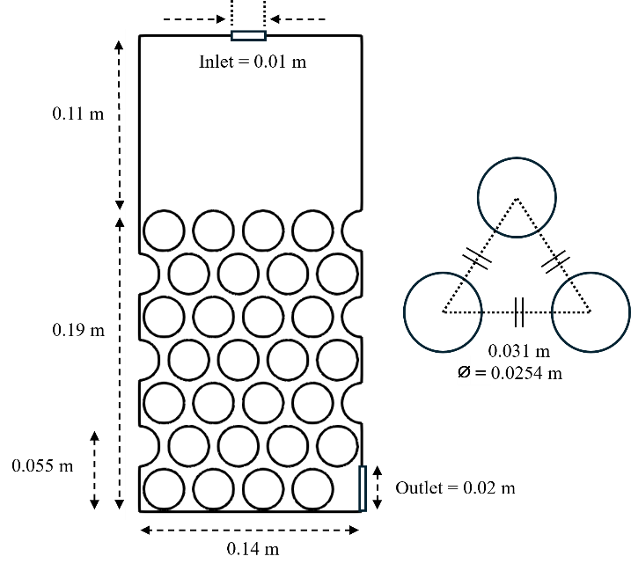
Figure 5. Perforated domain dimensions

  - Boundary Conditions
The computational domain comprises seven boundary conditions: Top, Left-Right, Bottom, Circular holes, Front-Back, Inlet, and Outlet. The top surface of the domain is referred to as Top and considered as a patch, where the atmospheric boundary condition is applied. The Left-Right, Bottom, and Circular holes boundary conditions represent the domain’s left-right and bottom, and the surface of circular through holes, respectively. All these boundaries are modeled as a wall. The Inlet serves as a liquid injector, while the Outlet functions as an exit point for both the fluid and solid phases. The flow boundary conditions to solve the partial differential equation governing the velocity and pressure are summarized as follows:
- No-slip boundary conditions at all walls (i.e., the Left-Right, Bottom, and Circular holes);
- Constant atmospheric pressure along the Top boundary;
- Zero pressure gradients along the wall boundaries (i.e., the Left-Right, Bottom, and Circular holes).
The boundary conditions for discrete particles are also defined by localPatchInterationModel in kinematicCloudProperties as follows:
- Rebound on the walls along the Left-Right, Bottom, and Circular holes boundaries;
- Escape at the Outlet boundary.

  - Results and Discussion
This section analyzes particle distribution, drainage behavior, and computational cost in the case study of the perforated domain. Specifically, the particle distribution analysis only examines the effects of particle dynamics alone, captured by both solvers, without considering multiphase fluid flow. In contrast, the drainage behavior and computational cost are analyzed under multiphase flow conditions to evaluate the solvers’ performance in simulating fluid–particle interactions.

Particle distribution analysis
This section focuses on analyzing the particle distribution resulting from packing one-third of the perforated domain, measuring 0.055 m in height and 0.14 m in length, as shown in Figure 5, using both solvers. The perforated structure, as previously described, is prepared for numerical simulation by completing all essential pre-processing steps, including domain creation, mesh generation, inlet and outlet definition, model configuration, and parameter setup. During pre-processing, particle properties are defined based on the values listed in Table 2. Following this setup, the particle packing process is executed in three sequential stages: injection, settlement, and selection.
In the first stage, i.e., particle injection, a patch injection model is used to introduce particles through the Circular holes boundary. A total of 120,000 particles is injected into the domain over a duration of 2 seconds, as shown in the example script in Appendix (Figure A. 6(a)). Following the injection, the simulation enters the settlement stage, during which no additional particles are introduced. The simulation continues for another 10 seconds, allowing the injected particles to settle under gravity. After the settlement phase, the final positions of the packed particles are collected. Next, in the selection stage, an in-house MATLAB script is employed to extract only the particles located within the lower one-third portion of the perforated structure (i.e., 0.055 m of the total height), as shown in Figure A. 7. These selected particles are then re-injected as shown in Figure A. 6(b), into the domain to analyze particle distribution between both solvers. To maintain consistency, the same procedure is followed across solvers. Additionally, to prevent particle loss throughout the simulation period, the outlet boundary is configured with the Rebound condition, particularly for distribution analysis, ensuring that no particles escape the domain. Figure 6 shows the particle distribution at the bottom one-third of the perforated structure, as simulated using the DPMInterFoam solver.
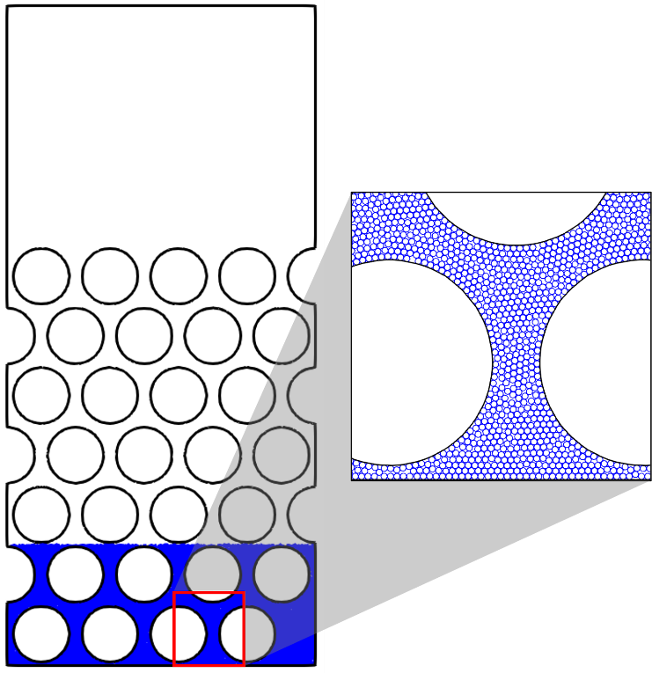
Figure 6. Particle distribution analysis obtained by DPMInterFoam
The analysis of particle distribution reveals a significant difference between the solvers, resulting in a substantial variation in the number of particles required to fill the region of interest. To occupy one-third of the perforated domain, the DPMInterFoam case requires only 5,606 particles. In contrast, the MPPICInterFoam solver needs 94,636 particles to fill the same region. The larger number of particles in the MPPICInterFoam case is due to particle overlap, which results from the different approach to modeling particle–particle collisions (stress model) compared to DPMInterFoam. These particle-particle overlaps in MPPICInterFoam significantly impact the particle volume fraction and distribution, as well as simulation accuracy.

Drainage Analysis
The primary objective of drainage analysis is to evaluate the drainage of water through the interstitial spaces of packed particles in perforated structures. Initially, water is injected into the domain through the Inlet on the Top patch for 4 seconds. During the injection period, water enters the domain, passes through the air, impinges on the surface of Circular holes, transports through the interstitial space of the perforated structure, accumulates at the domain floor, and drains through the Outlet along with particles. Here, the Outlet boundary is configured as an Escape for drainage analysis, unlike the previous section, to enable particle outflow. After the water injection period, each numerical case is run for an additional 2 seconds (non-injection) to allow the remaining water to drain from the domain. A post-processing utility (in-house code) is developed to measure water volume through the Inlet and Outlet and trapped within domain. These calculated water volumes are then utilized to assess and compare drainage performance under different particle volume fractions.
Table 2: Perforated domain parameters
 | Properties | Unit | Values | Source
General Parameters | Size of container | m | 0.14 x 0.3 | [8]
General Parameters | Number cells | - | 112 x 240 | [8]
General Parameters | Liquid density | kgm⁻³ | 1000 | [8]
General Parameters | Liquid viscosity | Pa·s | 1 x 10⁻³ | [15]
General Parameters | Fluid density | kgm⁻³ | 1 | [8]
General Parameters | Fluid viscosity | Pa·s | 1.48 x 10⁻⁵ | [15]
General Parameters | Particle diameter | m | 0.001 | [8]
General Parameters | Particle density | kgm⁻³ | 2500 | [8]
General Parameters | Gravity | ms⁻² | 0, -9.8, 0 | [8]
General Parameters | Restitution coefficient | - | 0.9 | [8]
General Parameters | Friction coefficient | - | 0.2 | [29]
DPMInterFoam | Spring constant | N/m | 1000 | [8]
DPMInterFoam | Young’s modulus | MPa | 2.75 | [33]
DPMInterFoam | Poisson’s ratio | - | 0.2 | [33]
DPMInterFoam | Coefficient of restitution: particle-particle | - | 0.2 | [33]
DPMInterFoam | Coefficient of restitution: particle-wall | - | 0.2 | [33]
DPMInterFoam | Coefficient of friction: particle-particle | - | 0.35 | [33]
DPMInterFoam | Coefficient of friction: particle-wall | - | 0.6 | [33]
DPMInterFoam | Collision resolution step | - | 12 | [33]
MPPICInterFoam | $$α_{cp}$$ | - | 0.64 | 0.5 ~ 0.7 [15]
MPPICInterFoam | $$p_{p}$$ | Pa | 10 | 5 ~ 100 [15]
MPPICInterFoam | $$β$$ | - | 2 | $2≤β≤5$ [15]
MPPICInterFoam | $$ϵ$$ | - | 1 x 10⁻⁷ | [15]
MPPICInterFoam | Packing model | - | Explicit | [15]
MPPICInterFoam | Particle stress model | - | Harris-Crighton | [15]

To evaluate the role of particle volume fraction in water transport and drainage, several cases are simulated with varying particle concentrations. Three case studies with particle volume fractions ($ε_{p}$) of 0.0005, 0.01, and 0.1 are considered for both solvers within the dilute regime, i.e., volume fraction of particles $ε_{p}<0.2$ . For the dense regime ($ε_{p}$ > 0.2), two cases with $ε_{p}=0.2$ and $0.3$ are examined. Note that $ε_{p}$ is determined in accordance with the equation (13).
The first numerical simulation of the perforated case study is conducted without any particle ($ε_{p}=0$) in DPMInterFoam, as shown in Figure 7(a). This baseline case assesses the accuracy of the post-processing utility developed for tracking water volumes. From the simulation data, the inlet water volume (green line) is obtained by integrating the volumetric flow rate over time across the Inlet boundaries. The results showed that the volume of injected water through the Inlet has increased linearly and reached the maximum volume ($2 ×{10}^{-5} m^{3}$) at 4 seconds. Due to the non-injection period, the injected water volume remains constant from 4 to 6 seconds. The outlet water volume (blue solid curve) is determined by a similar process that integrates the volumetric flow rate across the outlet area over the entire simulation duration. It shows an initial delay due to the time required for water to reach the outlet, followed by a steady rise over 0.5 to 5 seconds, after which it levels off. There are two methods to evaluate the water volume trapped in the computational domain. The first is to estimate it from simulation data as the difference between the inlet and outlet volumes at each time step based on mass conservation. This method shows that the volume of trapped water increases until peaking at 4 seconds, then decreases sharply, as shown by the blue curves in Figure 8. Alternatively, the trapped water volume could also be computed directly through a spatial integral. That is, the trapped volume is calculated by summing the product of the local volume fraction in each cell and its corresponding cell volume. We have compared both methods and found excellent agreement between them.
Following the validation of the post-processing in the baseline case, parametric simulations are conducted to investigate the influence of particle concentration (volume fraction) on water drainage. The number of particles considered in each case to calculate the volume fraction of particles is provided in Table 3. Figure 7 shows the relationship between injected water volume and the drained water volume for various volume fractions of particles over time, obtained with DPMInterFoam and MPPICInterFoam, respectively, in Figure 7(a) and Figure 7(b). The case studies within the dilute regime are represented by blue lines, while red lines correspond to the dense regime. In the dilute regime, the blue solid, dotted, dash-dotted, and dashed lines represent cases with particle volume fractions of 0, 0.0005, 0.01, and 0.1, respectively, for both solvers. In the dense flow regime, the red dashed and dotted lines correspond to volume fractions of 0.2 and 0.3, respectively. The baseline case, previously discussed, is also included in this figure to compare the effect of increasing particle concentration on the system's drainage behavior.
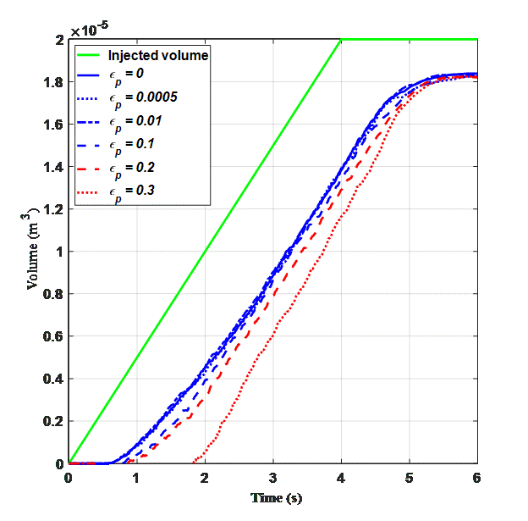 | 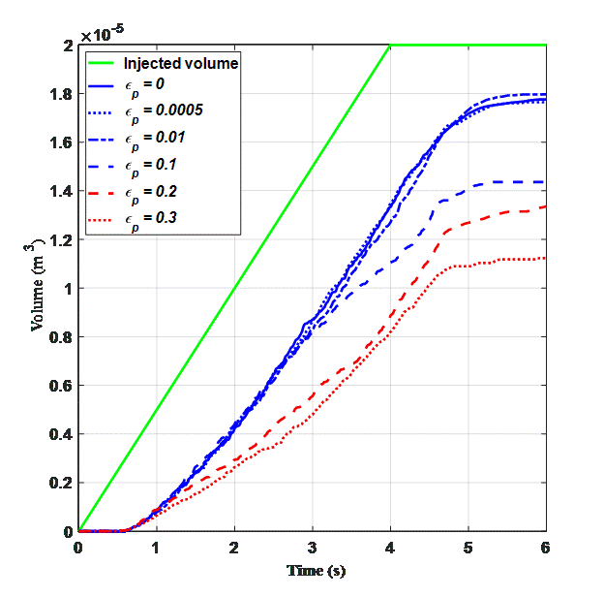
(a) | (b)
Figure 7. Water volume drained through outlet: (a) DPMInterFoam and (b) MPPICInterFoam
Figure 7(a) shows the drainage performance obtained with DPMInterFoam, revealing that the system drains nearly the same amount of water throughout the simulation duration for particle volume fractions $ε_{p}=$ 0, 0.0005, and 0.01. However, as $ε_{p}$ increases to 0.1, the volume of water drained through the Outlet decreases slightly. The red lines, corresponding to the dense regime ($ε_{p}$ = 0.2 and 0.3), show a further reduction in drained volume with increasing particle volume fraction. An important observation from the plot is that, at the highest particle volume fraction $ε_{p}=$ 0.3, water requires considerably more time to pass through the densely packed particle bed and reach the outlet. The plot also reveals that the outflow begins approximately at 1.9 seconds. This delay is attributed to reduced pore space and increased hydraulic resistance along the height of the entire computational domain, as shown by the first two rows in Figure 9(a), resulting in lower intermediate drainage rates. Over time, these differences diminish as the flow passage is gradually opened on the right side of the domain, as shown by the third and fourth rows in Figure 9(a), and the drainage also starts to catch up at a faster rate after 2 seconds. Eventually, the drainage curves for the dense cases approach a similar final volume. A detailed analysis of the volume of fluid field indicates that this convergence occurs because, after water injection stops at 4 seconds, the dispersed water within the perforated structure gradually migrates downward, carrying some particles along with it. Interestingly, some particles that remain immobile during the injection phase, particularly on the right side of the perforated domain, begin to migrate as the flow passage opens and local flow conditions become more favorable, e.g., higher local shear stress. Meanwhile, most of the water that has already reached the bottom of the domain accumulates and drains out slowly but continuously through the outlet, as illustrated by the last two columns in Figure 9(a). Consequently, the convergence of drainage curves to the same final water volume across different cases is attributed to the non-injection phase, during which the dense particle packing on the right side is loosened and opened. This convergence indicates that particle packing predominantly affects the transient drainage behavior, the onset and rate of flow, with less influence on the ultimate drained volume. Such behavior is consistent with observations in porous media behavior seen in real-world filtration systems, drainage layers, and packed-bed reactors. Figure 8(a) represents trapped water volume for the corresponding case studies. Since the injected water volume is fixed across all numerical cases, the observed decrease in drained water volume with increasing particle volume fraction, as discussed above, indicates a greater amount of water trapped within the domain in the DPMInterFoam solver, as expected and confirmed by observations in Figure 9(a).
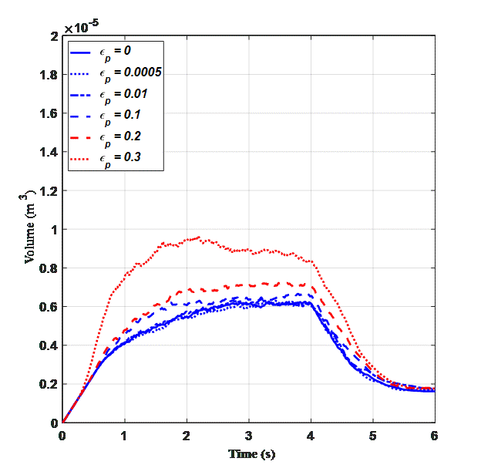 | 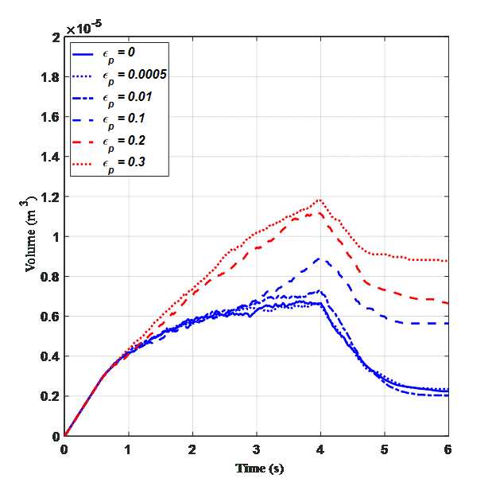
(a) | (b)
Figure 8. Trapped water volume: (a) DPMInterFoam; (b) MPPICInterFoam
Figure 7(b) presents the results obtained from the MPPICInterFoam solver, which are similar to those of DPMInterFoam in the dilute regime, particularly at lower volume fractions ($ε_{p}$ = 0, 0.0005, 0.01). However, as the volume fraction increases, the volume of water drained from the domain decreases, which leads to a higher trapped volume inside the domain, as seen in Figure 8(b). Further analysis of the water volume fraction in the very dense regime ($ε_{p}$ = 0.3), i.e., the third column in Figure 9(b) and its enlarged view in Figure 10, indicates that MPPICInterFoam traps a significant volume of water within the domain at the higher $ε_{p}$ due to the overlap of particles. It is noticed that water cannot penetrate through the heavily packed particle bed (due to overlaps), which causes water to be trapped within the interstitial space of the bottom perforated layer until the accumulated water level rises high enough to overflow the circular holes in the bottom layer, as shown in Figure 10, resulting in a reduced water volume at the Outlet. This trend becomes more noticeable for the denser regime cases. That is, an increased number of particles correlates with a decrease in the volume of water drained from the domain, similar to the cases of DPMInterFoam.
However, the most notable difference between the two solvers lies in the amount of water trapped within the domain. In DPMInterFoam, water is temporarily retained during the intermediate stages of the simulation. However, the system ultimately releases the same volume of water at the end of the simulation. In contrast, the MPPICInterFoam holds a greater portion of water within the domain for $ε_{p}$ = 0.1, 0.2, and 0.3 even at the end of the simulation, suggesting reduced drainage efficiency. Again, this observation is caused by overly dense particle packing due to overlaps, leading to larger simulation errors.
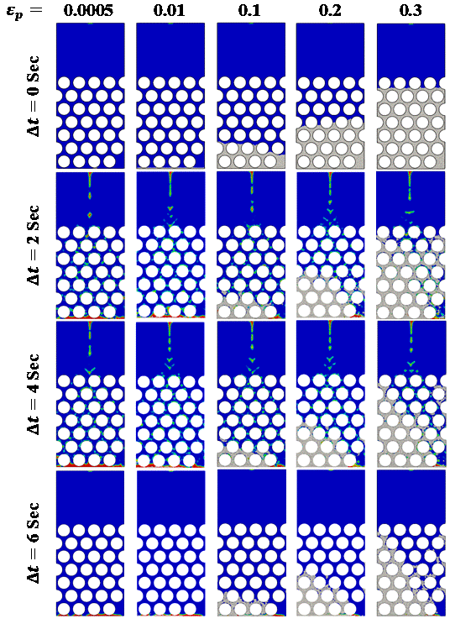 |  |  | 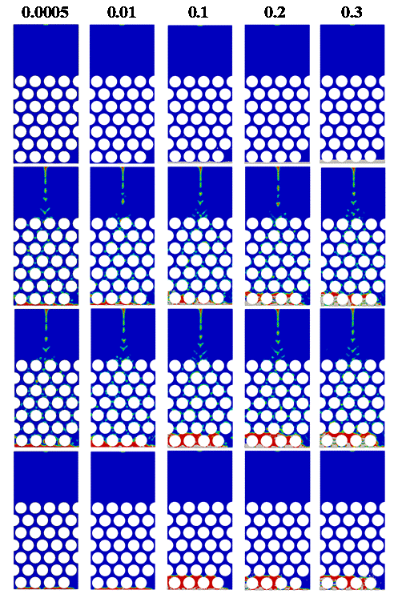
 | (a) |  |  | (b)
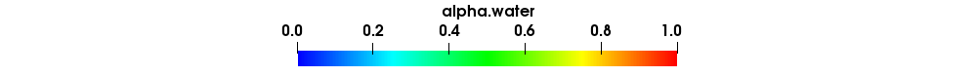
Figure 9. Volume fraction of water comparison: (a) DPMInterFoam and (b) MPPICInterFoam
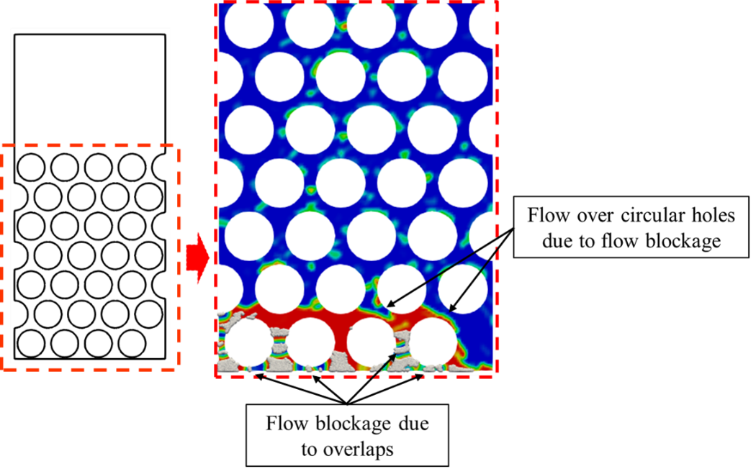
Figure 10. Volume fraction field at 4 seconds by MPPICInterFoam for $ε_{p}=0.3$

Computational Cost Analysis
Table 3 shows the required number of particles to reach the desired volume fractions and compares the computational costs between the two solvers. The computational cost is measured with OpenFOAM v2112 (openfoam.com) on Ubuntu 20.04, compiled with GCC 9.4.0 as a double-precision optimized build (linux64GccDPInt32Opt), on a workstation equipped with an Intel Xeon 6238R CPU (56 cores, 2.2 GHz) and 128 GB of RAM. Each numerical case is computed utilizing parallel computing with 20 cores for fair comparison.
Table 3: Computational cost comparison
$$ε_{p}$$ | Number of Particles | Computational cost (s) |  | Cost Increment (%)
$$ε_{p}$$ | Number of Particles | MPPICInterFoam | DPMInterFoam | Cost Increment (%)
0 | 0 | 928 | 930 | 0.22
0.0005 | 15 | 1303 | 1372 | 5.3
0.01 | 250 | 1734 | 1856 | 7.03
0.1 | 2850 | 2520 | 3452 | 36.98
0.2 | 6500 | 3129 | 5244 | 67.6
0.3 | 10000 | 3720 | 7920 | 112.9

An evaluation of computational costs shows that both solvers require approximately the same amount of time to complete the baseline case, i.e., $ε_{p}=0$. This is expected because only multiphase flow without particles is considered. However, as the particle volume fraction increases, the computational cost for DPMInterFoam rises more significantly compared to MPPICInterFoam. Specifically, the increases in computational time for DPMInterFoam, relative to MPPICInterFoam, are 5.3%, 7.03%, 36.98%, 67.6%, and 112.9% for the respective simulation cases as the particle concentration increases. It is important to note that these const analysis are case-specific measurements obtained for the presented mesh, particle loadings, numerical settings, and hardware; they indicate the relative cost of the two solvers under these conditions presented in this study.
In summary, for the perforated domain where water drains through a packed particle bed, either DPMInterFoam or MPPICInterFoam can be used effectively for lower particle volume fractions, such as $ε_{p}= 0.0005$and $0.01$. In these very dilute regimes, each solver performs comparably, draining similar volumes of water from the system. However, in cases with higher particle concentrations ($ε_{p}=0.1, 0.2,$and $0.3$), DPMInterFoam shows a clear advantage, eliminating the complications and model errors arising from particle overlaps. Although the volume of water drained through the outlet decreases during the intermediate times as particle fraction increases, the total drained volume at the end of the simulation remains almost the same. This indicates that DPMInterFoam is applicable even under densely packed conditions.
In contrast, MPPICInterFoam exhibits a continued decrease in drained water volume and an increase in the volume of trapped water within the domain by the end of the simulation. This behavior is mainly due to particle–particle overlaps that block water flow through the packed bed, resulting in difficulty in modeling dense particle regimes compared to DPMInterFoam.
In terms of computational efficiency, MPPICInterFoam offers a more cost-effective solution in the lower dilute flow regimes, with up to a 7% reduction in computational time compared to DPMInterFoam. However, as the particle volume fraction increases to $ε_{p}=0.1$and beyond, DPMInterFoam consistently delivers more physically coherent results, particularly in capturing water drainage and particle behavior under dense packing conditions.
Overall, the analysis suggests that MPPICInterFoam is a suitable choice for applications where computational cost is a critical concern and a moderate level of accuracy is acceptable. On the other hand, DPMInterFoam developed in this work is better suited for cases that demand higher accuracy, especially in dense particle regimes, but at the cost of longer computational time due to the employed collision method.

- CONCLUSION
The primary objective of this study is to develop an open-source VOF-DEM solver, DPMInterFoam, within the OpenFOAM framework based on the Lagrangian-Eulerian approach for simulating three-phase (gas-liquid-solid) flow and particle dynamics. The developed solver is verified using published benchmark data for a well-established three-phase dam-break case. Subsequently, three-phase flow within a perforated domain with various particle packing conditions is investigated to evaluate DPMInterFoam with respect to particle distribution and water drainage characteristics, and to compare it with MPPICInterFoam, the default solver in OpenFOAM for multiphase flow and particle interaction modeling. The following technical findings are obtained:
DPMInterFoam and MPPICInterFoam, in a regular rectangular domain, both capture particle migration and the waterfront motion in the benchmark case, i.e., the dam break. However, DPMInterFoam costs 53.4% more computation time than MPPICInterFoam. In the case study involving a perforated domain where water flows through packed particles, for dilute particle regimes such as $ε_{p}=0, 0.0005,$and $0.01$, both solvers can be employed to evaluate transient hydrodynamics and water volume retained or drained from the domain. Moreover, MPPICInterFoam can be more cost-efficient (up to 7%) than DPMInterFoam in the dilute regime. It is important to note that these cost analysis are case-specific and reflect the relative cost of the two solvers under the conditions presented in this study. Particle distribution analysis shows that DPMInterFoam produces physically accurate results of particle packing compared to MPPICInterFoam. These particle-particle overlaps in MPPICInterFoam are the underlying cause of incorrect particle packing results and require a larger number of particles to reach the same bed height, leading to erroneous evaluations of particle migration, particle distribution, and the drainage process. Finally, MPPICInterFoam can be employed when computational cost is a critical concern and a moderate level of accuracy is acceptable. On the other hand, DPMInterFoam is better suited for cases that demand higher accuracy, especially in dense particle regimes, though it requires greater computational resources due to the employed collision method.

ACKNOWLEDGEMENTS
We acknowledge Dr. Jung I. Shu at the Department of Mechanical Engineering of the University of South Carolina for his constructive discussion and suggestions.

Funding The authors did not receive support from any organization for the submitted work.

DECLARATION
Competing interests The authors declare no competing interests.

Appendix
Lagrangian phase (MPPICInterFoam)
The multiphase particle-in-cell method (MPPIC), the default MPPIC solver in OpenFOAM, employs a particle probability distribution function, denoted as $∅(x,u_{p}, ρ_{p}, V_{p}, t)$ which depends on particle position $x$, velocity $u_{p}$, density $ρ_{p}$, and volume $V_{p}$, respectively, at a given time $t$. The particle distribution function can be obtained by solving the Liouville equation [1]
$$\frac{∂∅}{∂t}+∇∙\left(∅u_{p}\right)+ ∇∙\left(∅A\right)=0$$ | (22)
where $A$ represents acceleration due to aerodynamic drag, pressure gradient, gravity, and gradient of interparticle stress, which is given by [16]
$$A=D_{p}\left(u_{f}-u_{p}\right)-\frac{1}{ρ_{p}}∇p+g-\frac{1}{ε_{p}ρ_{p}}∇τ$$ | (23)
where $D_{p}$, $u_{f}$, $ρ_{p}$,$ε_{p}$ denote drag coefficient, fluid velocity at the location of particle, density of particle, particle volume fraction, respectively. The drag coefficient can be defined as [16]
$$D_{p}=C_{d}\frac{3}{8}\frac{ρ_{f}}{ρ_{p}}\frac{\left|u_{f}-u_{p}\right|}{r_{p}}$$ | (24)
where $r_{p}$ is the particle radius. The particle stress $τ$ represents average collision force between the particles, and it is given by the following inter-particle stress model (Harris and Crighton)
$$τ=\frac{p_{p}{ε_{ }}_{p}^{b}}{max⁡[ε_{cp}-ε_{p}, ϵ\left(1-ε_{p}\right)]}$$ | (25)
in which $p_{p}$ and $ε_{cp}$ are the particle pressure and particle volume fraction at packing limit or close packing, respectively. $p_{p}$ and $b$ are constants in equation (25). $ϵ$ is the modified singularity correction parameters at close packing with a small value of ${10}^{-7}$. The particle volume fraction $ε_{p}$ is defined here based on the particle distribution function as following
$$ε_{p}=\iiint{∅V_{p}dV_{p}dρ_{p}du_{p}}$$ | (26)
Moreover, in MPPIC, the interphase momentum transfer function between Eulerian and Lagrangian phases can be calculated
$$F_{pf}=\iiint{∅V_{p}ρ_{p}\left[D_{p}\left(u_{f}-u_{p}\right)-\frac{1}{ρ_{p}}∇p\right]dV_{p}dρ_{p}du_{p}}$$ | (27)
Where the subscript $pf$ represents particle-fluid interphase. In MPPIC, the particle continuity equation is
$$\frac{∂(ε_{p}ρ_{p})}{∂t}+∇∙\left(ε_{p}ρ_{p}u_{p}\right)=0$$ | (28)
and the particle momentum is described as  $$\frac{∂\left(ε_{p}ρ_{p}u_{p}\right)}{∂t}+∇∙\left(ε_{p}ρ_{p}u_{p}u_{p}\right)=-ε_{p}∇p+ε_{p}\left(g∇ρ_{p}\right)- ∇τ_{p}$$  $$+\iiint{∅V_{p}ρ_{p}D_{p}\left(u_{f}-u_{p}\right)dV_{p}dρ_{p}du_{p}}$$  $$-∇∙\left[\iiint{∅V_{p}ρ_{p}\left(u_{p}-{\overline{u}}_{p}\right)\left(u_{p}-{\overline{u}}_{p}\right)dV_{p}dρ_{p}du_{p}}\right]$$ | (29)
$u_{f}$ is calculated by interpolating the fluid velocity on the Eulerian grid containing particles while ${\overline{u}}_{p}$ is the particle mean velocity, given by
$${\overline{u}}_{p}=\frac{1}{ε_{p}ρ_{p}}\iiint{∅V_{p}ρ_{p}u_{p}dV_{p}dρ_{p}du_{p}}$$ | (30)
As MPPICInterFoam is a default OpenFOAM solver, only the essential equations are presented here. These equations also incorporate with equations (1) - (8), corresponding to the Eulerian phase.

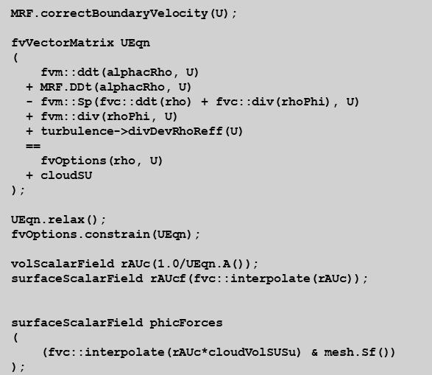
Figure A.1 Velocity field algorithm

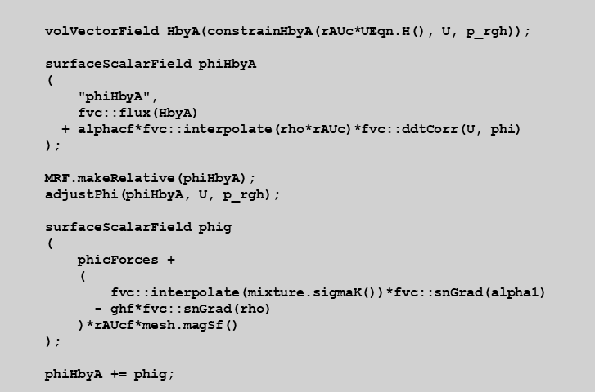
Figure A.2 Pressure field algorithm

(a) | 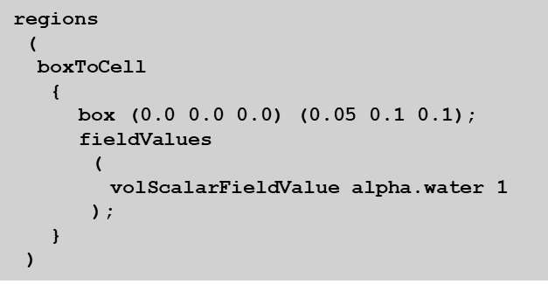 | 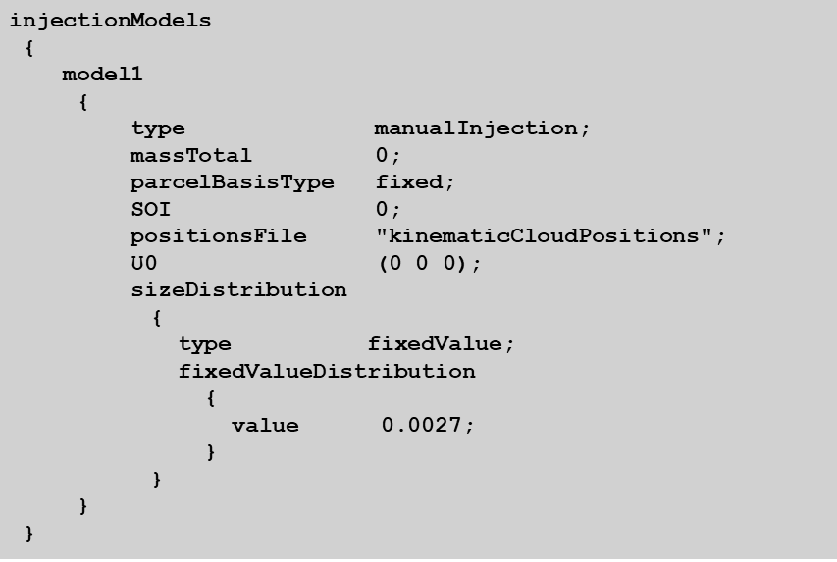
(b) | 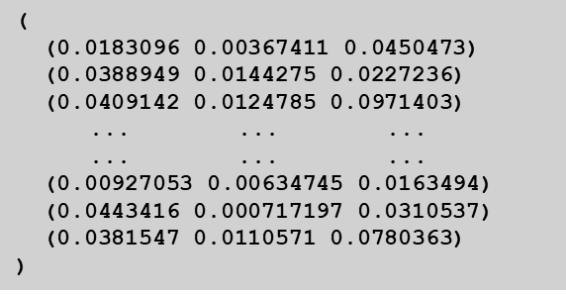
 |  | (c)
Figure A.3. Validation case: (a) water column, (b) particles position, and (c) particles injection model

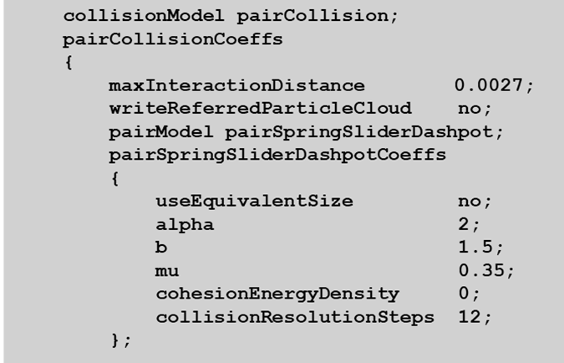 | 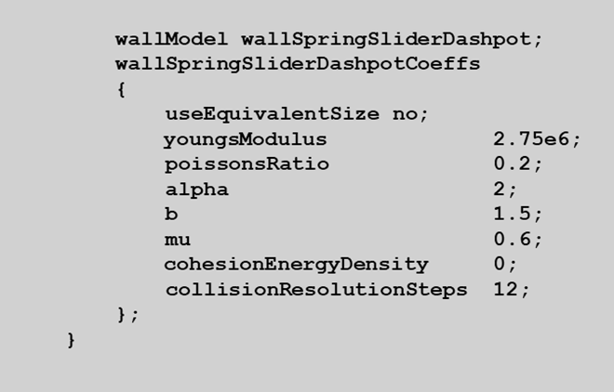
(a) | (b)
Figure A. 4. Validation case collision model: (a) particle-particle, (b) wall-particle

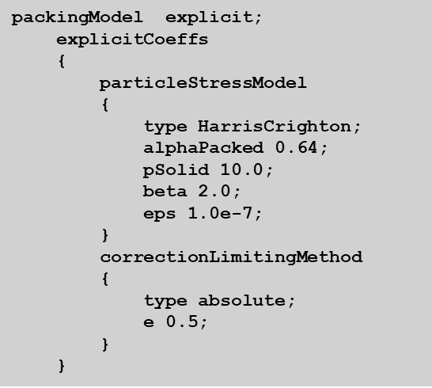
Figure A. 5. Validation case particle packing model for MPPICInterFoam

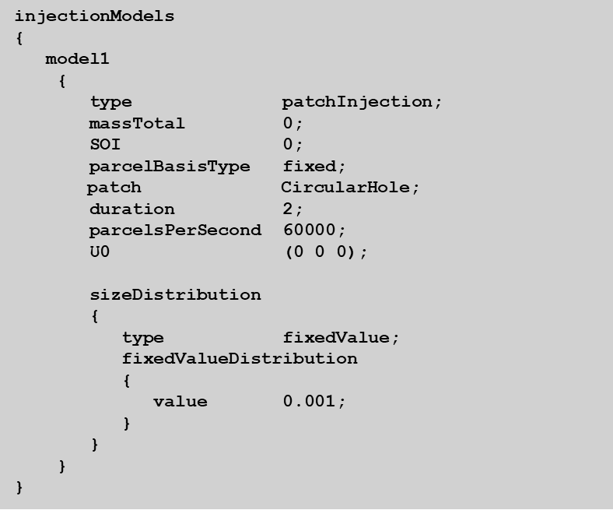 | 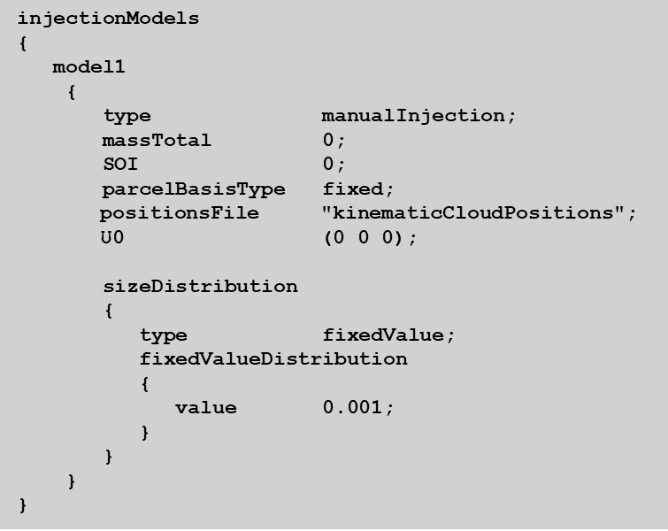
(a) | (b)
Figure A. 6. Perforated case particles inclusion process: (a) particles injection (patch), (b) particles re-injection (manual)

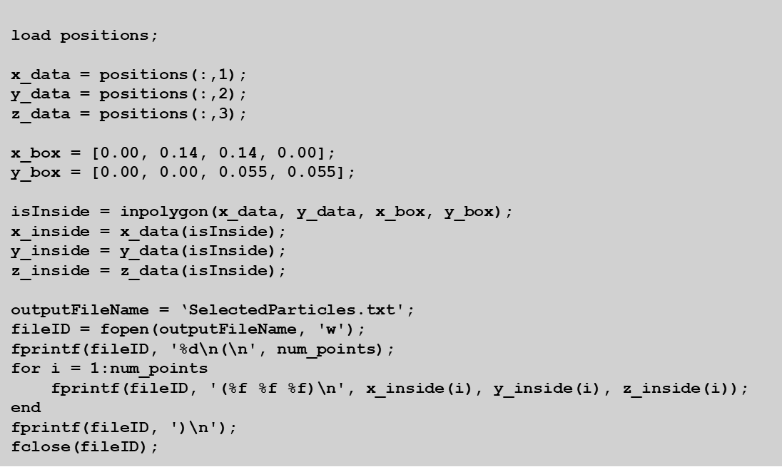
Figure A. 7. Perforated case particles selection process

REFERENCE
- Ranjbari, P., Emamzadeh, M., & Mohseni, A. (2023). Numerical analysis of particle injection effect on gas-liquid two-phase flow in horizontal pipelines using coupled MPPIC-VOF method. Advanced Powder Technology, 34(11), 104235.
- Lettieri, P., & Mazzei, L. (2009). Challenges and issues on the CFD modeling of fluidized beds: a review. The Journal of Computational Multiphase Flows, 1(2), 83-131.
- Pozzetti, G., & Peters, B. (2018). A multiscale DEM-VOF method for the simulation of three-phase flows. International Journal of Multiphase Flow, 99, 186-204.
- Chen, X., & Wang, J. (2014). A comparison of two-fluid model, dense discrete particle model and CFD-DEM method for modeling impinging gas–solid flows. Powder Technology, 254, 94-102.
- Lu, L., Gopalan, B., & Benyahia, S. (2017). Assessment of different discrete particle methods ability to predict gas-particle flow in a small-scale fluidized bed. Industrial & Engineering Chemistry Research, 56(27), 7865-7876.
- Guenther, C., & Syamlal, M. (2001). The effect of numerical diffusion on simulation of isolated bubbles in a gas–solid fluidized bed. Powder Technology, 116(2-3), 142-154.
- Tsuji, Y., Kawaguchi, T., & Tanaka, T. (1993). Discrete particle simulation of two-dimensional fluidized bed. Powder Technology, 77(1), 79-87.
- Sun, X., & Sakai, M. (2015). Three-dimensional simulation of gas–solid–liquid flows using the DEM–VOF method. Chemical Engineering Science, 134, 531-548.
- Li, L., & Li, B. (2018). Implementation and validation of a volume-of-fluid and discrete-element-method combined solver in OpenFOAM. Particuology, 39, 109-115.
- Park, K. M., Yoon, H. S., & Kim, M. I. (2018). CFD-DEM based numerical simulation of liquid-gas-particle mixture flow in dam break. Communications in Nonlinear Science and Numerical Simulation, 59, 105-121.
- Nian, T., Li, D., Liang, Q., Wu, H., & Guo, X. (2021). Multiphase flow simulation of landslide dam formation process based on extended coupled DEM-CFD method. Computers and Geotechnics, 140, 104438.
- Washino, K., Chan, E. L., Kaji, T., Matsuno, Y., & Tanaka, T. (2021). On large scale CFD–DEM simulation for gas–liquid–solid three-phase flows. Particuology, 59, 2-15.
- Vångö, M., Pirker, S., & Lichtenegger, T. (2018). Unresolved CFD–DEM modeling of multiphase flow in densely packed particle beds. Applied Mathematical Modelling, 56, 501-516.
- Jing, L., Kwok, C. Y., Leung, Y. F., & Sobral, Y. D. (2016). Extended CFD–DEM for free‐surface flow with multi‐size granules. International Journal for Numerical and Analytical Methods in Geomechanics, 40(1), 62-79.
- Snider, D. M. (2001). An incompressible three-dimensional multiphase particle-in-cell model for dense particle flows. Journal of Computational Physics, 170(2), 523-549.
- Andrews, M. J., & O'Rourke, P. J. (1996). The multiphase particle-in-cell (MP-PIC) method for dense particulate flows. International Journal of Multiphase Flow, 22(2), 379-402.
- Ariyaratne, W. H., Manjula, E. V. P. J., Ratnayake, C., & Melaaen, M. C. (2016, September). CFD approaches for modeling gas-solids multiphase flows–A review. In 9th EUROSIM & the 57th SIMS Conference, Oulu (pp. 680-686).
- Kumar, M., Reddy, R., Banerjee, R., & Mangadoddy, N. (2021). Effect of particle concentration on turbulent modulation inside hydrocyclone using coupled MPPIC-VOF method. Separation and Purification Technology, 266, 118206.
- Yin, S., Zhong, W., Jin, B., & Fan, J. (2014). Modeling on the hydrodynamics of pressurized high-flux circulating fluidized beds (PHFCFBs) by Eulerian–Lagrangian approach. Powder Technology, 259, 52-64.
- Karimipour, S., & Pugsley, T. (2012). Application of the particle in cell approach for the simulation of bubbling fluidized beds of Geldart A particles. Powder Technology, 220, 63-69.
- Jiang, Y., Qiu, G., & Wang, H. (2014). Modelling and experimental investigation of the full-loop gas–solid flow in a circulating fluidized bed with six cyclone separators. Chemical Engineering Science, 109, 85-97.
- Liao, Y., Wang, Q., Caliskan, U., & Miskovic, S. (2023). Investigation of particle effects on bubble coalescence in slurry with a chimera MP-PIC and VOF coupled method. Chemical Engineering Science, 265, 118174.
- Fatehifar, M., Revell, A., Jabbari, M., & De Rosis, A. (2023). A numerical analysis of particle encapsulation in a flow-focusing droplet generation device. Physics of Fluids, 35(11), 113317.
- van Sint Annaland, M., Deen, N. G., & Kuipers, J. A. M. (2005). Numerical simulation of gas–liquid–solid flows using a combined front tracking and discrete particle method. Chemical Engineering Science, 60(22), 6188-6198.
- Liu, J., Yu, F., & Zhang, Y. (2020). MP-PIC simulation of blood cell movement through a LAD with high stenosis. Powder Technology, 361, 448-454.
- Wörner, M. (2012). Numerical modeling of multiphase flows in microfluidics and micro process engineering: a review of methods and applications. Microfluidics and Nanofluidics, 12(6), 841-886.
- Rahman, M. A., Shu, J. I., Qian, Y., Wang, Y., & Khan, J. A. (2024). Multiphase flow simulation for transient analysis of ballast drainage behavior and shoulder cleaning effect. Transportation Geotechnics, 46, 101258.
- Fernandes, C., Semyonov, D., Ferrás, L. L., & Nóbrega, J. M. (2018). Validation of the CFD-DPM solver DPMFoam in OpenFOAM® through analytical, numerical and experimental comparisons. Granular Matter, 20(4), 64.
- Zhang, J., Zhang, N., Zhang, Q., Jiao, F., Xu, L., & Qi, J. (2022). Numerical Simulation of Wave Overtopping of an Ecologically Honeycomb-Type Revetment with Rigid Vegetation. Journal of Marine Science and Engineering, 10(11), 1615.
- Ergun, S., & Orning, A. A. (1949). Fluid flow through randomly packed columns and fluidized beds. Industrial & Engineering Chemistry, 41(6), 1179-1184.
- Wen, C. Y., & Yu, Y. H. (1966). Mechanics of fluidization. Chemical Engineering Progress Symposium Series, 62, 100–111.
- Jarray, A., Magnanimo, V., & Luding, S. (2019). Wet granular flow control through liquid induced cohesion. Powder Technology, 341, 126-139.
- Shu, J. I., Wang, Y., Qian, Y., & Khan, J. A. (2022). Analysis of the effect of shoulder cleaning on particle migration within ballast based on a coupled CFD-DEM approach. Transportation Geotechnics, 37, 100855.
- Crowe, C. T., Schwarzkopf, J. D., Sommerfeld, M., & Tsuji, Y. (2011). Multiphase Flows with Droplets and Particles (2nd ed.). CRC Press.
- Rahman, M. A., Qian, Y., & Wang, Y. (2026). Investigation of particle migration and drainage behavior in railway ballast induced by multiphase flow using a coupled VOF-DEM approach. Transportation Geotechnics, 57, 101886.

Corresponding Author: Professor, University of South Carolina, yiwang@cec.sc.edu

