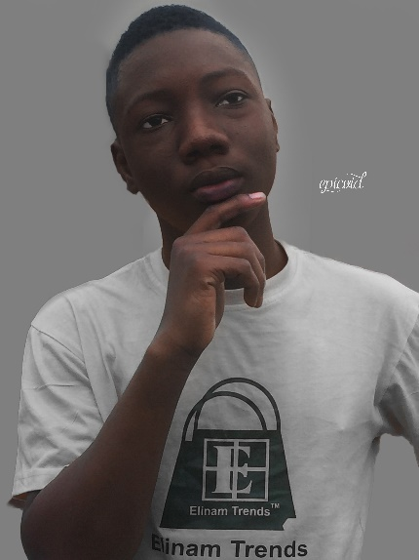

GRAPHIC DESIGNER

**EMMANUEL TAMEKLOE**

C:\Users\ima\AppData\Local\Temp\icons8_telephone_50px_1.pngC:\Users\ima\AppData\Local\Temp\icons8_secured_letter_50px_4.pngC:\Users\ima\AppData\Local\Temp\icons8_telephone_50px_1.pngC:\Users\ima\AppData\Local\Temp\icons8_secured_letter_50px_4.pngC:\Users\ima\AppData\Local\Temp\icons8_male_user_26px.pngC:\Users\ima\AppData\Local\Temp\icons8_new_job_30px_1.pngC:\Users\ima\AppData\Local\Temp\icons8_development_skill_24px.pngC:\Users\ima\AppData\Local\Temp\icons8_education_30px_2.png

[tamekloeemmanuel8@gmail.com](mailto:tamekloeemmanuel8@gmail.com)

[tamekloemawuli931@gmail.com](mailto:tamekloemawuli931@gmail.com)

+233 591 775 782

+233 558 324 931

I am self-taught graphic designer with a keen eye for detail and a passion for creativity. Through self-guided exploration and practice, I have honed my skills in graphic design software. What sets me apart is my relentless pursuit of perfection and my dedication to delivering design that exceed expectation.

**PROFILE**

**EXPERIENCE**

**SKILLS**

**EDUCATION**

**SECONDARY SCHOOL**

**TERTIARY SCHOOL**

Ho Technical University

2022 – 2025

2019 - 2022

Kpando Technical Institute

While I may not have a formal education in graphic design, my journey as a self-taught designer has filled with valuable experience and opportunities for growth. Through personal project and continuous learning, I have built a diverse portfolio that showcase my abilities.

* Proficient in Adobe Creative Suit
* Photoshop
* Illustrator
* After effect
* Premiere pro
* Strong understanding of graphic principles and composition
* Creative thinking a problem solving skills
* Excellent communication skills and teamwork abilities
* Attention to details and commitment to delivery high quality design
* Proficient in Microsoft Office Suit
* Word
* Excel
* PowerPoint