

Medical Report

Doctor's Name: imad
Patient's Name: aqqqaq xcvbnm
Date: 2025-04-12

Case Description:

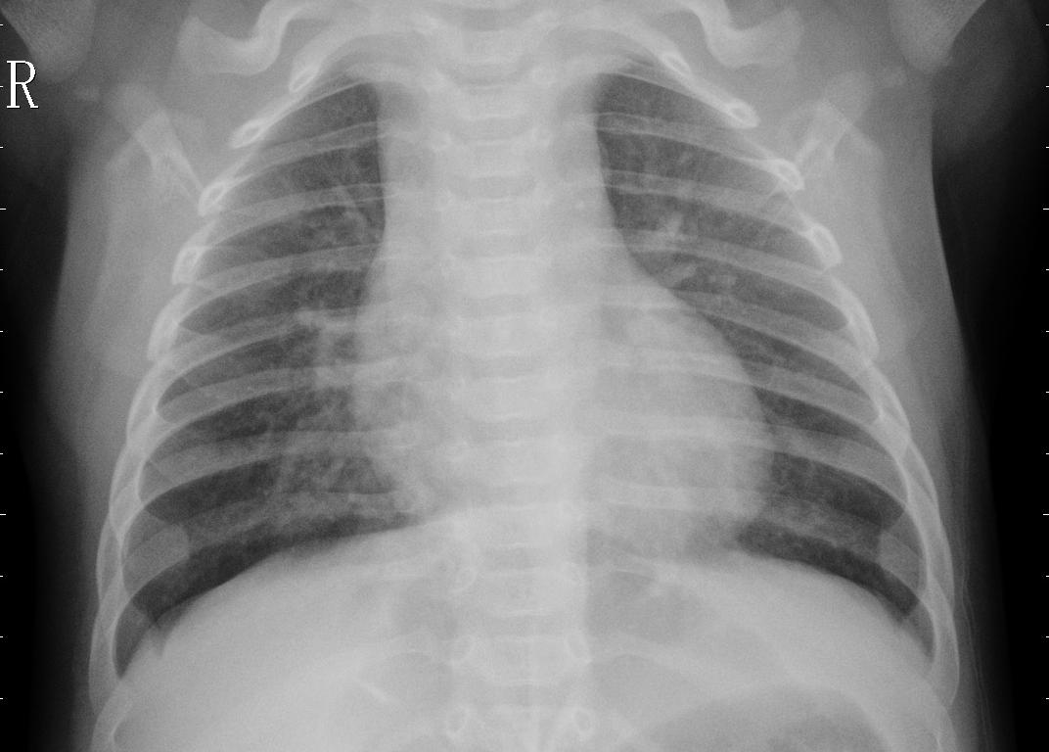

description

