

Medical Report

Doctor's Name: imad
Patient's Name: imad amine
Date: 2025-03-31

Case Description:

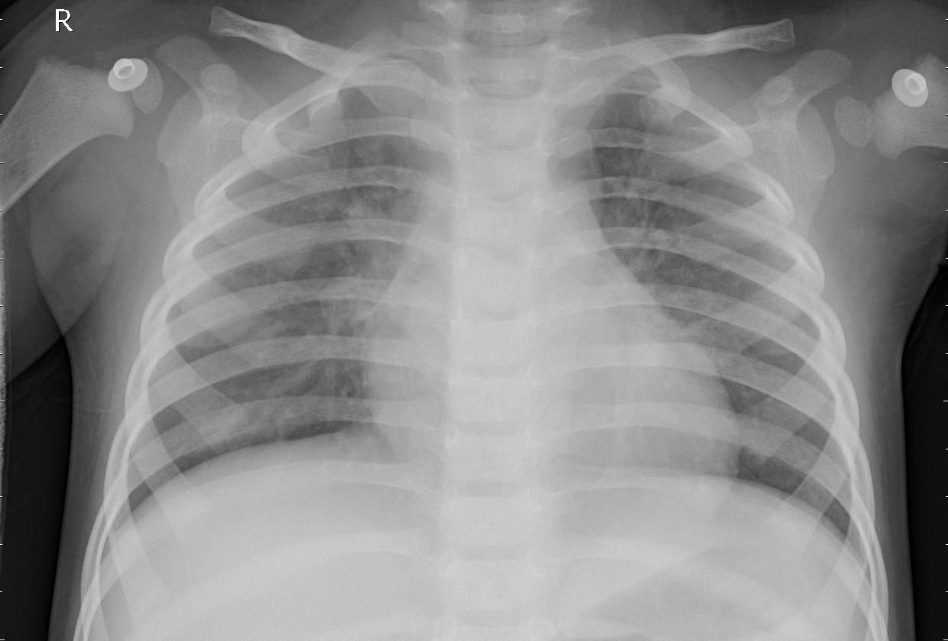

The thoracic radiographic examination reveals localized pulmonary opacities, suggesting pneumonia. Infiltrates and sometimes pleural effusions are observed, consistent with a respiratory tract infection. These radiographic findings, combined with the patient's clinical symptoms, confirm the diagnosis of pneumonia. Appropriate medical treatment is recommended to ensure the patient's recovery.

