

Medical Report

Doctor's Name: Mobile App User
Patient's Name: habibi abdulaal
Date: 2025-05-21

Case Description:

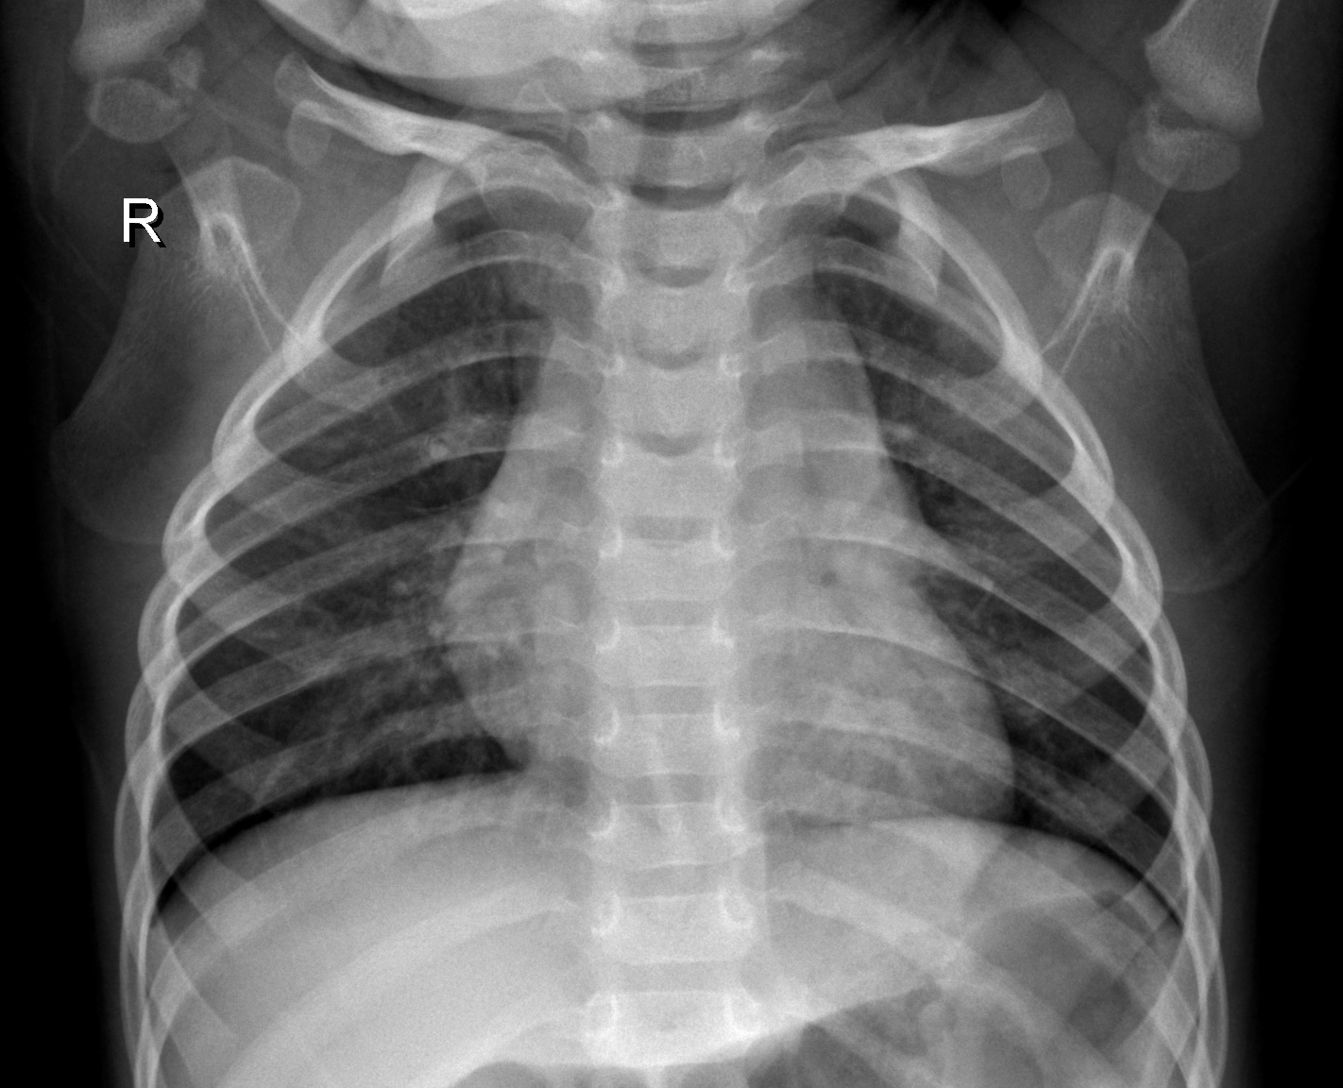

Prediction Result: Normal
Confidence: 88.07%
hada mrid f 3damo

