

Medical Report

Doctor's Name: doctor
Patient's Name: imad jjdjd
Date: 2025-05-20

Case Description:

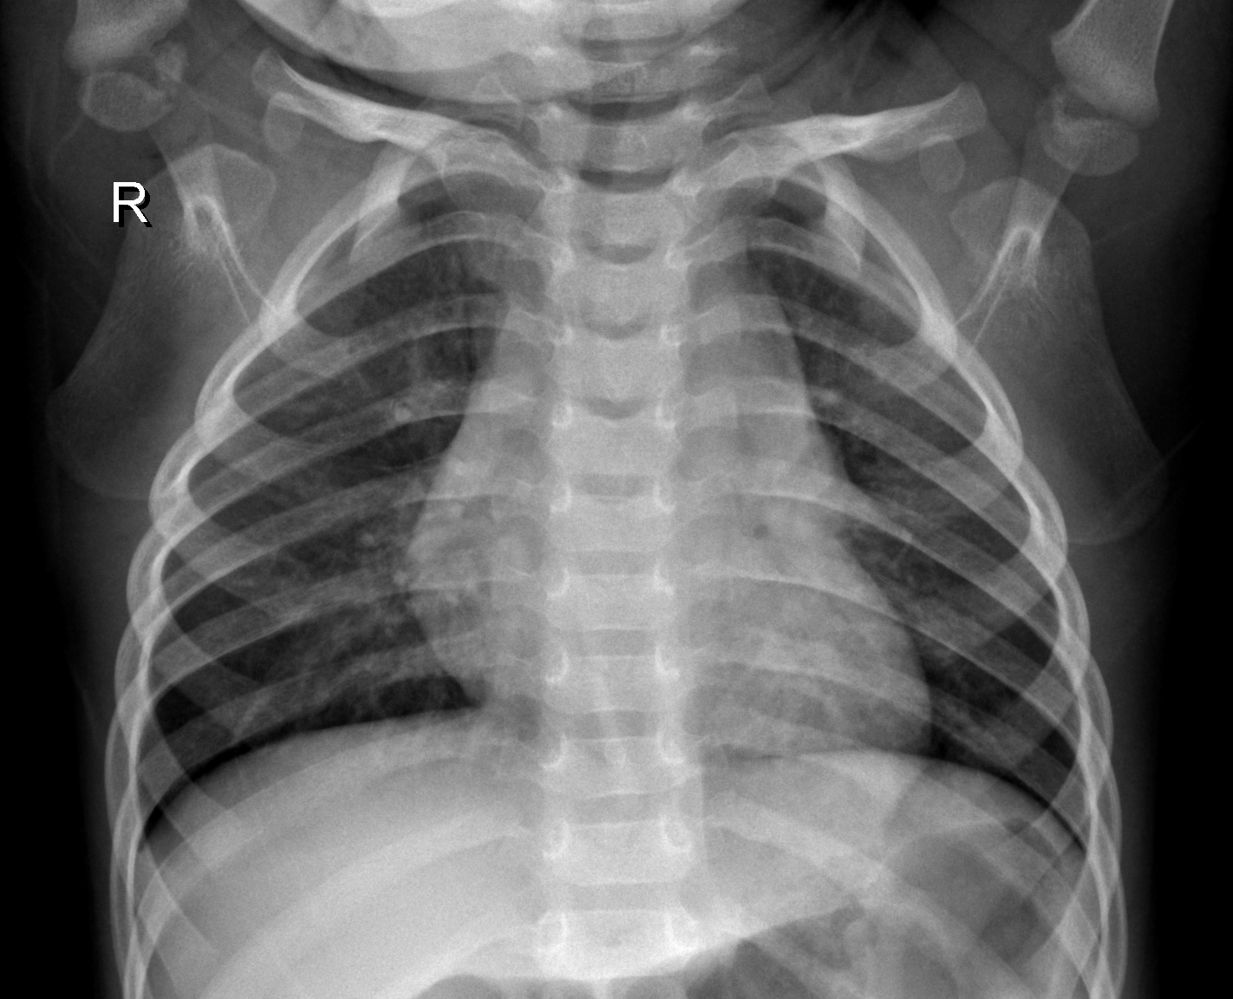

le patient souffre d'une maladie ....

