

Medical Report

Doctor's Name: doctor
Patient's Name: patient abc
Date: 2025-04-15

Case Description:

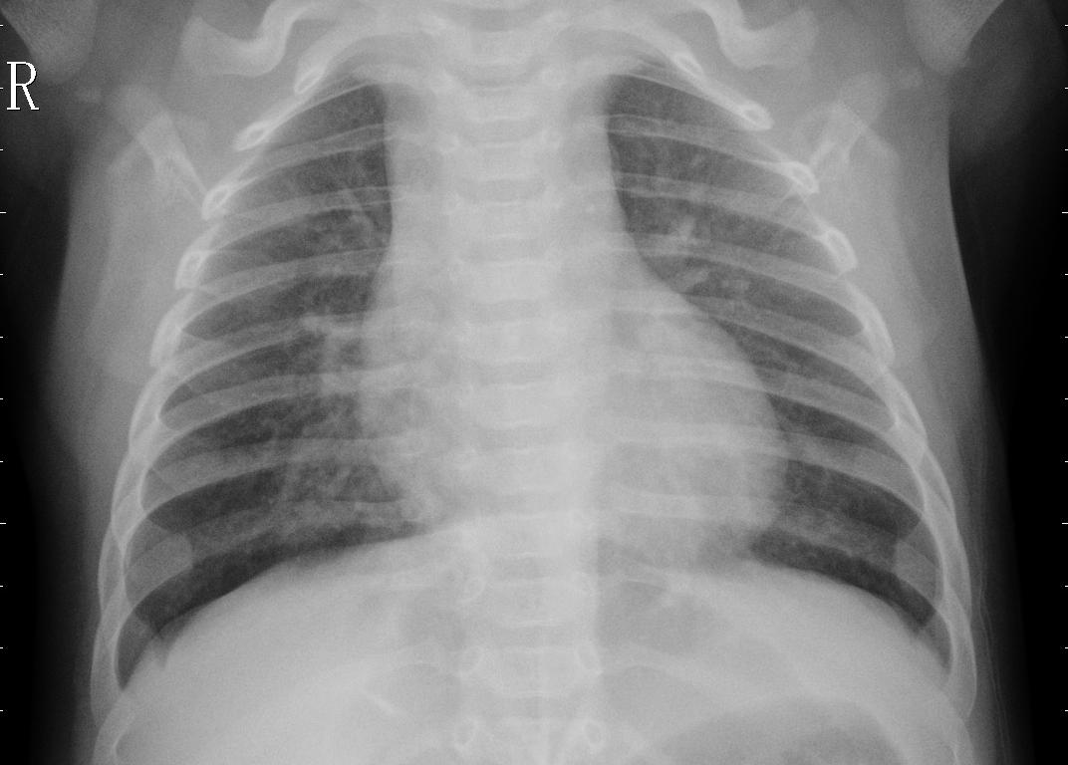

le patient souffre d'une maladie chronique .......

