

Medical Report

Doctor's Name: doctor
Patient's Name: patu hhas
Date: 2025-04-16

Case Description:

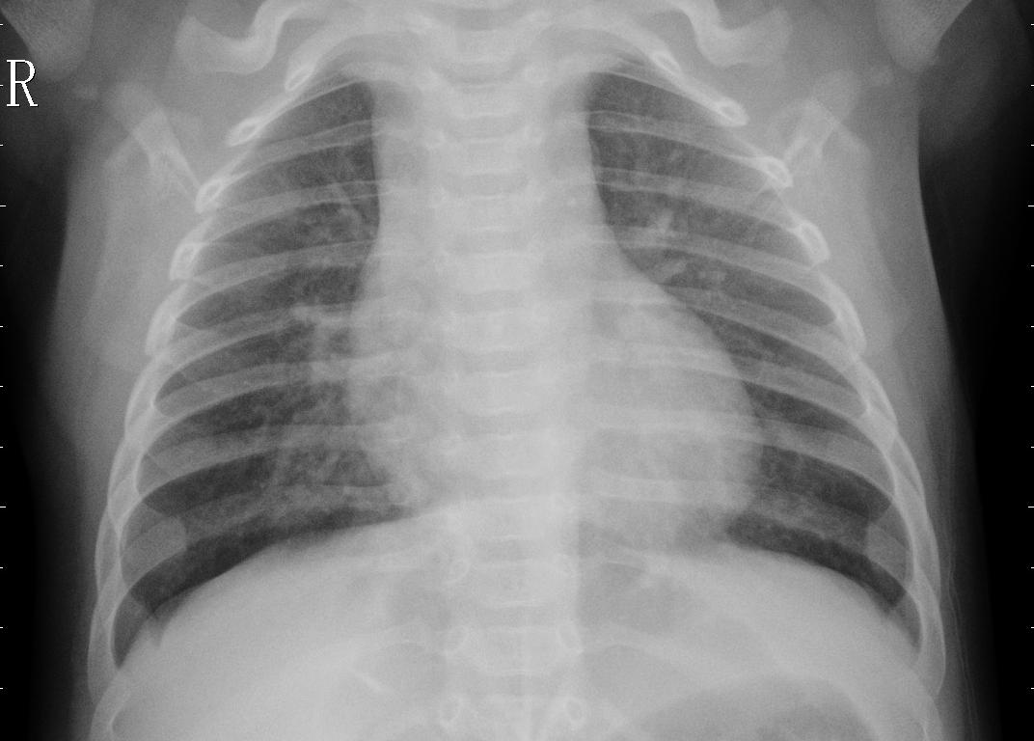

dfghbjnskmbwsbwsbdw

