

Medical Report

Doctor's Name: Mobile App User
Patient's Name: test test
Date: 2025-05-27

Case Description:

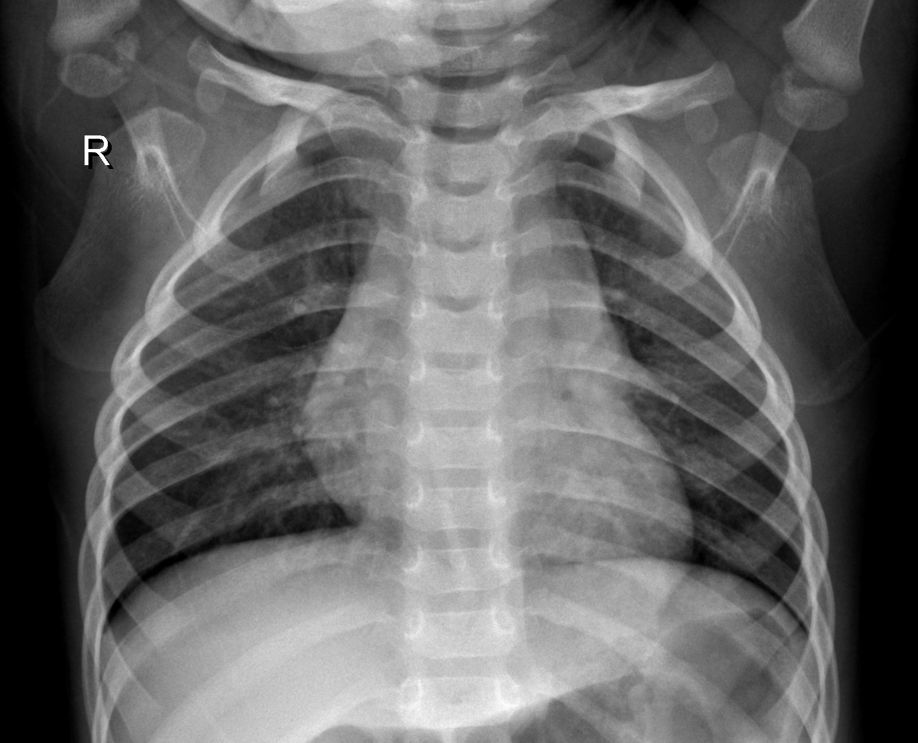

Prediction Result: Normal
Confidence: 88.07%
Please add your medical notes here...

