SECRETARY’S MONTHLY REPORT FORM

ASSOCIATION:______________________________________________________________

SECRETARY’S NAME:______________________SIGNATURE:______________________

DATE OF REPORT:_______________ MEETING DATE:__________________

Please indicate whether chairs personally attended meeting, and whether written reports were submitted.

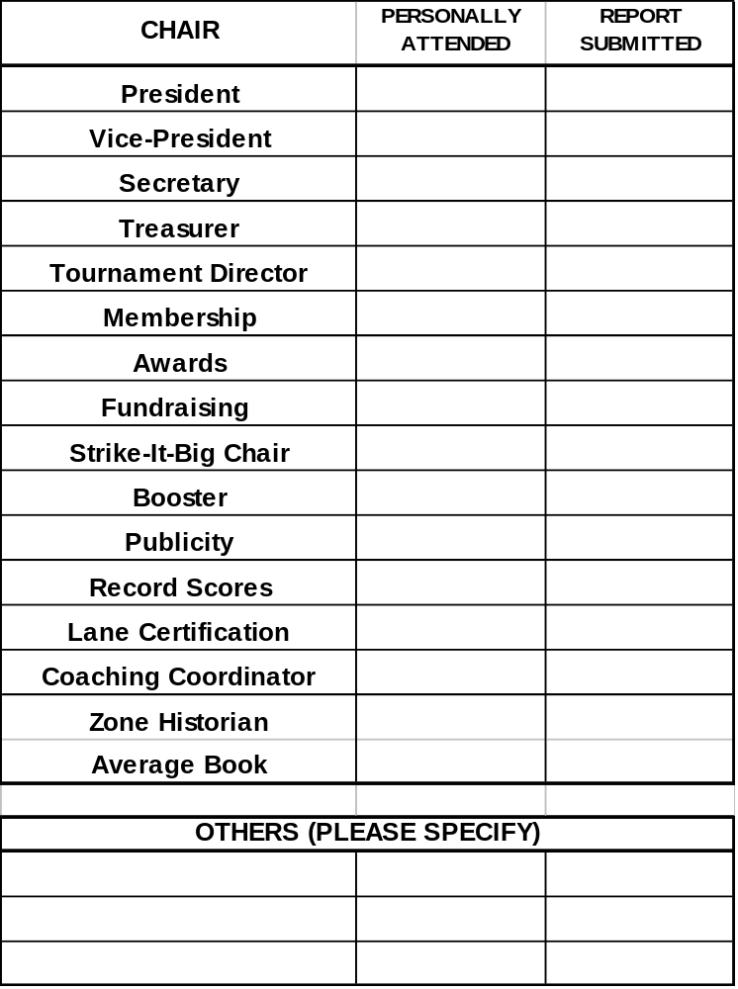

This form should be completed monthly, or more frequently if meeting s are held more often. All Incentive Report Forms submitted by the various chairs should also accompany this form.

