3 Standup Q&A

Q1. Since the last task, all remaining WBS tasks have been completed. This includes the sections of Implementation, Testing, and Deployment. Some modifications to Pseudocode in the Design Section was done in order to satisfy the ways that drawing is done per row on an update instead of per graph. All code works properly, and the testing was done to make sure that the correct graph is shown from the 0th generation all the way down to the 401st generation.

Q2. This is the final writeup, so the project will be turned in at this time.

Q3. Right now, there are no other obstacles to do before starting the next task.

WBS:

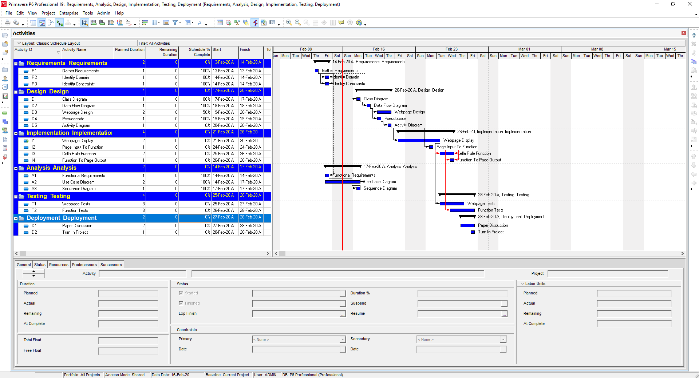

WIP:

|  |  |  |  |  |
| --- | --- | --- | --- | --- |
| **Task Activity ID** | **Ready** | **Working** | **QA** | **Done** |
| R1 |  |  |  | MA |
| R2 |  |  |  | AS |
| R3 |  |  |  | MA |
| A1 |  |  |  | AS |
| A2 |  |  |  | MA |
| A3 |  |  |  | AS |
| D1 |  |  |  | MA |
| D2 |  |  |  | MA |
| D3 |  |  |  | AS |
| D4 |  |  |  | MA |
| D5 |  |  |  | AS |
| I1 |  |  |  | MA, AS |
| I2 |  |  |  | RE |
| I3 |  |  |  | MA |
| I4 |  |  |  | RE |
| T1 |  |  |  | RE |
| T2 |  |  |  | RE |
| D1 |  |  |  | MA, AS, RE |
| D2 |  |  |  | MA, AS, RE |