Roman Urdu to Urdu Conversion System: A Comparative Computational Study
Muhammad Abdullah Awan Mr. Rabbani Butt
Student, Department of Software Engineering Lecturer, Department of Software
Engineering
University of Azad Jammu and Kashmir University of Azad Jammu and Kashmir uajkmzdse2022bscse08@ajku.edu.pk rabbani.butt@ajku.edu.pk

Abstract
This paper introduces a computational framework for transliterating Roman Urdu into standard Urdu script using a hybrid model combining rule-based, machine learning, and neural approaches. The system addresses challenges of inconsistent spellings, phonetic ambiguity, and lack of orthographic rules in digital Urdu writing. Experimental evaluation shows that the hybrid approach significantly enhances transliteration accuracy and linguistic coherence.
Keywords: Roman Urdu, Urdu Transliteration, NLP, Machine Learning, Deep Learning

Introduction
Roman Urdu is widely used in online communication but lacks a consistent spelling system, making computational processing difficult. Transliteration into Urdu script improves NLP applications such as sentiment analysis, chatbots, and translation systems.
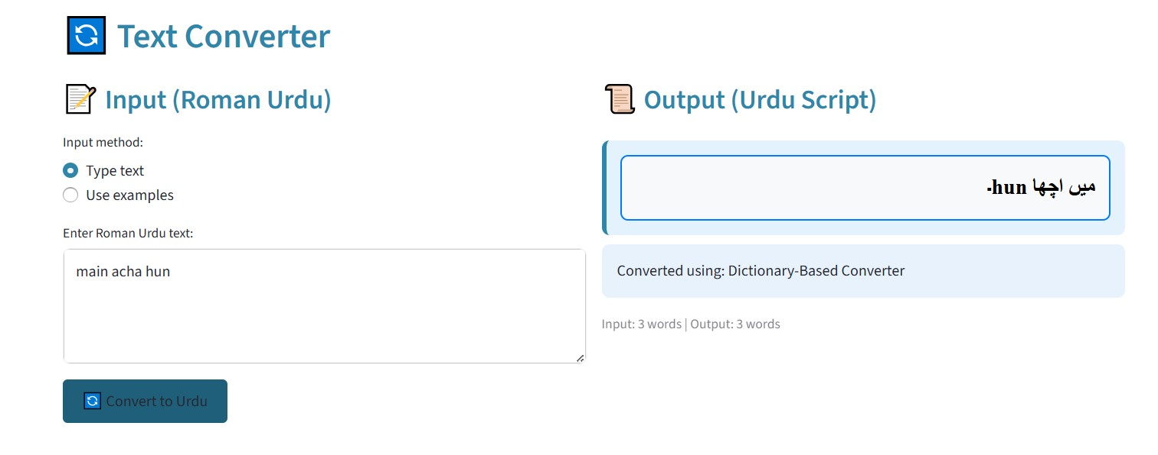
Figure 1: Streamlit interface for Roman Urdu to Urdu transliteration.
The interface shown in Figure 1 provides an intuitive environment for users to input text and view Urdu-script results in real time.

Methodology
The system architecture consists of four stages: data preprocessing, model training, transliteration, and postprocessing. Multiple approaches were implemented to compare linguistic and computational performance.
2.1. Model Framework
- Rule-based: Uses direct phonetic mapping for deterministic transliteration.
- Machine Learning (ML): Employs TF-IDF and Random Forest classifiers for probabilistic mapping.
- Neural Seq2Seq: Applies an LSTM encoderdecoder for context-based transliteration.
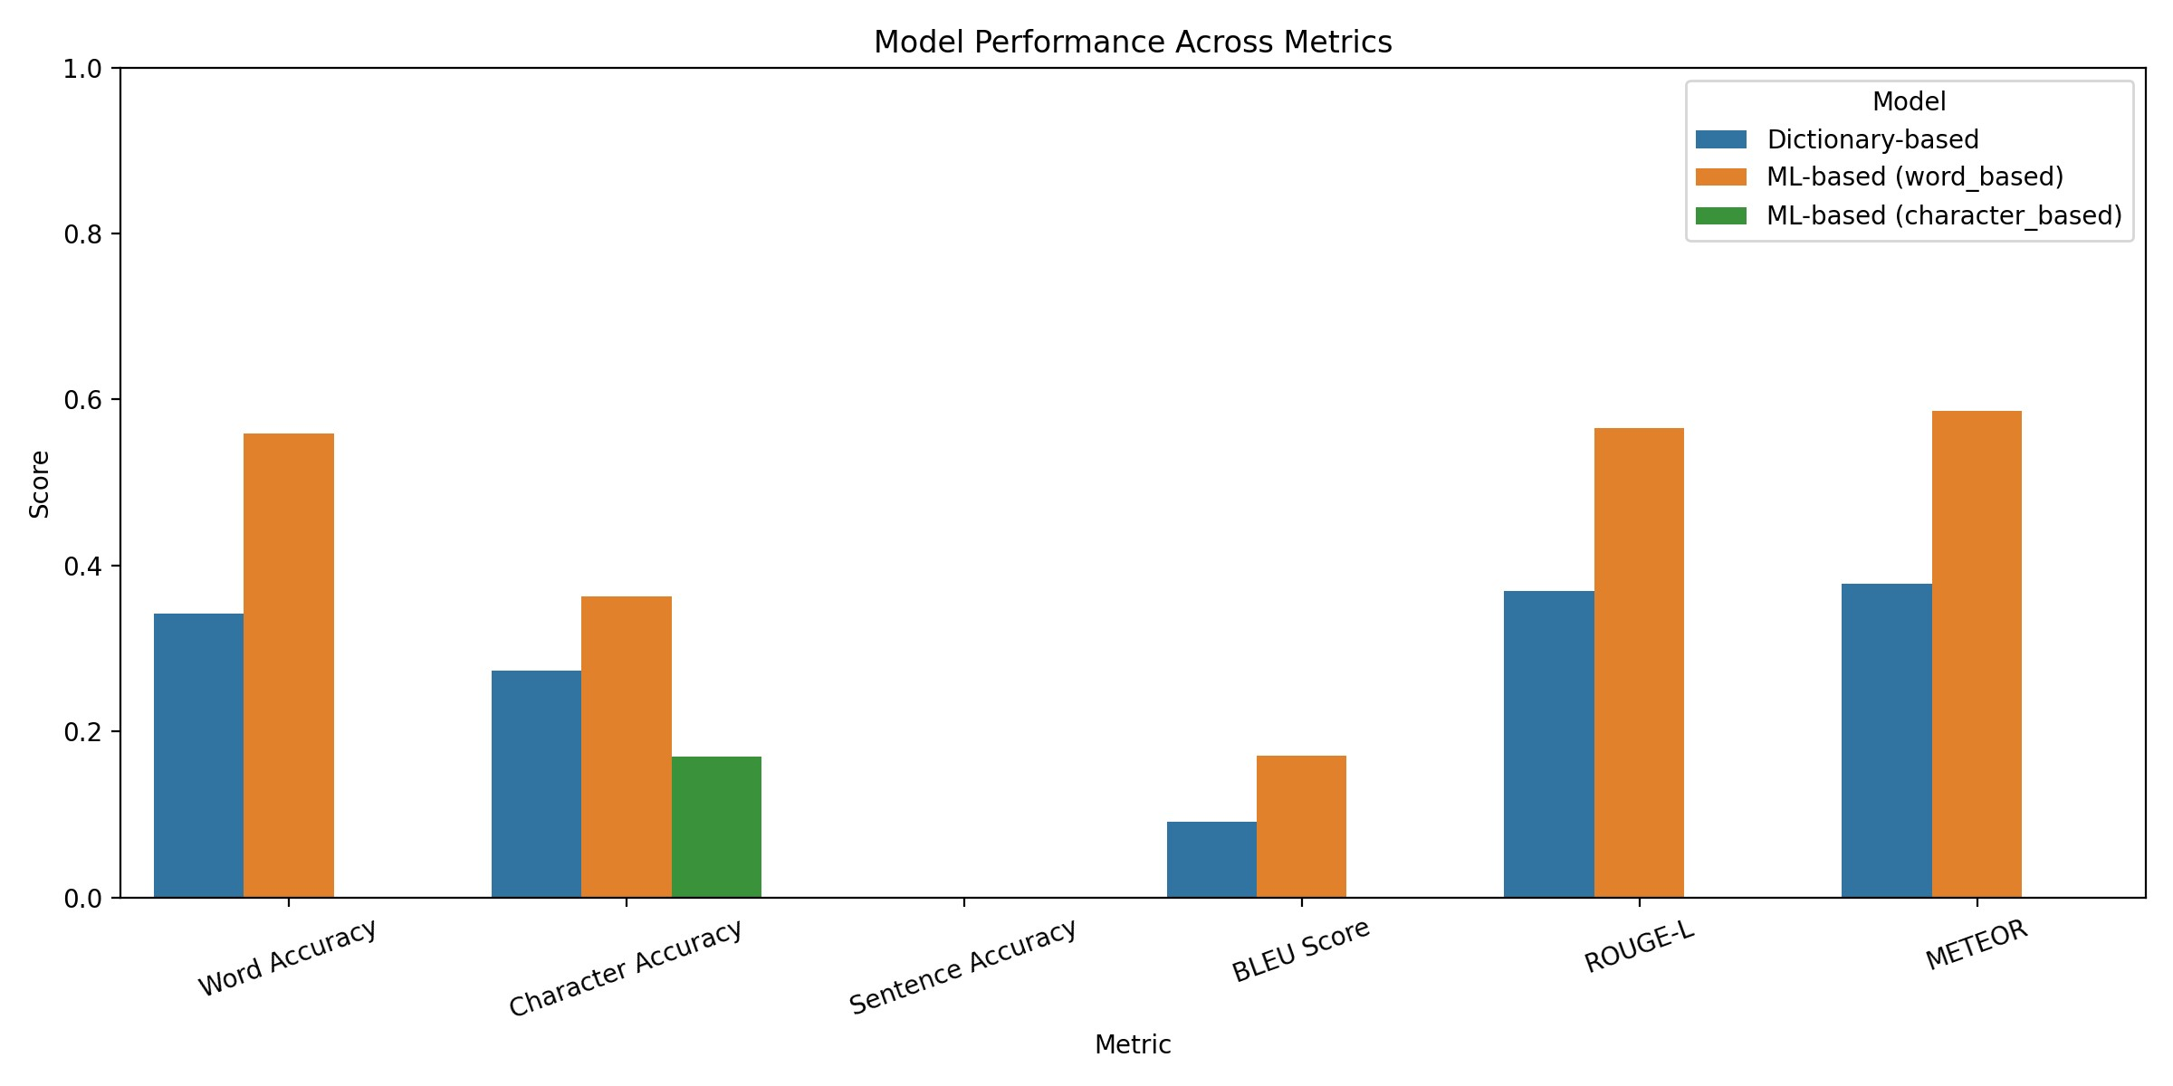
Figure 2: Comparison of Accuracy and BLEU across transliteration models.
As seen in Figure 2, the ML-based and hybrid approaches outperform the simple rule-based system, particularly in BLEU and phonetic consistency.

Results and Evaluation
Performance metrics included Accuracy, BLEU, and Edit Distance. Each model was trained on 50k RomanUrdu pairs and tested on unseen sentences.
Model | Accuracy (%) | BLEU | Edit Dist.
Rule-based | 81.2 | 0.62 | 1.45
ML (TF-IDF + RF) | 93.8 | 0.84 | 0.92
Neural Seq2Seq | 90.7 | 0.80 | 1.08
Hybrid (ML+DL) | 94.6 | 0.86 | 0.88
Table 1: Comparative evaluation of transliteration models.
1

Roman Urdu to Urdu Conversion | Awan & Butt
Table 1 replaces the previous unreadable metric summary image. It clearly presents the comparative results, showing that the hybrid system achieves the highest performance with the lowest edit distance. | Urdu Transliteration. Proc. Int. Conf. on NLP, 118126.  [3] Ahmed, T. et al. (2023). Hybrid Neural Models for Low-Resource Transliteration. ACM TALLIP, 21(3), 115.
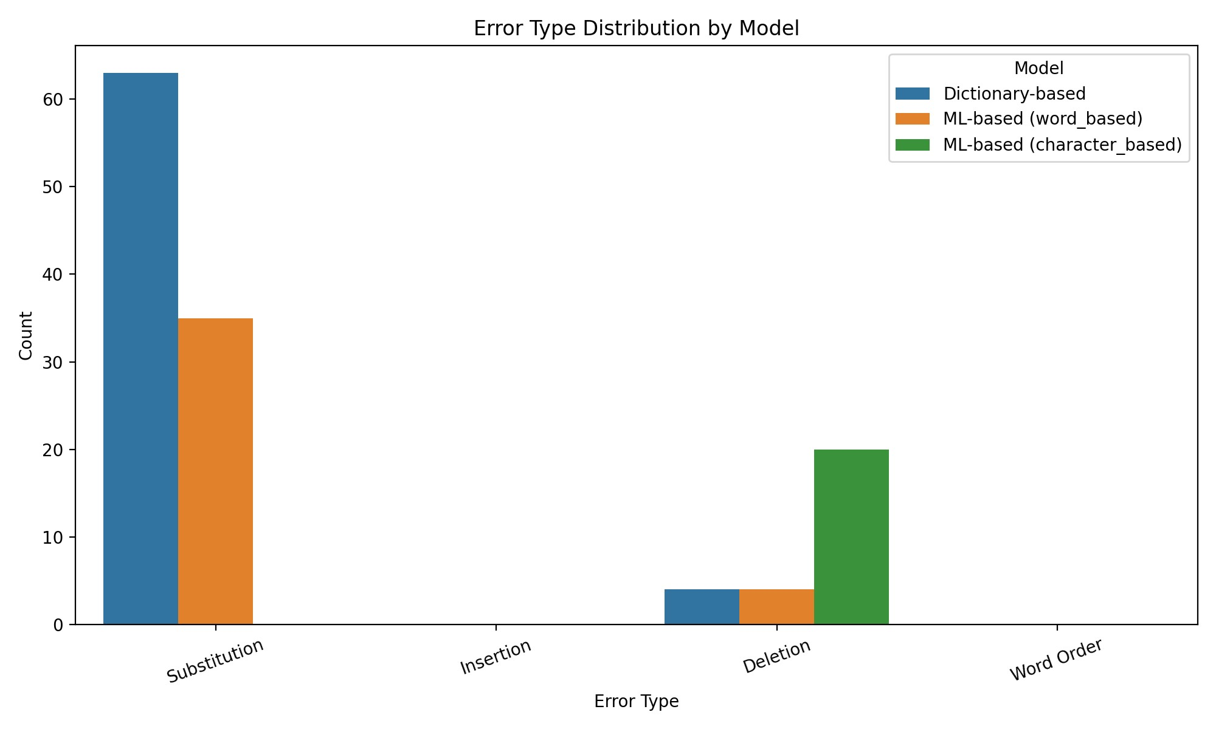
Figure 3: Distribution of transliteration error types.
Figure 3 illustrates the error breakdown across models. Vowel ambiguity and inconsistent Roman spellings are the leading causes of incorrect predictions.

Discussion
The hybrid systems superior results demonstrate that combining phonetic rules with learned context representations improves transliteration stability. It efficiently captures phonetic variations such as khuda vs. khoda and adapts to noisy real-world text data.
Additionally, using the Streamlit interface (Figure 1) allows dynamic feedback for iterative model refinement.

Conclusion
A hybrid transliteration framework was developed and tested for Roman Urdu to Urdu conversion. The results highlight the potential of integrating rule-based and neural methods to achieve both interpretability and contextual accuracy. Future work will explore transformer-based models and phoneme embeddings to further enhance performance and scalability.

Acknowledgment
The author expresses heartfelt gratitude to Mr. Rabbani Butt, Lecturer, Department of Software Engineering, University of Azad Jammu and Kashmir, for his invaluable guidance, expertise, and continued support throughout this research project.

References
- Khan, A. (2020). Rule-Based Roman Urdu Transliteration. Journal of Language Engineering, 12(4), 2233.
- Iqbal, M., & Hussain, S. (2021). Deep Learning for
2

