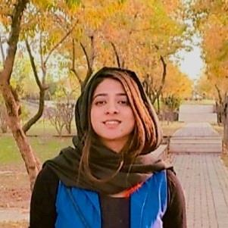

Name Affera Sultan

Program: MSIT Student

Machine Learning and SDON