**What is Eclipse..?**

* It is a dedicated IDE to develop Java based application.
* It is a free version tool

**Download the Eclipse:**

* We can download the Eclipse from the below mentioned link
* Choose the 32bit or x86_64 bit from Eclipse IDE for Java Developers package.
* It will download the Eclipse as Zip file

<https://www.eclipse.org/downloads/packages/release/oxygen/3a>

**Installation of Eclipse:**

We don’t need to install it, We can directly launch the Eclipse application

**Launching the Eclipse**

1. Exctract the downloaded Zip file
2. Find the Eclipse.exe file as Application type under extracted folder
3. Double click the file to launch the Eclipse.

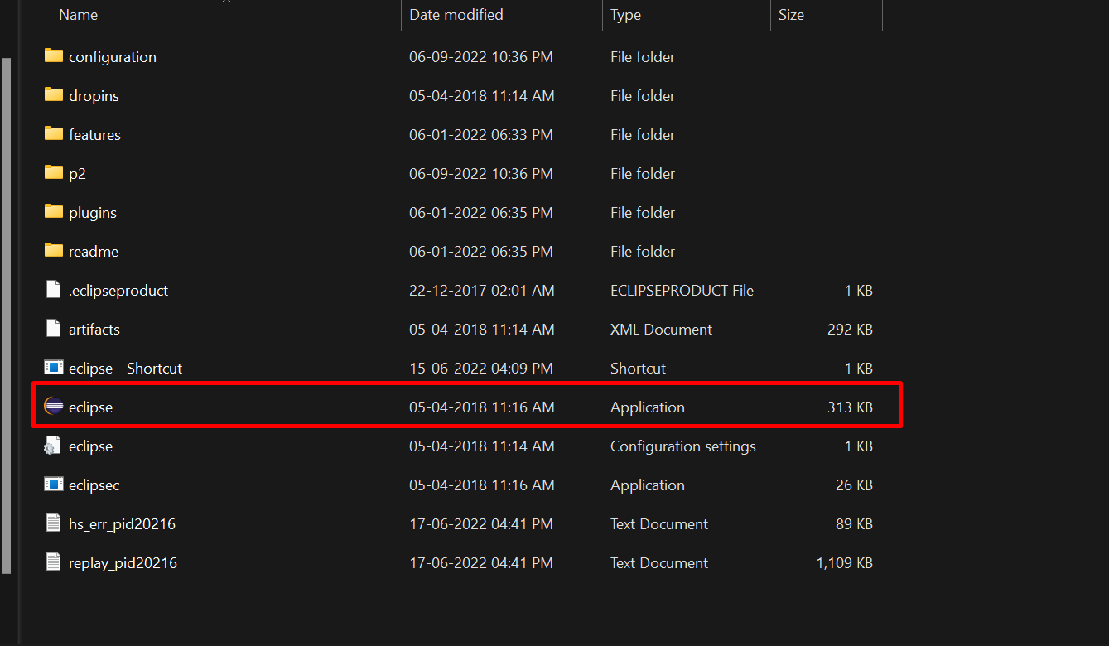

**Note:** Once we have launched the Eclipse, It will prompt to choose the workspace folder.

**What is Workspace..?**

* A workspace is a folder in the local system(computer)
* It will manage all the projects inside the workspace folder.
* As the name suggests, it is your "space of work". It defines your area of interest during an Eclipse session.

**What is the Structure of Java Project:**

Project --> Source Folder --> Package --> Class --> Variable, Method

We can also create files and folders under Project, source folder and packages.

**How to create a new wizard in Java..?**

* Wizard is nothing but general term like Project, source folder, package, class

To create a new wizard follow the below step:

File -- > New --> Choose any wizard

**Shortcut:**  Control + N