Locognosia in Amputees

Nathan A. Baune

University of Missouri-Columbia

Abstract

Locognosia in Amputees

Cortical reorganization following injury to the peripheral nervous system has been observed in humans (Bogdanov, Smith, & Frey, 2012; Elbert et al., 1994; Karl, Birbaumer, Lutzenberger, Cohen, & Flor, 2001), non-human primates (Jenkins, Merzenich, Ochs, Allard, & Guic-Robles, 1990; Wall et al., 1986), and rats (Endo, Spenger, Tominaga, Brene, & Olson, 2007; Kleim, Barbay, & Nudo, 1998). While reorganization has been well established, little is known about the functional correlates that may accompany these changes. An early study in amputees found lower tactile detection thresholds, increased point localization (locognosia), and better two-point discrimination on the amputated stump (Haber, 1955). Though another study found that even though some amputee patients reported increased sensitivity on the amputated stump, objective measures of tactile threshold and two point discrimination did not significantly vary from their intact limb, except at areas of scar tissue (Hunter, 2004).

After amputation of a limb the loss of afferent input results in a transient loss of activity in the respective cortical region. Reorganization occurs as intact cortical fields advance into the inactive region resulting in increased cortical representations. This increased cortical territory could translate to increased sensitivity. Yet numerous confounds plague any interpretation of increased sensitivity on an amputation stump. The severity of deafferenting injury leads to varying degrees of nerve damage and often multiple revision surgeries are needed following the initial amputation. Traumatic neuromas induced by the initial injury or subsequent surgeries also contribute to dramatic variability among amputee patients.

To avoid the aforementioned confounds and better address whether increased acuity stemming from central adaptations occurs in amputees we tested the functional ability of amputees to localize tactile stimuli (locognosia) on the ventral wrist area proximally adjacent to their amputation stump.

Method

Participants

Informed consent (in accordance with local ethics committee recommendations) was given by 22 healthy adults, ages 27–64 (mean 47.52) and 22 upper limb amputees (11 above elbow and 11 below elbow), ages 20–67 (mean 47.77).

Materials and Procedure

Using the locognosia method introduced by Noordenbos (1972) we measured the ability to localize touch (locognosia) on the residual limb and, if applicable, intact hand of upper-limb amputees, as well as the hands of healthy adults. The locognosia task requires participants to mark the perceived site of unseen dermal stimulation with a pen. For example, if testing the left hand of a healthy adult the participant would hold a pen in their right hand in order to respond to stimulation on the left, conversely they would use their left hand to respond to stimulation on the right. While participants held the response pen in their hand whenever possible, amputees had to use another effector when testing their intact hand or in cases of bilateral amputation. Participants were allowed to use whatever effector they felt the most comfortable with and ultimately chose to either hold the pen with their prosthetic limb, in their teeth/mouth, under the crease of the arm, or strapped to the residual limb, see Figure #. Table 1 offers a breakdown of effectors used by each participant.

response accuracy measure. To account for possible differences in response accuracy a calibration sheet was completed prior to the locognosia task, which required participants to mark a series of visible targets using each chosen effector. Participants were seated at a table and asked to don red tinted goggles, which prevent the wearer from discerning a range of similar colors. An 8.5”×11” sheet of white printer paper with 10 randomly placed black points (~.5mm in diameter) was placed in front of the participant. Participants were required to mark each point as accurately as possible with an orange response pen. The orange marks are indiscernible to the participant while wearing the goggles, consequently participants were encouraged to start at the top of the sheet and work their way down to help avoid missing any points. One calibration sheet was completed for each effector that would be used during the locognosia task.

locognosia. Video records were collected during the locognosia task. To avoid any performance feedback participants were asked to keep the goggles on until the end of the locognosia task. While the participant looked away and with an arm resting ventral side up on the table 16 pink target marks were made visually following a template, see Figure #, on the palmar surface of the subjects hand. A suprathreshold tactile stimulus (6.10 Semmes-Weinstein monofiliment) was delivered for approximately two seconds to a single target. The researcher waited for any visible depressions or pigment changes to return to normal before giving a verbal “Go” cue. Upon the cue the participant reoriented their gaze to their hand, and using the orange response pen made a small mark where they had felt the stimulation. The participant once more looked away as the researcher measured the distance between the pink mark (target) and the participants orange dot (response) to the nearest 1 mm using a caliper.

Stimuli were delivered to all 16 target marks in pseudo-random order; orders for each run were generated using MatLab (Mathworks-Natick, MA). Once all marks had been tested alcohol was used to remove the ink so that the experimenter could distinguish future marks. The same process was repeated at the next location. In healthy controls, locations tested included both hands. In unilateral amputees both forearms as well as their intact hand were tested. In bilateral amputees both forearms were tested. If any limbs were amputated above the elbow no measures were taken for that limb. Ten pink target marks were made on the forearm using a stencil, see Figure #. After each location was tested, we repeated the process for a total of three passes at each location. The mean of the participants’ response error (difference between target and response) was computed across all points, and used as the locognosia score (ability to localize tactile stimuli) for that location.

---------------------------

Insert Figure 2 About Here

---------------------------

Results

Response Accuracy

Among controls the grouped mean error when responding with the left hand was 0.47mm and 0.33mm for the right hand. Similarly for amputees, the grouped mean error when responding with the left and right hand was 0.33mm and 0.43mm, respectively. Among amputees who chose to respond with the pen affixed to their forearms the grouped mean was 0.32mm for the left forearm and 0.41mm for the right. The greatest error came from responses using either the mouth or prosthesis with a grouped mean error of 0.80mm when holding the pen in their mouth or teeth, 1.05mm when using their left prosthesis, and 0.57mm when using their right prosthesis. The disparity between mean error for the left and right may be due to sample size. We chose not to run significance tests on the response-accuracy data by chosen effector due to the infrequency of use among certain choices. The effect of accuracy error on our results should be minimal relative to the observed locognosia scores. See Table 1 for participants mean error by effector chosen.

Locognosia

Among unilateral below elbow amputees (n=7) a within-subjects ANOVA found no significant difference between their affected wrist and unaffected wrist, (p=0.46).

SCOTT: Would it be too much of a stretch to include analysis on the intact hand of amputees compared to controls? Possible interhemispheric interactions? I am trying to make sense of including the above elbow amputees.

Discussion

Following loss of input, the receptive field properties of deafferented sensory neurons previously responsive to stimuli from the affected hand come to respond to stimuli delivered to the residual forelimb or lower face. This shift of receptive fields leads to a larger number of units coding stimuli delivered to these somatotopically adjacent regions. The consequences of this dramatic functional reorganization, if any, remain contentious.

We found no significant difference between the wrist area of the amputated limb and the corresponding area of their intact limb. This suggests that previous findings of increased sensitivity on the amputated stump could be due to peripheral changes (scarring, neuromas, etc.) and not cortical reorganization.

References

Bogdanov, S., Smith, J., & Frey, S. H. (2012). Former Hand Territory Activity Increases After Amputation During Intact Hand Movements, but Is Unaffected by Illusory Visual Feedback. *Neurorehabilitation and Neural Repair, 26*, 604-615. doi: 10.1177/1545968311429687

Elbert, T., Flor, H., Birbaumer, N., Knecht, S., Hampson, S., Larbig, W., & Taub, E. (1994). Extensive reorganization of the somatosensory cortex in adult humans after nervous system injury. *Neuroreport, 5*, 2593–2597.

Endo, T., Spenger, C., Tominaga, T., Brene, S., & Olson, L. (2007). Cortical sensory map rearrangement after spinal cord injury: fMRI responses linked to Nogo signalling. *Brain, 130*, 2951-2961. doi: 10.1093/brain/awm237

Haber, W. B. (1955). Effects of loss of limb on sensory functions. *J. Psychol.*, 115-123.

Jenkins, W. M., Merzenich, M. M., Ochs, M. T., Allard, T., & Guic-Robles, E. (1990). Functional reorganization of primary somatosensory cortex in adult owl monkeys after behaviorally controlled tactile stimulation. *J Neurophysiol, 63*, 82–104.

Karl, A., Birbaumer, N., Lutzenberger, W., Cohen, L. G., & Flor, H. (2001). Reorganization of motor and somatosensory cortex in upper extremity amputees with phantom limb pain. *The Journal of Neuroscience, 21*, 3609–3618.

Kleim, J. A., Barbay, S., & Nudo, R. J. (1998). Functional reorganization of the rat motor cortex following motor skill learning. *J Neurophysiol, 80*(6), 3321-3325.

Noordenbos, W. (1972). The sensory stimulus and the verbalization of the response-the pain problem. *G.G. Somjen (Ed.), Neurophysiology Studies in Man*. Amsterdam: Excerpta Medica.

Wall, J. T., Kaas, J. H., Sur, M., Nelson, R. J., Felleman, D. J., & Merzenich, M. M. (1986). Functional reorganization in somatosensory cortical areas 3b and 1 of adult monkeys after median nerve repair: possible relationships to sensory recovery in humans. *The Journal of Neuroscience, 6*, 218–233.

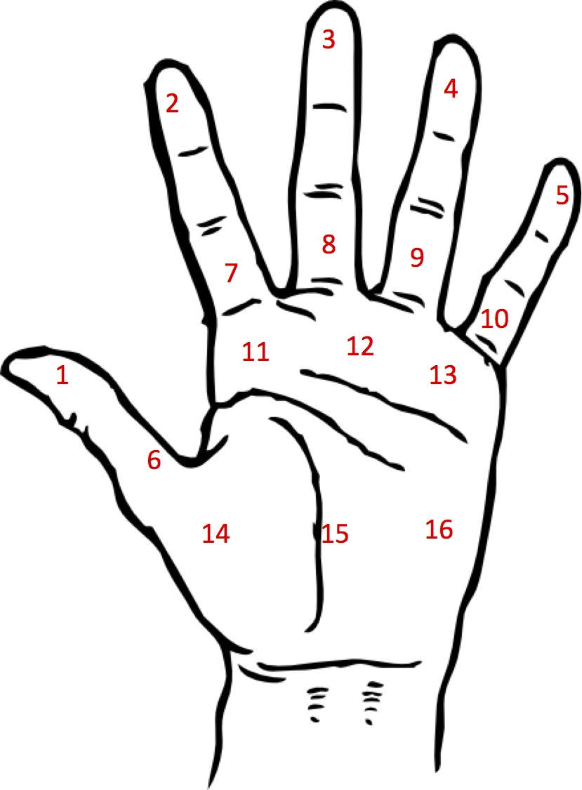

Figure 1. The left hand template for marking and testing the 16 target points.

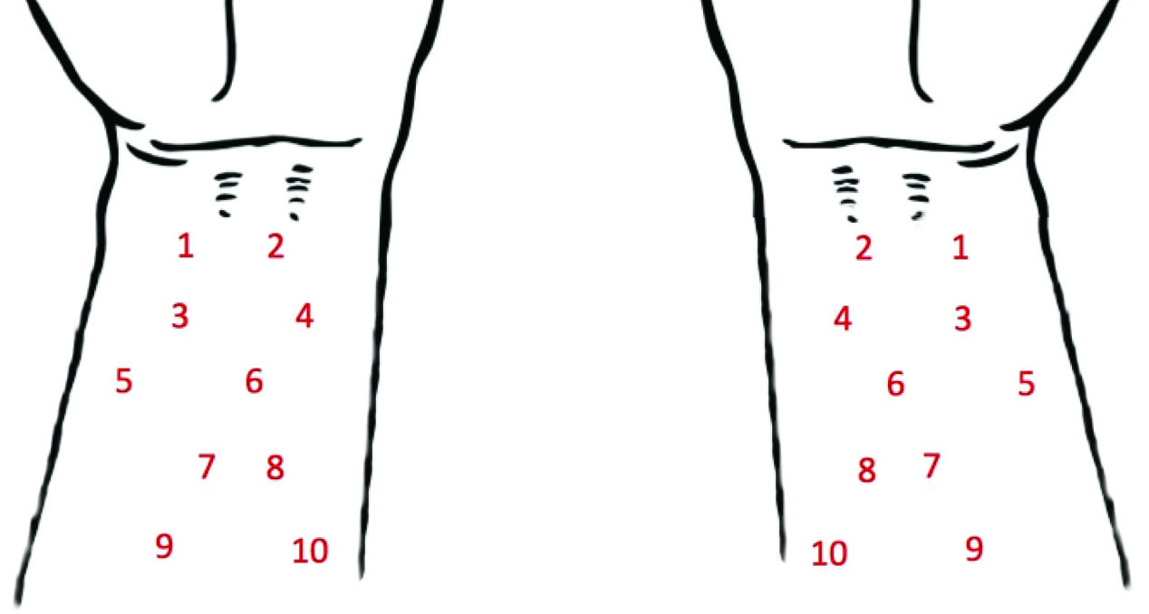

Figure 2. The right forearm template for marking and testing the 10 target points.

Figure 3. The box-plots depict the error in mm of each above elbow amputee by effector. The mean error of each control participant are grouped under controls. The left and right graph represent scores before and after correction for calibration scores, respectively. The upper whisker extends from the hinge (75th percentile) to the highest value that is within 1.5 * IQR of the hinge, where IQR is the inter-quartile range, or distance between the first and third quartiles. The lower whisker extends from the hinge (25th percentile) to the lowest value within 1.5 * IQR of the hinge. Data beyond the end of the whiskers are outliers and plotted as points (as specified by Tukey).

Figure 4. The box-plots depict the error in mm of each below elbow amputee by effector. The mean error of each control participant are grouped under controls. The left and right graph represent scores before and after correction for calibration scores, respectively. The upper whisker extends from the hinge (75th percentile) to the highest value that is within 1.5 * IQR of the hinge, where IQR is the inter-quartile range, or distance between the first and third quartiles. The lower whisker extends from the hinge (25th percentile) to the lowest value within 1.5 * IQR of the hinge. Data beyond the end of the whiskers are outliers and plotted as points (as specified by Tukey).

|  |  |  |  |  |  |  |  |
| --- | --- | --- | --- | --- | --- | --- | --- |
| Subject | Age | Gender | Amputation | | Effectors Used | | Calibration Mean Error |
| A01 | 41 | M | | Left (AE) | | Left Hand/Mouth | 0.4/0.4 |
| A02 | 62 | M | | Right (AE) | | Left Hand/Mouth | 0/0.25 |
| A03 | 47 | F | | Right (AE) | | Left Hand/Right Prosthesis | 0/0.1 |
| A04 | 57 | M | | Right (AE) | | Left Hand/Mouth | 0.9/1.3 |
| A05 | 43 | M | | Right (AE) | | Right Forearm | 0.35 |
| A06 | 67 | F | | Right (AE) | | Left Hand/Right Prosthesis | 0.6/0.4 |
| A07 | 31 | M | | Right (AE) | | Left Hand/Right Prosthesis | 0/1.3 |
| A08 | 64 | M | | Right (AE) | | Mouth | 1.2 |
| A09 | 43 | M | | Right (AE) | | Left Hand/Mouth | 0.35/1.65 |
| A10 | 56 | M | | Right (AE) | | Left Hand/Right Forearm | 0.1/0.55 |
| A11 | 56 | M | | Left (AE) | | Left Prosthesis | 2.45 |
| A12 | 47 | M | | Right (AE)/  Left (AE) | | Left Forearm/Right Forearm | 0.4/0.6 |
| A13 | 61 | M | | Right (AE)/  Left (BE) | | Left Hand/Right Hand | 0.85/0.6 |
| A14 | 55 | M | | Left (BE) | | Left Hand | 0.86 |
| A15 | 38 | F | | Left (BE) | | --- |  |
| A16 | 52 | M | | Left (BE) | | Left Prosthesis/Right Hand | 1.05/0.4 |
| A17 | 29 | M | | Right (BE) | | Left Hand/Right Forearm | 0.1/0.15 |
| A18 | 37 | F | | Right (BE) | | --- |  |
| A19 | 20 | M | | Left (BE) | | Left Forearm/Right Hand | 0.25/0.45 |
| A20 | 65 | M | | Right (BE) | | Right Prosthesis | 0.5 |
| A21 | 32 | M | | Right (BE) | | --- |  |
| A22 | 49 | M | | Right (BE) | | Left Hand/Mouth | 0/0 |