Primary sensory (S1) and motor (M1) cortices contain somatotopically organized maps of the body [Penfield, 1937 #2678]. Primate neurophysiological studies indicate that the organization of these maps is dependent on afferent and efferent activity and maintained through competitive interactions [Kaas, 1991 #24;Sanes, 2000 #1886]. Deafferenting injuries (e.g., limb amputation, brachial plexus lesion, or spinal cord injury) therefore result in significant changes in cortical maps [Kaas, 2000 #1434]. These changes begin almost immediately following hand amputation, continue for months or longer, and culminate in substantial receptive field changes [Pons, 1991 #1590]. Some neurons formerly responsive to stimulation of the amputated hand can subsequently be activated by input from the face and/or residual forearm [Buonomano, 1998 #1887]. Similar changes occur in M1 contralateral to the amputated hand. Several years after amputation, microstimulation of M1 neurons in areas that formerly targeted amputated hand muscles, evoke movements of the residual limb or shoulder [Qi, 2000 #1432].

Despite limited resolution, non-invasive studies of human amputees provide consistent evidence for gross reorganizational changes in the somatotopic organization of S1 [Elbert, 1994 #1485] and M1 [Cohen, 1991 #1573;Lotze, 2001 #1244]. These likely result from reductions in intracortical inhibition [Schwenkreis, 2000 #1442].

*Functional Implications.*  Understanding the extent to which the reorganizational changes that follow deafferenting injuries can be reversed is of substantial clinical importance for at least two reasons. First, single unit recording studies of adult monkeys indicate chronic disorganization of finger maps within the primary sensory (S1) hand representation following recovery from median nerve transection and repair [Florence, 1994 #2194]. In humans, this may be a contributing factor to the poor clinical outcomes following surgical nerve repairs in the hand or forearm [Almquist, 1970 #2660;Wall, 1986 #2199]. Second, the extent of reorganization in S1 and M1 maps is associated with the degree of neuropathic pain experienced in conditions including limb amputation [Flor, 1995 #1483] spinal cord injury [Wrigley, 2009 #2680], and complex regional pain syndrome [Maihofner, 2003 #2397].

*Reversibility Following Hand Transplantation and Replantation.* Despite substantial variation among cases, the small number of functional neuroimaging studies of allogeneic hand transplant recipients suggest that S1 [Frey, 2008 #2392;Neugroschl, 2005 #1908] and M1 [Brenneis, 2005 #1902;Giraux, 2001 #1460;Neugroschl, 2005 #1908;Lanzetta, 2004 #1996] can recover at least a grossly typical map organization even years after amputation. Complimentary results have been obtained in studies of heterotopic hand replant patients who have undergone similar injuries followed by a much shorter period of disrupted afferent and efferent flow [Bjorkman, 2007 #2672;Brenneis, 2005 #1902;Eickhoff, 2008 #2669]. These remarkable early findings leave a number of important questions unanswered, and these motivate the specific aims of the current proposal.

There is widespread evidence for expansion of the residual limb representation following limb amputation. Does this convey any functional advantage?

Previous reports suggest that amputees have better than normal ability to localize touch sensations, improved 2-point discrimination, and lower sensory thresholds for stimuli delivered to their residual limbs, (Haber, 1958). This may be due to sensory plasticity, specifically the expansion of the residual limb representation into the former sensory hand territory in primary sensory cortex, or to attentional factors (Moore & Schady, 1999).

We follow the procedure as described by Moore & Schady (1999) and originated by Noordenbos (1972).

Moore & Schady (1999). Neuroscience Letters, 270, 185-187.

*Locognosia Testing.*  As detailed above, previous reports indicate that following peripheral nerve repairs, patients have difficultly localizing light touch without vision. We will evaluate touch localization in hand transplant and hand replant recipients using a behavioral task that eliminates vision of the targets while allowing participants to see their hands [Moore, 1999 #3994].

*Procedure.* Briefly, the participant dons a pair of red goggles and closes his/her eyes. Small red dots are marked on 10 locations on each hand. The experimenter then randomly touches one marked location with a suprathreshold Semmes-Weinstein filament. The participant then opens his/her eyes and marks the location on the hand where the touch was perceived using a yellow marker. The red goggles prevent the participant from seeing the red marks, forcing them to rely on touch localization. The experimenter uses a caliper to measure the distance between the stimulated mark, and the participant’s response. *Duration:* This task tasks approximately 30mins to administer to both hands. Performances will be video-recorded for off-line analysis.

*Prediction.* We predict that hand transplant and hand replant patients will show deficiencies in localization that are inversely related to the time since their surgeries.

**Methods**

**Participants**

As summarized in Table 1, four unilateral hand replant patients three unilateral hand transplant recipients, and fourteen controls (Mean age ± SD = 53 ± 11.09) participated (Table 1). All participants provided informed consent. For participant DR, data was collected on three separate occasions. Data was collected once for all other participants.

|  |  |  |  |  |  |
| --- | --- | --- | --- | --- | --- |
| Table 1 |  |  |  |  | |
| Group | Participant | Age | Gender | Hand | |
|  |  |  |  | Dominant | Affected |
| Replant | CH(WH) | 60 | Male | Right | Left |
|  | JS | 49 | Male | Right | Right |
|  | PP | 61 | Female | Right | Right |
|  | RW | 59 | Male | Right | Left |
| Transplant | DR | 37 | Male | Right | Left |
|  | GF | 46 | Male | Right | Left |
|  | MS | 49 | Male | Left | Left |

**Procedure**

Localization (locognosia) of focal cutaneous stimulation was tested using a method established by Noordenbos (1972). Participants were seated at a table in a quiet room and donned a pair of custom made red-tinted glasses. The investigator then briefed participants on the intent of the locognosia task to test their ability in localizing tactile stimuli applied to the palmar surface of the hand. The investigator demonstrated that the pen marks are indiscernible by marking their own palm with the pink target pen. A camera positioned above the participant with top-down view of the table surface and the participants’ hands was used to record the session from that point. A calibration sheet consisting of fifteen randomly distributed black points (12 pt. font periods) printed on 8.5x11inch printer paper was placed on the table directly in front of the participant and they were asked to accurately mark each black dot with the orange response marker, starting from the top of the page and moving down to assure all target dots were marked. A separate calibration sheet was completed for each hand to measure the participants base accuracy with the pen given a visible target. Participants were informed that, while potentially tempting given the lack of visual feedback, they should not use excessive force or drag the pen across the paper and that light controlled marks were ideal. This was repeated again prior to the main task. Participants were then asked to rest a hand palm side up on the table while holding the orange response marker in the opposite hand. The participant looked away as the investigator applied fifteen points on the palmar surface of the hand with the pink marker according to a predetermined schematic, see Figure 1. The participant continued to look away as the investigator applied stimuli to a single point using a 6.10-gram Semmes-Weinstein monofilament. The investigator briefly waited for any indentations or discoloration at the target site to disappear before giving a verbal cue for the participant to redirect their gaze and mark the perceived location of the stimuli with the orange pen. The participant was then asked to look away as the investigator measured the distance between the target location and the recent response to the nearest 1 mm. All fifteen points were tested in randomized order. A second investigator recorded corresponding measurements. After a complete pass of all fifteen points on one hand a close up picture of the entire palm was taken next to a ruler for reference. Participants hands were cleaned with hand sanitizer which faded the marks sufficiently to ensure that future targets and responses could be distinguished by the investigator. The procedure was then applied to the opposite hand, starting with application of the pink target marks, and repeated a total of three times for each hand.

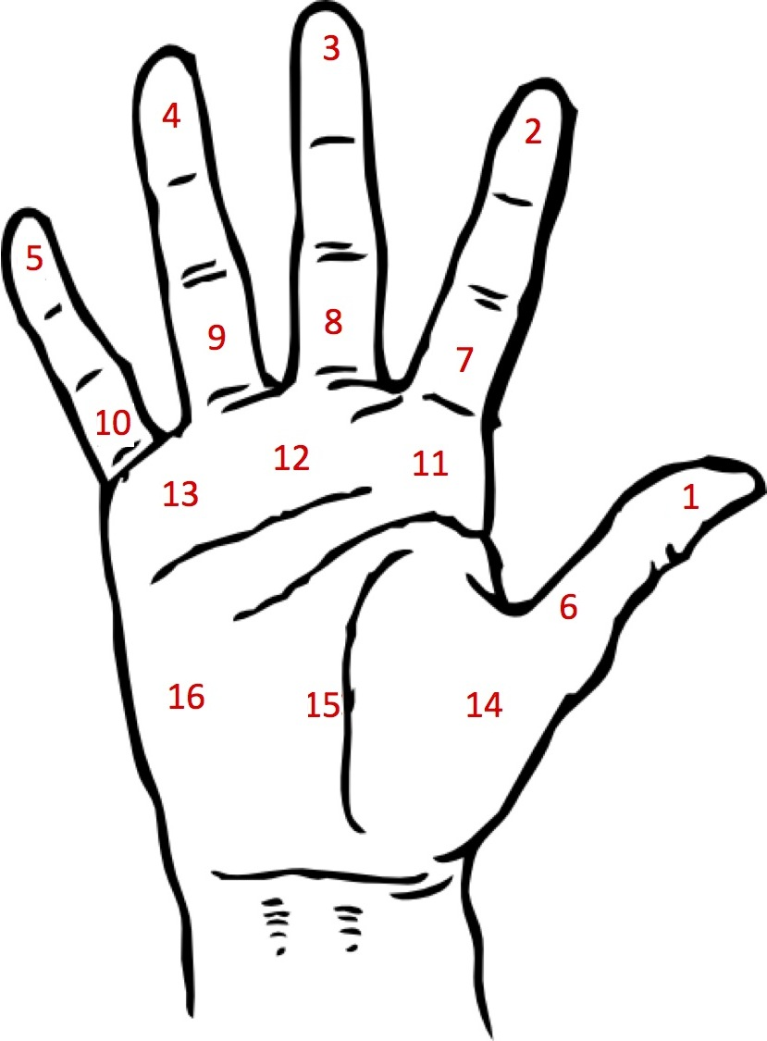

Figure 1. Target location schematic.

**Results**



Figure 2.



Figure 3.

|  |  |  |  |  |  |  |
| --- | --- | --- | --- | --- | --- | --- |
| Table 2 |  |  |  |  |  |  |

|  |  |  |  |  |  |  |
| --- | --- | --- | --- | --- | --- | --- |
| *Affected hand* |  |  |  |  |  |  |

|  |  |  |  |  |  |  |  |
| --- | --- | --- | --- | --- | --- | --- | --- |
| Participant | N  (# of samples) | | Mean | Median | SD | Range | SE |
| Controls | 512 | | 3.75 | 3 | 3.43 | 20 | 0.15 |
| CH(WH) | 16 | | 16.56 | 13 | 12.96 | 52.5 | 3.24 |
| JS | | 16 | 4.56 | 5.19 | 2.1 | 8.29 | .53 |
| PP | 16 | | 12.94 | 8 | 11.56 | 42 | 2.89 |
| RW | 16 | | 27.19 | 20.5 | 18 | 64 | 4.5 |
| DR1 | 16 | | 44.44 | 43.5 | 21.97 | 95 | 5.49 |
| DR2 | 16 | | 34.44 | 29 | 26.54 | 86 | 6.64 |
| DR3 | 48 | | 37.35 | 32.5 | 30.29 | 116 | 4.37 |
| GF | 10 | | 11.3 | 8.5 | 7.57 | 25 | 4.37 |
| MS | 10 | | 12.1 | 10 | 7.88 | 24 | 2.49 |