Locognosia in Amputees
Nathan A. Baune
University of Missouri-Columbia

Abstract

Locognosia in Amputees
have reported cortical reorganization following injury to the peripheral nervous system both in humans (Bogdanov, Smith, & Frey, 2012; Elbert et al., 1994; Karl, Birbaumer, Lutzenberger, Cohen, & Flor, 2001) and animals (Endo, Spenger, Tominaga, Brene, & Olson, 2007; Jenkins, Merzenich, Ochs, Allard, & Guic-Robles, 1990; Wall et al., 1986). After amputation of a limb the loss of afferent input results in a transient loss of activity in the respective cortical region. Reorganization occurs as intact cortical fields advance into the inactive region resulting in increased cortical representations. This increased representation has been posited as a mechanism behind the proposed increases in sensory acuity.
Method
Participants
Informed consent (in accordance with local ethics committee recommendations) was given by 14 healthy adults, ages 34–64 (median 58) and 22 upper limb amputees, ages 20–67 (median 48.5).
Materials and Procedure
Using the locognosia method introduced by Noordenbos (1972) we measured the ability to localize touch of upper limb amputees on their amputated forearms and intact hands. Participants were seated at a table and asked to don red goggles. While the participant looked away and with an arm resting ventral side up on the table 16 pink target marks were made following a template, see figure 1, on the palmar surface of the subjects hands. A suprathreshold tactile stimulus (6.10 Semmes-Weinstein monofiliment) was delivered for approximately two seconds to a single target. Following the stimulus the participant reoriented their gaze to their hand, and made a small dot where they had felt the stimulation with an orange pen. The participant once more looked away as the researcher measured the distance between the pink mark (target) and the participants orange dot (response) to the nearest 1 mm using a caliper. Stimuli were delivered to all 16 target marks in pseudo-random order and once all marks had been tested alcohol was used to remove the ink so that future marks could be distinguished. The same process was repeated at the next location. In healthy controls, locations tested included both hands and forearms, in unilateral amputees both forearms as well as their intact hand, and in bilateral amputees both forearms; if any limbs were amputated above the elbow no measures were taken for that limb. Ten pink target marks were made on the forearm using a stencil, see Figure 2. After each location was tested, we repeated the process for a total of three passes at each location. The mean of the participants’ response error (difference between target and response) was computed across all points, and used as the locognosia score (ability to localize tactile stimuli) for that location.
In order to determine the participants’ ability to accurately mark a visible target, a calibration sheet was completed out prior to the locognosia testing. Participants marked 10 randomly placed dots on a 8.5×11in. sheet of paper with the orange marker. One sheet was completed for each effector that would be used during the locognosia testing.
---------------------------
Insert Figure 2 About Here
---------------------------
Results
As a group, above elbow (AE) amputees showed no significant differences between their intact hand and the hand of healthy controls. Amputees’ median error was, in all but one case, greater than the healthy controls median error. Though this may be due to the fact that AE participants were responding to stimuli delivered only on their intact hands and had to use alternative methods for holding the pen, five participants chose to hold it in their mouth/teeth, four used their prosthesis, and one held the pen under the crease of his arm. After correcting their scores via the calibration measure their results were indistinguishable from the healthy controls, see Figure 3.
Among below elbow (BE) amputees, one participant held the pen by mouth, four used their prostheses and five used an elastic strap attached to the forearm of their amputated limb. BE amputees showed an increased error on both their affected and unaffected wrists, as would be expected. We found no evidence for decreased error on their affected wrist compared to their unaffected wrist.
Discussion
Following loss of input, the receptive field properties of deafferented sensory neurons previously responsive to stimuli from the affected hand come to respond to stimuli delivered to the residual forelimb or lower face. This shift of receptive fields leads to a larger number of units coding stimuli delivered to these somatotopically adjacent regions. The consequences of this dramatic functional reorganization, if any, remain contentious.

One study found lower tactile detection thresholds, increased point localization (locognosia), and better two point discrimination among amputees (Haber, 1955).
Reports of increased perceptual acuity following the loss of another sensory input such as acute hearing in the blind or heightened sensitivity on the stump of an amputee have been around for quite some time, though little research exists to corroborate these claims.
Though another study found that even though some amputee patients reported increased sensitivity on the amputee stump objective measures of tactile threshold and two point discrimination did not significantly vary from their intact limb except at areas of scar tissue (Hunter, 2004). In fact numerous confounds plague any interpretation of increased sensitivity on an amputation stump. The severity of deafferenting injury leads to varying degrees of nerve damage and often multiple revision surgeries on the stump are needed following the initial amputation. Traumatic neuromas induced by the initial injury or subsequent surgeries also contribute to dramatic variability among amputee patients. This detracts from the idea of central mechanisms leading to increased sensitivity and hints towards factors related to the injured limb.
To avoid the aforementioned confounds and better address whether increased acuity stemming from central adaptations occurs in amputees we tested the ability of amputees to localize tactile stimuli (locognosia) on the ventral wrist area proximaly adjacent to their amputation stump. We found no significant difference between the wrist area of the amputated limb and the corresponding area of their intact limb.

References
Bogdanov, S., Smith, J., & Frey, S. H. (2012). Former Hand Territory Activity Increases After Amputation During Intact Hand Movements, but Is Unaffected by Illusory Visual Feedback. Neurorehabilitation and Neural Repair, 26(6), 604–615. doi:10.1177/1545968311429687
Elbert, T., Flor, H., Birbaumer, N., Knecht, S., Hampson, S., Larbig, W., & Taub, E. (1994). Extensive reorganization of the somatosensory cortex in adult humans after nervous system injury. Neuroreport, 5(18), 2593–2597.
Endo, T., Spenger, C., Tominaga, T., Brene, S., & Olson, L. (2007). Cortical sensory map rearrangement after spinal cord injury: fMRI responses linked to Nogo signalling. Brain, 130(11), 2951–2961. doi:10.1093/brain/awm237
Haber, W. B. (1955). Effects of loss of limb on sensory functions. J. Psychol., (40), 115–123.
Hunter, J. P. (2004). Dissociation of phantom limb phenomena from stump tactile spatial acuity and sensory thresholds. Brain, 128(2), 308–320. doi:10.1093/brain/awh350
Jenkins, W. M., Merzenich, M. M., Ochs, M. T., Allard, T., & Guic-Robles, E. (1990). Functional reorganization of primary somatosensory cortex in adult owl monkeys after behaviorally controlled tactile stimulation. J Neurophysiol, 63(1), 82–104.
Kaas, J. H. (1991). Plasticity of sensory and motor maps in adult mammals. Annu. Rev. Neurosci., 14, 137–167.
Karl, A., Birbaumer, N., Lutzenberger, W., Cohen, L. G., & Flor, H. (2001). Reorganization of motor and somatosensory cortex in upper extremity amputees with phantom limb pain. The Journal of Neuroscience, 21(10), 3609–3618.
Noordenbos, W. (1972). The sensory stimulus and the verbalization of the response-the pain problem. In G.G. Somjen (Ed.), Neurophysiology Studies in Man. Amsterdam: Excerpta Medica.
Wall, J. T., Kaas, J. H., Sur, M., Nelson, R. J., Felleman, D. J., & Merzenich, M. M. (1986). Functional reorganization in somatosensory cortical areas 3b and 1 of adult monkeys after median nerve repair: possible relationships to sensory recovery in humans. The Journal of Neuroscience, 6(1), 218–233.

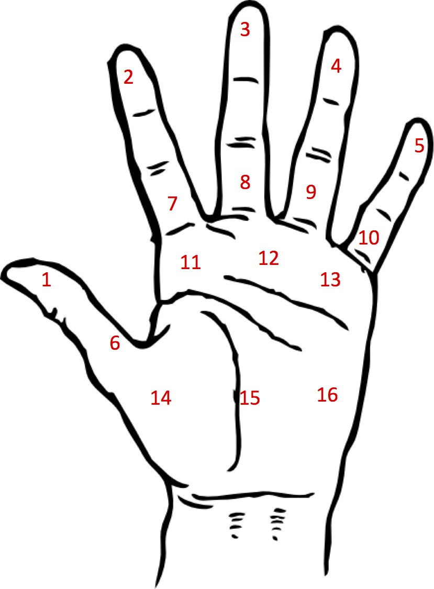

Figure 1. left hand template for marking and testing the 16 target points.

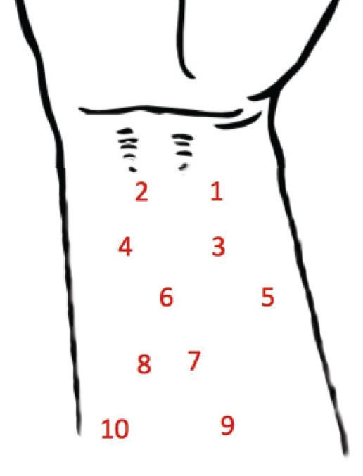

Figure 2. The right forearm template for marking and testing the 10 target points.

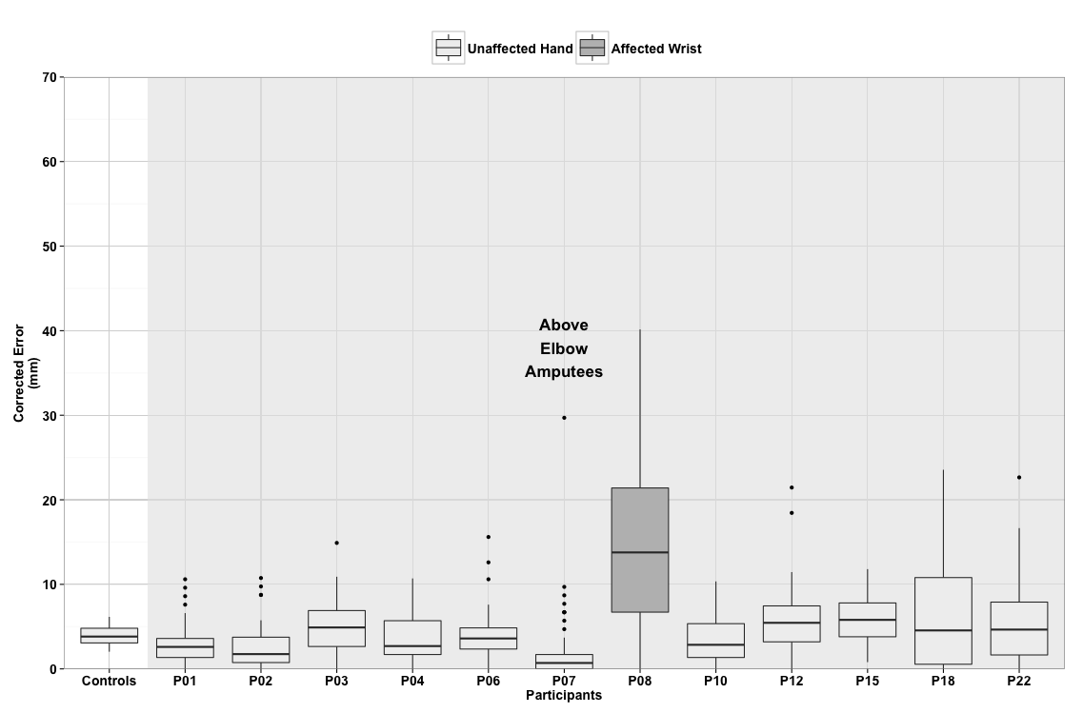
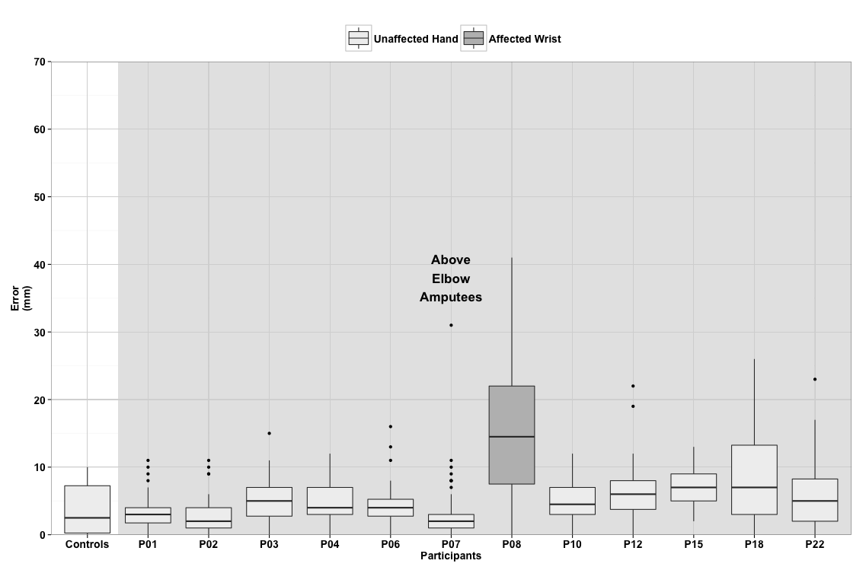
Figure 3. The box-plots depict the error in mm of each above elbow amputee by effector. The mean error of each control participant are grouped under controls. The left and right graph represent scores before and after correction for calibration scores, respectively. The upper whisker extends from the hinge (75th percentile) to the highest value that is within 1.5 * IQR of the hinge, where IQR is the inter-quartile range, or distance between the first and third quartiles. The lower whisker extends from the hinge (25th percentile) to the lowest value within 1.5 * IQR of the hinge. Data beyond the end of the whiskers are outliers and plotted as points (as specified by Tukey).

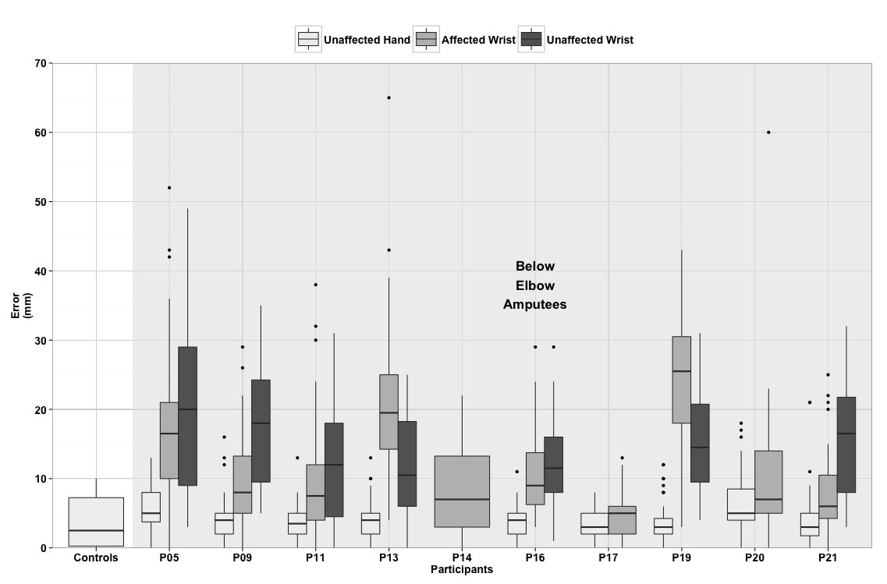
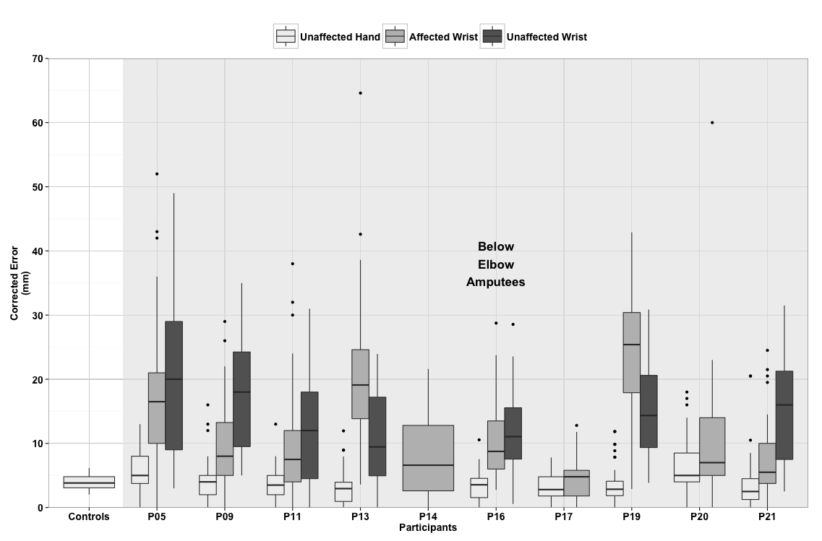
Figure 4. The box-plots depict the error in mm of each below elbow amputee by effector. The mean error of each control participant are grouped under controls. The left and right graph represent scores before and after correction for calibration scores, respectively. The upper whisker extends from the hinge (75th percentile) to the highest value that is within 1.5 * IQR of the hinge, where IQR is the inter-quartile range, or distance between the first and third quartiles. The lower whisker extends from the hinge (25th percentile) to the lowest value within 1.5 * IQR of the hinge. Data beyond the end of the whiskers are outliers and plotted as points (as specified by Tukey).

