注意：本实验代码所用编码为GB2312

- 源语言的描述
基于C语法设计的源语言LittleC
（1）结构和语义说明：
a. 该语言的一个程序由且仅由一个块结构组成，该块中包含两部分：可选的声明语句和必须的执行语句。声明语句用于声明变量，执行语句用于表达计算过程，过程中使用这些变量来存储内部数据和计算结果。
b. 该语言支持两种数据类型：整型和布尔型。整型数据占4个字节，布尔型占1个字节。整型数据的常量是整常数，布尔型数据的常量是 true 和 false 。
c. 整型数据支持 +、-、*、/ 四种算术运算，运算结果为整型值。整型数据可与>、>=...等六个关系运算符结合，运算结果为布尔型值。
d. 布尔型数据支持 || 、&& 、！三种逻辑运算，运算结果为布尔常量。
e. 整型的变量和常量可以用算术运算符组合成算术表达式，其值为整常数；布尔型的变量和常量可以用逻辑运算符组成成布尔表达式，其值为布尔常量；算术表达式可以加上关系运算符构造出布尔表达式。
f. 整常数和算术表达式可以用于整型变量赋值，布尔常量和布尔表达式可以用于布尔型变量赋值；两者不兼容（文法中使用不同的赋值运算符以示区别）。
g. 各种运算符的优先级和结合规则参照C语言语法理解。
h. 控制流语句中的控制条件限定为1个布尔型变量，该量应该在引用之前定值。
i. 该语言不支持数组、结构体、指针等复杂数据类型。
j. 该语言不含有子程序结构，也不支持过程调用。
k. 该语言有简单的I/O功能：使用read指令能够从键盘读入1个整常数，使用write指令能向屏幕打印输出1个整常数。
（2）文法定义：
PROG → { DECLS STMTS }
DECLS → DECLS DECL | empty
DECL → int NAMES ; | bool NAMES ;
NAMES → NAMES , NAME | NAME
NAME → id
STMTS → STMTS STMT | STMT
STMT → id = EXPR ; | id: = BOOL;
STMT → if id then STMT
STMT → if id then STMT else STMT
STMT → while id do STMT
STMT → { STMTS STMT }
STMT → read id ;
STMT → write id ;
EXPR → EXPR ADD TERM | TERM
ADD → + | -
TERM → TERM MULNEGA | NEGA
MUL → * |/
NEGA → FACTOR | -FACTOR
FACTOR → (EXPR ) | id | number
BOOL → BOOL || JOIN | JOIN
JOIN → JOIN && NOT | NOT
NOT → REL | !REL
REL → EXPR ROP EXPR
ROP → > | >= | < | <= | == | !=。
- 语法规则描述和分析与设计
【1】该语法可以转化为LL(1)文法，并进行自顶向下的非递归分析。
经过实践验证，给定语法通过消除直接左递归和提取最大公因子后，可以转化为LL(1)文法。处理结果如上，处理完成后，该文法的相同左部的产生式的select集之间没有交集。可以非递归地进行自顶向下LL(1)分析。
【2】该文法的终结符和非终结符
- 非终结符
经过处理之后：
该文法一共有27个非终结符。27个非终结符如下：
DECLS、DECLS'、DECL、NAMES、NAMES'、NAME、STMTS、STMTS'、STMT、STMT’、ELSESTMT、EXPR、ADD'、ADD、TERM、MUL'、MUL、NEGA、FACTOR、BOOL、BOOL'、JOIN、JOIN'、NOT、REL、ROP
这26个非终结符对应预测分析表的二十六个状态。每个状态中的多个产生式有相同的产生式左部，通过不同的终结符匹配不同的产生式右部
- 终结符
该文法一共有31个终结符，31个终结符如下：
int、bool、if、then、while、do、read、write、else、+、-、*、/、||、&&、!、>=、>、<=、<、:=、==、=、(、)、{、}、;、,、number、id
终结符是程序自上而下生成的语法分析树中，叶子结点的组成部分。也是预测分析表中列属性的组成部分。
【3】处理之后文法的select集合
经过消除左递归，提取最大公因子，分析可得
FIRST集：
FIRST(PROG) = { {,}
FIRST(DECLS) = { int, bool, ε }
FIRST(DECLS') = { int, bool, ε }
FIRST(DECL) = { int, bool }
FIRST(NAMES) = { id }
FIRST(NAMES') = { ,, ε }
FIRST(NAME) = { id }
FIRST(STMTS) = { id, if, while, {, read, write, ε }
FIRST(STMTS') = { id, if, while, {, read, write, ε }
FIRST(STMT) = { id, if, while, {, read, write }
FIRST(ELSESTMT) = { else, ε }
FIRST(EXPR) = { id, number, (, -, }
FIRST(ADD') = { +, -, ε }
FIRST(ADD) = { +, - }
FIRST(TERM) = { id, number, (, -, }
FIRST(MUL') = { *, /, ε }
FIRST(MUL) = { *, / }
FIRST(NEGA) = { id, number, (, -, }
FIRST(FACTOR) = { id, number, ( }
FIRST(BOOL) = { id, number, (, !, -, }
FIRST(BOOL') = { ||, ε }
FIRST(JOIN) = { id, number, (, !, -, }
FIRST(JOIN') = { &&, ε }
FIRST(NOT) = { id, number, (, !, -, }
FIRST(REL) = { id, number, (, -, }
FIRST(ROP) = { >, >=, <, <=, ==, != }

FOLLOW集：
FOLLOW(PROG) = {$}
FOLLOW(DECLS) = FOLLOW(DECLS') = {id, if, while, {, read, write, $}
FOLLOW(DECL) = {int, bool, id, if, while, {, read, write, $}
FOLLOW(NAMES) = FOLLOW(NAMES') = {;}
FOLLOW(NAME) = {,, ;}
FOLLOW(STMTS) = FOLLOW(STMTS') = {id, if, while, {, read, write, }, $}
FOLLOW(STMT) = {id, if, while, {, read, write, }, $}
FOLLOW(ELSESTMT) = {id, if, while, {, read, write, }, $}
FOLLOW(EXPR) = {), ;, >, >=, <, <=, ==, !=}
FOLLOW(ADD') = FOLLOW(ADD) = {), ;, >, >=, <, <=, ==, !=}
FOLLOW(TERM) = {+, -, ), ;, >, >=, <, <=, ==, !=}
FOLLOW(MUL') = FOLLOW(MUL) = {+, -, ), ;, >, >=, <, <=, ==, !=}
FOLLOW(NEGA) = {*, /, +, -, ), ;, >, >=, <, <=, ==, !=}
FOLLOW(FACTOR) = {*, /, +, -, ), ;, >, >=, <, <=, ==, !=}
FOLLOW(BOOL) = FOLLOW(BOOL') = {;, }
FOLLOW(JOIN) = FOLLOW(JOIN') = {||, ;, }
FOLLOW(NOT) = {&&, ||, ;, }
FOLLOW(REL) = {&&, ||, ;, }
FOLLOW(ROP) = {id, number, (, -, }

SELECT集:
1
SELECT(PROG → { DECLS STMTS }) = { { }
2
SELECT(DECLS → DECL DECLS') = { int, bool }
SELECT(DECLS → empty) = { id, if, while, {, read, write, $ }
3
SELECT(DECLS' → DECL DECLS') = { int, bool }
SELECT(DECLS' → empty) = { id, if, while, {, read, write, $ }
4
SELECT(DECL → int NAMES ;) = { int }
SELECT(DECL → bool NAMES ;) = { bool }
5
SELECT(NAMES → NAME NAMES') = { id }
6
SELECT(NAMES' → , NAME NAMES') = { , }
SELECT(NAMES' → empty) = { ; }
7
SELECT(NAME → id) = { id }
8
SELECT(STMTS → STMT STMTS') = { id, if, while, {, read, write }
SELECT(STMTS → empty) = { }, $ }
9
SELECT(STMTS' → STMT STMTS') = { id, if, while, {, read, write }
SELECT(STMTS' → empty) = { }, $ }
10
SELECT(STMT → id STMT')={id}
SELECT(STMT → if id then STMT ELSESTMT) = { if }
SELECT(STMT → while id do STMT) = { while }
SELECT(STMT → { STMTS }) = { { }
SELECT(STMT → read id ;) = { read }
SELECT(STMT → write id ;) = { write }
11
SELECT(STMT’ → = EXPR;)={=}
SELECT(STMT’ → := BOOL;)={:=}
12
SELECT(ELSESTMT → else STMT) = { else }
SELECT(ELSESTMT → empty) = { id, if, while, {, read, write, }, $ }
13
SELECT(EXPR → TERM ADD') = { id, number, (, - }
14
SELECT(ADD' → ADD TERM ADD') = { +, - }
SELECT(ADD' → empty) = { ), ;, >, >=, <, <=, ==, != }
15
SELECT(ADD → +) = { + }
SELECT(ADD → -) = { - }
16
SELECT(TERM → NEGA MUL') = { id, number, (, - }
17
SELECT(MUL' → MUL NEGA MUL') = { *, / }
SELECT(MUL' → empty) = { +, -, ), ;, >, >=, <, <=, ==, != }
18
SELECT(MUL → *) = { * }
SELECT(MUL → /) = { / }
19
SELECT(NEGA → FACTOR) = { id, number, ( }
SELECT(NEGA → - FACTOR) = { - }
20
SELECT(FACTOR → ( EXPR )) = { ( }
SELECT(FACTOR → id) = { id }
SELECT(FACTOR → number) = { number }
21
SELECT(BOOL → JOIN BOOL') = { id, number, (, !, - }
22
SELECT(BOOL' → || JOIN BOOL') = { || }
SELECT(BOOL' → empty) = { ;, } }
23
SELECT(JOIN → NOT JOIN') = { id, number, (, !, - }
24
SELECT(JOIN' → && NOT JOIN') = { && }
SELECT(JOIN' → empty) = { ;, ||, } }
25
SELECT(NOT → REL) = { id, number, (, - }
SELECT(NOT → ! REL) = { ! }
26
SELECT(REL → EXPR ROP EXPR) = { id, number, (, - }
27
SELECT(ROP → >) = { > }
SELECT(ROP → >=) = { >= }
SELECT(ROP → <) = { < }
SELECT(ROP → <=) = { <= }
SELECT(ROP → ==) = { == }
SELECT(ROP → !=) = { != }
通过SELECT集合可以实现非递归下降分析的预测分析表
结合预测分析表、运行栈，可以实现非递归的自顶向下的LL(1)分析

- 程序的主要流程
【1】分析给定语法，得到语法的SELECT集合
【2】将SELECT集合转化为预测分析表存储在语法分析的类中
【3】通过已经实现的词法分析器，先对源语言进行词法分析
【4】通过文件处理函数，将词法分析的结果转化为vector<pair<string,string>>,以便于后续处理
【5】由于语法分析匹配的终结符，与词法分析器的分析结果存在差异，用一个转换函数，将词法分析器的结果二元组，转化为符合语法分析的程度。去掉如KW,BL这样的无效信息。保留bool,id这样的关键信息。id的真实字符串存储在id后，方便语义分析处理。在vector的结尾加上终结符<”$”,”$”>，作为语法分析的终止符
【6】创建一个程序处理栈，先将终结符入栈，然后将起始符号入栈，然后根据LL(1)分析流程对语句进行语法分析
【7】错误处理。
词法分析的错误主要是字符编码不对。对于这种错误在词法分析的时候就直接输出源文件第几行的什么位置出错。
语法分析的错误主要是终结符不匹配。如果不是终结符不匹配，输出源代码文件中第几行第几列的，什么位置报错。
如果是结尾多余字符，输出结尾多余字符
- 关键算法
【1】树的创立
【2】树结点的插入
【3】树的序列化算法
这里我才用了将所有空字符串也存储的方法。这种方法同样可以完成反序列化任务。（代码中有验证代码，即对序列化结果反序列化再序列化，比较两次结果）。在树比较大的时候，本方法比两次序更省空间，而且实现也更简单
【4】树的反序列化算法
【5】字符串的匹配算法
【6】LL(1)文法的自顶向下的非递归分析方法
【7】字符串的按字符分割算法
【8】文件中第n个字符串的行数
【9】文件中第n个字符的行数
【10】FIRST集合、FOLLOW集合、SELECT集合的求解算法
- 总体结构
【1】lexical_analyzer.h
提供词法分析器相关的所有功能函数和词法分析结果转化为vector<pair<string,string>>的算法。
【2】class tree
class tree {
public:
tree();
~tree();
TreeNode* getroot() {
return root;
}
bool add_node(TreeNode* current, pair<string, string> data, TreeNode*& NowInsert);//在current下面插入一个子节点。从左向右的顺序，如果满了，返回false.
string serialize(TreeNode* root); // 树转化为字符串。非空输入pair中两个值，空的话输出#
TreeNode* NewNode(pair<string, string>); //创建一个新的树节点
TreeNode* deserialize(string data); // 字符串转化为树
private:
TreeNode* root;
TreeNode* deserializeHelper(const vector<pair<string, string>>& vals, int& pos);//字符串转化为树的辅助函数
}
【3】语法分析器类
class Parser {
public:
Parser(const string& InputFile, const string& middleFile, const string& OutputFile);
~Parser();
void print(); //输出预测分析表
TreeNode* deserialize(const string& input); //序列化结果文件的反序列化，反序列化是否成功
void serialize(const string& output, TreeNode* root); //序列化结果文件的反序列化结果文件的序列化，通过与序列化结果文件对比来验证序列化和反序列化函数
bool do_parser(const vector<pair<string, string>>& input, TreeNode*& result); //语法分析函数
bool do_and_write(); //词法分析、语法分析及所有结果输出函数
private:
bool isComment(const std::string& line, size_t& pos); //当前行是否存在注释
bool is_end_character(const string& a); //当前字符串是否是终结符
string in; //输入文件名
string out; //语法分析结果输出文件名
string middle; //词法分析结果输出文件名
int findNthStringLine(const std::string& filename, int n, string& result); //找到当前文件中第i个字符串的函数。方便语法分析错误处理
vector<vector<pair<vector<string>, vector<string>>>>LL1_t; //预测分析表。最外层数组表示不同的非终结符对应的每个状态。第二层数组表示每个状态的多个语句。第三层数组，表示每个状态的产生式右部非终结符集合和相应select集中终结符结合
void init_LL1_able();
bool do_parser_input_change(vector<pair<string, string>>& result, const vector<pair<string, string>>& input); //处理词法分析结果，使其更适合进行语法分析
int find_status(string a); //在预测分析表中找到相应的非终结符
string true_string(const string& a); //当前字符串如果分隔符算一个字符串，则当前字符串的所有分隔符用空格隔开
int judge_status(string a, int status); //在预测分析表中，找到相应的产生式
};
【4】文件判断函数，判断两个文件中的内容是否完全一致
bool file_same(const string& file1, const string& file2) {
ifstream input1(file1);
ifstream input2(file2);
string current1;
string current2;
bool result = true;
while ((input1 >> current1) && (input2 >> current2))
if (current1 != current2)
result = false;
return result;
}
【5】主函数
int main() {
string a = "test.txt"; //源代码
string b = "result.txt"; //词法分析结果
string e = "result_parser.txt"; //语法分析结果
string test = "test_parser_result.txt"; //根据语法分析结果重新构造树之后再进行序列化的结果
Parser d(a, b, e);
if (d.do_and_write()) {
TreeNode* root = d.deserialize(e); //反序列化构造树
d.serialize(test, root); //序列化反序列化结果
if (file_same(e, test))
cout << "反序列化成功" << endl; //判断两个序列化结果是否一致
else
cout << "反序列化失败" << endl;
}
return 0;
}
- 测试用例与程序运行截图
【1】给定测试用例1
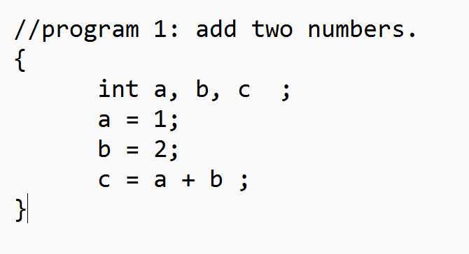
测试结果：
命令行结果：分析正常，反序列化正常
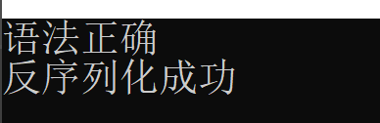
Result.txt 正常
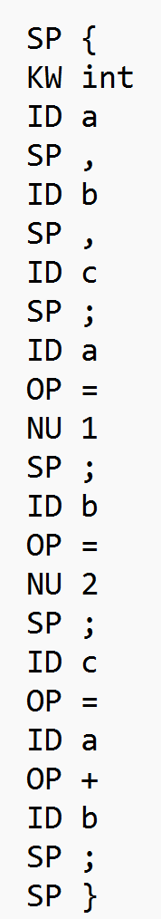
Result_parser.txt、Test_result_parser正常
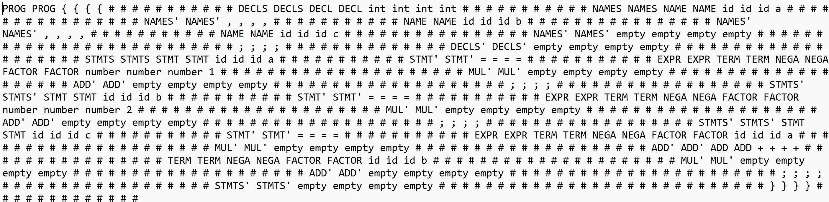
【2】给定测试用例2
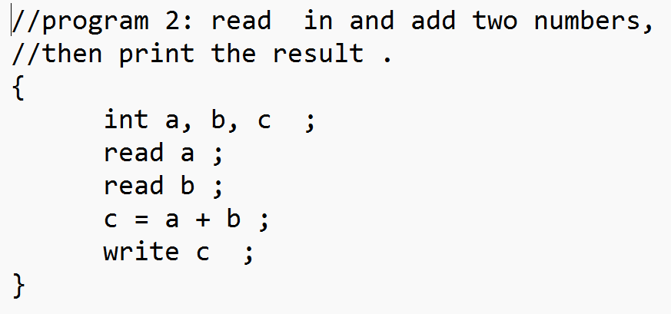
测试结果：
命令行结果：分析正常，反序列化正常
Result.txt 正常
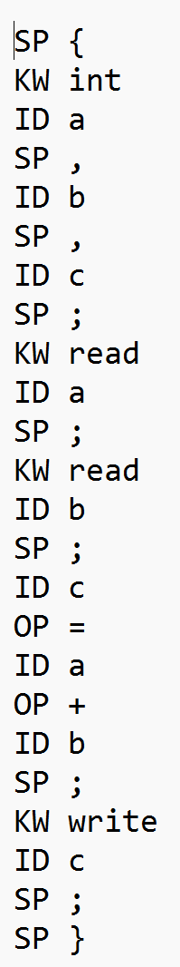
Result_parser.txt、Test_result_parser正常
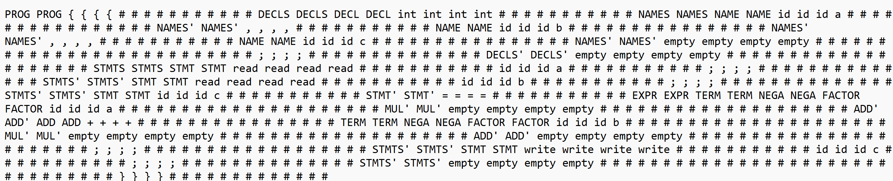
【3】给定测试用例3
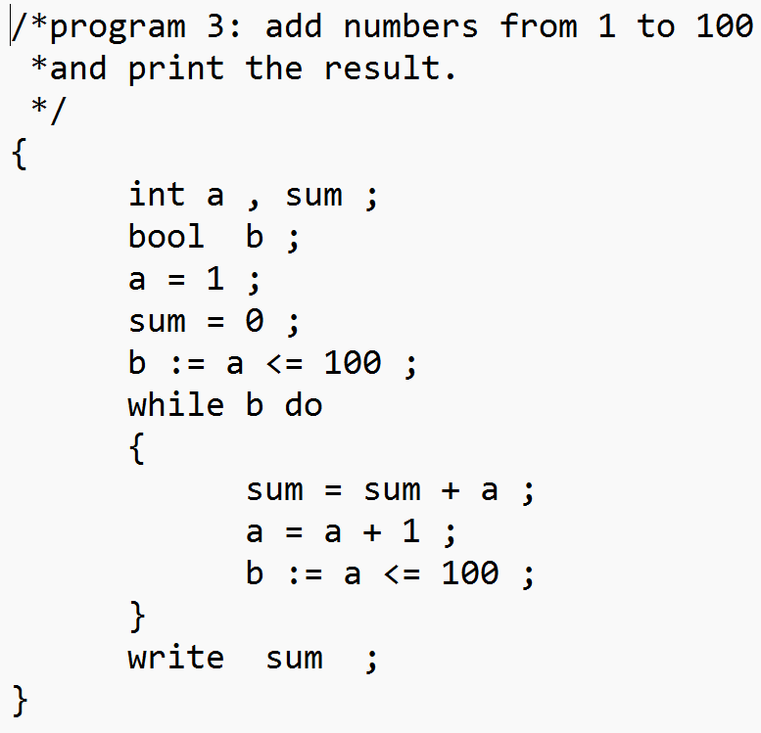
测试结果：
命令行结果：分析正常，反序列化正常
Result.txt 正常
SP {
KW int
ID a
SP ,
ID sum
SP ;
KW bool
ID b
SP ;
ID a
OP =
NU 1
SP ;
ID sum
OP =
NU 0
SP ;
ID b
OP :=
ID a
OP <=
NU 100
SP ;
KW while
ID b
KW do
SP {
ID sum
OP =
ID sum
OP +
ID a
SP ;
ID a
OP =
ID a
OP +
NU 1
SP ;
ID b
OP :=
ID a
OP <=
NU 100
SP ;
SP }
KW write
ID sum
SP ;
SP }
Result_parser.txt、Test_result_parser正常
PROG PROG { { { { # # # # # # # # # # # DECLS DECLS DECL DECL int int int int # # # # # # # # # # # NAMES NAMES NAME NAME id id id a # # # # # # # # # # # # # # # # NAMES' NAMES' , , , , # # # # # # # # # # # NAME NAME id id id sum # # # # # # # # # # # # # # # # NAMES' NAMES' empty empty empty empty # # # # # # # # # # # # # # # # # # # # # # # ; ; ; ; # # # # # # # # # # # # # # DECLS' DECLS' DECL DECL bool bool bool bool # # # # # # # # # # # NAMES NAMES NAME NAME id id id b # # # # # # # # # # # # # # # # NAMES' NAMES' empty empty empty empty # # # # # # # # # # # # # # # # # # # # ; ; ; ; # # # # # # # # # # # # # # DECLS' DECLS' empty empty empty empty # # # # # # # # # # # # # # # # # # # # # # # # STMTS STMTS STMT STMT id id id a # # # # # # # # # # # STMT' STMT' = = = = # # # # # # # # # # # EXPR EXPR TERM TERM NEGA NEGA FACTOR FACTOR number number number 1 # # # # # # # # # # # # # # # # # # # # # MUL' MUL' empty empty empty empty # # # # # # # # # # # # # # # # # # # # ADD' ADD' empty empty empty empty # # # # # # # # # # # # # # # # # # # # ; ; ; ; # # # # # # # # # # # # # # # # # # STMTS' STMTS' STMT STMT id id id sum # # # # # # # # # # # STMT' STMT' = = = = # # # # # # # # # # # EXPR EXPR TERM TERM NEGA NEGA FACTOR FACTOR number number number 0 # # # # # # # # # # # # # # # # # # # # # MUL' MUL' empty empty empty empty # # # # # # # # # # # # # # # # # # # # ADD' ADD' empty empty empty empty # # # # # # # # # # # # # # # # # # # # ; ; ; ; # # # # # # # # # # # # # # # # # # STMTS' STMTS' STMT STMT id id id b # # # # # # # # # # # STMT' STMT' := := := := # # # # # # # # # # # BOOL BOOL JOIN JOIN NOT NOT REL REL EXPR EXPR TERM TERM NEGA NEGA FACTOR FACTOR id id id a # # # # # # # # # # # # # # # # # # # # # MUL' MUL' empty empty empty empty # # # # # # # # # # # # # # # # # # # # ADD' ADD' empty empty empty empty # # # # # # # # # # # # # # # # # # # # ROP ROP <= <= <= <= # # # # # # # # # # # # # # # # EXPR EXPR TERM TERM NEGA NEGA FACTOR FACTOR number number number 100 # # # # # # # # # # # # # # # # # # # # # MUL' MUL' empty empty empty empty # # # # # # # # # # # # # # # # # # # # ADD' ADD' empty empty empty empty # # # # # # # # # # # # # # # # # # # # # # # # # # # # JOIN' JOIN' empty empty empty empty # # # # # # # # # # # # # # # # # # # # BOOL' BOOL' empty empty empty empty # # # # # # # # # # # # # # # # # # # # ; ; ; ; # # # # # # # # # # # # # # # # # # STMTS' STMTS' STMT STMT while while while while # # # # # # # # # # # id id id b # # # # # # # # # # # do do do do # # # # # # # # # # # STMT STMT { { { { # # # # # # # # # # # STMTS STMTS STMT STMT id id id sum # # # # # # # # # # # STMT' STMT' = = = = # # # # # # # # # # # EXPR EXPR TERM TERM NEGA NEGA FACTOR FACTOR id id id sum # # # # # # # # # # # # # # # # # # # # # MUL' MUL' empty empty empty empty # # # # # # # # # # # # # # # # # # # # ADD' ADD' ADD ADD + + + + # # # # # # # # # # # # # # # # TERM TERM NEGA NEGA FACTOR FACTOR id id id a # # # # # # # # # # # # # # # # # # # # # MUL' MUL' empty empty empty empty # # # # # # # # # # # # # # # # # # # # ADD' ADD' empty empty empty empty # # # # # # # # # # # # # # # # # # # # # # # ; ; ; ; # # # # # # # # # # # # # # # # # # STMTS' STMTS' STMT STMT id id id a # # # # # # # # # # # STMT' STMT' = = = = # # # # # # # # # # # EXPR EXPR TERM TERM NEGA NEGA FACTOR FACTOR id id id a # # # # # # # # # # # # # # # # # # # # # MUL' MUL' empty empty empty empty # # # # # # # # # # # # # # # # # # # # ADD' ADD' ADD ADD + + + + # # # # # # # # # # # # # # # # TERM TERM NEGA NEGA FACTOR FACTOR number number number 1 # # # # # # # # # # # # # # # # # # # # # MUL' MUL' empty empty empty empty # # # # # # # # # # # # # # # # # # # # ADD' ADD' empty empty empty empty # # # # # # # # # # # # # # # # # # # # # # # ; ; ; ; # # # # # # # # # # # # # # # # # # STMTS' STMTS' STMT STMT id id id b # # # # # # # # # # # STMT' STMT' := := := := # # # # # # # # # # # BOOL BOOL JOIN JOIN NOT NOT REL REL EXPR EXPR TERM TERM NEGA NEGA FACTOR FACTOR id id id a # # # # # # # # # # # # # # # # # # # # # MUL' MUL' empty empty empty empty # # # # # # # # # # # # # # # # # # # # ADD' ADD' empty empty empty empty # # # # # # # # # # # # # # # # # # # # ROP ROP <= <= <= <= # # # # # # # # # # # # # # # # EXPR EXPR TERM TERM NEGA NEGA FACTOR FACTOR number number number 100 # # # # # # # # # # # # # # # # # # # # # MUL' MUL' empty empty empty empty # # # # # # # # # # # # # # # # # # # # ADD' ADD' empty empty empty empty # # # # # # # # # # # # # # # # # # # # # # # # # # # # JOIN' JOIN' empty empty empty empty # # # # # # # # # # # # # # # # # # # # BOOL' BOOL' empty empty empty empty # # # # # # # # # # # # # # # # # # # # ; ; ; ; # # # # # # # # # # # # # # # # # # STMTS' STMTS' empty empty empty empty # # # # # # # # # # # # # # # # # # # # # # # # # # # # } } } } # # # # # # # # # # # # # # # # STMTS' STMTS' STMT STMT write write write write # # # # # # # # # # # id id id sum # # # # # # # # # # # ; ; ; ; # # # # # # # # # # # # # # STMTS' STMTS' empty empty empty empty # # # # # # # # # # # # # # # # # # # # # # # # # # # # # # # # # # # # } } } } # # # # # # # # # # # # #
【4】给定测试用例4
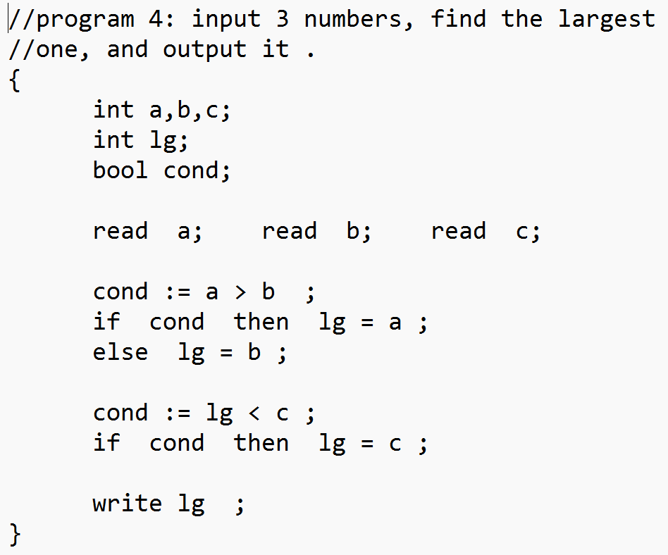
测试结果：
命令行结果：分析正常，反序列化正常
Result.txt 正常
SP {
KW int
ID a
SP ,
ID sum
SP ;
KW bool
ID b
SP ;
ID a
OP =
NU 1
SP ;
ID sum
OP =
NU 0
SP ;
ID b
OP :=
ID a
OP <=
NU 100
SP ;
KW while
ID b
KW do
SP {
ID sum
OP =
ID sum
OP +
ID a
SP ;
ID a
OP =
ID a
OP +
NU 1
SP ;
ID b
OP :=
ID a
OP <=
NU 100
SP ;
SP }
KW write
ID sum
SP ;
SP }

Result_parser.txt、Test_result_parser正常
PROG PROG { { { { # # # # # # # # # # # DECLS DECLS DECL DECL int int int int # # # # # # # # # # # NAMES NAMES NAME NAME id id id a # # # # # # # # # # # # # # # # NAMES' NAMES' , , , , # # # # # # # # # # # NAME NAME id id id sum # # # # # # # # # # # # # # # # NAMES' NAMES' empty empty empty empty # # # # # # # # # # # # # # # # # # # # # # # ; ; ; ; # # # # # # # # # # # # # # DECLS' DECLS' DECL DECL bool bool bool bool # # # # # # # # # # # NAMES NAMES NAME NAME id id id b # # # # # # # # # # # # # # # # NAMES' NAMES' empty empty empty empty # # # # # # # # # # # # # # # # # # # # ; ; ; ; # # # # # # # # # # # # # # DECLS' DECLS' empty empty empty empty # # # # # # # # # # # # # # # # # # # # # # # # STMTS STMTS STMT STMT id id id a # # # # # # # # # # # STMT' STMT' = = = = # # # # # # # # # # # EXPR EXPR TERM TERM NEGA NEGA FACTOR FACTOR number number number 1 # # # # # # # # # # # # # # # # # # # # # MUL' MUL' empty empty empty empty # # # # # # # # # # # # # # # # # # # # ADD' ADD' empty empty empty empty # # # # # # # # # # # # # # # # # # # # ; ; ; ; # # # # # # # # # # # # # # # # # # STMTS' STMTS' STMT STMT id id id sum # # # # # # # # # # # STMT' STMT' = = = = # # # # # # # # # # # EXPR EXPR TERM TERM NEGA NEGA FACTOR FACTOR number number number 0 # # # # # # # # # # # # # # # # # # # # # MUL' MUL' empty empty empty empty # # # # # # # # # # # # # # # # # # # # ADD' ADD' empty empty empty empty # # # # # # # # # # # # # # # # # # # # ; ; ; ; # # # # # # # # # # # # # # # # # # STMTS' STMTS' STMT STMT id id id b # # # # # # # # # # # STMT' STMT' := := := := # # # # # # # # # # # BOOL BOOL JOIN JOIN NOT NOT REL REL EXPR EXPR TERM TERM NEGA NEGA FACTOR FACTOR id id id a # # # # # # # # # # # # # # # # # # # # # MUL' MUL' empty empty empty empty # # # # # # # # # # # # # # # # # # # # ADD' ADD' empty empty empty empty # # # # # # # # # # # # # # # # # # # # ROP ROP <= <= <= <= # # # # # # # # # # # # # # # # EXPR EXPR TERM TERM NEGA NEGA FACTOR FACTOR number number number 100 # # # # # # # # # # # # # # # # # # # # # MUL' MUL' empty empty empty empty # # # # # # # # # # # # # # # # # # # # ADD' ADD' empty empty empty empty # # # # # # # # # # # # # # # # # # # # # # # # # # # # JOIN' JOIN' empty empty empty empty # # # # # # # # # # # # # # # # # # # # BOOL' BOOL' empty empty empty empty # # # # # # # # # # # # # # # # # # # # ; ; ; ; # # # # # # # # # # # # # # # # # # STMTS' STMTS' STMT STMT while while while while # # # # # # # # # # # id id id b # # # # # # # # # # # do do do do # # # # # # # # # # # STMT STMT { { { { # # # # # # # # # # # STMTS STMTS STMT STMT id id id sum # # # # # # # # # # # STMT' STMT' = = = = # # # # # # # # # # # EXPR EXPR TERM TERM NEGA NEGA FACTOR FACTOR id id id sum # # # # # # # # # # # # # # # # # # # # # MUL' MUL' empty empty empty empty # # # # # # # # # # # # # # # # # # # # ADD' ADD' ADD ADD + + + + # # # # # # # # # # # # # # # # TERM TERM NEGA NEGA FACTOR FACTOR id id id a # # # # # # # # # # # # # # # # # # # # # MUL' MUL' empty empty empty empty # # # # # # # # # # # # # # # # # # # # ADD' ADD' empty empty empty empty # # # # # # # # # # # # # # # # # # # # # # # ; ; ; ; # # # # # # # # # # # # # # # # # # STMTS' STMTS' STMT STMT id id id a # # # # # # # # # # # STMT' STMT' = = = = # # # # # # # # # # # EXPR EXPR TERM TERM NEGA NEGA FACTOR FACTOR id id id a # # # # # # # # # # # # # # # # # # # # # MUL' MUL' empty empty empty empty # # # # # # # # # # # # # # # # # # # # ADD' ADD' ADD ADD + + + + # # # # # # # # # # # # # # # # TERM TERM NEGA NEGA FACTOR FACTOR number number number 1 # # # # # # # # # # # # # # # # # # # # # MUL' MUL' empty empty empty empty # # # # # # # # # # # # # # # # # # # # ADD' ADD' empty empty empty empty # # # # # # # # # # # # # # # # # # # # # # # ; ; ; ; # # # # # # # # # # # # # # # # # # STMTS' STMTS' STMT STMT id id id b # # # # # # # # # # # STMT' STMT' := := := := # # # # # # # # # # # BOOL BOOL JOIN JOIN NOT NOT REL REL EXPR EXPR TERM TERM NEGA NEGA FACTOR FACTOR id id id a # # # # # # # # # # # # # # # # # # # # # MUL' MUL' empty empty empty empty # # # # # # # # # # # # # # # # # # # # ADD' ADD' empty empty empty empty # # # # # # # # # # # # # # # # # # # # ROP ROP <= <= <= <= # # # # # # # # # # # # # # # # EXPR EXPR TERM TERM NEGA NEGA FACTOR FACTOR number number number 100 # # # # # # # # # # # # # # # # # # # # # MUL' MUL' empty empty empty empty # # # # # # # # # # # # # # # # # # # # ADD' ADD' empty empty empty empty # # # # # # # # # # # # # # # # # # # # # # # # # # # # JOIN' JOIN' empty empty empty empty # # # # # # # # # # # # # # # # # # # # BOOL' BOOL' empty empty empty empty # # # # # # # # # # # # # # # # # # # # ; ; ; ; # # # # # # # # # # # # # # # # # # STMTS' STMTS' empty empty empty empty # # # # # # # # # # # # # # # # # # # # # # # # # # # # } } } } # # # # # # # # # # # # # # # # STMTS' STMTS' STMT STMT write write write write # # # # # # # # # # # id id id sum # # # # # # # # # # # ; ; ; ; # # # # # # # # # # # # # # STMTS' STMTS' empty empty empty empty # # # # # # # # # # # # # # # # # # # # # # # # # # # # # # # # # # # # } } } } # # # # # # # # # # # # #
【5】给定测试用例5
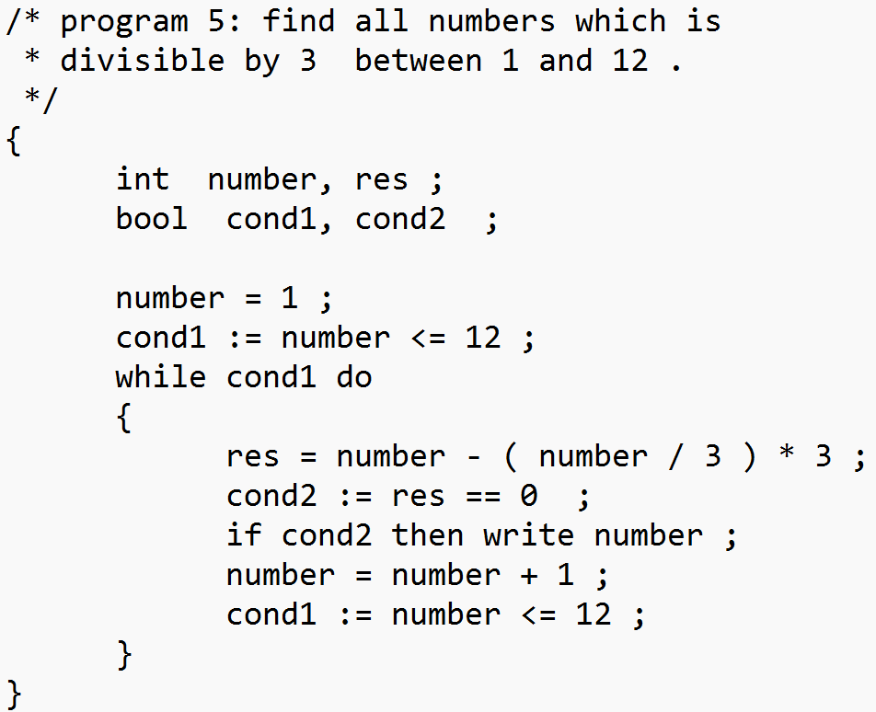
测试结果：
命令行结果：分析正常，反序列化正常
Result.txt 正常
SP {
KW int
ID a
SP ,
ID sum
SP ;
KW bool
ID b
SP ;
ID a
OP =
NU 1
SP ;
ID sum
OP =
NU 0
SP ;
ID b
OP :=
ID a
OP <=
NU 100
SP ;
KW while
ID b
KW do
SP {
ID sum
OP =
ID sum
OP +
ID a
SP ;
ID a
OP =
ID a
OP +
NU 1
SP ;
ID b
OP :=
ID a
OP <=
NU 100
SP ;
SP }
KW write
ID sum
SP ;
SP }
Result_parser.txt、Test_result_parser正常
PROG PROG { { { { # # # # # # # # # # # DECLS DECLS DECL DECL int int int int # # # # # # # # # # # NAMES NAMES NAME NAME id id id a # # # # # # # # # # # # # # # # NAMES' NAMES' , , , , # # # # # # # # # # # NAME NAME id id id sum # # # # # # # # # # # # # # # # NAMES' NAMES' empty empty empty empty # # # # # # # # # # # # # # # # # # # # # # # ; ; ; ; # # # # # # # # # # # # # # DECLS' DECLS' DECL DECL bool bool bool bool # # # # # # # # # # # NAMES NAMES NAME NAME id id id b # # # # # # # # # # # # # # # # NAMES' NAMES' empty empty empty empty # # # # # # # # # # # # # # # # # # # # ; ; ; ; # # # # # # # # # # # # # # DECLS' DECLS' empty empty empty empty # # # # # # # # # # # # # # # # # # # # # # # # STMTS STMTS STMT STMT id id id a # # # # # # # # # # # STMT' STMT' = = = = # # # # # # # # # # # EXPR EXPR TERM TERM NEGA NEGA FACTOR FACTOR number number number 1 # # # # # # # # # # # # # # # # # # # # # MUL' MUL' empty empty empty empty # # # # # # # # # # # # # # # # # # # # ADD' ADD' empty empty empty empty # # # # # # # # # # # # # # # # # # # # ; ; ; ; # # # # # # # # # # # # # # # # # # STMTS' STMTS' STMT STMT id id id sum # # # # # # # # # # # STMT' STMT' = = = = # # # # # # # # # # # EXPR EXPR TERM TERM NEGA NEGA FACTOR FACTOR number number number 0 # # # # # # # # # # # # # # # # # # # # # MUL' MUL' empty empty empty empty # # # # # # # # # # # # # # # # # # # # ADD' ADD' empty empty empty empty # # # # # # # # # # # # # # # # # # # # ; ; ; ; # # # # # # # # # # # # # # # # # # STMTS' STMTS' STMT STMT id id id b # # # # # # # # # # # STMT' STMT' := := := := # # # # # # # # # # # BOOL BOOL JOIN JOIN NOT NOT REL REL EXPR EXPR TERM TERM NEGA NEGA FACTOR FACTOR id id id a # # # # # # # # # # # # # # # # # # # # # MUL' MUL' empty empty empty empty # # # # # # # # # # # # # # # # # # # # ADD' ADD' empty empty empty empty # # # # # # # # # # # # # # # # # # # # ROP ROP <= <= <= <= # # # # # # # # # # # # # # # # EXPR EXPR TERM TERM NEGA NEGA FACTOR FACTOR number number number 100 # # # # # # # # # # # # # # # # # # # # # MUL' MUL' empty empty empty empty # # # # # # # # # # # # # # # # # # # # ADD' ADD' empty empty empty empty # # # # # # # # # # # # # # # # # # # # # # # # # # # # JOIN' JOIN' empty empty empty empty # # # # # # # # # # # # # # # # # # # # BOOL' BOOL' empty empty empty empty # # # # # # # # # # # # # # # # # # # # ; ; ; ; # # # # # # # # # # # # # # # # # # STMTS' STMTS' STMT STMT while while while while # # # # # # # # # # # id id id b # # # # # # # # # # # do do do do # # # # # # # # # # # STMT STMT { { { { # # # # # # # # # # # STMTS STMTS STMT STMT id id id sum # # # # # # # # # # # STMT' STMT' = = = = # # # # # # # # # # # EXPR EXPR TERM TERM NEGA NEGA FACTOR FACTOR id id id sum # # # # # # # # # # # # # # # # # # # # # MUL' MUL' empty empty empty empty # # # # # # # # # # # # # # # # # # # # ADD' ADD' ADD ADD + + + + # # # # # # # # # # # # # # # # TERM TERM NEGA NEGA FACTOR FACTOR id id id a # # # # # # # # # # # # # # # # # # # # # MUL' MUL' empty empty empty empty # # # # # # # # # # # # # # # # # # # # ADD' ADD' empty empty empty empty # # # # # # # # # # # # # # # # # # # # # # # ; ; ; ; # # # # # # # # # # # # # # # # # # STMTS' STMTS' STMT STMT id id id a # # # # # # # # # # # STMT' STMT' = = = = # # # # # # # # # # # EXPR EXPR TERM TERM NEGA NEGA FACTOR FACTOR id id id a # # # # # # # # # # # # # # # # # # # # # MUL' MUL' empty empty empty empty # # # # # # # # # # # # # # # # # # # # ADD' ADD' ADD ADD + + + + # # # # # # # # # # # # # # # # TERM TERM NEGA NEGA FACTOR FACTOR number number number 1 # # # # # # # # # # # # # # # # # # # # # MUL' MUL' empty empty empty empty # # # # # # # # # # # # # # # # # # # # ADD' ADD' empty empty empty empty # # # # # # # # # # # # # # # # # # # # # # # ; ; ; ; # # # # # # # # # # # # # # # # # # STMTS' STMTS' STMT STMT id id id b # # # # # # # # # # # STMT' STMT' := := := := # # # # # # # # # # # BOOL BOOL JOIN JOIN NOT NOT REL REL EXPR EXPR TERM TERM NEGA NEGA FACTOR FACTOR id id id a # # # # # # # # # # # # # # # # # # # # # MUL' MUL' empty empty empty empty # # # # # # # # # # # # # # # # # # # # ADD' ADD' empty empty empty empty # # # # # # # # # # # # # # # # # # # # ROP ROP <= <= <= <= # # # # # # # # # # # # # # # # EXPR EXPR TERM TERM NEGA NEGA FACTOR FACTOR number number number 100 # # # # # # # # # # # # # # # # # # # # # MUL' MUL' empty empty empty empty # # # # # # # # # # # # # # # # # # # # ADD' ADD' empty empty empty empty # # # # # # # # # # # # # # # # # # # # # # # # # # # # JOIN' JOIN' empty empty empty empty # # # # # # # # # # # # # # # # # # # # BOOL' BOOL' empty empty empty empty # # # # # # # # # # # # # # # # # # # # ; ; ; ; # # # # # # # # # # # # # # # # # # STMTS' STMTS' empty empty empty empty # # # # # # # # # # # # # # # # # # # # # # # # # # # # } } } } # # # # # # # # # # # # # # # # STMTS' STMTS' STMT STMT write write write write # # # # # # # # # # # id id id sum # # # # # # # # # # # ; ; ; ; # # # # # # # # # # # # # # STMTS' STMTS' empty empty empty empty # # # # # # # # # # # # # # # # # # # # # # # # # # # # # # # # # # # # } } } } # # # # # # # # # # # # #
【6】给定测试用例6
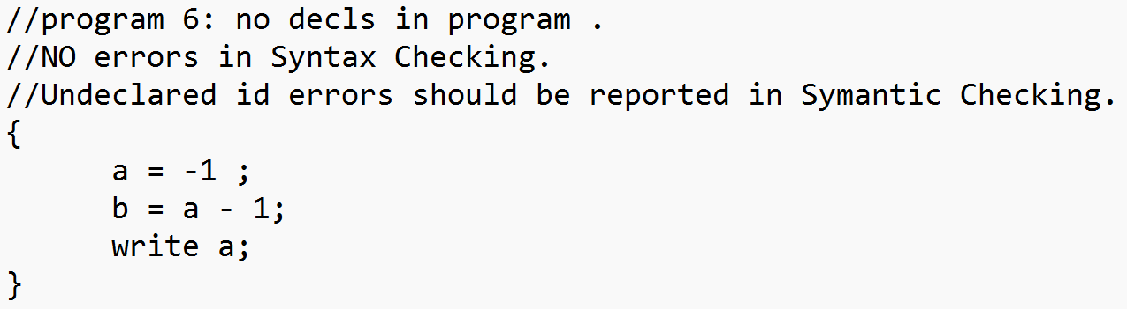
测试结果：
命令行结果：分析正常，反序列化正常
Result.txt 正常
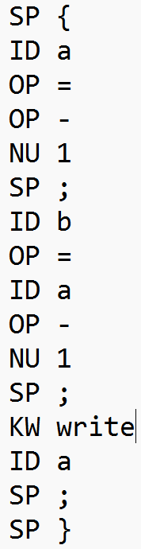
Result_parser.txt、Test_result_parser正常
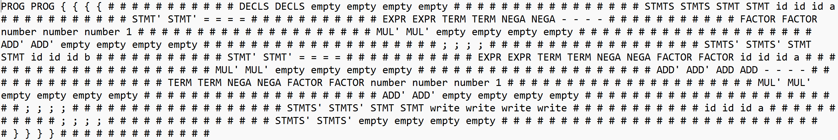
【7】给定测试用例7
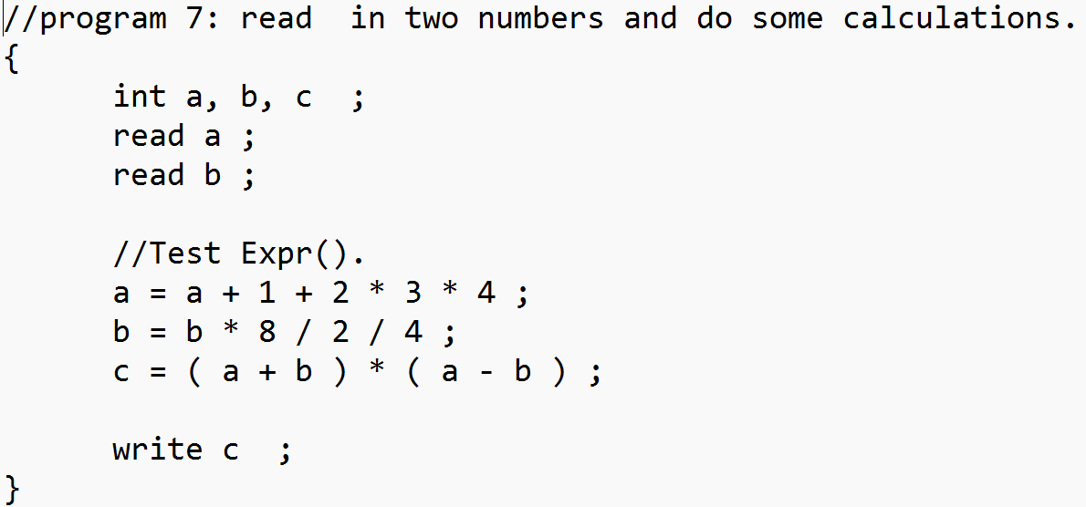
测试结果：
命令行结果：分析正常，反序列化正常
Result.txt 正常
SP {
KW int
ID a
SP ,
ID b
SP ,
ID c
SP ;
KW read
ID a
SP ;
KW read
ID b
SP ;
ID a
OP =
ID a
OP +
NU 1
OP +
NU 2
OP *
NU 3
OP *
NU 4
SP ;
ID b
OP =
ID b
OP *
NU 8
OP /
NU 2
OP /
NU 4
SP ;
ID c
OP =
SP (
ID a
OP +
ID b
SP )
OP *
SP (
ID a
OP -
ID b
SP )
SP ;
KW write
ID c
SP ;
SP }
Result_parser.txt、Test_result_parser正常
PROG PROG { { { { # # # # # # # # # # # DECLS DECLS DECL DECL int int int int # # # # # # # # # # # NAMES NAMES NAME NAME id id id a # # # # # # # # # # # # # # # # NAMES' NAMES' , , , , # # # # # # # # # # # NAME NAME id id id b # # # # # # # # # # # # # # # # NAMES' NAMES' , , , , # # # # # # # # # # # NAME NAME id id id c # # # # # # # # # # # # # # # # NAMES' NAMES' empty empty empty empty # # # # # # # # # # # # # # # # # # # # # # # # # # ; ; ; ; # # # # # # # # # # # # # # DECLS' DECLS' empty empty empty empty # # # # # # # # # # # # # # # # # # # # STMTS STMTS STMT STMT read read read read # # # # # # # # # # # id id id a # # # # # # # # # # # ; ; ; ; # # # # # # # # # # # # # # STMTS' STMTS' STMT STMT read read read read # # # # # # # # # # # id id id b # # # # # # # # # # # ; ; ; ; # # # # # # # # # # # # # # STMTS' STMTS' STMT STMT id id id a # # # # # # # # # # # STMT' STMT' = = = = # # # # # # # # # # # EXPR EXPR TERM TERM NEGA NEGA FACTOR FACTOR id id id a # # # # # # # # # # # # # # # # # # # # # MUL' MUL' empty empty empty empty # # # # # # # # # # # # # # # # # # # # ADD' ADD' ADD ADD + + + + # # # # # # # # # # # # # # # # TERM TERM NEGA NEGA FACTOR FACTOR number number number 1 # # # # # # # # # # # # # # # # # # # # # MUL' MUL' empty empty empty empty # # # # # # # # # # # # # # # # # # # # ADD' ADD' ADD ADD + + + + # # # # # # # # # # # # # # # # TERM TERM NEGA NEGA FACTOR FACTOR number number number 2 # # # # # # # # # # # # # # # # # # # # # MUL' MUL' MUL MUL * * * * # # # # # # # # # # # # # # # # NEGA NEGA FACTOR FACTOR number number number 3 # # # # # # # # # # # # # # # # # # # # # MUL' MUL' MUL MUL * * * * # # # # # # # # # # # # # # # # NEGA NEGA FACTOR FACTOR number number number 4 # # # # # # # # # # # # # # # # # # # # # MUL' MUL' empty empty empty empty # # # # # # # # # # # # # # # # # # # # # # # # # # ADD' ADD' empty empty empty empty # # # # # # # # # # # # # # # # # # # # # # # # # # ; ; ; ; # # # # # # # # # # # # # # # # # # STMTS' STMTS' STMT STMT id id id b # # # # # # # # # # # STMT' STMT' = = = = # # # # # # # # # # # EXPR EXPR TERM TERM NEGA NEGA FACTOR FACTOR id id id b # # # # # # # # # # # # # # # # # # # # # MUL' MUL' MUL MUL * * * * # # # # # # # # # # # # # # # # NEGA NEGA FACTOR FACTOR number number number 8 # # # # # # # # # # # # # # # # # # # # # MUL' MUL' MUL MUL / / / / # # # # # # # # # # # # # # # # NEGA NEGA FACTOR FACTOR number number number 2 # # # # # # # # # # # # # # # # # # # # # MUL' MUL' MUL MUL / / / / # # # # # # # # # # # # # # # # NEGA NEGA FACTOR FACTOR number number number 4 # # # # # # # # # # # # # # # # # # # # # MUL' MUL' empty empty empty empty # # # # # # # # # # # # # # # # # # # # # # # # # # # # # ADD' ADD' empty empty empty empty # # # # # # # # # # # # # # # # # # # # ; ; ; ; # # # # # # # # # # # # # # # # # # STMTS' STMTS' STMT STMT id id id c # # # # # # # # # # # STMT' STMT' = = = = # # # # # # # # # # # EXPR EXPR TERM TERM NEGA NEGA FACTOR FACTOR ( ( ( ( # # # # # # # # # # # EXPR EXPR TERM TERM NEGA NEGA FACTOR FACTOR id id id a # # # # # # # # # # # # # # # # # # # # # MUL' MUL' empty empty empty empty # # # # # # # # # # # # # # # # # # # # ADD' ADD' ADD ADD + + + + # # # # # # # # # # # # # # # # TERM TERM NEGA NEGA FACTOR FACTOR id id id b # # # # # # # # # # # # # # # # # # # # # MUL' MUL' empty empty empty empty # # # # # # # # # # # # # # # # # # # # ADD' ADD' empty empty empty empty # # # # # # # # # # # # # # # # # # # # # # # ) ) ) ) # # # # # # # # # # # # # # # # # # # MUL' MUL' MUL MUL * * * * # # # # # # # # # # # # # # # # NEGA NEGA FACTOR FACTOR ( ( ( ( # # # # # # # # # # # EXPR EXPR TERM TERM NEGA NEGA FACTOR FACTOR id id id a # # # # # # # # # # # # # # # # # # # # # MUL' MUL' empty empty empty empty # # # # # # # # # # # # # # # # # # # # ADD' ADD' ADD ADD - - - - # # # # # # # # # # # # # # # # TERM TERM NEGA NEGA FACTOR FACTOR id id id b # # # # # # # # # # # # # # # # # # # # # MUL' MUL' empty empty empty empty # # # # # # # # # # # # # # # # # # # # ADD' ADD' empty empty empty empty # # # # # # # # # # # # # # # # # # # # # # # ) ) ) ) # # # # # # # # # # # # # # # # # # # MUL' MUL' empty empty empty empty # # # # # # # # # # # # # # # # # # # # # # # ADD' ADD' empty empty empty empty # # # # # # # # # # # # # # # # # # # # ; ; ; ; # # # # # # # # # # # # # # # # # # STMTS' STMTS' STMT STMT write write write write # # # # # # # # # # # id id id c # # # # # # # # # # # ; ; ; ; # # # # # # # # # # # # # # STMTS' STMTS' empty empty empty empty # # # # # # # # # # # # # # # # # # # # # # # # # # # # # # # # # # # # # # # # } } } } # # # # # # # # # # # # #
【8】给定测试用例8
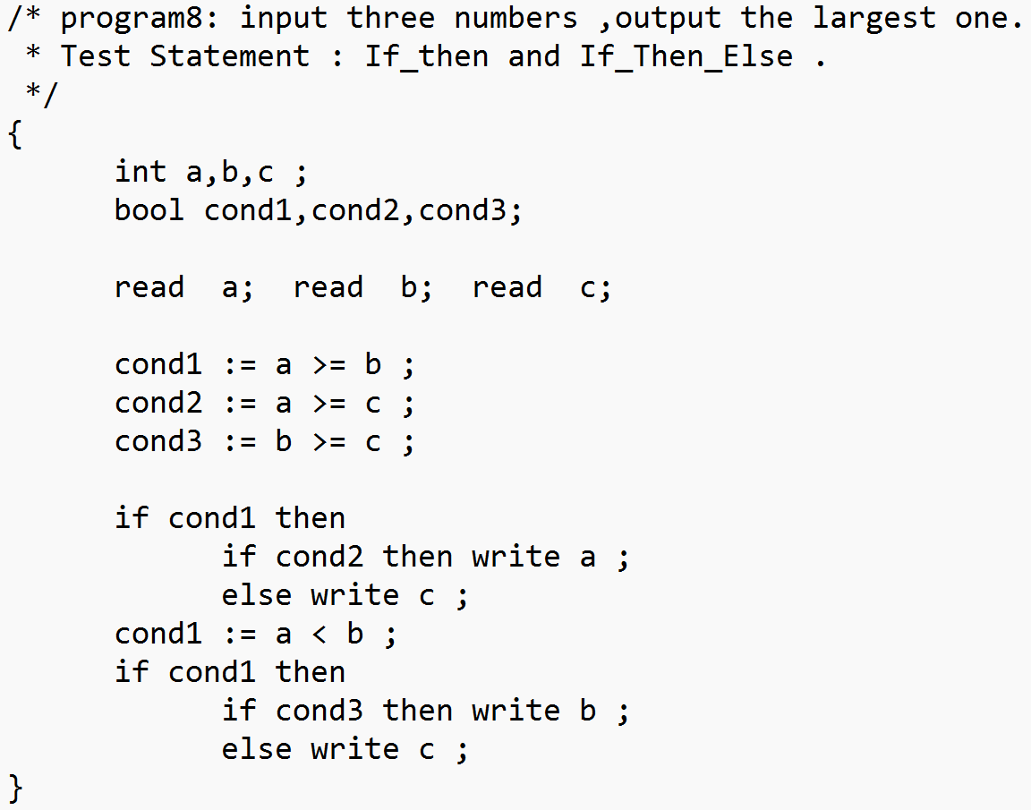
测试结果：
命令行结果：分析正常，反序列化正常
Result.txt 正常
SP {
KW int
ID a
SP ,
ID b
SP ,
ID c
SP ;
KW bool
ID cond1
SP ,
ID cond2
SP ,
ID cond3
SP ;
KW read
ID a
SP ;
KW read
ID b
SP ;
KW read
ID c
SP ;
ID cond1
OP :=
ID a
OP >=
ID b
SP ;
ID cond2
OP :=
ID a
OP >=
ID c
SP ;
ID cond3
OP :=
ID b
OP >=
ID c
SP ;
KW if
ID cond1
KW then
KW if
ID cond2
KW then
KW write
ID a
SP ;
KW else
KW write
ID c
SP ;
ID cond1
OP :=
ID a
OP <
ID b
SP ;
KW if
ID cond1
KW then
KW if
ID cond3
KW then
KW write
ID b
SP ;
KW else
KW write
ID c
SP ;
SP }
Result_parser.txt、Test_result_parser正常
PROG PROG { { { { # # # # # # # # # # # DECLS DECLS DECL DECL int int int int # # # # # # # # # # # NAMES NAMES NAME NAME id id id a # # # # # # # # # # # # # # # # NAMES' NAMES' , , , , # # # # # # # # # # # NAME NAME id id id b # # # # # # # # # # # # # # # # NAMES' NAMES' , , , , # # # # # # # # # # # NAME NAME id id id c # # # # # # # # # # # # # # # # NAMES' NAMES' empty empty empty empty # # # # # # # # # # # # # # # # # # # # # # # # # # ; ; ; ; # # # # # # # # # # # # # # DECLS' DECLS' DECL DECL bool bool bool bool # # # # # # # # # # # NAMES NAMES NAME NAME id id id cond1 # # # # # # # # # # # # # # # # NAMES' NAMES' , , , , # # # # # # # # # # # NAME NAME id id id cond2 # # # # # # # # # # # # # # # # NAMES' NAMES' , , , , # # # # # # # # # # # NAME NAME id id id cond3 # # # # # # # # # # # # # # # # NAMES' NAMES' empty empty empty empty # # # # # # # # # # # # # # # # # # # # # # # # # # ; ; ; ; # # # # # # # # # # # # # # DECLS' DECLS' empty empty empty empty # # # # # # # # # # # # # # # # # # # # # # # # STMTS STMTS STMT STMT read read read read # # # # # # # # # # # id id id a # # # # # # # # # # # ; ; ; ; # # # # # # # # # # # # # # STMTS' STMTS' STMT STMT read read read read # # # # # # # # # # # id id id b # # # # # # # # # # # ; ; ; ; # # # # # # # # # # # # # # STMTS' STMTS' STMT STMT read read read read # # # # # # # # # # # id id id c # # # # # # # # # # # ; ; ; ; # # # # # # # # # # # # # # STMTS' STMTS' STMT STMT id id id cond1 # # # # # # # # # # # STMT' STMT' := := := := # # # # # # # # # # # BOOL BOOL JOIN JOIN NOT NOT REL REL EXPR EXPR TERM TERM NEGA NEGA FACTOR FACTOR id id id a # # # # # # # # # # # # # # # # # # # # # MUL' MUL' empty empty empty empty # # # # # # # # # # # # # # # # # # # # ADD' ADD' empty empty empty empty # # # # # # # # # # # # # # # # # # # # ROP ROP >= >= >= >= # # # # # # # # # # # # # # # # EXPR EXPR TERM TERM NEGA NEGA FACTOR FACTOR id id id b # # # # # # # # # # # # # # # # # # # # # MUL' MUL' empty empty empty empty # # # # # # # # # # # # # # # # # # # # ADD' ADD' empty empty empty empty # # # # # # # # # # # # # # # # # # # # # # # # # # # # JOIN' JOIN' empty empty empty empty # # # # # # # # # # # # # # # # # # # # BOOL' BOOL' empty empty empty empty # # # # # # # # # # # # # # # # # # # # ; ; ; ; # # # # # # # # # # # # # # # # # # STMTS' STMTS' STMT STMT id id id cond2 # # # # # # # # # # # STMT' STMT' := := := := # # # # # # # # # # # BOOL BOOL JOIN JOIN NOT NOT REL REL EXPR EXPR TERM TERM NEGA NEGA FACTOR FACTOR id id id a # # # # # # # # # # # # # # # # # # # # # MUL' MUL' empty empty empty empty # # # # # # # # # # # # # # # # # # # # ADD' ADD' empty empty empty empty # # # # # # # # # # # # # # # # # # # # ROP ROP >= >= >= >= # # # # # # # # # # # # # # # # EXPR EXPR TERM TERM NEGA NEGA FACTOR FACTOR id id id c # # # # # # # # # # # # # # # # # # # # # MUL' MUL' empty empty empty empty # # # # # # # # # # # # # # # # # # # # ADD' ADD' empty empty empty empty # # # # # # # # # # # # # # # # # # # # # # # # # # # # JOIN' JOIN' empty empty empty empty # # # # # # # # # # # # # # # # # # # # BOOL' BOOL' empty empty empty empty # # # # # # # # # # # # # # # # # # # # ; ; ; ; # # # # # # # # # # # # # # # # # # STMTS' STMTS' STMT STMT id id id cond3 # # # # # # # # # # # STMT' STMT' := := := := # # # # # # # # # # # BOOL BOOL JOIN JOIN NOT NOT REL REL EXPR EXPR TERM TERM NEGA NEGA FACTOR FACTOR id id id b # # # # # # # # # # # # # # # # # # # # # MUL' MUL' empty empty empty empty # # # # # # # # # # # # # # # # # # # # ADD' ADD' empty empty empty empty # # # # # # # # # # # # # # # # # # # # ROP ROP >= >= >= >= # # # # # # # # # # # # # # # # EXPR EXPR TERM TERM NEGA NEGA FACTOR FACTOR id id id c # # # # # # # # # # # # # # # # # # # # # MUL' MUL' empty empty empty empty # # # # # # # # # # # # # # # # # # # # ADD' ADD' empty empty empty empty # # # # # # # # # # # # # # # # # # # # # # # # # # # # JOIN' JOIN' empty empty empty empty # # # # # # # # # # # # # # # # # # # # BOOL' BOOL' empty empty empty empty # # # # # # # # # # # # # # # # # # # # ; ; ; ; # # # # # # # # # # # # # # # # # # STMTS' STMTS' STMT STMT if if if if # # # # # # # # # # # id id id cond1 # # # # # # # # # # # then then then then # # # # # # # # # # # STMT STMT if if if if # # # # # # # # # # # id id id cond2 # # # # # # # # # # # then then then then # # # # # # # # # # # STMT STMT write write write write # # # # # # # # # # # id id id a # # # # # # # # # # # ; ; ; ; # # # # # # # # # # # # # # ELSESTMT ELSESTMT else else else else # # # # # # # # # # # STMT STMT write write write write # # # # # # # # # # # id id id c # # # # # # # # # # # ; ; ; ; # # # # # # # # # # # # # # # # # # # ELSESTMT ELSESTMT empty empty empty empty # # # # # # # # # # # # # # # # # STMTS' STMTS' STMT STMT id id id cond1 # # # # # # # # # # # STMT' STMT' := := := := # # # # # # # # # # # BOOL BOOL JOIN JOIN NOT NOT REL REL EXPR EXPR TERM TERM NEGA NEGA FACTOR FACTOR id id id a # # # # # # # # # # # # # # # # # # # # # MUL' MUL' empty empty empty empty # # # # # # # # # # # # # # # # # # # # ADD' ADD' empty empty empty empty # # # # # # # # # # # # # # # # # # # # ROP ROP < < < < # # # # # # # # # # # # # # # # EXPR EXPR TERM TERM NEGA NEGA FACTOR FACTOR id id id b # # # # # # # # # # # # # # # # # # # # # MUL' MUL' empty empty empty empty # # # # # # # # # # # # # # # # # # # # ADD' ADD' empty empty empty empty # # # # # # # # # # # # # # # # # # # # # # # # # # # # JOIN' JOIN' empty empty empty empty # # # # # # # # # # # # # # # # # # # # BOOL' BOOL' empty empty empty empty # # # # # # # # # # # # # # # # # # # # ; ; ; ; # # # # # # # # # # # # # # # # # # STMTS' STMTS' STMT STMT if if if if # # # # # # # # # # # id id id cond1 # # # # # # # # # # # then then then then # # # # # # # # # # # STMT STMT if if if if # # # # # # # # # # # id id id cond3 # # # # # # # # # # # then then then then # # # # # # # # # # # STMT STMT write write write write # # # # # # # # # # # id id id b # # # # # # # # # # # ; ; ; ; # # # # # # # # # # # # # # ELSESTMT ELSESTMT else else else else # # # # # # # # # # # STMT STMT write write write write # # # # # # # # # # # id id id c # # # # # # # # # # # ; ; ; ; # # # # # # # # # # # # # # # # # # # ELSESTMT ELSESTMT empty empty empty empty # # # # # # # # # # # # # # # # # STMTS' STMTS' empty empty empty empty # # # # # # # # # # # # # # # # # # # # # # # # # # # # # # # # # # # # # # # # # # # # # # # # # # # # } } } } # # # # # # # # # # # # #
【9】给定测试用例9
错误一：关键字与标识符连在了一起
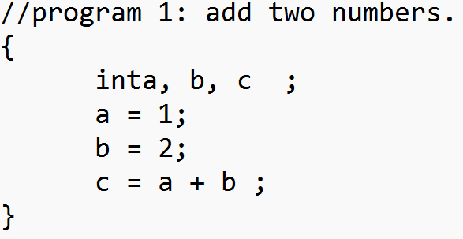
测试结果：
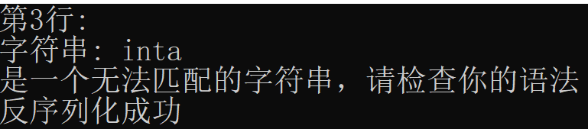
命令行结果：分析得到错误
【10】给定测试用例10（非法字符输入 ；（中文形式））
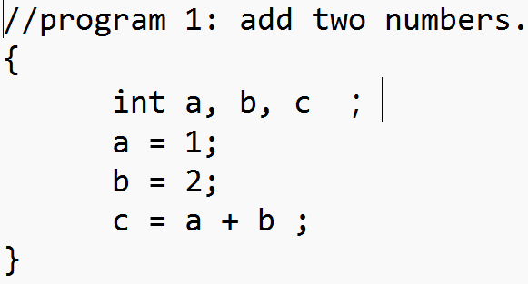
测试结果：
命令行结果：分析得到错误
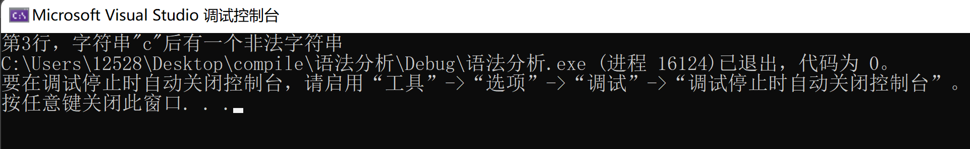
命令行结果：分析得到错误
【11】给定测试用例11（终结符号错误）
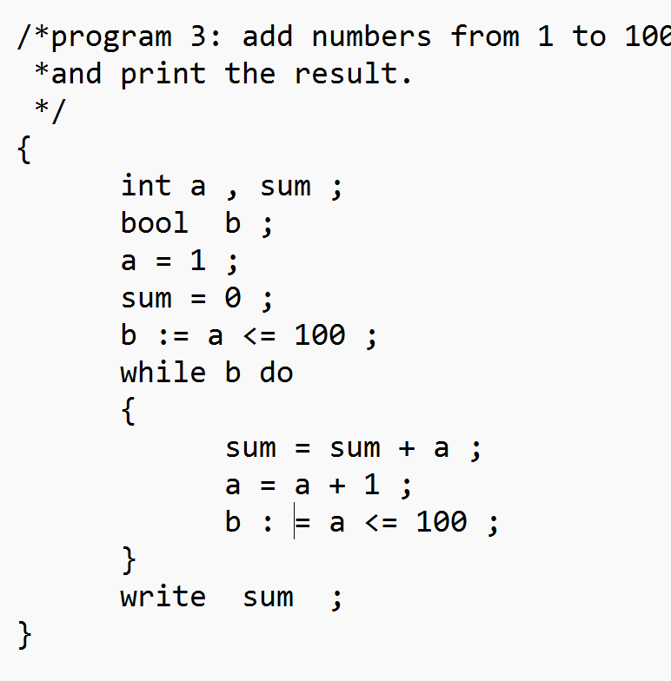
测试结果：
命令行结果：分析得到错误
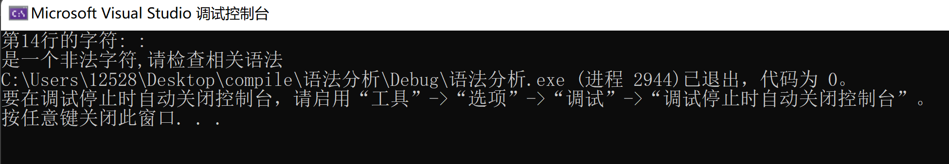
【12】给定测试用例12（多余标识符）
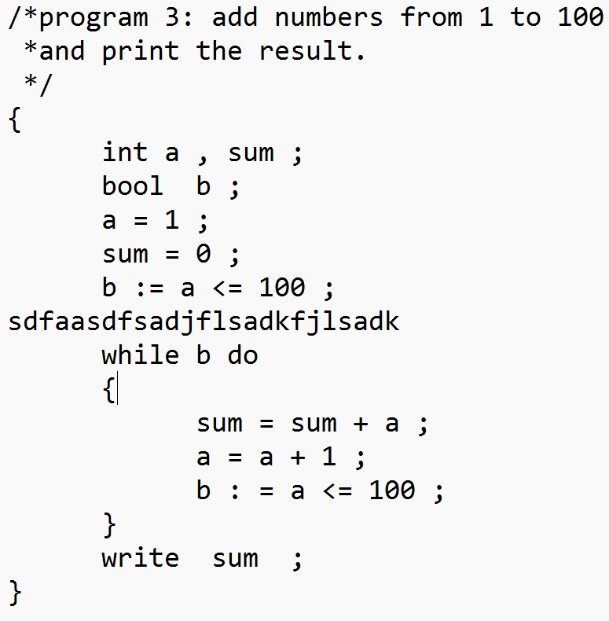
测试结果：
命令行结果：分析得到错误
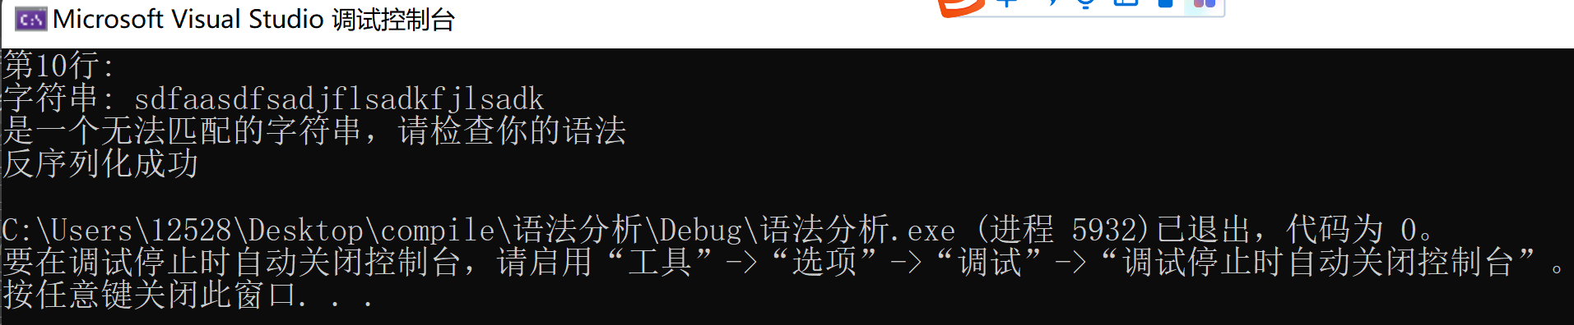

【13】给定测试用例13（开头错误）
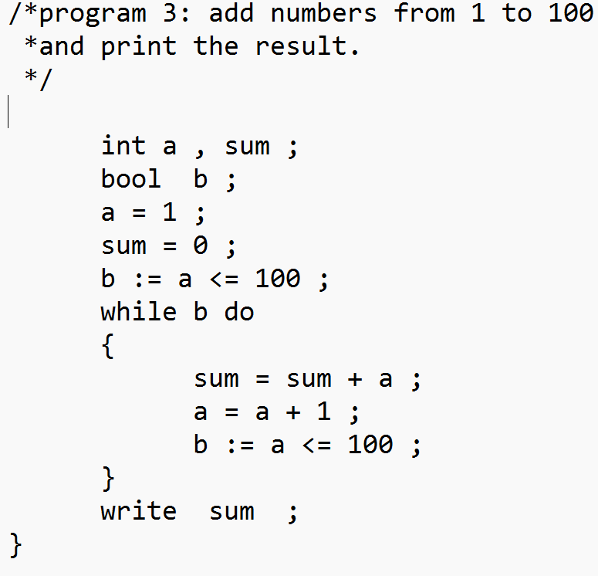
测试结果：
命令行结果：分析得到错误
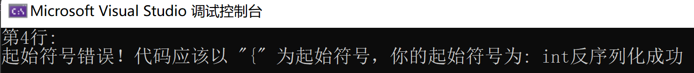
【14】给定测试用例14（结尾多余的字符）
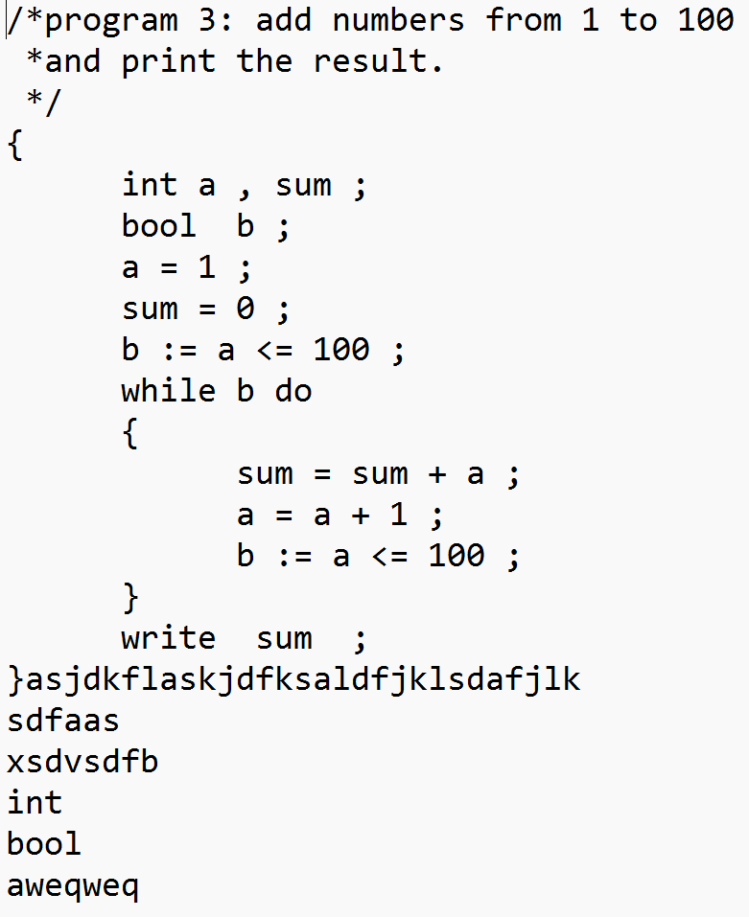
测试结果：
命令行结果：分析得到错误
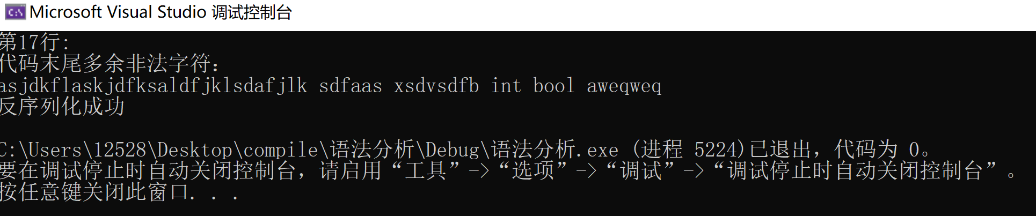
【15】给定测试用例15（缺少分隔符}）
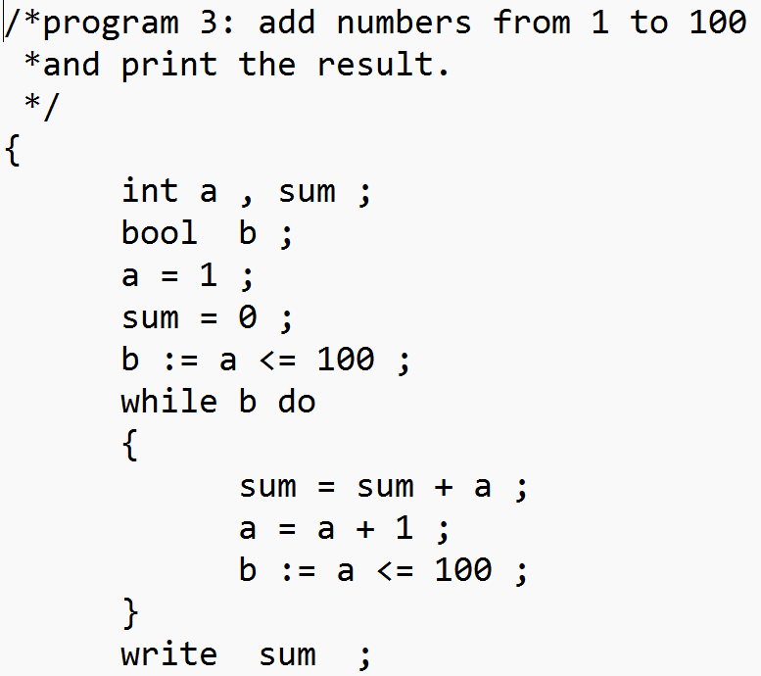
测试结果：
命令行结果：分析得到错误
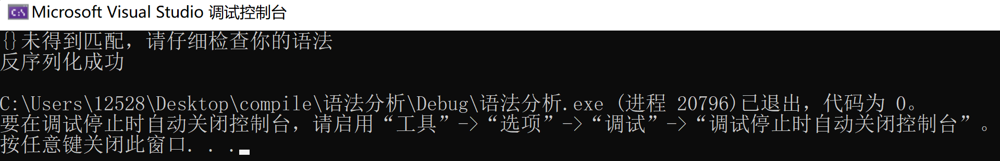
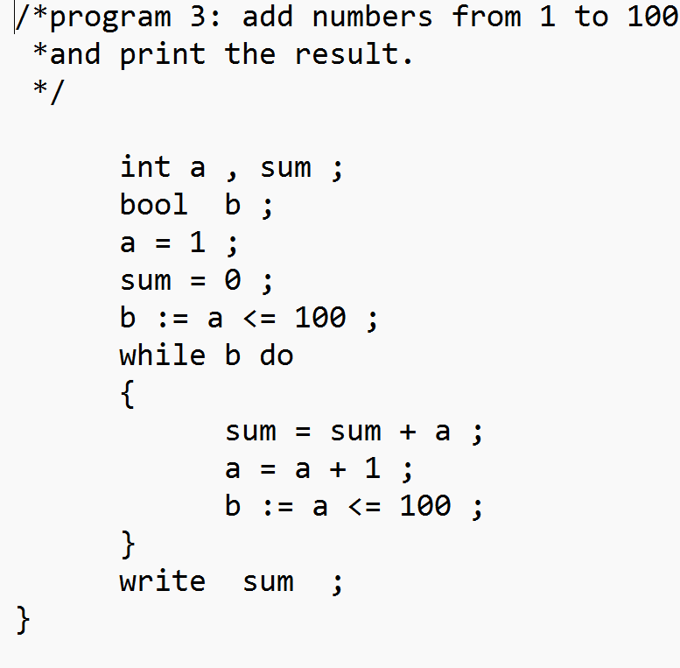
测试结果：
命令行结果：分析得到错误
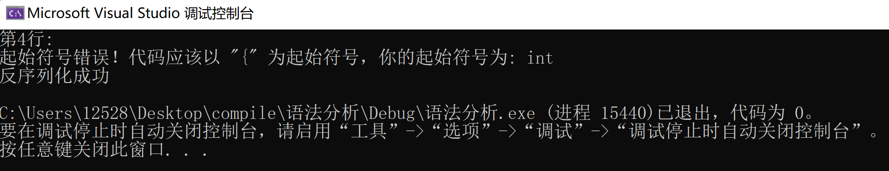
【16】给定测试用例16（test.txt文件不存在或为空）
测试结果：
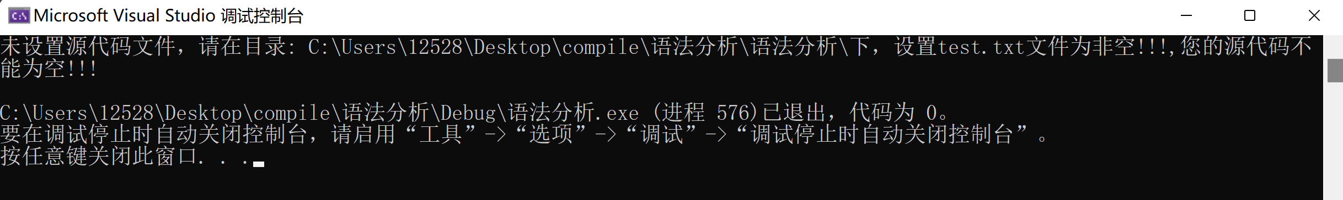
- 实验总结
- 通过本次实验，我加深了对LL1文法的理解和自顶向下分析的各个实现细节的理解
- 本次实验实现的错误检测只能检测到第一个错误。这里的第一个不一定是按照源代码顺序。（如果你的输入中有类似中文的非法字符的话，就会首先显示该类型错误。其余错误按照源代码的次序）。多次运行后可以实现对所有错误的检测与提示，但无法实现所有错误同时检测与提示。
- 在实现错误检测的时候。我处理了目前我能想到的错误。可能有一些我没有意料到的情况的错误的提示并不准确。
- 我对语法树的序列化方法在查询资料和经过代码验证之后，可以实现语法树的序列化功能。这种方案是抽象语法树和两种序列化存储方法的折中方法。可以实现对更多语法翻译的支持。
- 在开始本次实验的时候，我低估了复杂度，所以有些函数在编写过程中临时加上的。这样的话代码就不可避免的有一些冗余，运行效率也还没有进行专门的优化。

