Activity Recognition Using AlphaPose &
Machine Learning (XGBOOST)

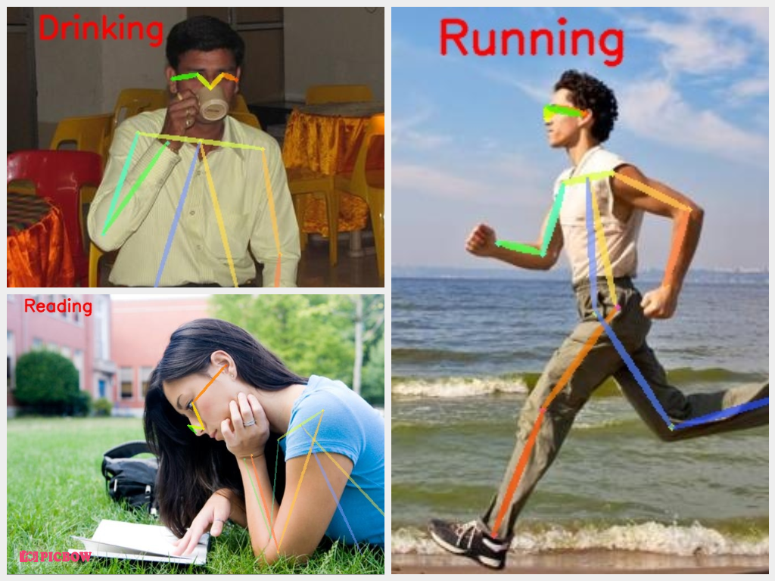

Description :-
- This implemantation is based on official Alphapose repository ( https://github.com/MVIG-SJTU/AlphaPose ).
- In this project we have used Alphapose and XGBOOST for activity recognition.

- Why we have choose this “AlphaPose” over other Pose models :-
1) AlphaPose is an accurate multi-person pose estimator, which is the first open-source system that achieves 70+ mAP (75 mAP) on COCO dataset and 80+ mAP (82.1 mAP) on MPII dataset.
2) To match poses that correspond to the same person across frames, we also provide an efficient online pose tracker called Pose Flow. It is the first open-source online pose tracker that achieves both 60+ mAP (66.5 mAP) and 50+ MOTA (58.3 MOTA) on PoseTrack Challenge dataset.
3) AlphaPose supports both Linux and Windows.

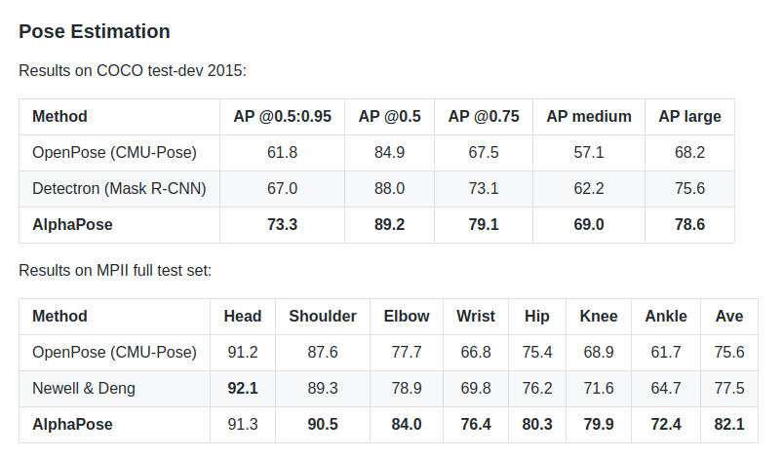

- Working Flow :-
- First after running the AlphaPose model on image it will gives us Skeleton & one json file which contains the keypoints of detected persons of that image.
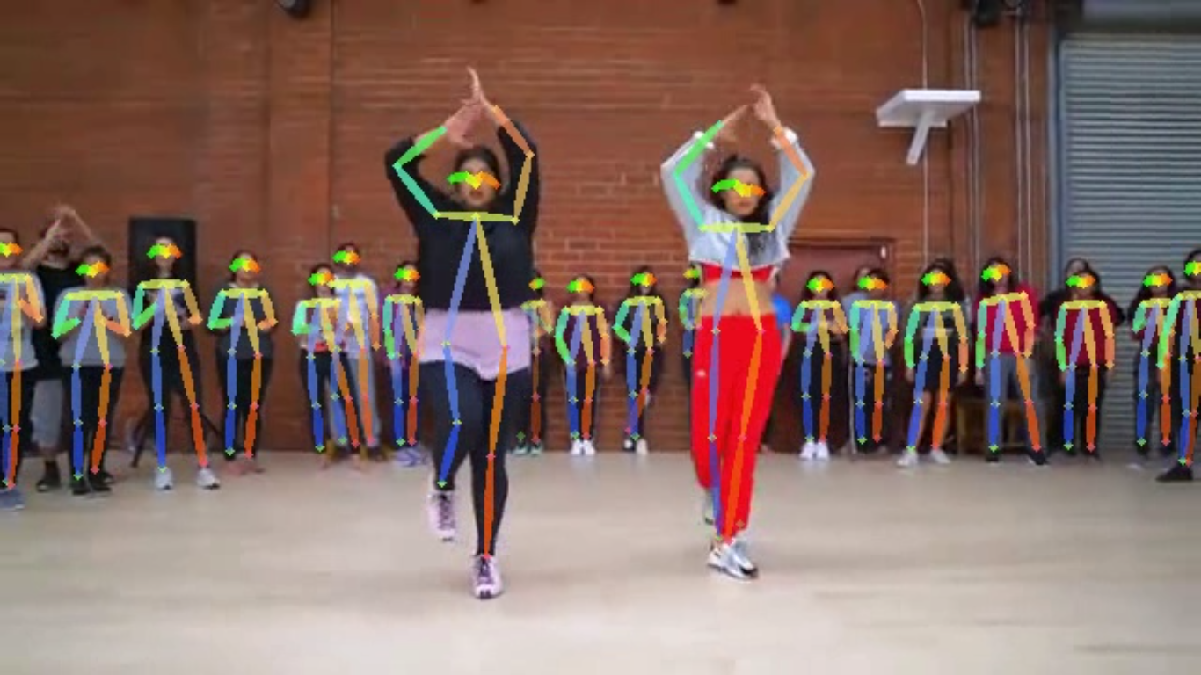
(Skeleton)
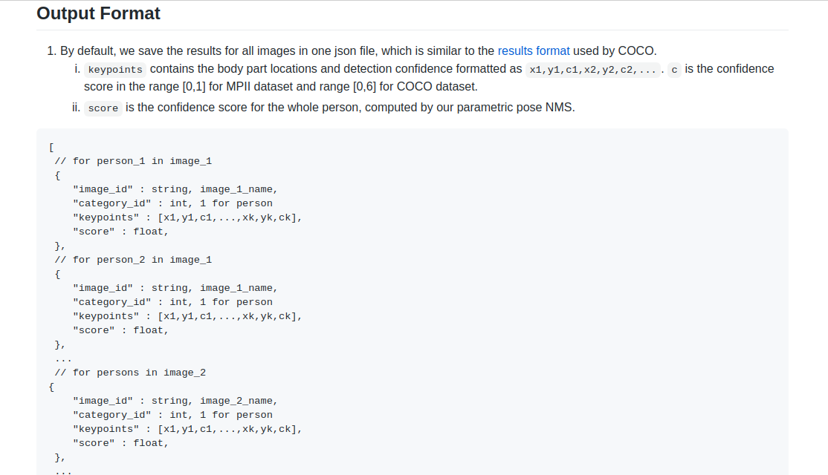
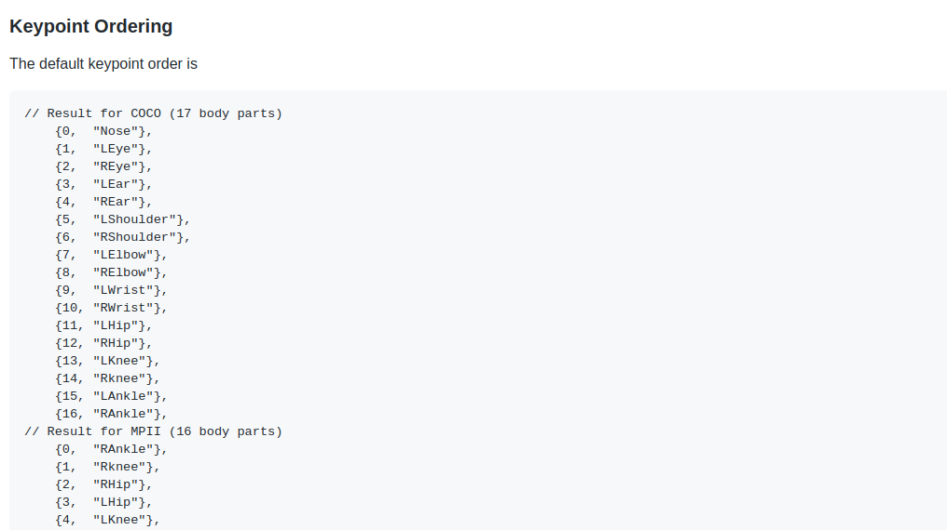

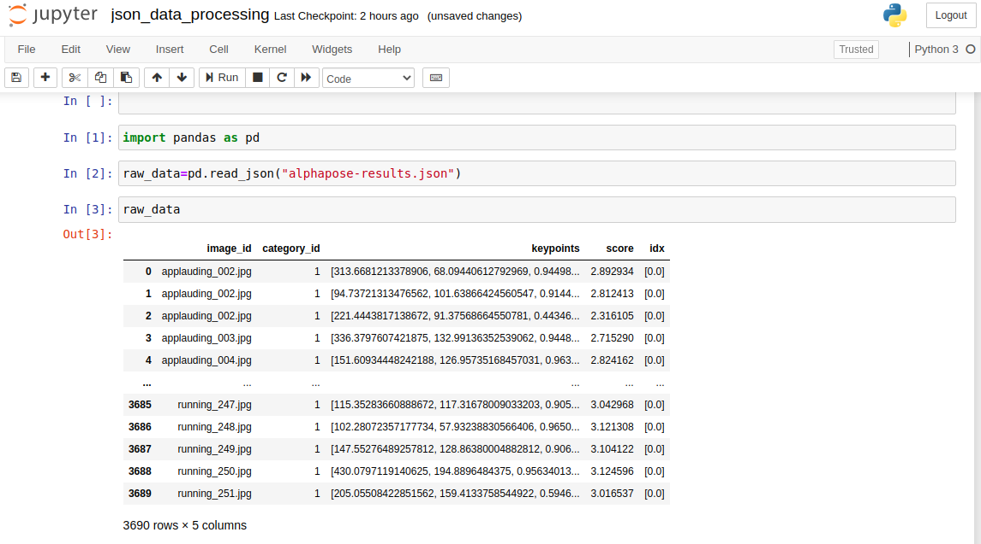
raw json file
2) Now based on that keypoints we can train any Machine Learning model to recognize the activity along with AlphaPose.

- Custom Traning for Activity Recognition :-
1) First we will take ‘Human Activity’ image dataset and we will run the AlphaPose model on that images.our dataset is look like,
A) Training Dataset :-
Categories | Images
Applauding | 250
Drinking | 250
Jumping | 250
Reading | 250
Running | 250
Phoning | 250
Total | 1500

2) After running the model on dataset we will get the corrosponding json file.
3) Now we can use any ML model to train this data for activity prediction.here we have used “XGBOOST”model because of it’s better performance on the dataset.
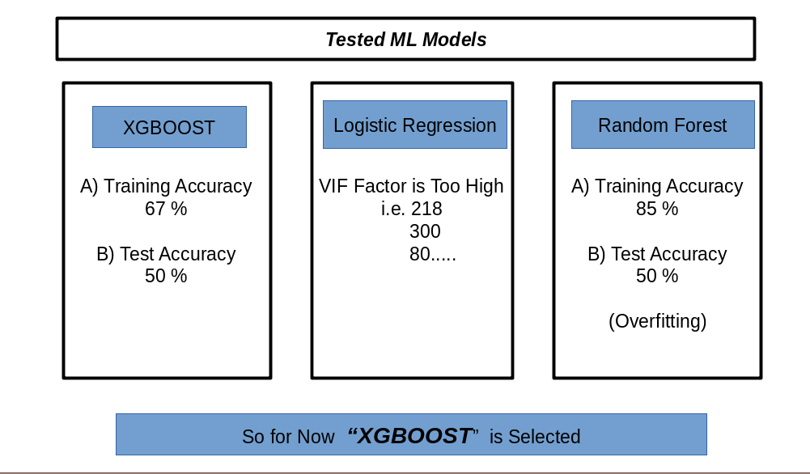

4) So in this way now you can combine your ML model with Alphapose for activity prediction.

- Results :-



