**DevOps Day 12**

**Agenda:**

* **Installation of Docker.**
* **Basic command of Docker.**

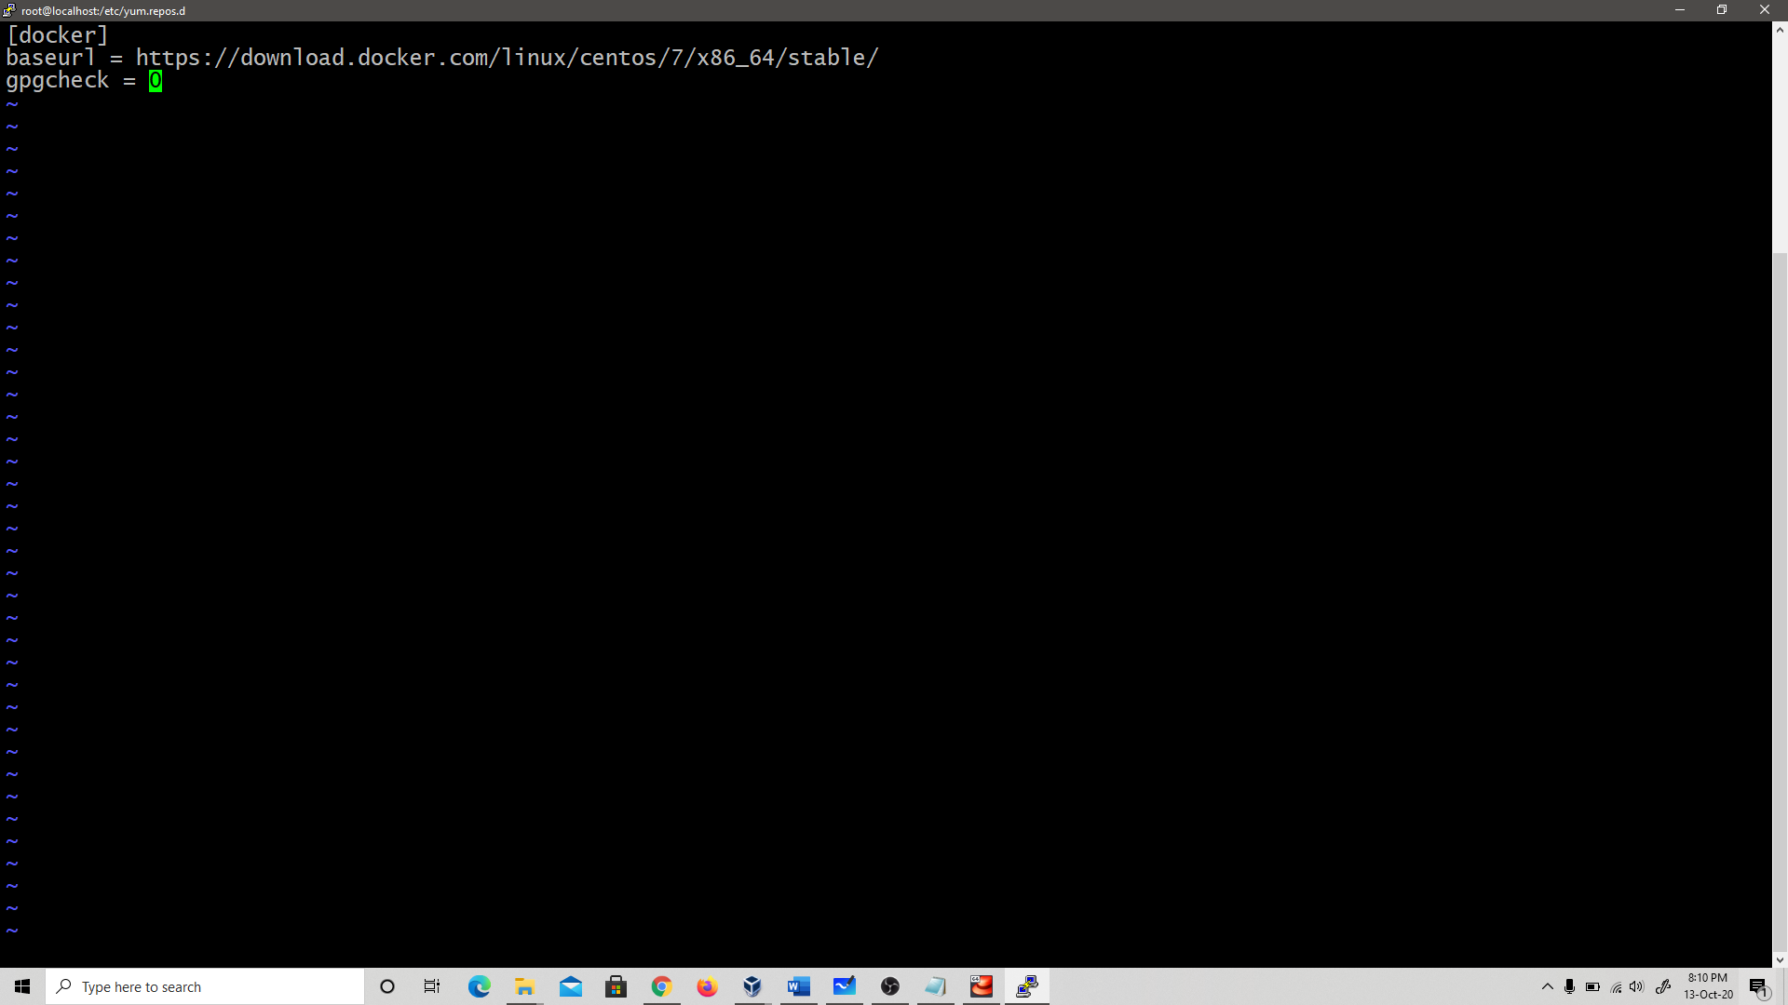

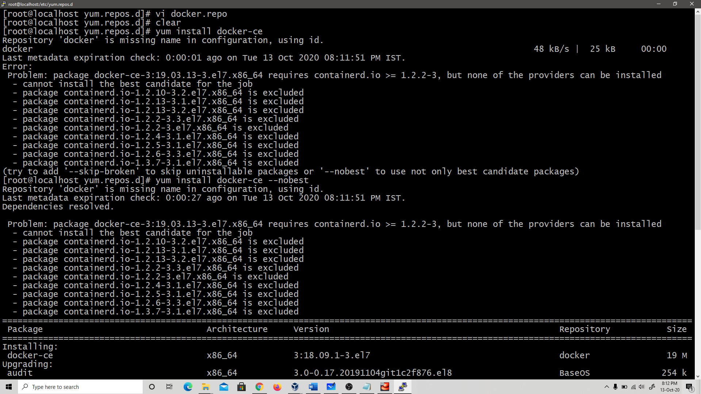

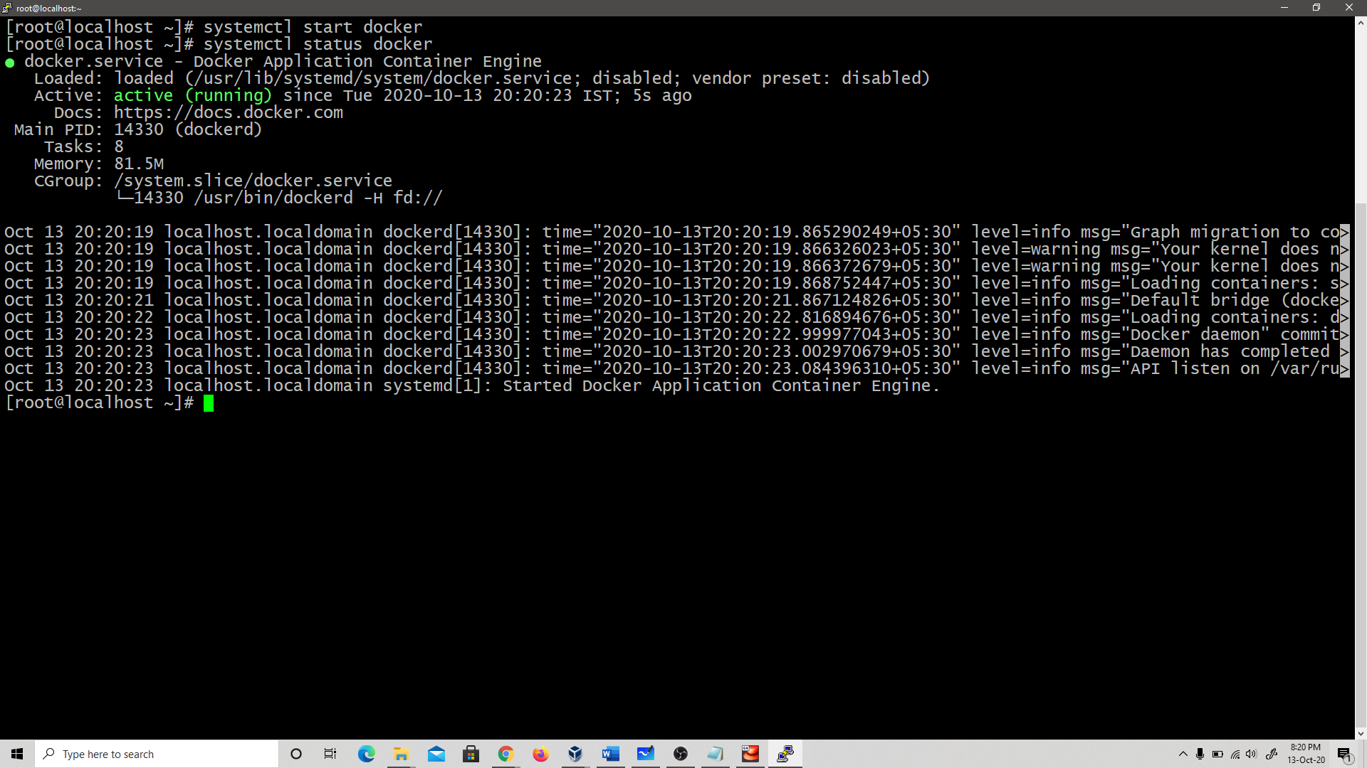

**Docker pull Image_name**

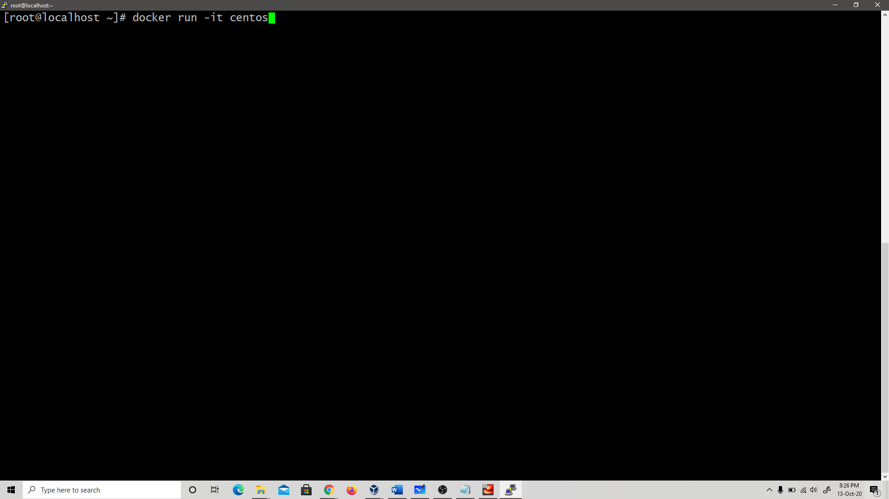

**# Masquerading allows for docker ingress and egress (this is the juicy bit)**

**firewall-cmd --zone=public --add-masquerade --permanent**

**# Specifically allow incoming traffic on port 80/443 (nothing new here)**

**firewall-cmd --zone=public --add-port=80/tcp**

**firewall-cmd --zone=public --add-port=443/tcp**

**# Reload firewall to apply permanent rules**

**firewall-cmd --reload**

