**DevOpsDay17**

**Agenda:**

* **Docker Compose**

**https://docs.docker.com/compose/**

[**https://docs.docker.com/compose/install/**](https://docs.docker.com/compose/install/)

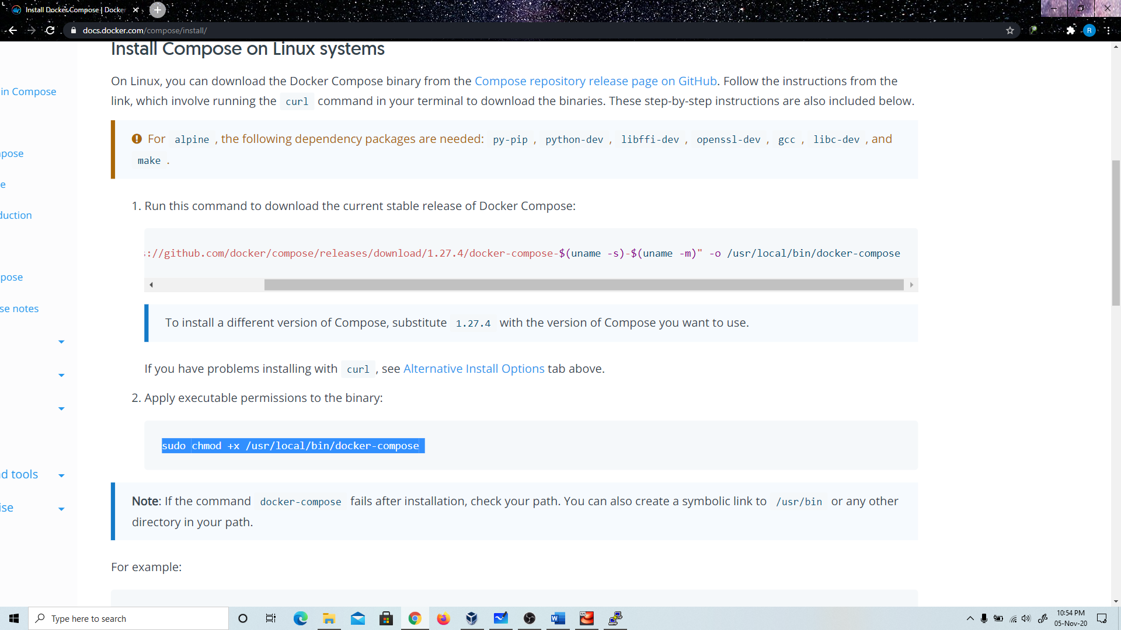

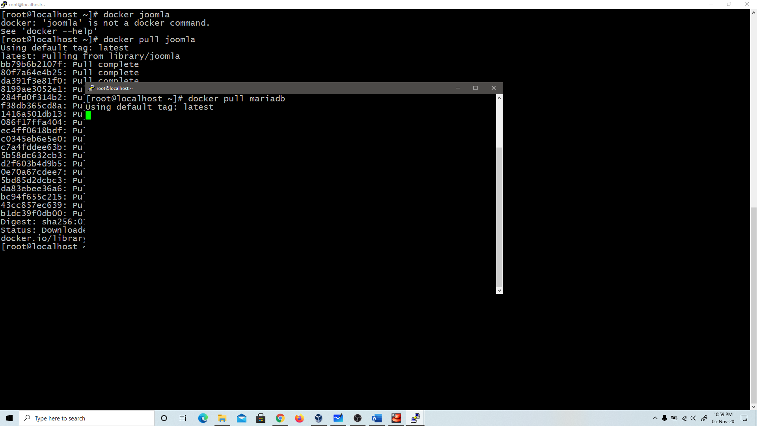

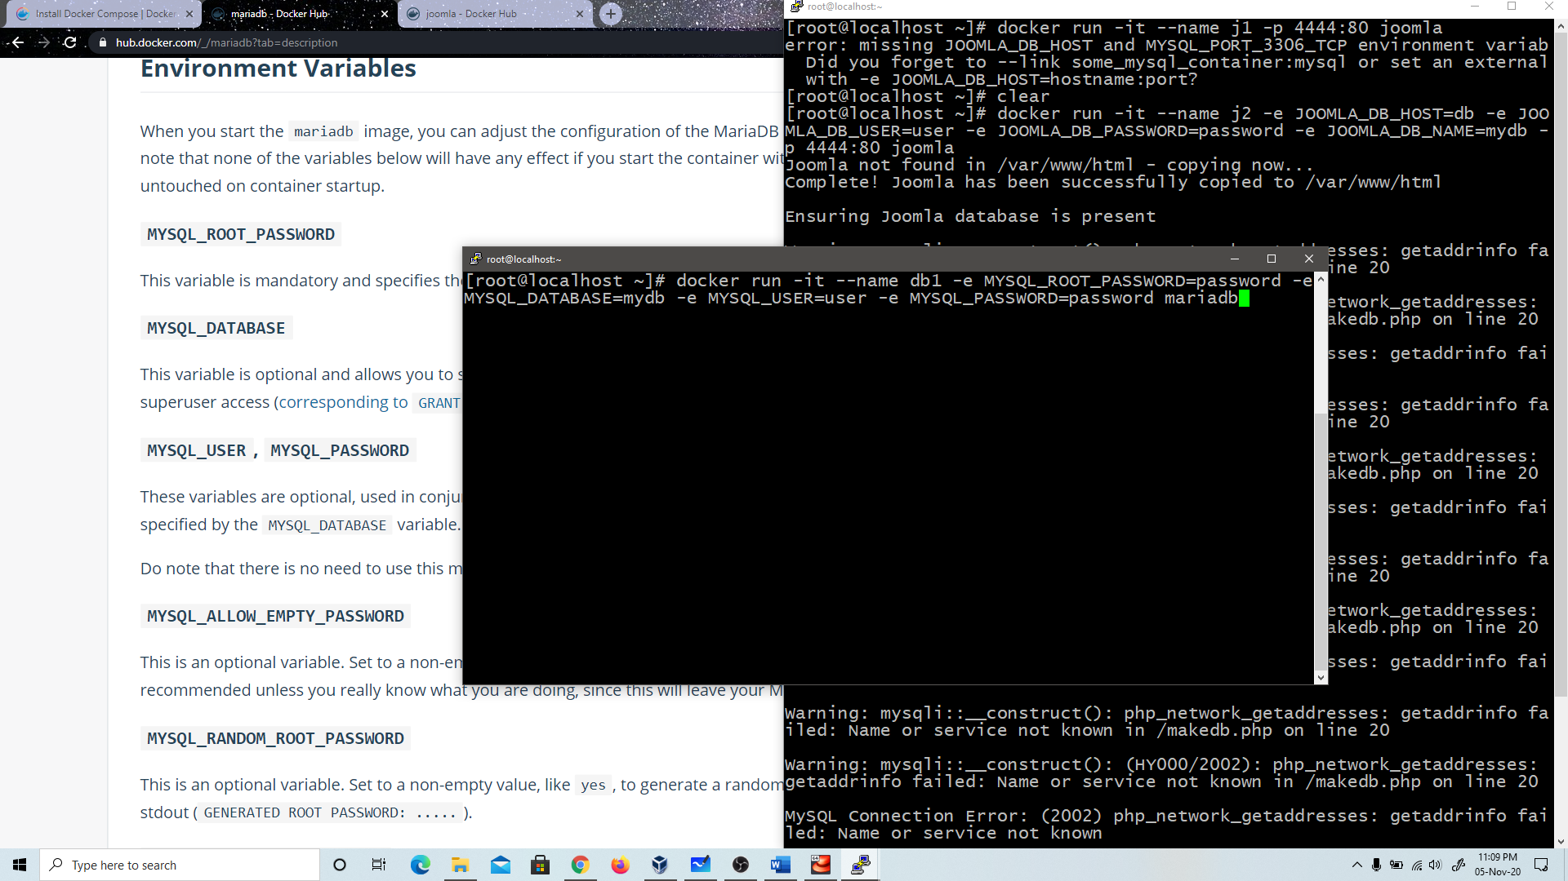

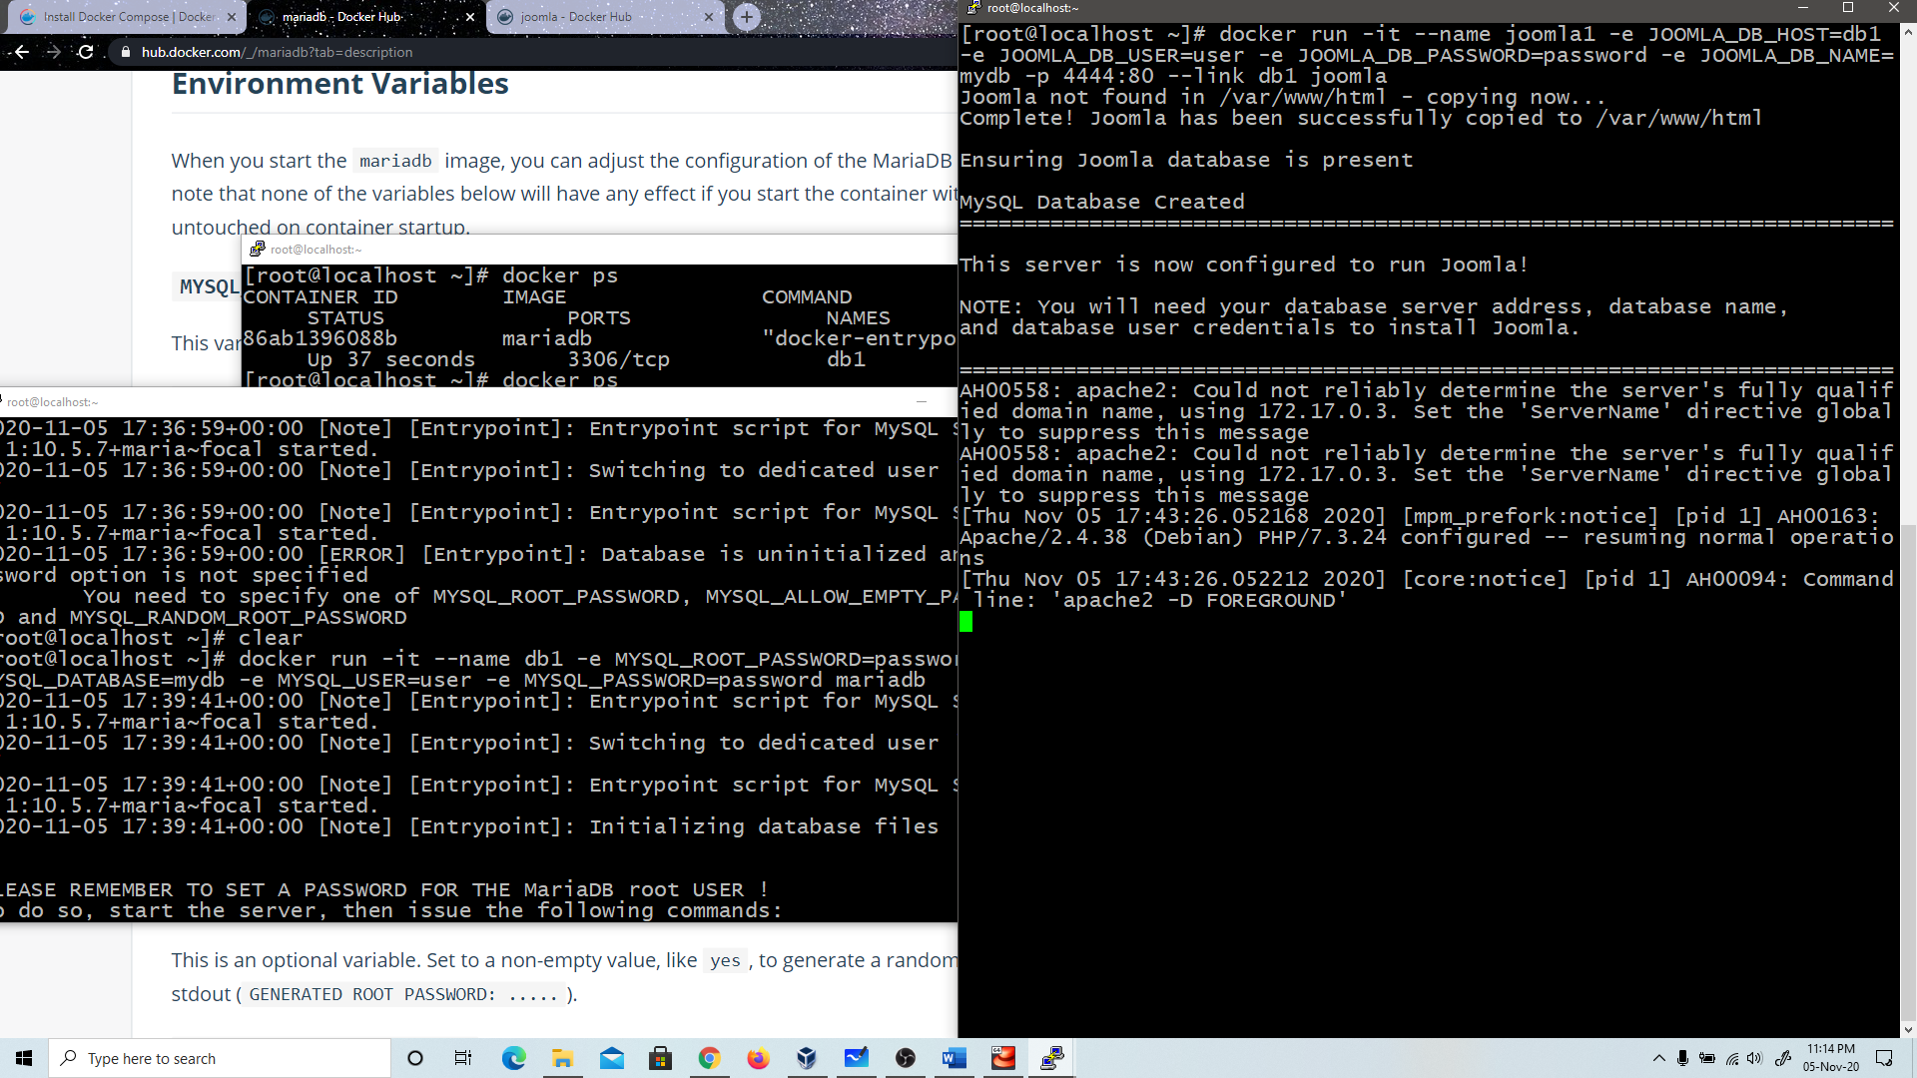

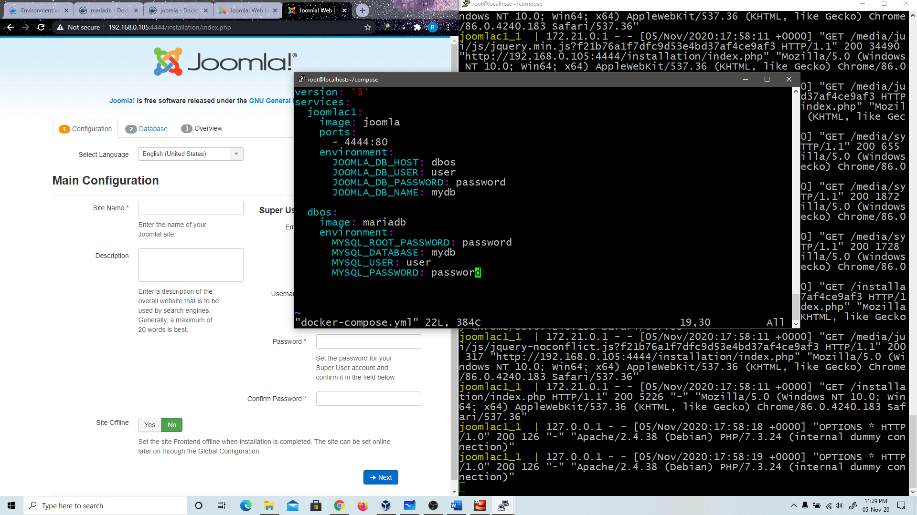

**: docker-compose up**

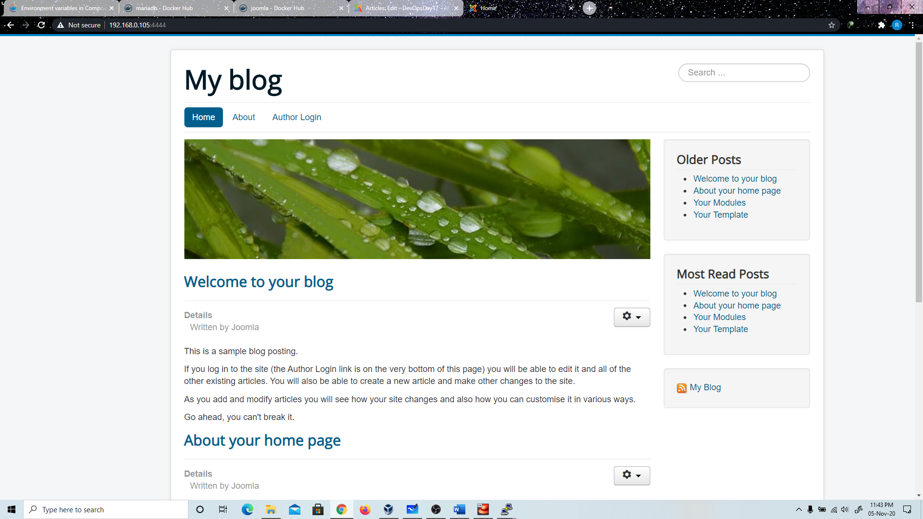

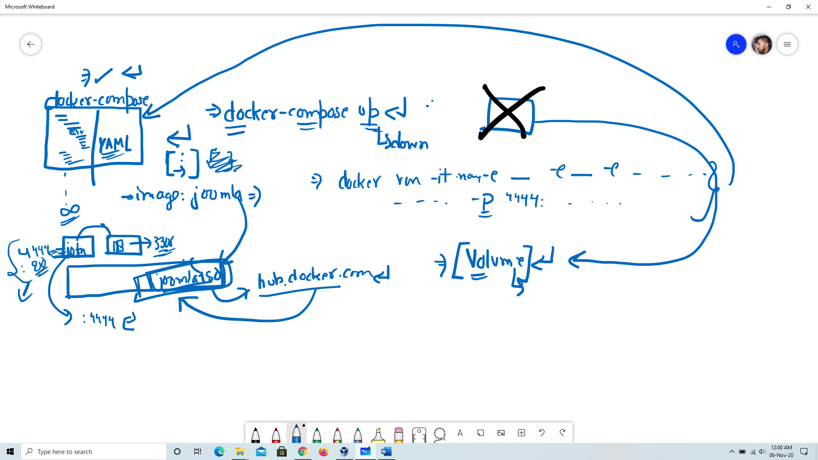

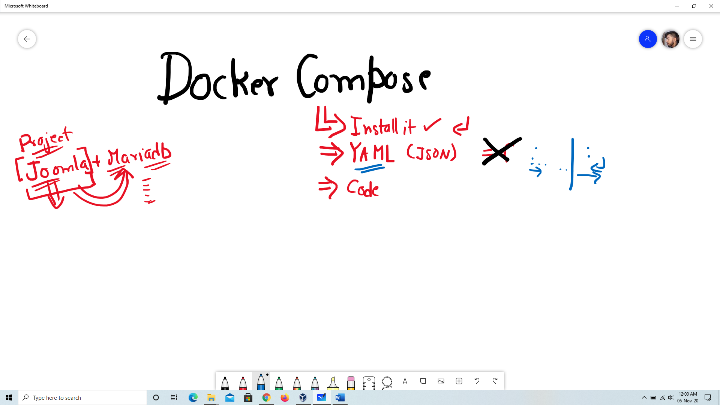

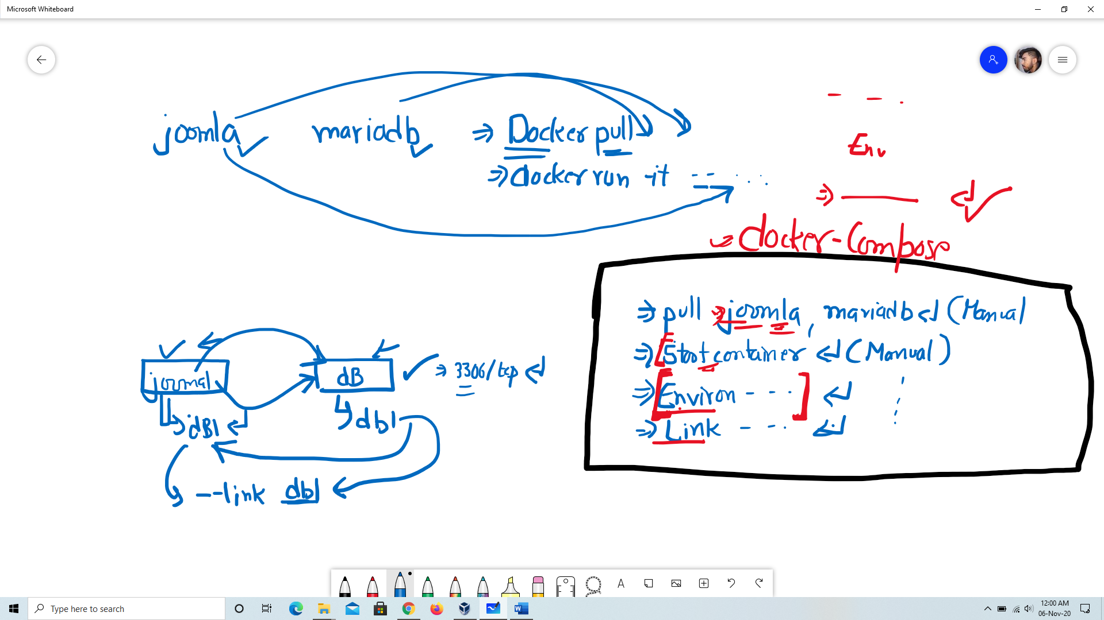

* **docker-compose.yml**

version: '3'

services:

joomlac1:

image: joomla

ports:

- 4444:80

environment:

JOOMLA_DB_HOST: dbos

JOOMLA_DB_USER: user

JOOMLA_DB_PASSWORD: password

JOOMLA_DB_NAME: mydb

dbos:

image: mariadb

environment:

MYSQL_ROOT_PASSWORD: password

MYSQL_DATABASE: mydb

MYSQL_USER: user

MYSQL_PASSWORD: password