# Programming Languages Final Project Report

## Programming Languages REST API Comparison

**Course:** ITCS 4102 â€“ Programming Languages

**Student:** Tai Yang

**Semester:** Summer 2026

---

# Introduction

Programming languages provide different approaches to solving the same programming problems. Although many languages can produce identical results, they differ in syntax, type systems, performance, tooling, readability, and development workflow.

The purpose of this project was to compare three popular programming languages by implementing the same RESTful CRUD API using each language's commonly used web framework.

The three languages selected for this project were:

* Python using FastAPI

* JavaScript using Express.js

* Go using the Gin framework

By implementing identical functionality in each language, it became possible to compare their strengths and weaknesses in a practical software development scenario.

---

# Project Objectives

The objectives of this project were:

* Compare multiple programming languages.

* Implement the same REST API in each language.

* Demonstrate CRUD operations.

* Compare static and dynamic typing.

* Compare different development tools.

* Evaluate readability, performance, and developer experience.

---

# Development Tools

The following tools were used throughout the project.

| Tool | Purpose |

| ------------------------- | ---------------------------------- |

| Visual Studio Code | Source code editor |

| GitHub | Version control |

| FastAPI | Python web framework |

| Express.js | JavaScript web framework |

| Gin | Go web framework |

| Thunder Client | API testing |

| Swagger UI | Python API testing |

---

# Project Structure

The project was organized into separate folders for each language implementation.

* Python-FastAPI

* Javascript-express

* Go-gin

* Docs

* Proposal

* Report

* Screenshots

Each implementation contains the same REST API endpoints.

---

# Python Implementation

The Python implementation was created using FastAPI.

FastAPI provided automatic API documentation through Swagger UI, making testing extremely simple. Data validation was handled using Pydantic models, reducing the amount of manual validation code required.

Implemented endpoints included:

* GET /

* GET /languages

* GET /languages/{id}

* POST /languages

* PUT /languages/{id}

* DELETE /languages/{id}

The Python implementation required the least amount of code and offered the easiest development experience.

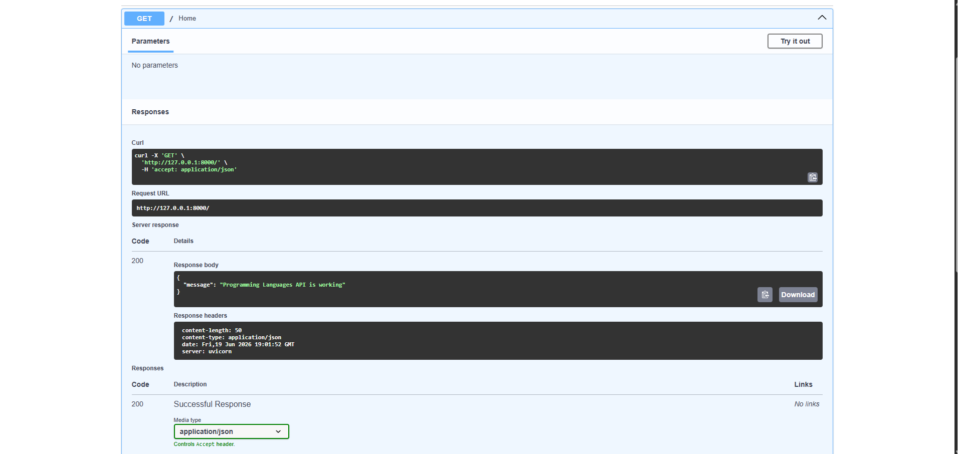

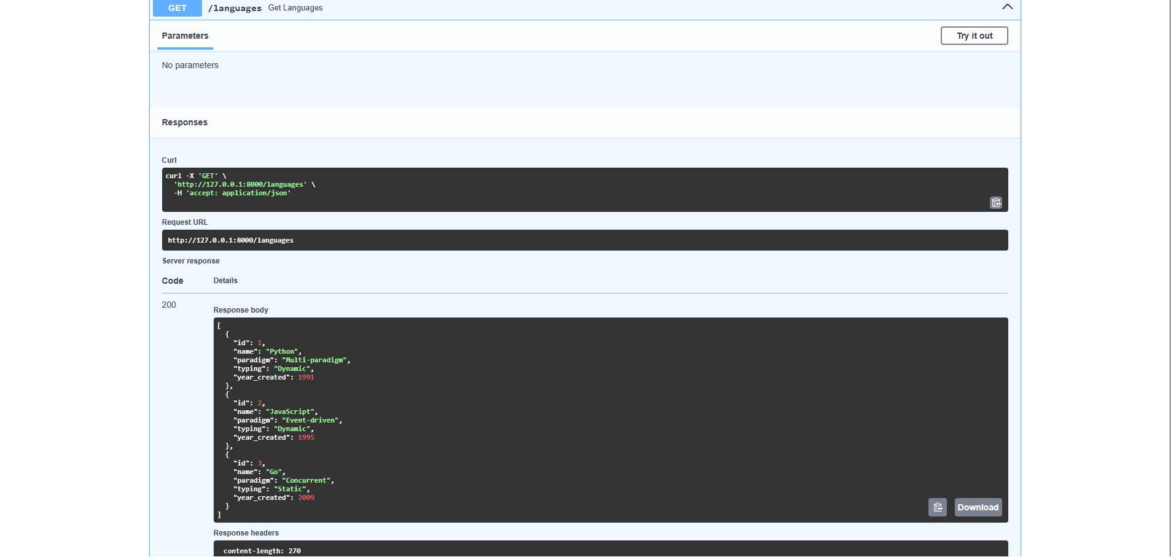

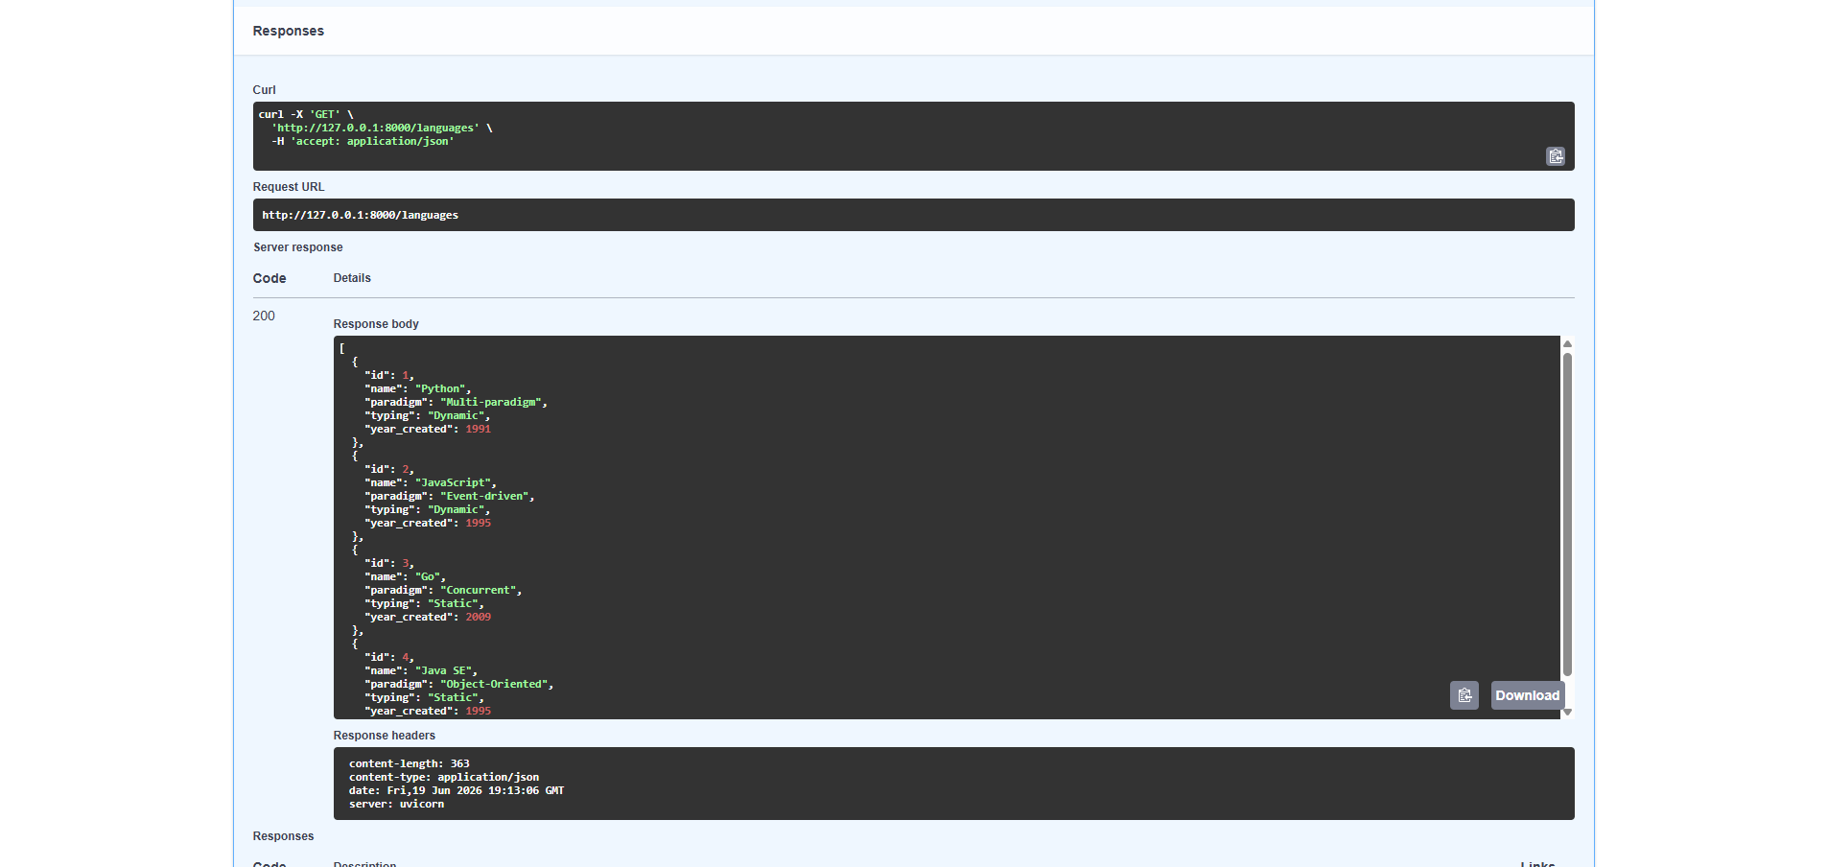
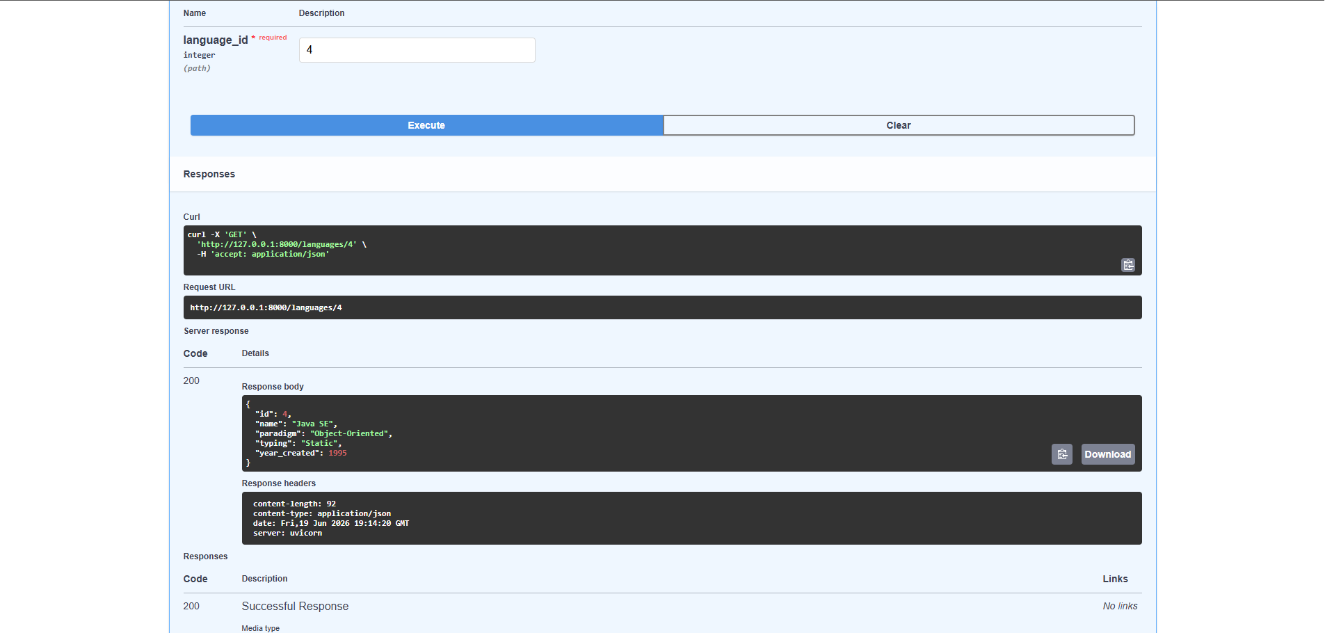
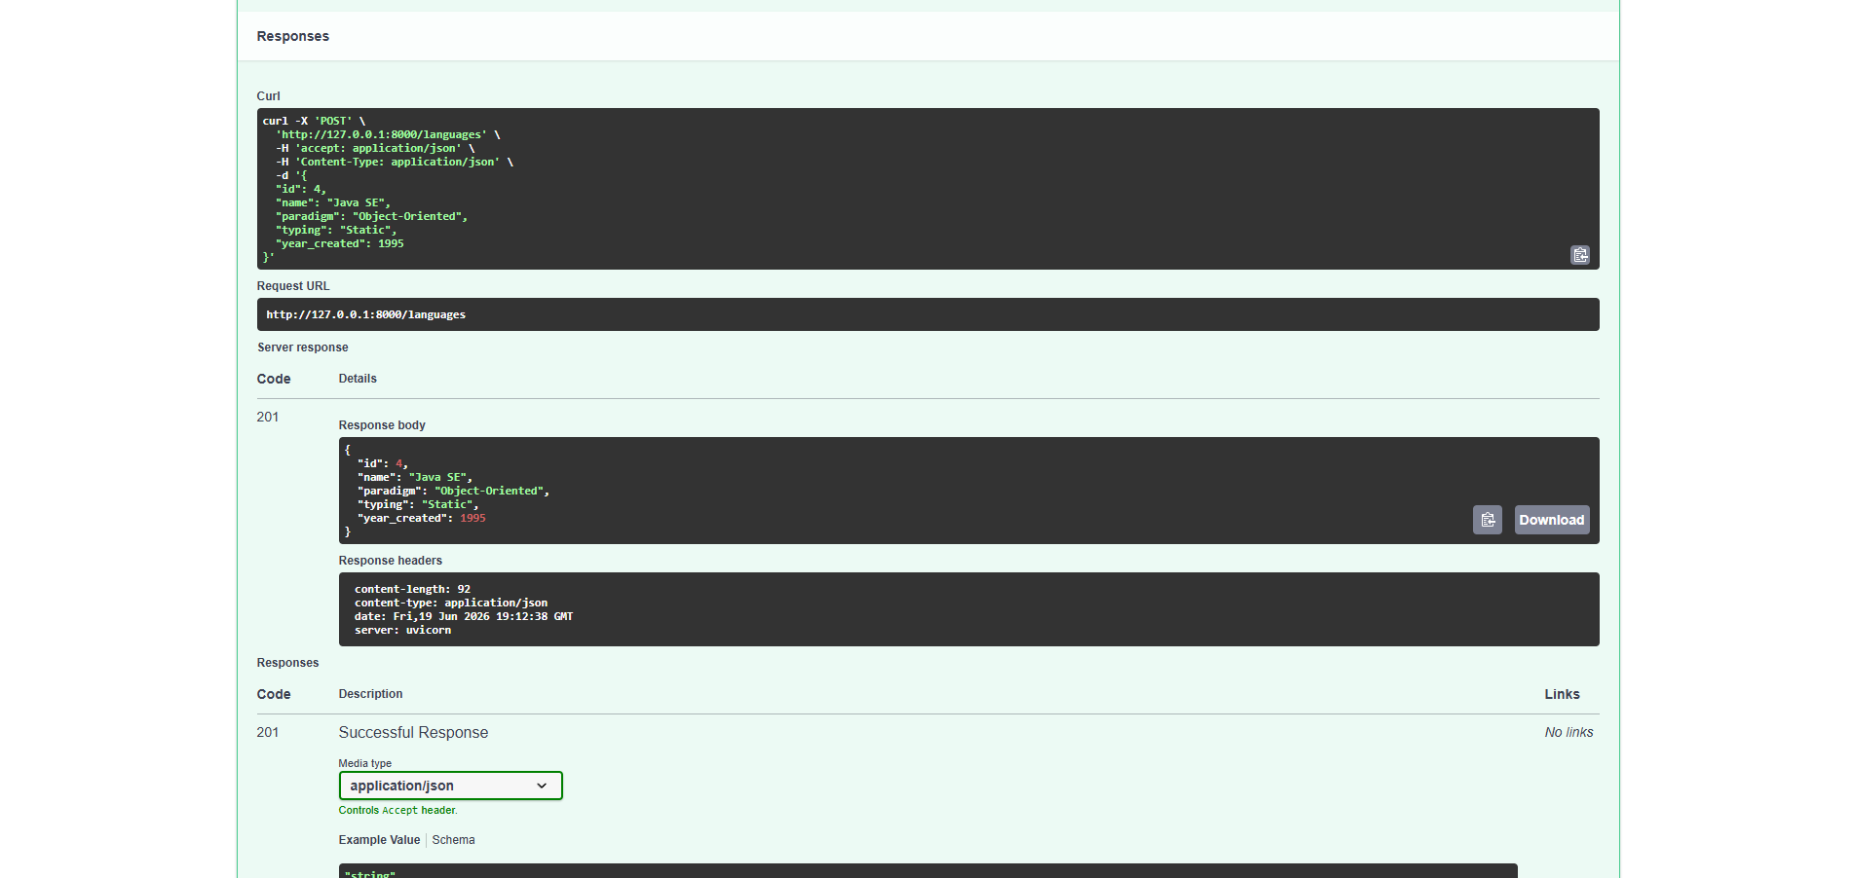
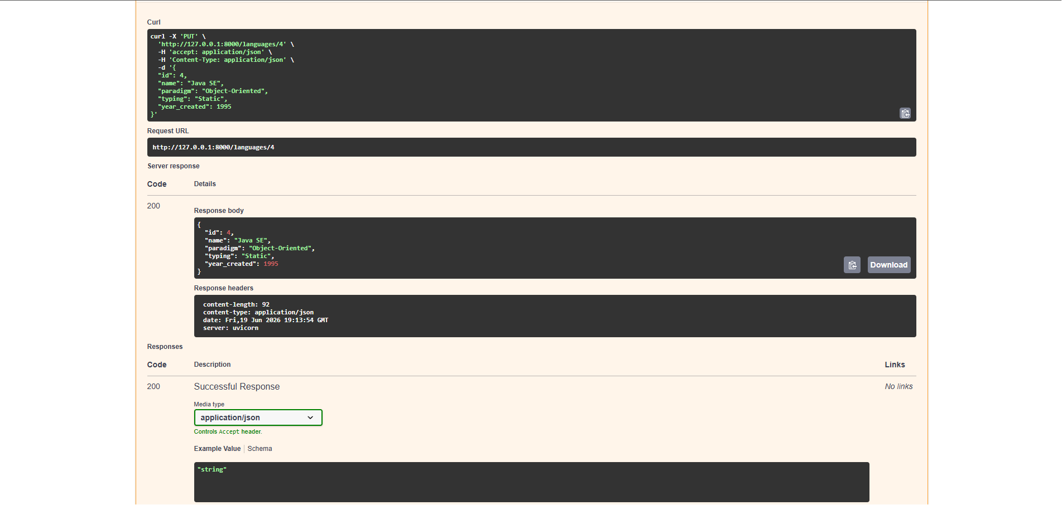
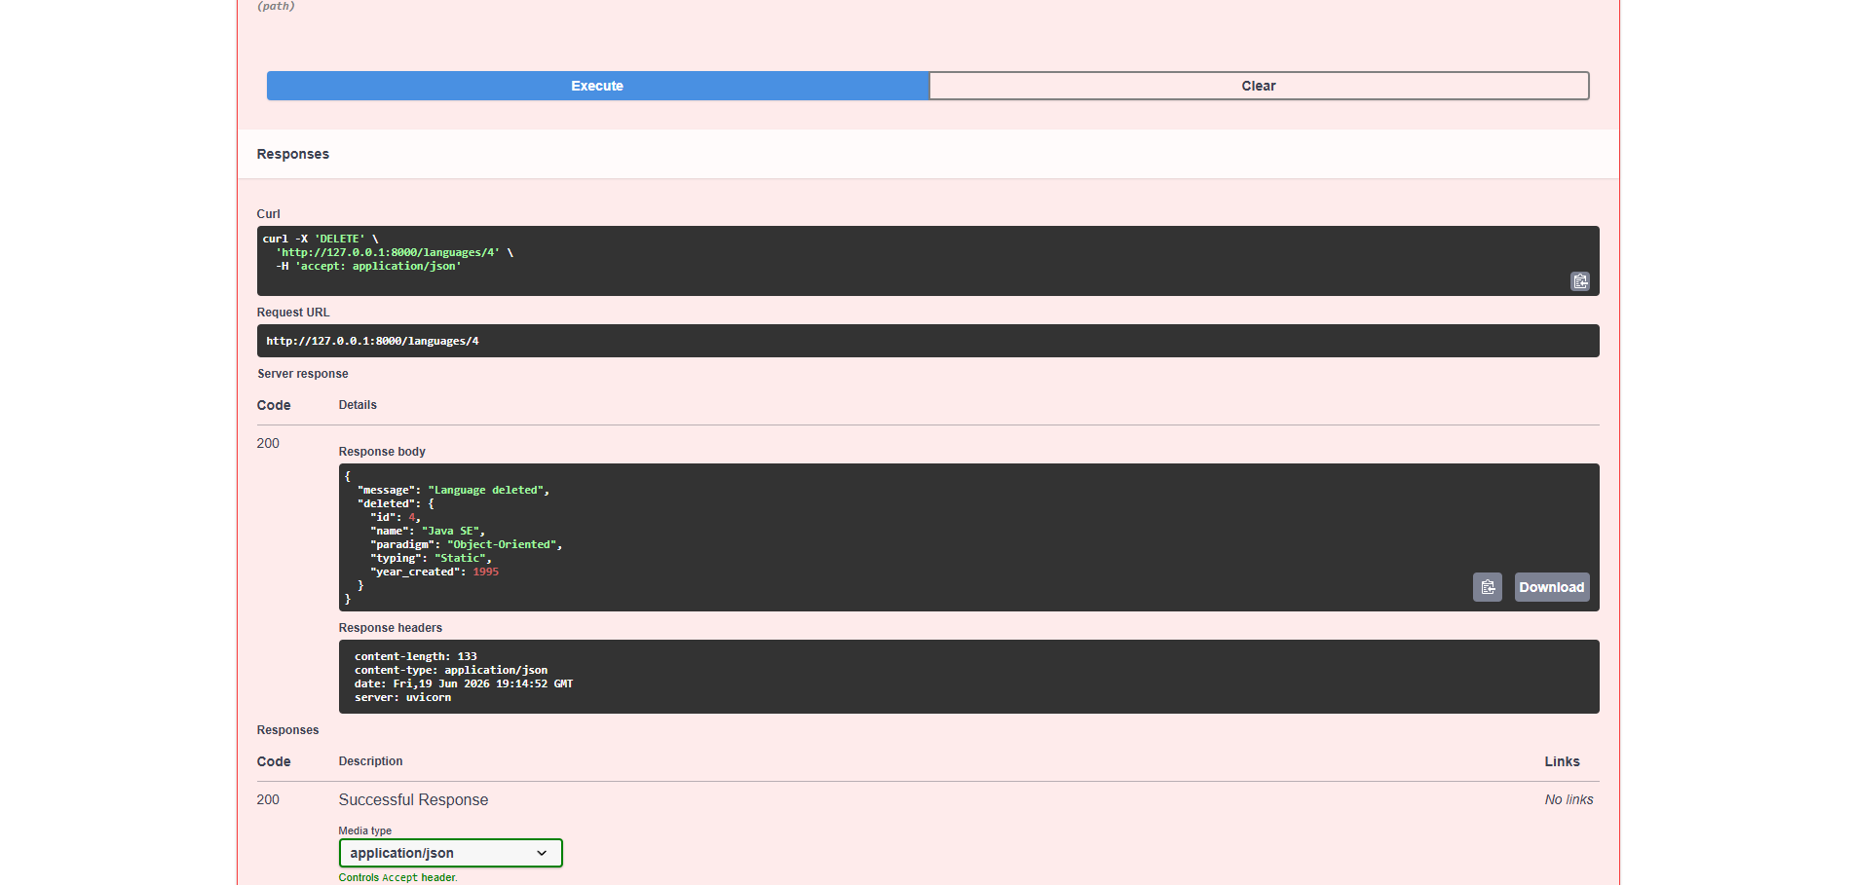

# JavaScript Implementation

The JavaScript implementation used Node.js together with the Express framework.

Unlike FastAPI, Express required more manual configuration but provided excellent flexibility and a very large package ecosystem.

The same CRUD endpoints were implemented and tested using Thunder Client.

Implemented endpoints:

* GET /

* GET /languages

* GET /languages/:id

* POST /languages

* PUT /languages/:id

* DELETE /languages/:id

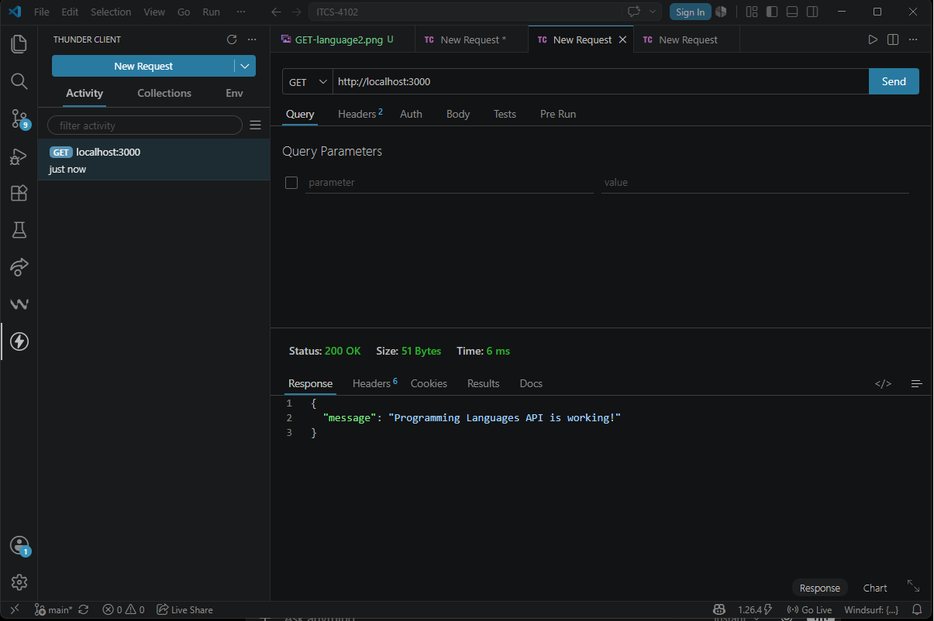

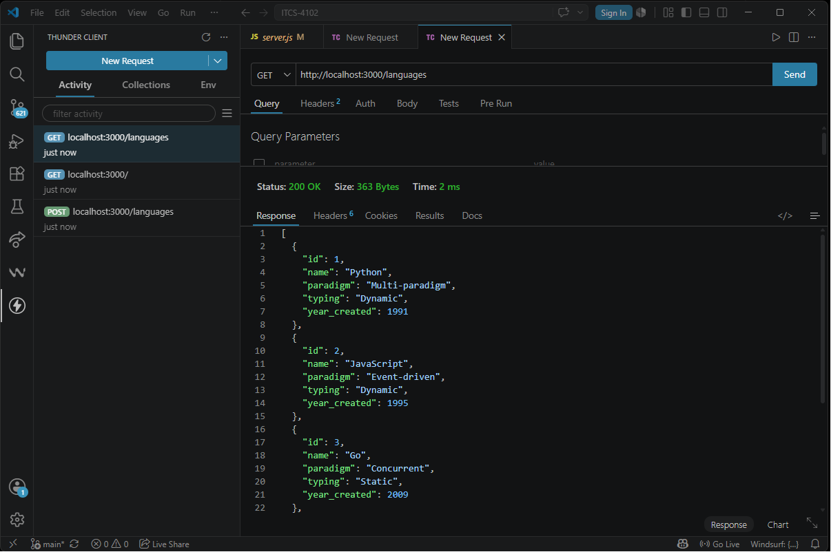
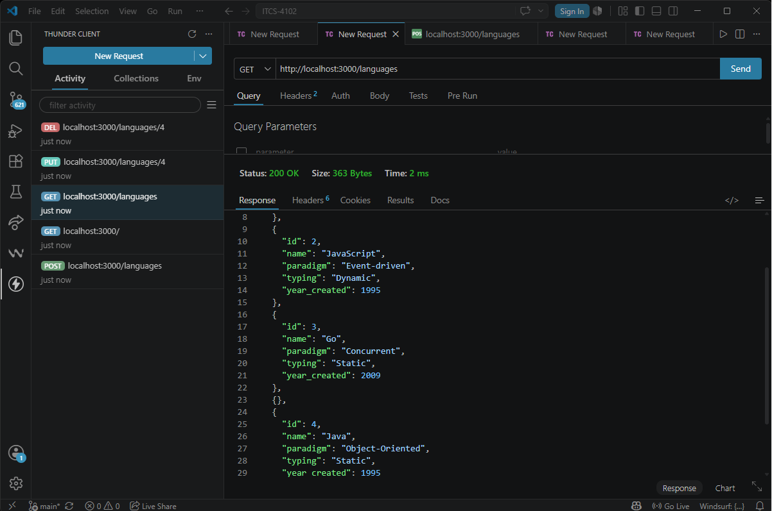

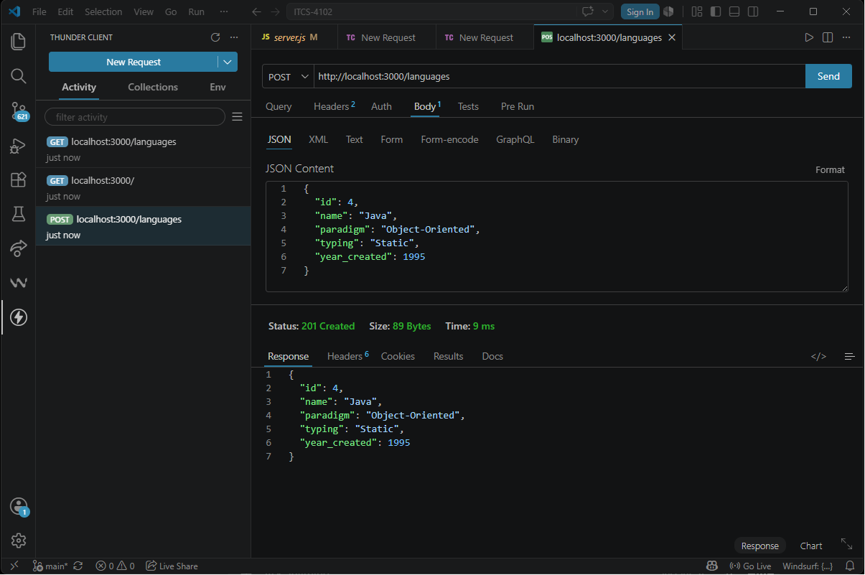
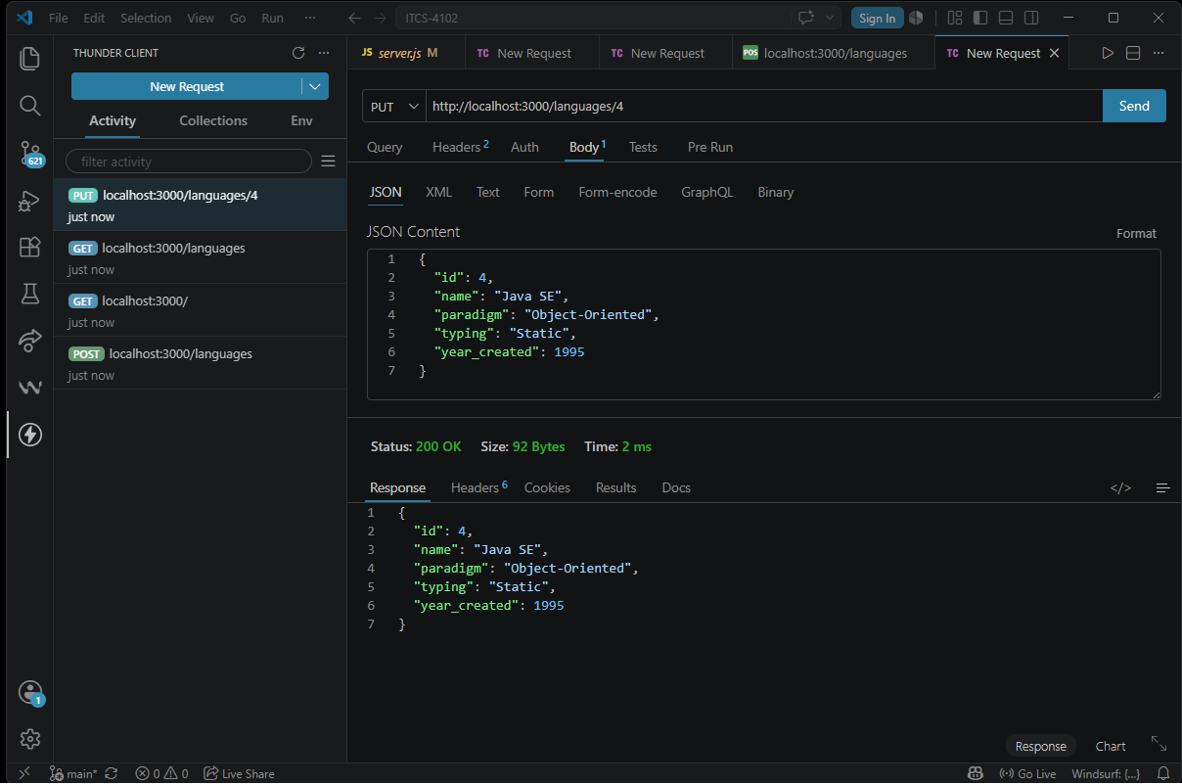
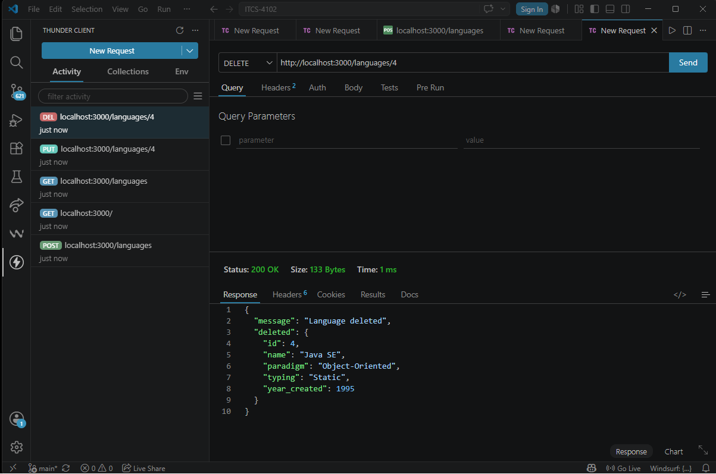

# Go Implementation

The Go implementation used the Gin framework.

Go required more explicit code because of its static type system but provided excellent performance and very clean routing.

The same CRUD functionality was implemented successfully.

Implemented endpoints:

* GET /

* GET /languages

* GET /languages/:id

* POST /languages

* PUT /languages/:id

* DELETE /languages/:id

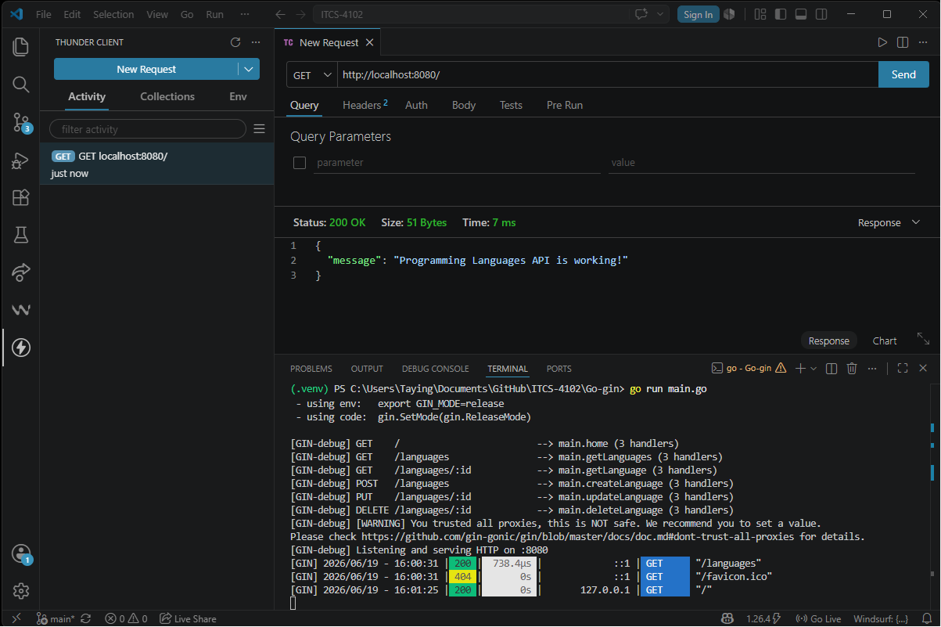

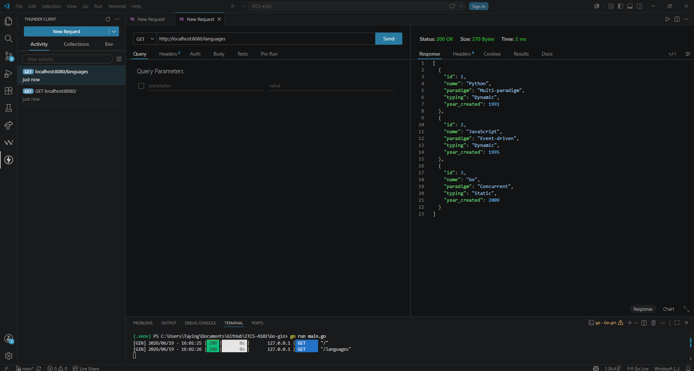
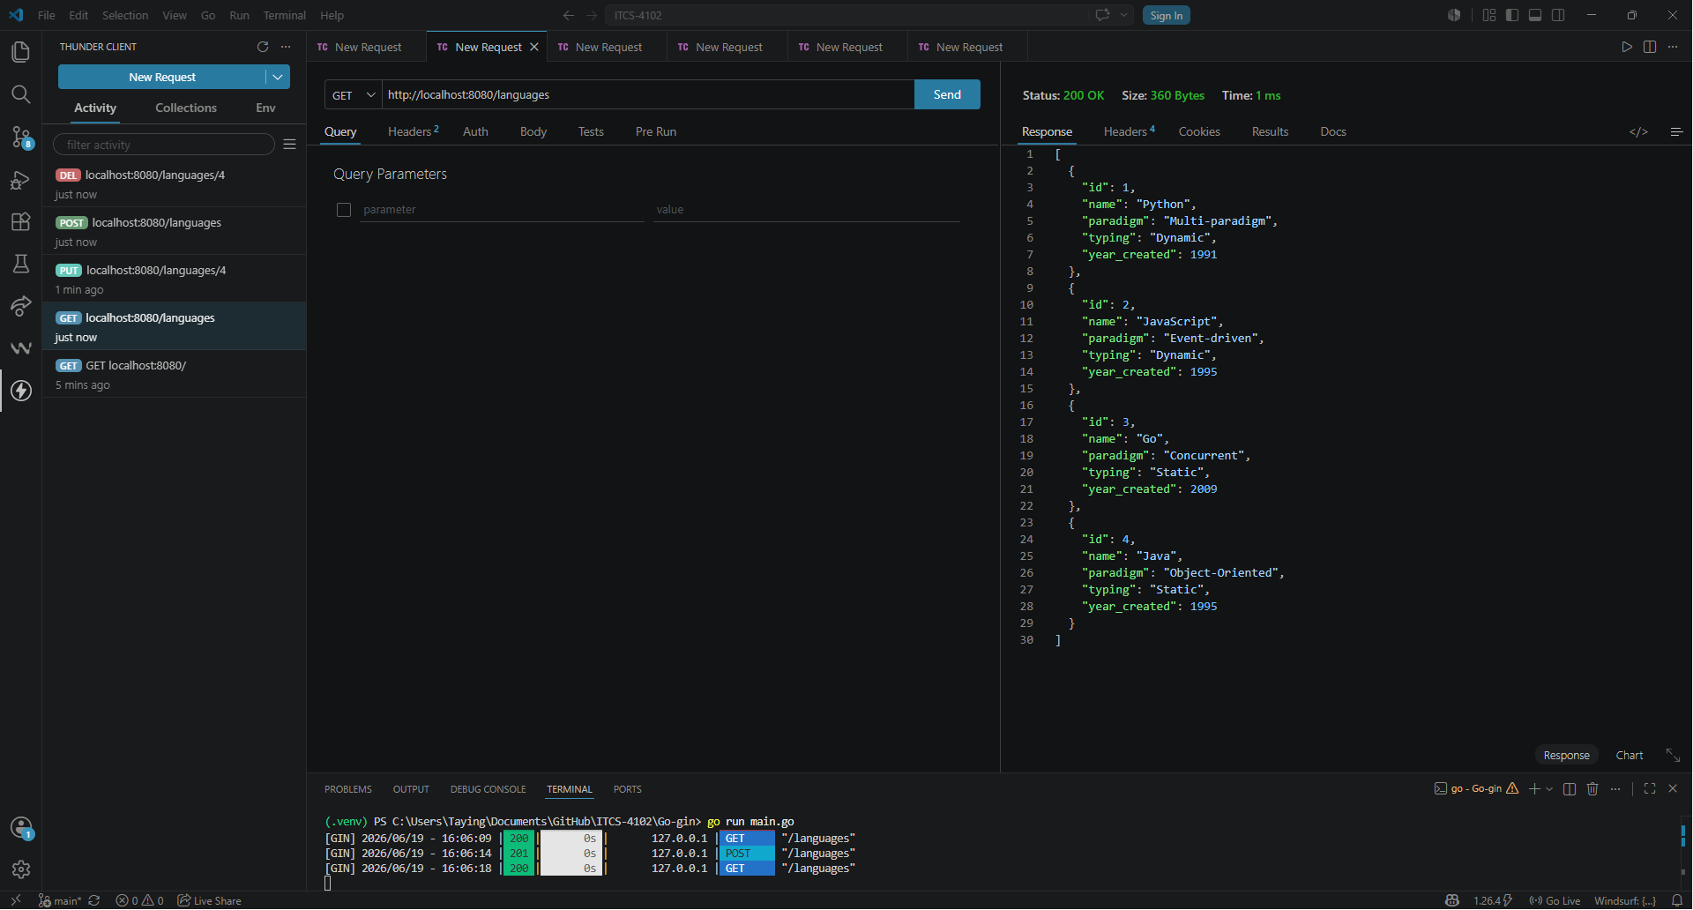
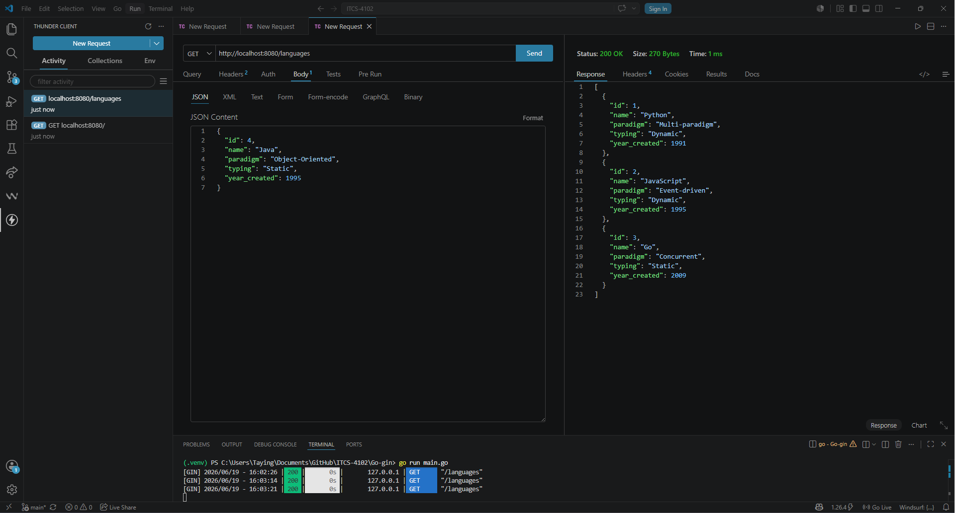

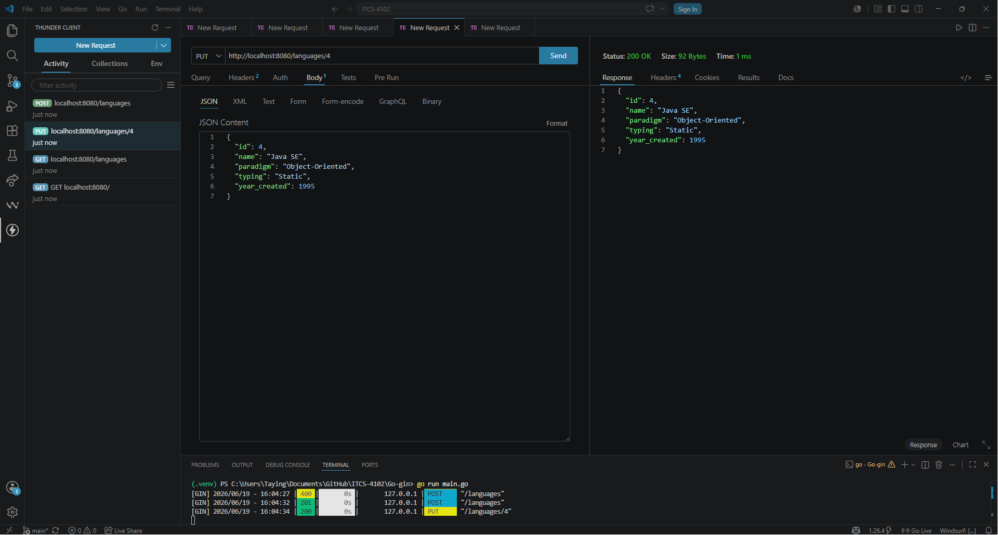
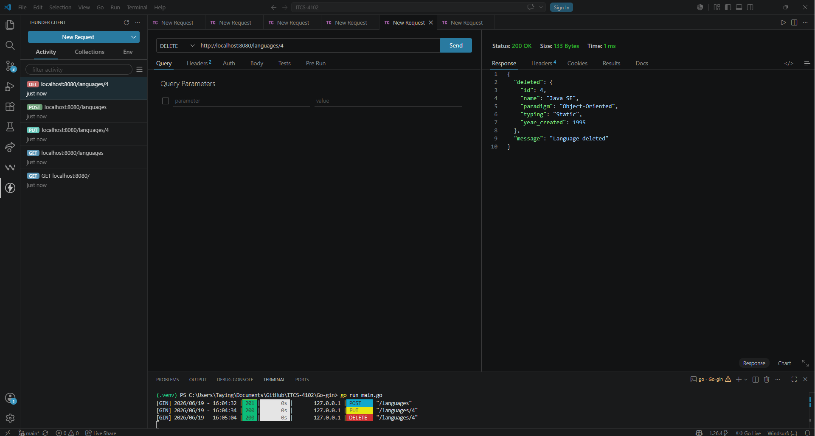
# Testing

All three implementations were tested successfully.

Python was tested using Swagger UI.

JavaScript and Go were tested using Thunder Client.

Each implementation successfully completed the following operations:

* Retrieve all languages

* Retrieve one language

* Add a language

* Update a language

* Delete a language

Testing screenshots are included within the project.

---

# Programming Language Comparison

| Feature | Python | JavaScript | Go |

| ----------------- | ---------------------- | --------------------- | --------------------- |

| Typing | Dynamic | Dynamic | Static |

| Compilation | Interpreted | Interpreted (Node.js) | Compiled |

| Framework | FastAPI | Express | Gin |

| Readability | Excellent | Good | Good |

| Performance | Good | Good | Excellent |

| Learning Curve | Easy | Moderate | Moderate |

| API Documentation | Automatic Swagger | Manual Testing | Manual Testing |

| Best Use | AI, APIs, Data Science | Web Development | High Performance APIs |

---

# Discussion

Python provided the easiest development experience because FastAPI automatically generated API documentation and handled much of the validation process.

JavaScript required additional setup but benefited from an extensive ecosystem and flexibility through Express.

Go required more explicit programming but produced efficient and highly performant applications. Static typing also reduced the possibility of runtime type errors.

Each language successfully implemented the same REST API while demonstrating different design philosophies and development workflows.

---

# Conclusion

This project demonstrated that the same software problem can be solved effectively using multiple programming languages.

Although the resulting APIs behaved identically from the user's perspective, the development process differed significantly between Python, JavaScript, and Go.

Python emphasized simplicity and rapid development.

JavaScript emphasized flexibility and ecosystem support.

Go emphasized performance, reliability, and simplicity.

Overall, Python was the easiest language to develop with, JavaScript provided the most flexibility, and Go produced the most efficient implementation.

The project successfully achieved its objectives by comparing three programming languages through the implementation of identical RESTful CRUD APIs.

---

# References

* FastAPI Documentation

* Express.js Documentation

* Gin Web Framework Documentation

* Go Programming Language Documentation

* Python Documentation

* Node.js Documentation

* Visual Studio Code Documentation

* Thunder Client Documentation

