CS378IOS



**Group Number:** 6 **Application Name:** todo **Group Members:**

Nelma PereraRodriguez (np8259)

Quyen Castellanos (qac68)

Kiu Lam (kl26725)

Mockups Paper

Mockups and Operational Description:

|  |  |
| --- | --- |
| Screens and Operational Description | |
|  |  |
| On the login screen users can either login or sign up for an account. | Where User fills the Sign Up data and is added to the database. |

|  |  |
| --- | --- |
| Requester’s Screen in Time and  Operational Description | Tutor’s Screen at the Same Time and Operational Description |
|  |  |
| This is the first screen after log in. This screen shows a summary of dots balance and movements in a given time.  Using the on/off swich the user select if he wants to be on tutor mode (on), means ready to give tutoring, or if he wants to ask for help (off) and do not be disturbed with tutoring requests.  This screen is showing the user on requester mode, means he wants to ask for help.  The “Request Tutoring” button is the starting point that triggers the request process.  The right nav button is for sign out and to return to the login screen. | This is the first screen after log in. This screen shows a summary of dots balance and movements in a given time.  Using the on/off swich the user select if he wants to be on tutor mode (on), means ready to give tutoring, or if he wants to ask for help (off) and do not be disturbed with tutoring requests.  This screen is showing the user on tutor mode, means he is ready to help others and earn some dots.  The “Request Tutoring” button is disable on this mode, since in the tutor mode the user is waiting for tutoring request.  The right nav button is for sign out and to return to the login screen. |

|  |  |
| --- | --- |
| Requester’s Screen in Time and  Operational Description | Tutor’s Screen at the Same Time and Operational Description |
|  |  |
| After pressing the “Request Tutoring” button and the screen before this, the requester is driving to a form he needs to fill with the detail data needed to match him with a tutor.  After the form is filled the user tap “Send Request” button. Then the app will try to match the subject filled with subjects on the database of users on tutoring mode at this moment, if matches are found then the request is sent to those who matched. | Nothing happen at this time, yet, on tutoring mode, he is still waiting with the same home screen. |

|  |  |
| --- | --- |
| Requester’s Screen in Time and  Operational Description | Tutor’s Screen at the Same Time and Operational Description |
|  |  |
| The app is working on the matching process, and sending request to those who match, noone is yet acepted the request. | The tutor/tutors who match received the request with the related data and then they the option to accept or not.  If they do not accept then the app returns to tutor’s home screen.  If they accept then they are driven to the next screen.  At the same time, the requester is just waiting. |

|  |  |
| --- | --- |
| Requester’s Screen in Time and  Operational Description | Tutor’s Screen at the Same Time and Operational Description |
|  |  |
| After the tutor acepted the request the requester has the option to start the session or cancel.  If he cancel he is driven to the requester home screen and tutor is notified.  If he wants to continue then when they meet each other he is able to start the tutoting session. On this case tutor is more concerned to start the session than the requester, that’s why the control of starting is given to the requester, and avoid the tutor to start earning dots before they meet each other. | On this screen the tutor is suppose to be walking on the requester direction and meet with him sometime soon.  After they meet, the tutor is able to see if the requester tap “Start Session” or not, just when this screen change to a open session time/dots counter. |

|  |  |
| --- | --- |
| Requester’s Screen in Time and  Operational Description | Tutor’s Screen at the Same Time and Operational Description |
|  |  |
| After the requester tap on “Start Session”, the session of tutoring start and this screen will reflect the time is passing and amount of dots the requester is paying until this time.  The time and amount of dots represented on this screen are not static, they change as the time pass, they are counters to let the user knows how much the session is costing. | After the requester tap on “Start Session”, the session of tutoring start and this screen will reflect the time is passing and amount of dots the tutor is earning until this time.  The time and amount of dots represented on this screen are not static, they change as the time pass, they are counters to let the user knows how much the session is costing.  When the tutor finished the tutoring session, he can tap on “Finish Session” button, and both requester and tutor will return to their respective home screens. The control of finishing the session was given to the tutor to avoid the requester finish the session before the tutor session is in fact finished on real life. On the other hand, is harder for tutors to cheat on this one because the requester will be notice instantly if the session finished and the tutor didn’t tap on “Finish Session”. |

|  |  |
| --- | --- |
| Requester’s Screen in Time and  Operational Description | Tutor’s Screen at the Same Time and Operational Description |
|  |  |
| This will be the same requester home screen, just with updated values reflecting the last transaction session.  (We think to put again other home screen is redundant, since the point is clear enough just putting one of them). | After the tutor tap on “Finish Session” he is returning to his home screen with an already updated summary. |

|  |  |
| --- | --- |
| Screens and Operational Description | |
|  |  |
| History Screen shows the previous records tutor or requesters had been seeker helped or helped someone on the tutor session. For example:  On every cells, there will be a bold textview, to indicate whether user had helped, or got helped from a person, along with the corresponding user picture,  There will also a time below, with an icon of a clock, and a location, with an icon of a needle. | On the notifications screen, accessible from the notifications tab, users can view previous notifications that they have received. Some notifications include when another user has specifically requested to be tutored by them, when a user's balance has recently been updated, or when new, current tutoring opportunities are available. |

|  |  |
| --- | --- |
| Screens and Operational Description | |
|  |  |
| On the user profile screen, accessible from the profile tab, users can view their own profile which includes information like their name, a photo, and their tutoring activity. | When entered the setting tab, you can adjust multiple option, in order to fit each tutors or students need. Here are several option I had thought of for the tutors:  If the app goes offline, then tutors wouldn’t receive any updated, message or other related stuff from the app.  Gapless is an alternative option for tutors who demand unlimited, or restless, experience of tutoring students, the more tutors “stayed”, the more dots they gained.  In the opposite, if tutors want some “gap” time between each tutor session in order to adjust themselves, they may as well setup it up in “Tutoring request”  Apart from adjusting themselves for using the app in their need, tutor can also edit their own profiles, such as updating, change pictures etc., the same for the requesters.  If tutors made a mistake while adjusting the app, they may restore to default. |

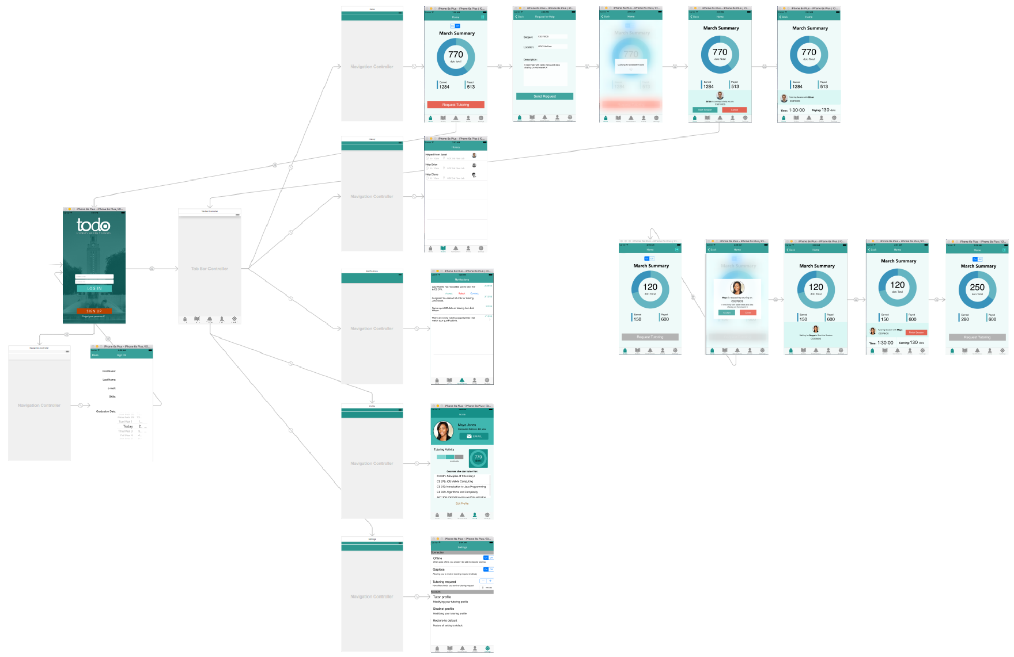

Tutor’s Screens