新闻解读与归因智能体
输入：
- 多条新闻（标题 + 正文 或 标题 + 简述）
- 时间戳（可选）

输出：
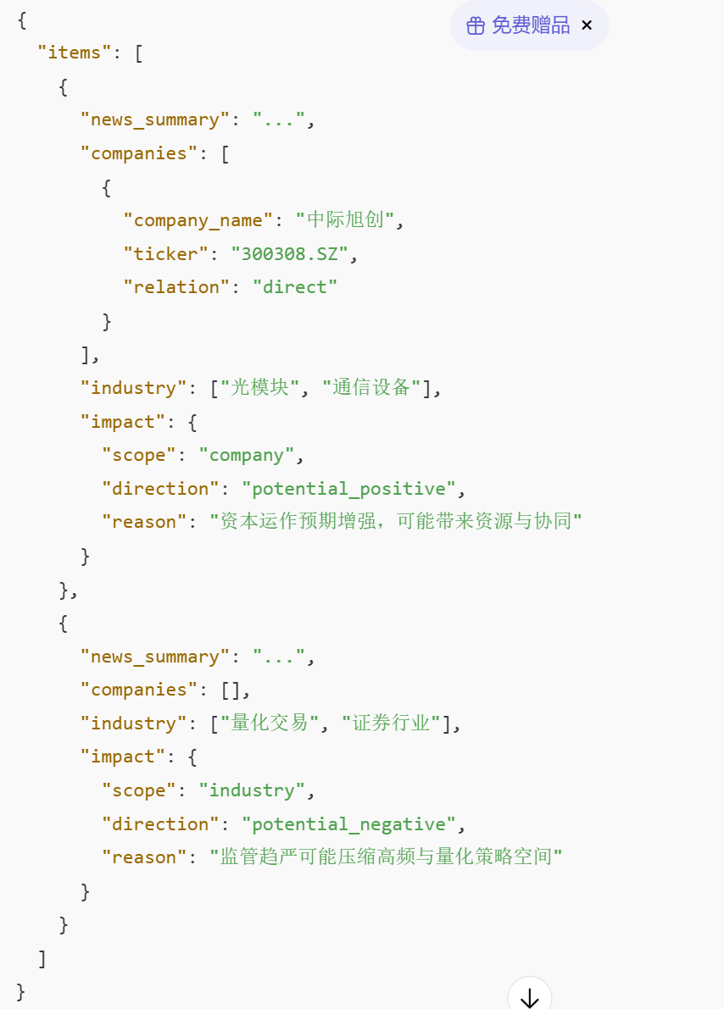

新闻筛选层
News Selector Agent
新闻选取逻辑：
输入：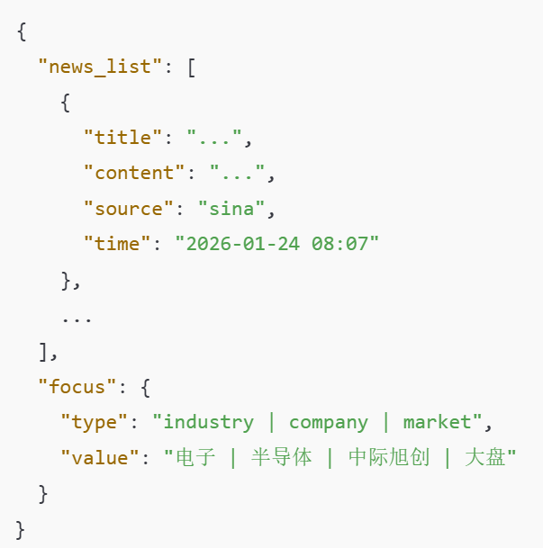
输出：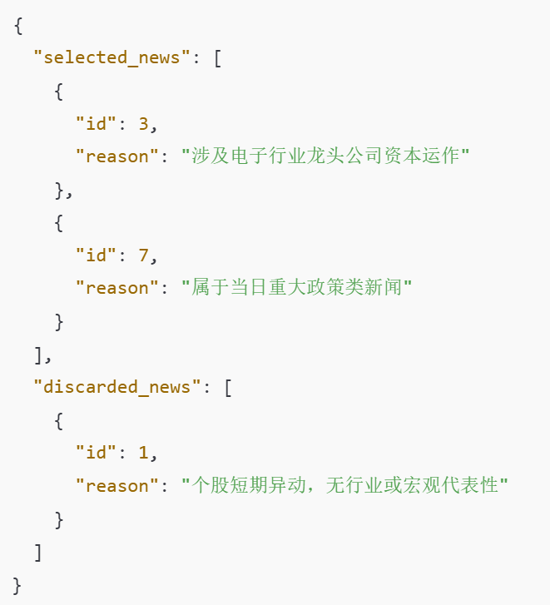
行业相关性筛选：是否涉及：
- 行业关键词
- 行业龙头
- 行业政策
重大性筛选：是否满足：
- 政策 / 监管 / 制度
- 央行 / 证监会 / 国务院
- 影响面广（非单一公司）
时效性筛选：是否：
- 当日 / 前 24h
- 突发事件
- 明确时间节点（发布 / 执行）

输入market analyst之间的格式要求：
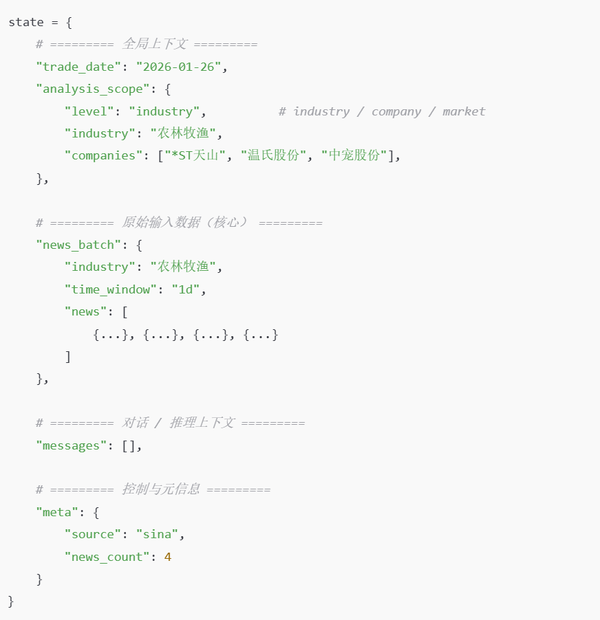
东方财富舆情信息：
正文帖子：
{
"post_is_like": false,
"post_is_collected": false,
"post_status": 0,
"source_post_id": 0,
"source_post_state": 0,
"source_post_user_id": "",
"source_post_user_nickname": "",
"source_post_user_type": 0,
"source_post_user_is_majia": false,
"source_post_user_extendinfos": {},
"source_post_pic_url": [],
"source_post_title": "",
"source_post_content": "",
"source_post_ip": "",
"source_post_type": 0,
"source_post_guba": {
"stockbar_type": -1,
"stockbar_code": "",
"stockbar_inner_code": null,
"stockbar_name": "",
"stockbar_market": "",
"stockbar_quote": -1,
"stockbar_exchange": -1,
"stockbar_external_code": ""
},
"source_post_from": "股吧网页版",
"source_post_like_count": 0,
"source_comment_count": "",
"selected_post_code": "",
"selected_post_name": "",
"selected_relate_guba": null,
"source_extend": null,
"source_post_source_id": "",
"zwpage_flag": 0,
"source_post_comment_count": 0,
"post_from_num": 31,
"content_type": 1,
"media_type": 1,
"source_modules": [],
"post_content": "近日，黄金价格先涨到5500多美元，然后又出现下跌走势，一度击穿4700美元，创下了40年来最大单日跌幅，在这样的情况下，一位男子竟然又趁着金价下跌，花费20多万购买了200克金子，感觉胆子也是太大了。\n就在前几年的时候，2023年5月，国际金价大概也就是1900多美元一盎司的样子，折算下来 ，黄金价格大概也就是450元左右一克的样子，而到了前几天，黄金价格最高涨到了5500美元一盎司，折合金 价也达...",
"post_abstract": "",
"post_publish_time": "2026-02-01 12:31:32",
"post_display_time": "2026-02-01 12:31:32",
"post_ip": "",
"post_state": 0,
"post_checkState": 0,
"post_forward_count": 75,
"post_comment_authority": 0,
"post_like_count": 180,
"post_type": 20,
"post_source_id": "20260201123133097522490",
"post_top_status": 0,
"post_from": "东方财富iPhone版",
"post_has_pic": true,
"post_pic_url": [
"https://gbres.dfcfw.com/Files/picture/20260201/size500/8DFC2DACFF8931B7A67F397BD76EE14F_w480h853.jpg"
],
"ask_question": "",
"ask_answer": "",
"qa": null,
"extend": {
"ZMTBizType": 0,
"ZMTLKType": 0,
"ZMTLKVideoID": "",
"ZMTLKVideoState": 0,
"ZMTLKVideoUIStyle": 0,
"ZMTLKStartTime": "",
"ZMTLKEndTime": "",
"ZMTLKCover": "",
"ZMTLKHCover": "",
"ZMTLKVCover": "",
"ZMTLKHotScore": 0,
"ZMTLKWebDistType": 0,
"ZMTLKHotScoreSwitch": false,
"ZMTLKAppDistType": 0,
"ZMTLKMpParam": null,
"ZMTLKExt": null,
"ListImage": "",
"ex_topic": [
{
"id": "8089",
"name": "复盘记录",
"h5_url": "https://mgubatopic.eastmoney.com/#/topic_v2/8089",
"guide": "",
"version": 1
},
{
"id": "8091",
"name": "强势机会",
"h5_url": "https://mgubatopic.eastmoney.com/#/topic_v2/8091",
"guide": "",
"version": 1
}
]
},
"post_pic_url2": [],
"relate_topic": {
"id": "8089",
"name": "复盘记录",
"h5_url": "https://mgubatopic.eastmoney.com/#/topic_v2/8089",
"guide": "",
"version": 1
},
"post_atuser": [],
"reply_list": [
{
"reply_id": 9839787801,
"reply_user": {
"user_id": "8069366092908748",
"user_nickname": "八分清醒两分醉",
"user_name": "g8069366092908748",
"user_v": 0,
"user_type": 0,
"user_is_majia": false,
"user_level": 0,
"user_first_en_name": "八分清醒两分醉",
"user_age": "5.2年",
"user_influ_level": 6,
"user_black_type": 0,
"user_third_intro": null,
"user_bizflag": "2",
"user_bizsubflag": "",
"passport_medal_details": {
"medal_list": [],
"medal_count": 0
},
"user_extendinfos": {
"user_accreditinfos": null,
"deactive": "0",
"user_v_hide": null,
"user_column": "0",
"is_enterprise": "false",
"new_medal": "{\"medal_list\":[],\"medal_count\":0}",
"asset_rank": null,
"spzhshow": null
}
},
"reply_ar": "上海网友",
"reply_time": "2026-02-01 13:56:44",
"reply_text": "这个男子有实力，有眼光。全球人均黄金只有35克，首饰，电子，航天，医疗，各国 央行，五大需求非常强劲，剩下的能让普通人购买的金条数量极其有限，三年金价必翻倍，未来万元1克不是 梦！ ",
"source_reply": [],
"reply_picture": "",
"reply_is_author": false
},
{
"reply_id": 9839796862,
"reply_user": {
"user_id": "7061047661490608",
"user_nickname": "豪爽大气的朱涛",
"user_name": "u7061047661490608",
"user_v": 0,
"user_type": 0,
"user_is_majia": false,
"user_level": 0,
"user_first_en_name": "豪爽大气的朱涛",
"user_age": "1个月",
"user_influ_level": 3,
"user_black_type": 0,
"user_third_intro": null,
"user_bizflag": "",
"user_bizsubflag": "",
"passport_medal_details": {
"medal_list": [],
"medal_count": 0
},
"user_extendinfos": {
"user_accreditinfos": null,
"deactive": "0",
"user_v_hide": null,
"user_column": "0",
"is_enterprise": "false",
"new_medal": "{\"medal_list\":[],\"medal_count\":0}",
"asset_rank": null,
"spzhshow": null
}
},
"reply_ar": "上海网友",
"reply_time": "2026-02-01 14:36:22",
"reply_text": "别人恐惧我贪婪，准备明天抄底 ",
"source_reply": [],
"reply_picture": "",
"reply_is_author": false
}
],
"repost_state": 0,
"modules": [],
"spec_column": "",
"post_mod_time": "",
"reptile_state": 0,
"allow_likes_state": 0,
"disable_color": 0,
"top_like_user": null,
"post_id": 1663300498,
"post_user": {
"user_id": "4740093981553674",
"user_nickname": "陈添财论市2026",
"user_name": "m4740093981553674",
"user_v": 0,
"user_type": 0,
"user_is_majia": false,
"user_level": 0,
"user_first_en_name": "陈添财论市2026",
"user_age": "12年",
"user_influ_level": 8,
"user_black_type": 0,
"user_third_intro": null,
"user_bizflag": "2",
"user_bizsubflag": "",
"passport_medal_details": {
"medal_list": [],
"medal_count": 0
},
"user_extendinfos": {
"user_accreditinfos": null,
"deactive": "0",
"user_v_hide": null,
"user_column": "0",
"is_enterprise": "false",
"new_medal": "{\"medal_list\":[],\"medal_count\":0}",
"asset_rank": null,
"spzhshow": null
}
},
"post_guba": {
"stockbar_type": 100,
"stockbar_code": "002165",
"stockbar_inner_code": "002165",
"stockbar_name": "红宝丽吧",
"stockbar_market": "002165.sz",
"stockbar_quote": 1,
"stockbar_exchange": 101,
"stockbar_external_code": "002165"
},
"post_title": "胆子太大了！男子看金价下跌又买20多万！",
"post_last_time": "2026-02-01 19:02:40",
"post_click_count": 58516,
"post_comment_count": 346,
"post_address": null,
"post_is_hot": true
}
观点型帖子：
{ "post_id": 1663327468, "post_title": "齐翔腾达30万吨你们不买！买这个", "stockbar_code": "002165", "stockbar_name": "红宝丽吧", "stockbar_type": 100, "stockbar_exchange": 101, "user_id": "1313013732702448", "user_nickname": "n131313732702448", "user_extendinfos": { "user_accreditinfos": null, "deactive": "0", "user_v_hide": null, "user_column": "0", "is_enterprise": "false", "new_medal": "{\"medal_list\":[],\"medal_count\":1}", "asset_rank": "{\"BadgeCode\":\"BD256\",\"Level\":5,\"LevelName\":\"V3\",\"LevelDesc\":\"东 方财富证券实盘用户\",\"PicSmall\":\"https://avator.eastmoney.com/badge/BD256/small_5.png\",\"IsHidden\":false}", "spzhshow": null }, "post_click_count": 137, "post_forward_count": 0, "post_comment_count": 3, "post_publish_time": "2026-02-01 17:31:24", "post_last_time": "2026-02-01 17:58:40", "post_type": 0, "post_state": 0, "post_from_num": 42, "v_user_code": "0", "post_top_status": 0, "post_has_pic": false, "post_has_video": false, "user_is_majia": false, "post_ip": "", "qa": null, "grade_type": null, "institution": null, "notice_type": null, "notice_type_code": null, "post_display_time": "2026-02-01 17:31:24", "media_type": 0, "zmt_article": null, "post_source_id": "", "bullish_bearish": 0, "modules": [], "spec_column": "", "cms_media_type": 0, "art_unique_url": null }

咨训型帖子（不能直接提供正文部分）：
{"post_id":1663317626,"post_title":"红宝丽：环氧丙烷综合技术改造项目进入试生产前期准备阶段","stockbar_code":"002165","stockbar_name":"红宝丽吧","stockbar_type":100,"stockbar_exchange":101,"user_id":"5496113638111728","user_nickname":"红宝丽资讯","user_extendinfos":{"user_accreditinfos":null,"deactive":"0","user_v_hide":null,"user_column":"0","is_enterprise":"false","new_medal":"{\"medal_list\":[],\"medal_count\":0}","asset_rank":null,"spzhshow":null},"post_click_count":5150,"post_forward_count":4,"post_comment_count":27,"post_publish_time":"2026-02-01 15:53:59","post_last_time":"2026-02-01 19:20:05","post_type":1,"post_state":0,"post_from_num":5,"v_user_code":"0","post_top_status":1,"post_has_pic":false,"post_has_video":false,"user_is_majia":true,"post_ip":"","qa":null,"grade_type":null,"institution":null,"notice_type":null,"notice_type_code":null,"post_display_time":"2026-02-01 15:52:28","media_type":0,"zmt_article":null,"post_source_id":"202602013637883445","bullish_bearish":0,"modules":[],"spec_column":"","cms_media_type":0,"art_unique_url":null},{"post_id":1663315527,"post_title":"红宝丽:股票交易异常波动公告","stockbar_code":"002165","stockbar_name":"红宝丽吧","stockbar_type":100,"stockbar_exchange":101,"user_id":"5496113638111728","user_nickname":"红宝丽资讯","user_extendinfos":{"user_accreditinfos":null,"deactive":"0","user_v_hide":null,"user_column":"0","is_enterprise":"false","new_medal":"{\"medal_list\":[],\"medal_count\":0}","asset_rank":null,"spzhshow":null},"post_click_count":426,"post_forward_count":2,"post_comment_count":27,"post_publish_time":"2026-02-01 15:31:44","post_last_time":"2026-02-01 18:17:30","post_type":3,"post_state":0,"post_from_num":5,"v_user_code":"0","post_top_status":1,"post_has_pic":false,"post_has_video":false,"user_is_majia":true,"post_ip":"","qa":null,"grade_type":null,"institution":null,"notice_type":"股票交易异常波动","notice_type_code":"001002004007","post_display_time":"2026-02-02 00:00:00","media_type":0,"zmt_article":null,"post_source_id":"AN202602011819066364","bullish_bearish":0,"modules":[],"spec_column":"","cms_media_type":0,"art_unique_url":null,"title_ch":""}

