# Labo 5

## Figure2: schematic with AXI-timer

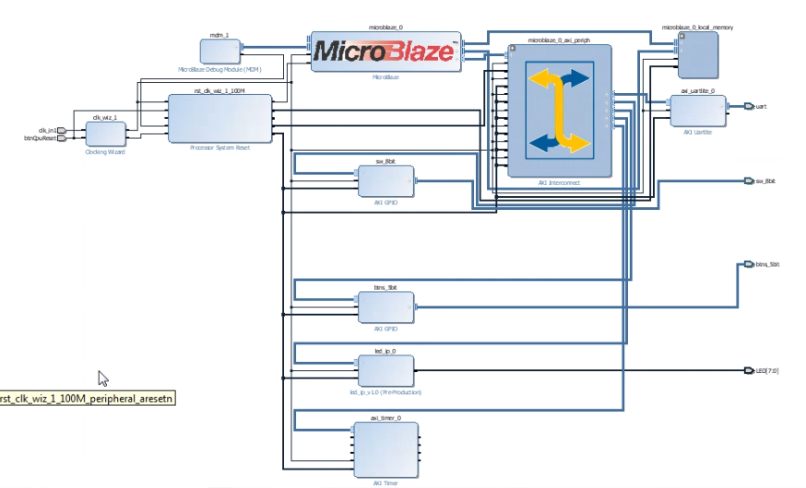

## Code fig 6 en 7 aangevuld

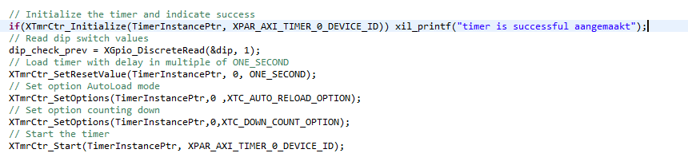

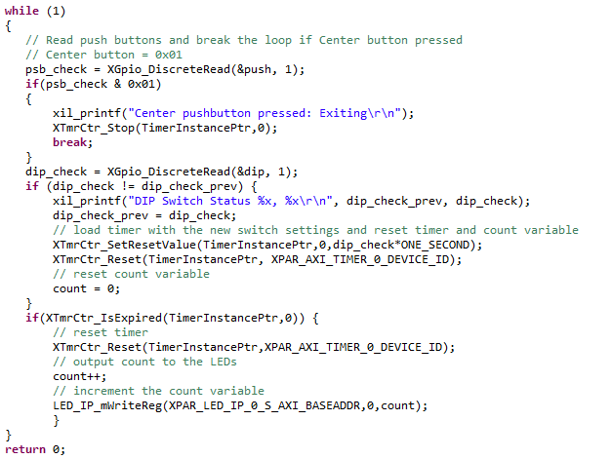

## 4-1-3 Breakpoints

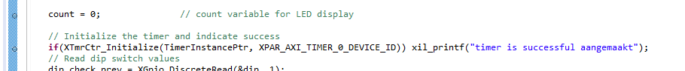

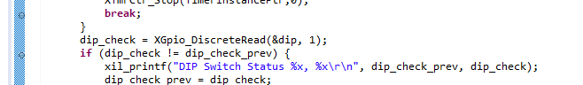



## Register & memory

