**Lab Task:**

Implement the following network on packet tracer.

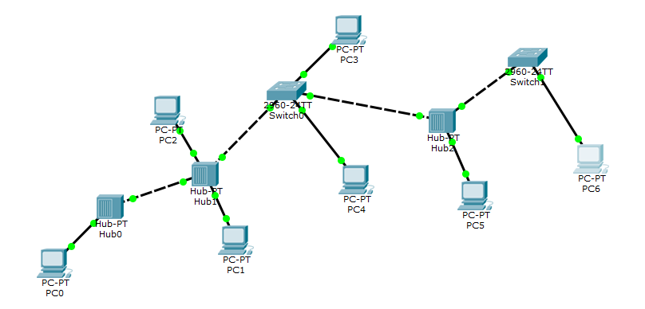

Ping,

1. PC0 from PC5,
2. PC6 from PC2,
3. PC3 from PC1,

Also, display the above results in the simulation mode of packet tracer. Attach snapshots of the pinging results and the network created.

Complete the following table:

|  |  |
| --- | --- |
| End Device | IP Used |
| PC0 |  |
| PC1 |  |
| PC2 |  |
| PC3 |  |
| PC4 |  |
| PC5 |  |
| PC6 |  |

**NOTE:**

The commands must be run on the command prompt and clear snapshots with headings must be attached with proper numbering. Answers to the other questions must be given on a separate sheet, typed or handwritten with proper numbering. Any other formats apart from the above will not be entertained.

**SOLUTION:**

|  |  |
| --- | --- |
| End Device | IP Used |
| PC0 | 192.168.10.2 |
| PC1 | 192.168.10.4 |
| PC2 | 192.168.10.6 |
| PC3 | 192.168.10.8 |
| PC4 | 192.168.10.10 |
| PC5 | 192.168.10.12 |
| PC6 | 192.168.10.14 |
|  |  |
|  |  |
|  |  |

**Simulation mode:**

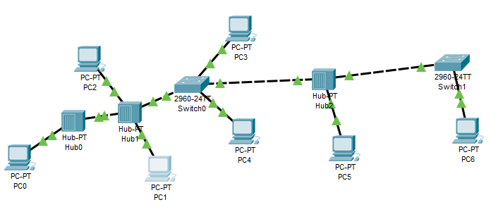

**Ping,**

1. **PC0 from PC5,**

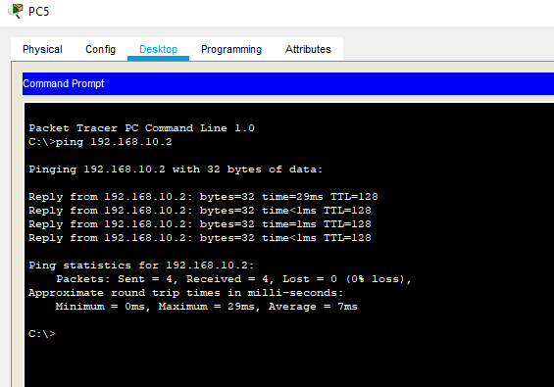

1. **PC6 from PC2,**

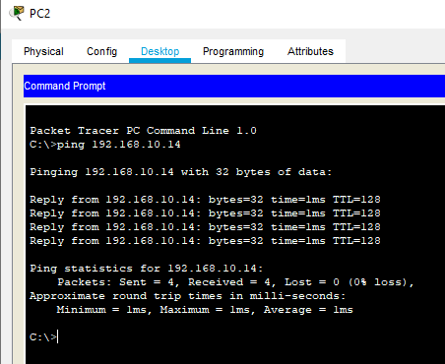

1. **PC3 from PC1,**

