**LAB TASKS:**

# **Define following network terminologies:**

## **EIA/TIA 568A and 568B standards:**

The EIA/TIA 568A and 568B standards pertain to twisted pair wires. These are the two cable pinout standards that are regulated by the Telecommunications Industry Association/Electronic Industries Alliance (TIA/EIA). The TIA 568A and 568B pinout standards specify the ordering of the wires to ensure that proper networking communication can take place.

## **Color combination of straight and cross Ethernet cable**

Below is the given colors scheme followed in each standard.

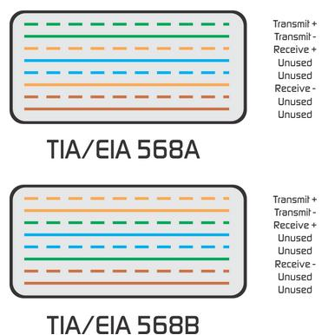

## **Unshielded Twisted Pair (UTP) & Shielded Twisted Pair (STP)**

STP and UTP both are types of twisted pair cables. the main difference between STP ([Shielded Twisted Pair Cables](https://www.paradisespecialitycables.com/38-shielded-cables-shielded-twisted-pair-wire-multi-conductor-cable)) and UTP ([Unshielded Twisted Pair Cables](https://www.paradisespecialitycables.com/51-lan-cables-ethernet-lan-cat6a-cat5-cable-at-best-price)) is manufacturing difference. STP cables are twisted and enclosed with in foil where in UTP cables with wires are twisted together.

**Difference**

* UTP data rate is slow as comparatively to STP.
* UTP is cheap as comparatively to STP.
* UTP reduce Noise high comparatively STP.
* UTP works on LAN (Local Area Network) where STP works on Ethernet Network.
* UTP easily Installed and Flexible as comparatively to STP.

## **Straight Through and Cross-over Ethernet Cable**

Ethernet cable connect LAN and share signal among them.

Straight through ethernet cable is the one, which both ends of wire are following color scheme of 568A OR both ends are following 568B color scheme.

Crossover ethernet cable is the one, where both ends of the wire are following different color scheme i.e. one end has 568A and another end has 568B.

## **RJ-45 connector**

RJ-45 connector is basically plugged to NIC. It consists of totally 8 cables which means 4 pairs. Unlike RJ-11 which have 2 pairs, or 4 cables. RJ-45 can be of male type or female type.

## **What are precautionary measures to be taken care of while dealing with the ethernet cables (setting up ethernet cable wiring)**

* Do not use stapler to secure UTP cables. Use telephone wire hangers.
* Keep cables away from devices that can inject noise into them.
* Try not to run cables parallel to power cables.
* Do not bend cables less than four times the diameter of the cable.
* Avoid stretching UTP cables (power should not exceed 25 lbs).
* Do not run UTP cable outside the building.
* If you tie a group of cables together with cable ties (zip ties), do not pinch them too much.