**Lab Assignments:**

* **Run the following commands on the command prompt of your PCs and attach snapshots of the result:**

1. **ping** [**www.google.com**](http://www.google.com)

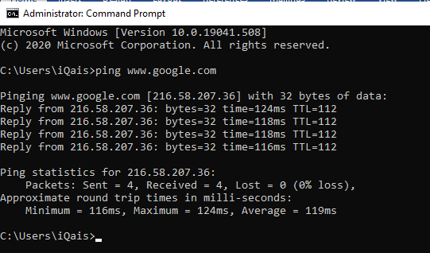

1. **tracert** [**www.yahoo.com**](http://www.yahoo.com)

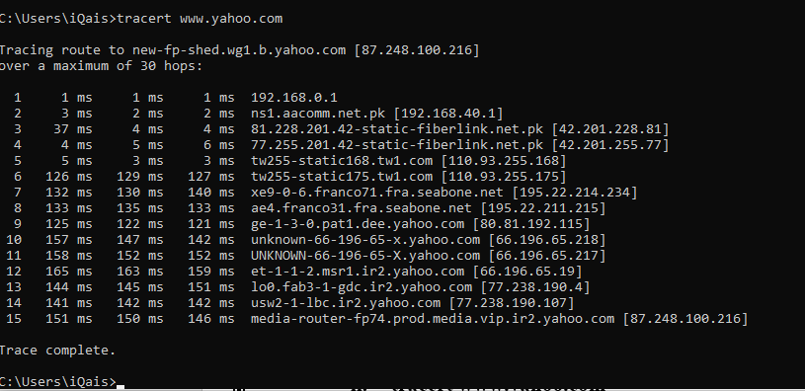

It took 15 hops to get to [www.yahoo.com](http://www.yahoo.com)

1. **ping -i 6 www.facebook.com, did you receive the correct reply? If not, explain why.**

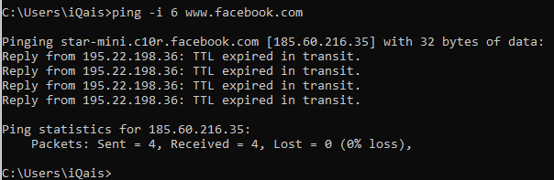

* TTL is “Time-To-Live”
* The ping request is failed with *TTL expired in transit.* The response also indicate the IP address of the router where the TTL expired.
* This error indicates network configuration problem. There is **loop in routing.**

1. **nslookup www.live.com, did you result show ‘Non-authoritative answer’? If yes, explain what does it indicate, you are advised to browse the internet to attain this answer.**

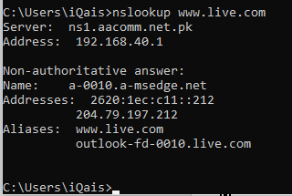

* Yes. Authoritative answers only come from servers which directly host the data; non-authoritative answers come from caches/proxies.
* nslookup www.live.com, I would get a response from one of my configured nameservers. (Either from my ISP, or my domain.) It would come back as non-authoritative because neither my ISP's nameservers, nor my own are in the list of nameservers for www.live.com. They aren't Live’s nameservers, so they're not the authoritative source that creates the NS records.

**Differentiate between Ping and PathPing commands.**

1. [Ping command](https://www.omnisecu.com/tcpip/ping-command-tool.php) is used to test the network connectivity between end points, that is between source and destination. If you are getting a proper success output from the [ping command](https://www.omnisecu.com/tcpip/ping-command-tool.php), the meaning is that the [IPv4 datagram](https://www.omnisecu.com/tcpip/ipv4-protocol-and-ipv4-header.php) packet can reach up to destination IPv4 address.
2. [Pathping command](https://www.omnisecu.com/tcpip/pathping-command-tool.php) can be used to test the network connectivity between end points, that is between source and destination. [Pathping command](https://www.omnisecu.com/tcpip/pathping-command-tool.php" \t "_blank) can also trace the path followed by and [IPv4 datagram](https://www.omnisecu.com/tcpip/ipv4-protocol-and-ipv4-header.php) from source to destination. But [pathping command](https://www.omnisecu.com/tcpip/pathping-command-tool.php" \t "_blank) can also find the packet loss and network latency between source and destination and also between network links.

* **Find all Active/ Used IP addresses on your network.**

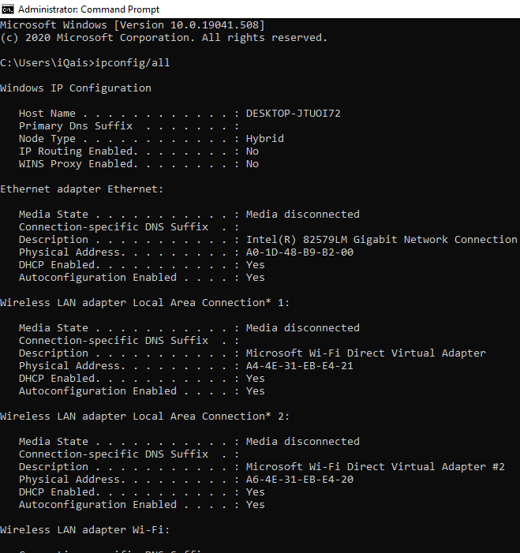

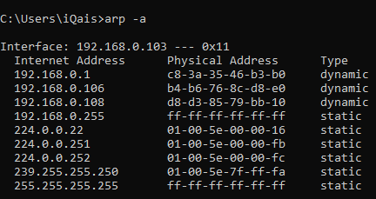

* **How to verify connection with remote computer?**

