**Lab Tasks:**

1. **On Cisco routers, where is the running configuration loaded from?**

* If console wire is connected between an end device like pc and a network device e.g. switch only then we can get the access of terminal or command line interface. And when we have access of terminal then we can do all the configuration
* Console wire must be connected from RS232 to Console.
* Then we click on switch and go to option of CLI as given in screenshot below.

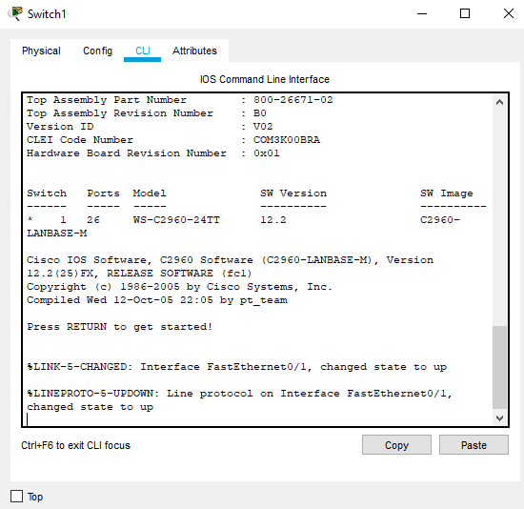

1. **What does the flash memory on a router store?**

* Flash memory is basically Non-volatile memory because all the data in it doesn't get erased after shutting down.
* So, it is obvious, that it is storing data.
* It can be electronically programmed as well as erased when needed.
* All the passwords, usernames we have created in IOS (internetwork operating system), all are going store in flash memory of router.
* Similarly, whenever any user login in IOS, then all the data is retrieved from the flash memory.

1. **When you are logged into a router, which prompt indicates that you are in privileged mode?**

* By default, when we start work on CLI we start from USER EXEC mode.
* The prompt here looks like as **Switch>**

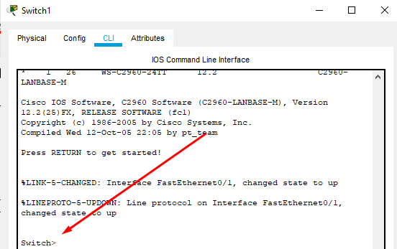

* Then to go to privileged mode we type **enable** or **en**

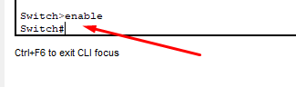

* Here Switch# indicates that we are in privileged mode.

1. **On which modes in Cisco's IOS you can issue show commands?**

* privileged mode can issue show command.
* First let add new user

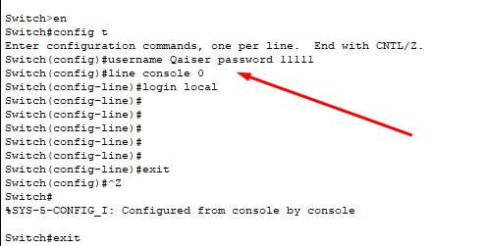

* Now we go to privileged mode and we can use show command

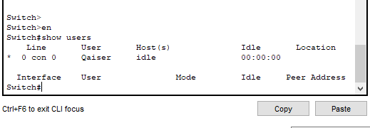

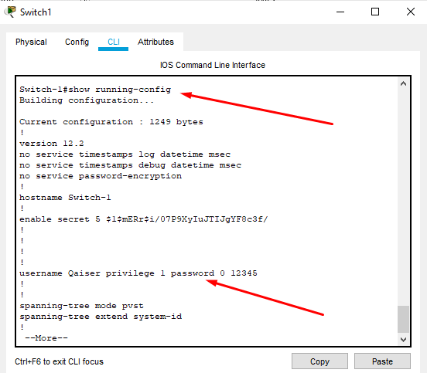

1. **Configure Switch hostname as Switch-1.**

Switch>enable

Switch#configure terminal

Enter configuration commands, one per line. End with CNTL/Z.

Switch(config)#hostname Switch-1

Switch-1(config)#

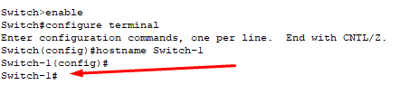

1. **Configure the message of the day as "Unauthorized access is restricted".**

Switch-1(config)#banner motd Q

Enter TEXT message. End with the character 'Q'.

Unauthorized access is restricted

Q

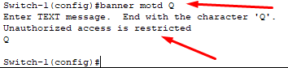

1. **Configure a password for privileged mode access as "DCNLAB". The password must be encrypted.**

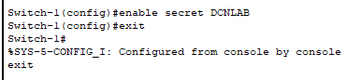

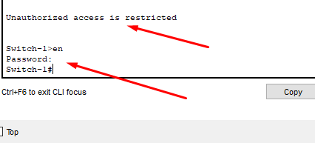

**How to verify?**

