**Lab Task:**

1. **Take 4 switches named as: A, B, C, D and connect them in alphabetical order.**

**Perform and show the following configurations in your lab task:**

* 1. **Switch A with VLANs faculty and students having 1 logical port each.**
  2. **Now assign 1 logical port each to VLANs faculty and students in Switch B and D.**
  3. **Now make switch A in server mode, whereas B and D in client mode and switch C in transparent mode.**
  4. **Assign IP addresses to PCs connected to Switch A, B and D.**
  5. **Now ping within the same VLAN and outside the same VLAN and show your results.**

**Solution:**

* 1. **Switch A with VLANs faculty and students having 1 logical port each.**

Switch>en

Switch#config t

Enter configuration commands, one per line. End with CNTL/Z.

Switch(config)#hostname A

A(config)#

A(config)#vlan 2

A(config-vlan)#name faculty

A(config-vlan)#exit

A(config)#vlan 3

A(config-vlan)#name students

A(config-vlan)#exit

A(config)#

%LINK-5-CHANGED: Interface FastEthernet0/1, changed state to up

%LINEPROTO-5-UPDOWN: Line protocol on Interface FastEthernet0/1, changed state to up

%LINK-5-CHANGED: Interface FastEthernet0/2, changed state to up

%LINEPROTO-5-UPDOWN: Line protocol on Interface FastEthernet0/2, changed state to up

A(config)#interface fastethernet 0/1

A(config-if)#switch port mode access

^

% Invalid input detected at '^' marker.

A(config-if)#switchport mode access

A(config-if)#switchport access vlan 2

A(config-if)#exit

A(config)#interface fastethernet 0/2

A(config-if)#switchport mode access

A(config-if)#switchport access vlan 3

A(config-if)#exit

A(config)#exit

Ah#

%SYS-5-CONFIG_I: Configured from console by console

A#show vlan brief

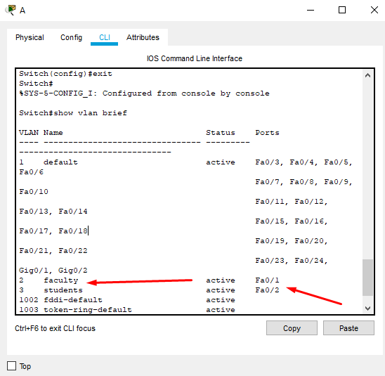

**Now assign 1 logical port each to VLANs faculty and students in Switch B and D.**

Switch>en

Switch#config t

Enter configuration commands, one per line. End with CNTL/Z.

Switch(config)#hostname B

B(config)#

B(config)#vlan 4

B(config-vlan)#name faculty

B(config-vlan)#exit

B(config)#vlan 5

B(config-vlan)#name students

B(config-vlan)#exit

B(config)#interface fastethernet 0/1

B(config-if)#switchport mode access

B(config-if)#switchport access vlan 4

B(config-if)#exit

B(config)#

B(config)#interface fastethernet 0/2

B(config-if)#switchport mode access

B(config-if)#switchport access vlan 5

B(config-if)#exit

B(config)#exit

B#

%SYS-5-CONFIG_I: Configured from console by console

B#show vlan brief

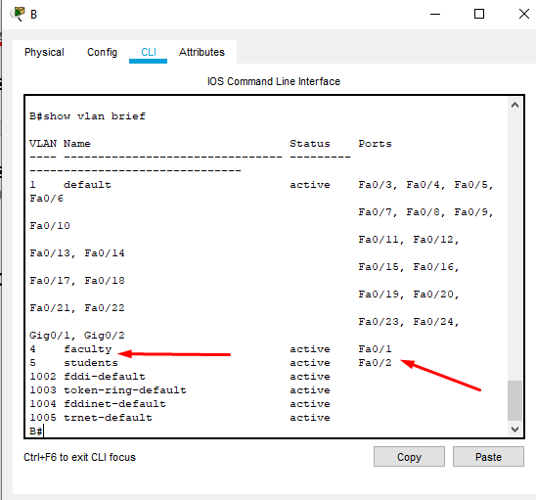

Switch>

Switch>en

Switch#config t

Enter configuration commands, one per line. End with CNTL/Z.

Switch(config)#hostname D

D(config)#vlan 6

D(config-vlan)#name faculty

D(config-vlan)#exit

D(config)#vlan 7

D(config-vlan)#name students

D(config-vlan)#exit

D(config)#

%LINK-5-CHANGED: Interface FastEthernet0/1, changed state to up

%LINEPROTO-5-UPDOWN: Line protocol on Interface FastEthernet0/1, changed state to up

%LINK-5-CHANGED: Interface FastEthernet0/2, changed state to up

%LINEPROTO-5-UPDOWN: Line protocol on Interface FastEthernet0/2, changed state to up

D(config)#interface fastethernet 0/1

D(config-if)#switchport mode access

D(config-if)#switchport access vlan 6

D(config-if)#exit

D(config)#interface fastethernet 0/2

D(config-if)#switchport mode access

D(config-if)#switchport access vlan 7

D(config-if)#exit

D(config)#exit

D#

%SYS-5-CONFIG_I: Configured from console by console

D#show vlan brief

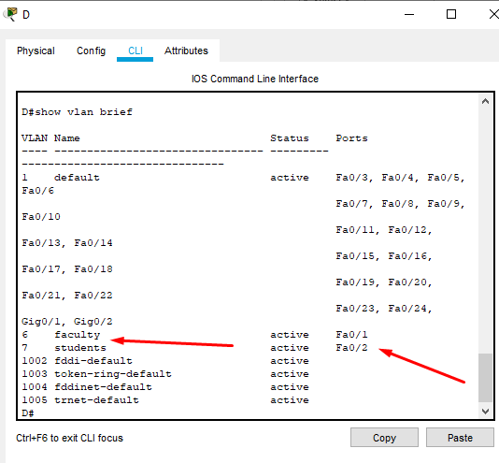

**Now make switch A in server mode, whereas B and D in client mode and switch C in transparent mode.**

**First lets add trunk to switch**

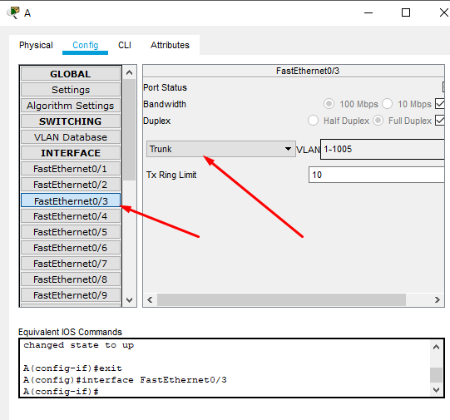

**And so on to all switches**

Now apply the vtp modes to switches.

**Switch A configuration:**

**Setting the vtp mode server:**

A(config)#vtp mode server

Device mode already VTP SERVER.

A(config)#vtp domain qaiser

Changing VTP domain name from NULL to qaiser

A(config)#exit

**Checking the vtp status:**

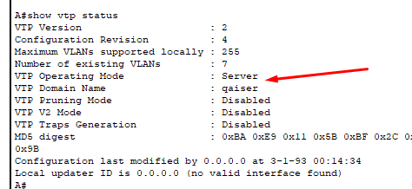

**Switch B configuration:**

**Setting the vtp mode client:**

B>

B>en

B#config t

Enter configuration commands, one per line. End with CNTL/Z.

B(config)#vtp mode client

Setting device to VTP CLIENT mode.

B(config)#vtp domain qaiser

Domain name already set to qaiser.

B(config)#exit

**Checking the vtp status:**

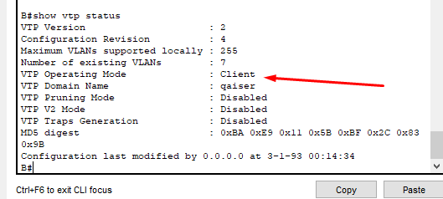

**Switch C configuration:**

**Setting the vtp mode transparent:**

Switch>en

Switch#config t

Enter configuration commands, one per line. End with CNTL/Z.

Switch(config)#vtp mode transparent

Setting device to VTP TRANSPARENT mode.

Switch(config)#vtp domain qaiser

Domain name already set to qaiser.

Switch(config)#exit

Switch#

**Checking the vtp status:**

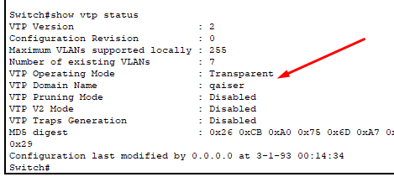

**Switch D configuration:**

**Setting the vtp mode client:**

D>en

D#config t

Enter configuration commands, one per line. End with CNTL/Z.

D(config)#vtp mode client

Setting device to VTP CLIENT mode.

D(config)#vtp domain qaiser

Domain name already set to qaiser.

D(config)#exit

**Checking the vtp status:**

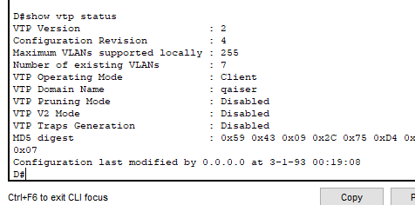

**Assign IP addresses to PCs connected to Switch A, B and D.**

|  |  |  |
| --- | --- | --- |
| PC | Switch | IP |
| Faculty-PC-0 | A | 192.168.111.1 |
| Student-PC-1 |  | 192.168.111.2 |
| Faculty-PC-2 | B | 192.168.111.3 |
| Student-PC-3 |  | 192.168.111.4 |
| Faculty-PC-4 | D | 192.168.111.5 |
| Student-PC-5 |  | 192.168.111.6 |

**Overall Configuration:**

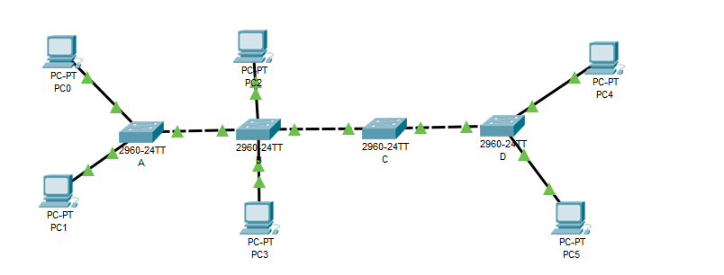

**Now ping within the same VLAN and outside the same VLAN and show your results.**

**Within the same Vlan:**

**Pinging Student vlan from PC 1 to PC 3:**

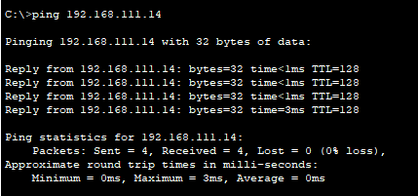

**Pinging Student vlan from PC 1 to PC 5:**

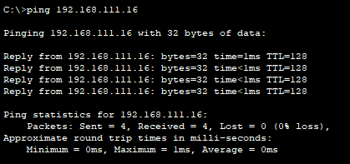

**Pinging Faculty vlan from PC 0 to PC 2:**

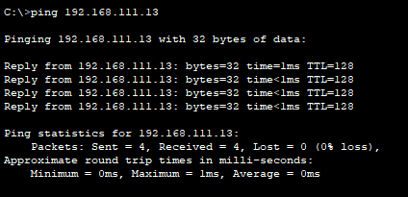

**Pinging Faculty vlan from PC 0 to PC 4:**

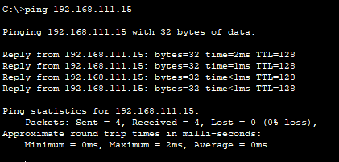

**Within the different Vlan:**

**Pinging from PC 0 to PC 3:**

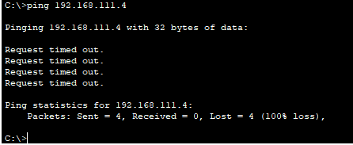

**Pinging from PC 5 to PC 2:**

