**TASK 1:**

**Study and discover more about STP**

**Solution:**

We use redundancy in case one path gets down, so packet can use an alternate path to get to destination. So our network will keep operational.

So when we have multiple cables then we have redundancy. And without using STP so we can face problems:

The first problem is Broadcast storm, so when a switch receive broadcast it exports it from all the ports instead of one it is receiving from. So in this case we have a loop of packets copy. TTL will also not work here, cause switches work on layer 2. So this will stay always which is a big problem. The other problem is, one switch will receive multiple copies of a single frame that it has to send.

Spanning tree protocol is also known as 802.1D. This is IEEE reference of stp. It is very old protocol and was created in late 80’s and it is very slow so that is why we have created rapid spanning tree to make spanning tree faster.

Root bride is STP is elected with the lowest bridge id while bridge id is the sum of priority, mac address and vlan number. All ports linked to root bridge are designated ports. Route port and designated ports are always on the forwarding state. The alternate port is the state of blocking.

We have 4 states in STP:

**Blocking**: Port is blocked since it is causing loops, but is receiving BPDUs. It consumes maximum of 20 seconds.

**Listening**: will receive and send BPDUs, neither learning MAC addresses nor data transmission. It consumes maximum of 15 seconds.

**Learning**: sending and receiving BPDUs, but now the switch will also learn MAC address still no data transmission will start. It consumes maximum of 15 seconds.

**Forwarding**: port participates in traffic forwarding and is learning MAC addresses, also receiving BPDUs.

**TASK 2**

**Analyze the above network, deactivate another working interface and monitor the shift to the redundant interface. Also, change the root switch to a switch of your choice and implement the rapid STP and finally show the pinging results**

**Solution:**

Making Rapid STP in All switches

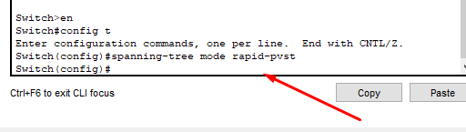

And so on to all three switches

**Which is the switch working as root bridge?**

**Switch 4:**

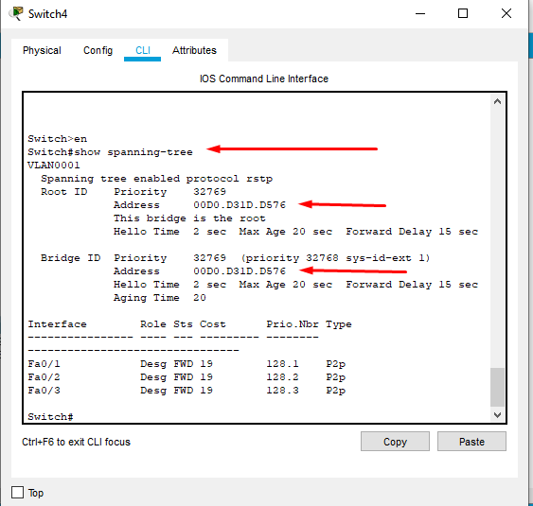

So switch 4 is my root bridge for now.

Root priority: 32769

Address: 00D0.D31D.D576

Root port: No one

Designation port: 0/1, 0/2 and 0/3

**Switch 5:**

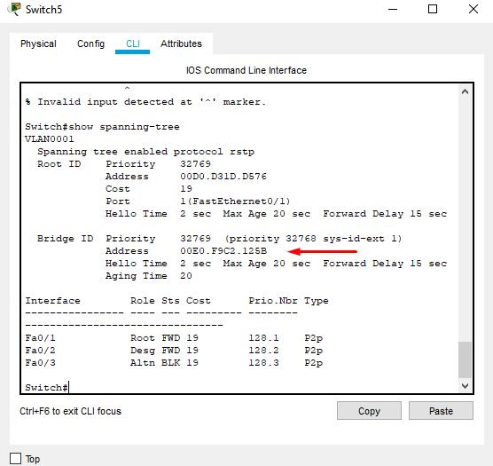

So switch 5 is not root bridge.

Root priority: 32769

Address: 00E0.F9C2.125B

Root port: 0/1

Designation port: 0/2

Alternate port: Blocked one => 0/3

**Switch 6:**

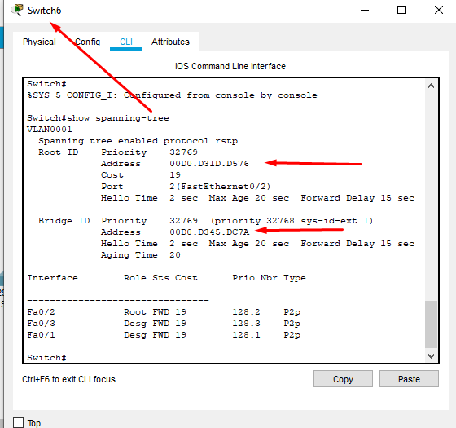

So switch6 is not root bridge.

Root priority: 32769

Address: 00D0.D345.DC7A

Root port: 0/2

Designation port: 0/3 and 0/1

**Configuration:**

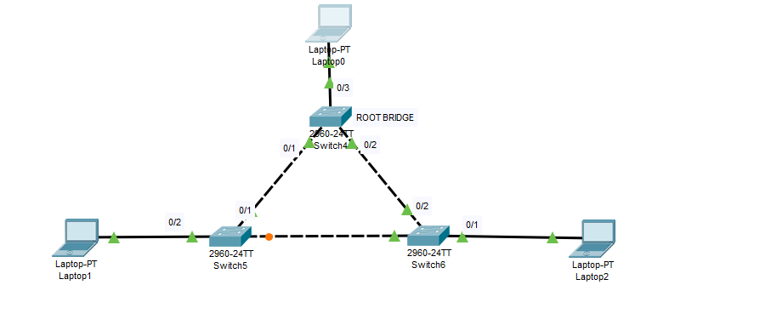

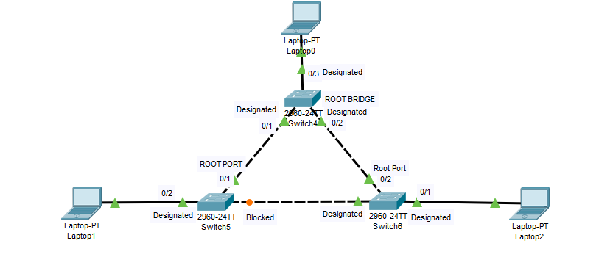

**Changing ROOT Switch from Switch 4 to Switch 5:**

Switch(config)#spanning-tree vlan 1 root primary

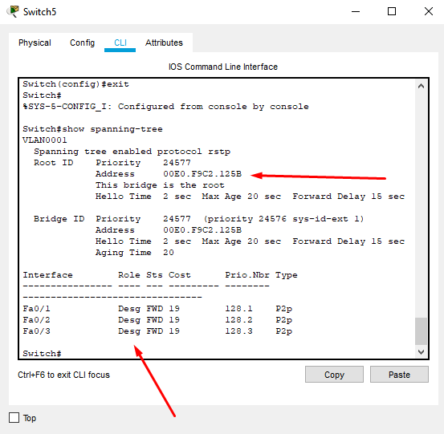

**New Configuration:**

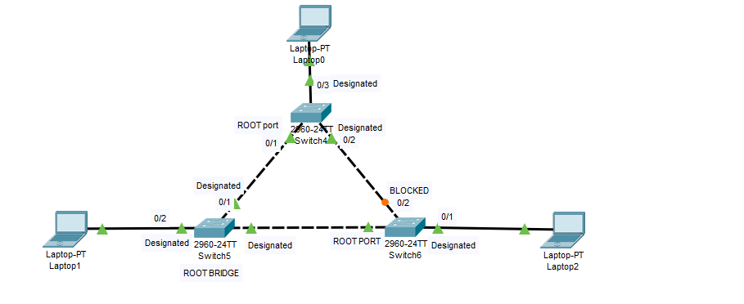

**IP ADDRESSES:**

**LAPTOP 0: 192.168.222.5**

**LAPTOP 1: 192.168.222.7**

**LAPTOP 2: 192.168.222.9**

Pinging Laptop 1 from Laptop 0:

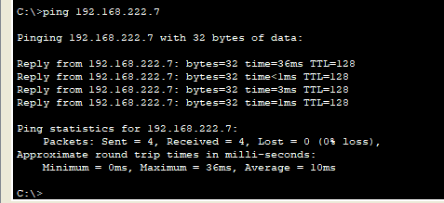

Pinging Laptop 2 from Laptop 0:

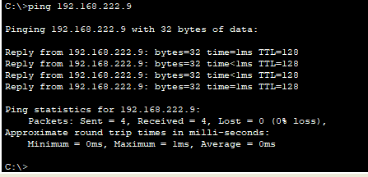

Pinging Laptop 1 from Laptop 2:

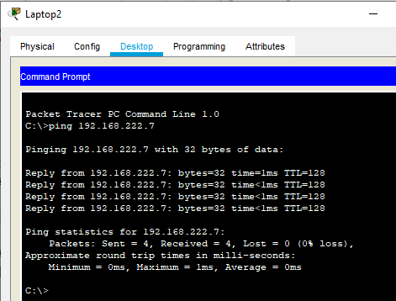

Pinging Laptop 2 from Laptop 1:

