**TASK 1:**

**Configure static route on the following network and show all necessary configuration steps for each router.**



**Solution:**

**Topology:**

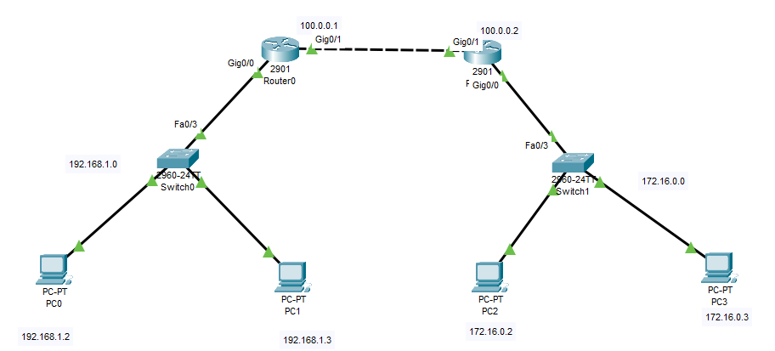

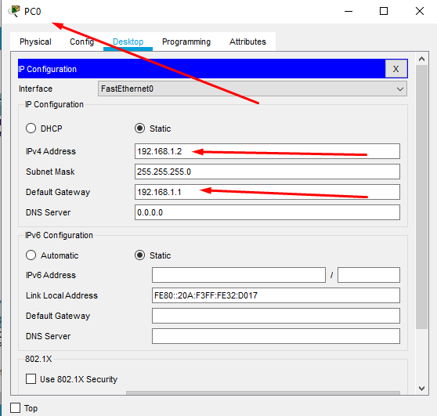

Router 0:

Router>en

Router#conf t

Enter configuration commands, one per line. End with CNTL/Z.

Router(config)#int gig0/0

Router(config-if)#ip add 192.168.1.1 255.255.255.0

Router(config-if)#no shut

Router(config-if)#

%LINK-5-CHANGED: Interface GigabitEthernet0/0, changed state to up

%LINEPROTO-5-UPDOWN: Line protocol on Interface GigabitEthernet0/0, changed state to up

Router(config-if)#exit

Router(config)#int gig0/1

Router(config-if)#ip add 100.0.0.1 255.0.0.0

Router(config-if)#no shut

Router(config-if)#

%LINK-5-CHANGED: Interface GigabitEthernet0/1, changed state to up

Router(config-if)#exit

Router(config)#

%LINEPROTO-5-UPDOWN: Line protocol on Interface GigabitEthernet0/1, changed state to up

Router(config)#exit

Router#

%SYS-5-CONFIG_I: Configured from console by console

Router#show ip int brief

Interface IP-Address OK? Method Status Protocol

GigabitEthernet0/0 192.168.1.1 YES manual up up

GigabitEthernet0/1 100.0.0.1 YES manual up up

Vlan1 unassigned YES unset administratively down down

Router#

Router 1:

Router>en

Router#conf t

Enter configuration commands, one per line. End with CNTL/Z.

Router(config)#int gig0/0

Router(config-if)#ip add 172.16.0.1 255.255.0.0

Router(config-if)#no shut

Router(config-if)#

%LINK-5-CHANGED: Interface GigabitEthernet0/0, changed state to up

%LINEPROTO-5-UPDOWN: Line protocol on Interface GigabitEthernet0/0, changed state to up

Router(config-if)#exit

Router(config)#int gig0/1

Router(config-if)#ip add 100.0.0.2 255.0.0.0

Router(config-if)#no shut

Router(config-if)#

%LINK-5-CHANGED: Interface GigabitEthernet0/1, changed state to up

%LINEPROTO-5-UPDOWN: Line protocol on Interface GigabitEthernet0/1, changed state to up

Router(config-if)#exit

Router(config)#

Router(config)#exit

Router#

%SYS-5-CONFIG_I: Configured from console by console

Router#show ip int brief

Interface IP-Address OK? Method Status Protocol

GigabitEthernet0/0 172.16.0.1 YES manual up up

GigabitEthernet0/1 100.0.0.2 YES manual up up

Vlan1 unassigned YES unset administratively down down

Router#

**Configuration as per now:**

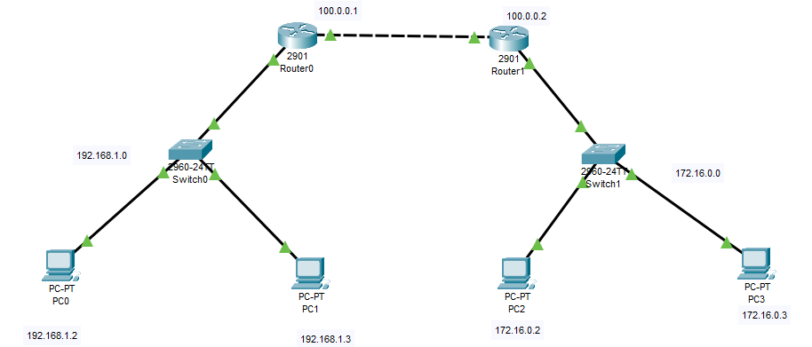

Router 1 setting static path:

Router(config)#ip route 172.16.0.0 255.255.0.0 100.0.0.2

Router(config)#Router1(config)#exit

Router#

%SYS-5-CONFIG_I: Configured from console by console

Router#show ip route

**Router 2 setting static path:**

Router(config)#ip route 192.168.1.0 255.255.255.0 100.0.0.1

Router(config)#exit

Router#

%SYS-5-CONFIG_I: Configured from console by console

**Verify the route by pinging from Router 0 to Router 1**

Router1#ping 172.16.0.2

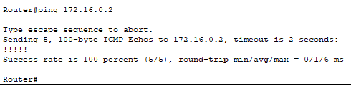

Router0#ping 192.168.1.2

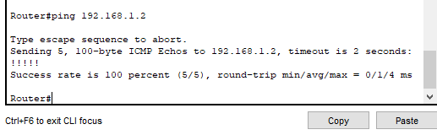

**Digital Ping test:**

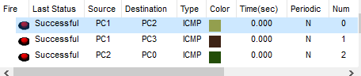

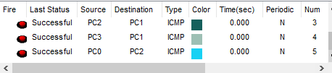

**Verify the route by pinging from PC 1 to PC3**

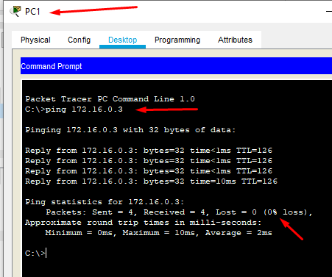

**Verify the route by pinging from PC 2 to PC 0**

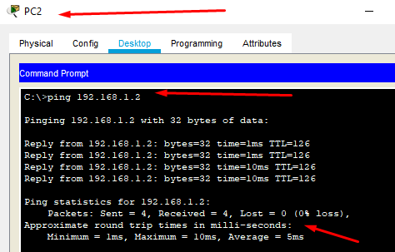

**TASK 2**

**Configure static route on the following network and show all necessary configuration steps for each router.**



**Solution:**

Topology:

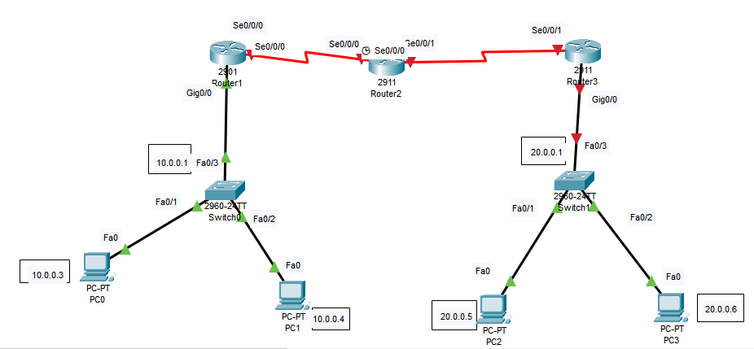

Availing extra ports on all routers:

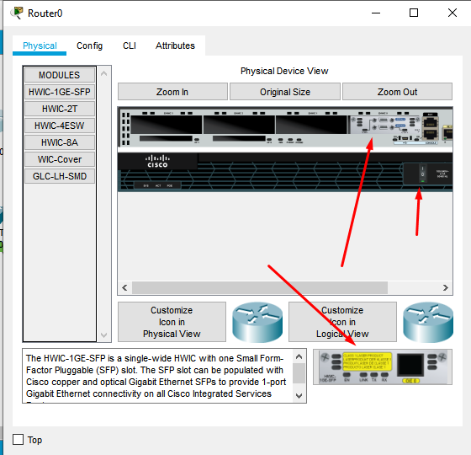

Adding default gateway and ip add. to every pc:

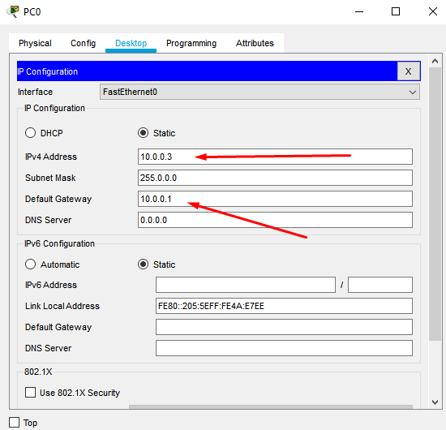

Router 1:

Router>en

Router#conf t

Enter configuration commands, one per line. End with CNTL/Z.

Router(config)#hostname R1

R1(config)#int gig0/0

R1(config-if)#ip address 10.0.0.1 255.0.0.0

R1(config-if)#no shut

R1(config-if)#

%LINK-5-CHANGED: Interface GigabitEthernet0/0, changed state to up

%LINEPROTO-5-UPDOWN: Line protocol on Interface GigabitEthernet0/0, changed state to up

R1(config)#int Se0/0/0

R1(config-if)#ip add 15.0.0.1 255.0.0.0

R1(config-if)#clock rate 64000

This command applies only to DCE interfaces

R1(config-if)#no shut

%LINK-5-CHANGED: Interface Serial0/0/0, changed state to down

R1(config-if)#exit

Router2:

Router>en

Router#conf t

Enter configuration commands, one per line. End with CNTL/Z.

Router(config)#hostname R2

R2(config)#exit

R2>en

R2#conf t

Enter configuration commands, one per line. End with CNTL/Z.

R2(config)#int se0/0/0

R2(config-if)#ip add 15.0.0.2 255.0.0.0

R2(config-if)#no shut

R2(config-if)#

%LINK-5-CHANGED: Interface Serial0/0/0, changed state to up

%LINEPROTO-5-UPDOWN: Line protocol on Interface Serial0/0/0, changed state to up

R2(config-if)#exit

R2(config)#int se0/0/1

R2(config-if)#clock rate 64000

This command applies only to DCE interfaces

R2(config-if)#ip add 16.0.0.2 255.0.0.0

R2(config-if)#no shut

%LINK-5-CHANGED: Interface Serial0/0/1, changed state to down

R2(config-if)#

Router3:

Router>en

Router#conf t

Enter configuration commands, one per line. End with CNTL/Z.

Router(config)#hostname R3

R3(config)#int gig0/0

R3(config-if)#ip address 20.0.0.1 255.0.0.0

R3(config-if)#no shut

R3(config-if)#

%LINK-5-CHANGED: Interface GigabitEthernet0/0, changed state to up

%LINEPROTO-5-UPDOWN: Line protocol on Interface GigabitEthernet0/0, changed state to up

R3(config-if)#ex

R3(config)#

R3>en

R3#config t

Enter configuration commands, one per line. End with CNTL/Z.

R3(config)#int se0/0/1

R3(config-if)#ip ad 16.0.0.1 255.0.0.0

R3(config-if)#no shut

R3(config-if)#

%LINK-5-CHANGED: Interface Serial0/0/1, changed state to up

%LINEPROTO-5-UPDOWN: Line protocol on Interface Serial0/0/1, changed state to up

**Configuration as per now:**

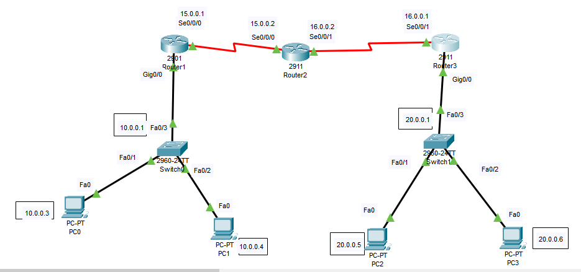

Router 1 setting static path:

R1(config)#ip route 20.0.0.0 255.0.0.0 15.0.0.2

R1(config)#ip route 16.0.0.0 255.0.0.0 15.0.0.2

R1(config)#

Router 2 setting static path:

R2(config)#ip route 10.0.0.0 255.0.0.0 15.0.0.1

R2(config)#ip route 20.0.0.0 255.0.0.0 16.0.0.1

R2(config)#

Router 3 setting static path:

R3(config)#ip route 10.0.0.0 255.0.0.0 16.0.0.2

R3(config)#ip route 15.0.0.0 255.0.0.0 16.0.0.2

R3(config)#

**Digital Ping test:**

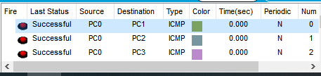

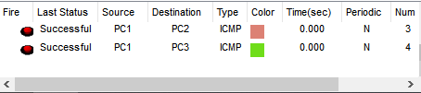

**Testing from PC 1 to PC 3:**

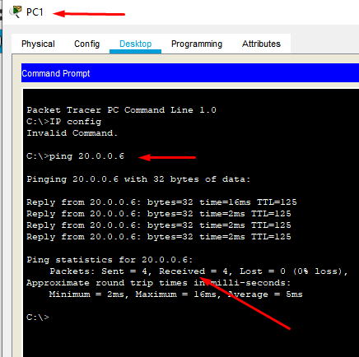

**Pinging Pc 0 from PC 2:**

