**TASK 1:**

**Configure OSPF on the following network and show all necessary configuration steps for each router.**



**Solution:**

Topology:

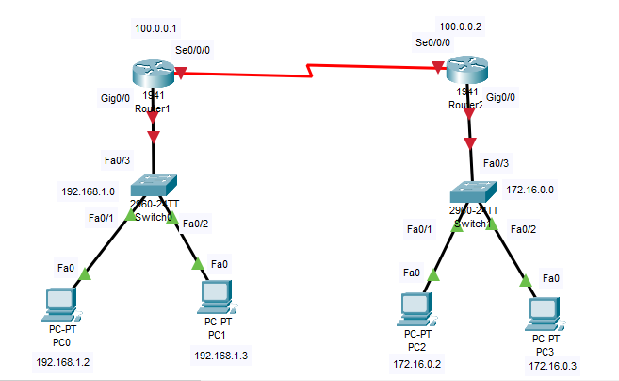

Setting Ips and default gateway:

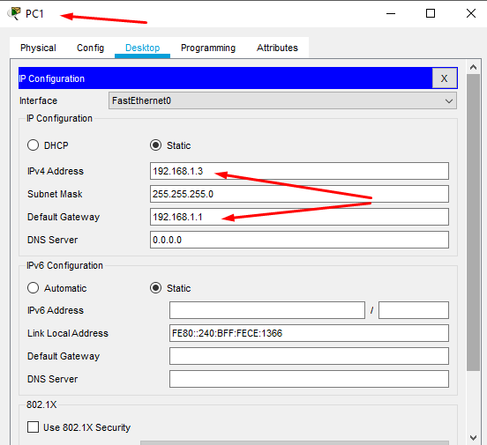

**Configuring OSPF routing on router 1:**

Router>en

Router#conf t

Enter configuration commands, one per line. End with CNTL/Z.

Router(config)#Hostname R1

R1(config)#INT gig0/0

R1(config-if)#ip add 192.168.1.1 255.255.255.0

R1(config-if)#no shutdown

R1(config-if)#

%LINK-5-CHANGED: Interface GigabitEthernet0/0, changed state to up

%LINEPROTO-5-UPDOWN: Line protocol on Interface GigabitEthernet0/0, changed state to up

R1(config-if)#exit

R1(config)#int se0/0/0

R1(config-if)#ip add 100.0.0.1 255.0.0.0

R1(config-if)#clock rate 64000

R1(config-if)#no shutdown

%LINK-5-CHANGED: Interface Serial0/0/0, changed state to down

R1(config-if)#

R1(config)#router ospf 1

R1(config-router)#network 192.168.1.0 0.0.0.255 area 0

R1(config-router)#network 100.0.0.0 0.255.255.255 area 0

R1(config-router)#exit

**Configuring OSPF routing on router 2:**

Router>en

Router#conf t

Enter configuration commands, one per line. End with CNTL/Z.

Router(config)#hostname R2

R2(config)#int gig0/0

R2(config-if)#ip add 172.16.0.1 255.255.0.0

R2(config-if)#no shutdown

R2(config-if)#

%LINK-5-CHANGED: Interface GigabitEthernet0/0, changed state to up

%LINEPROTO-5-UPDOWN: Line protocol on Interface GigabitEthernet0/0, changed state to up

R2(config-if)#exit

R2(config)#int se0/0/0

R2(config-if)#ip add 100.0.0.2 255.0.0.0

R2(config-if)#clock rate 64000

This command applies only to DCE interfaces

R2(config-if)#no shutdown

R2(config-if)#

%LINK-5-CHANGED: Interface Serial0/0/0, changed state to up

R2(config-if)#

%LINEPROTO-5-UPDOWN: Line protocol on Interface Serial0/0/0, changed state to up

R2(config-if)#

R2(config)#router ospf 1

R2(config-router)#network 100.0.0.0 0.255.255.255 area 0

R2(config-router)#network 172.16.0.0 0.0.255.255 area 0

R2(config-router)#exit

R2(config)#

**Digital Ping test:**

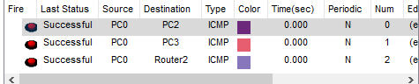

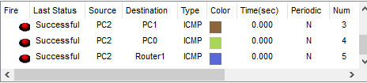

**Verify the route by pinging from PC 3 to PC 1:**

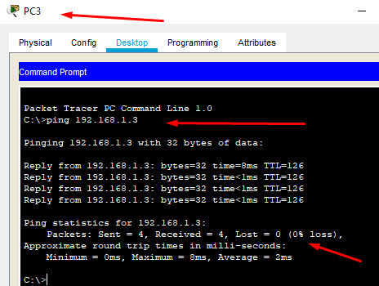

**Verify the route by pinging from PC0 to PC2**

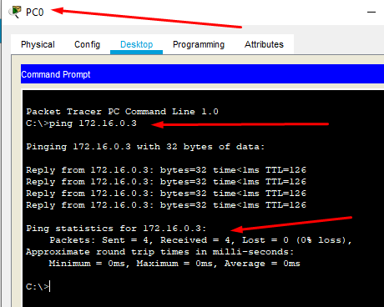

**Verify the route by pinging from PC2 to Router1:**

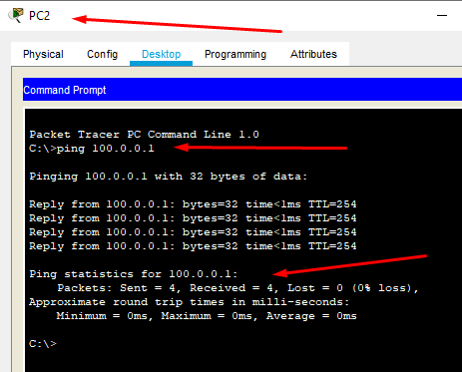

**TASK 2**

**Configure OSPF on the following network and show all necessary configuration steps for each router.**



**Solution:**

Topology:

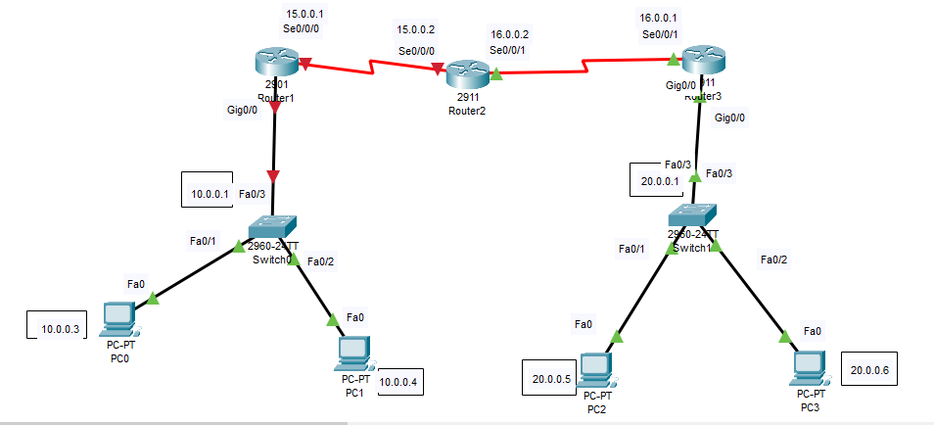

Availing extra ports on all routers:

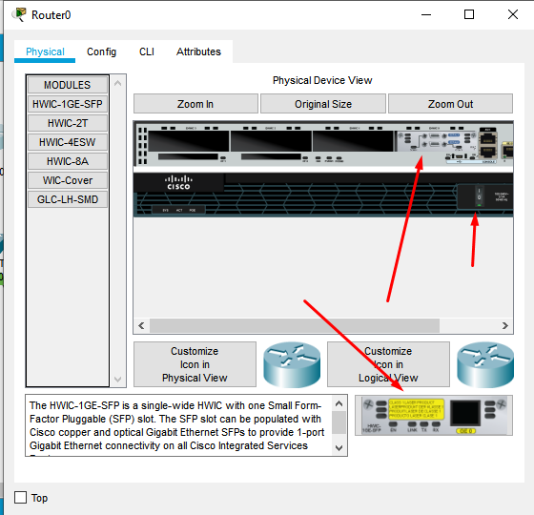

Adding default gateway and ip add. to every pc:

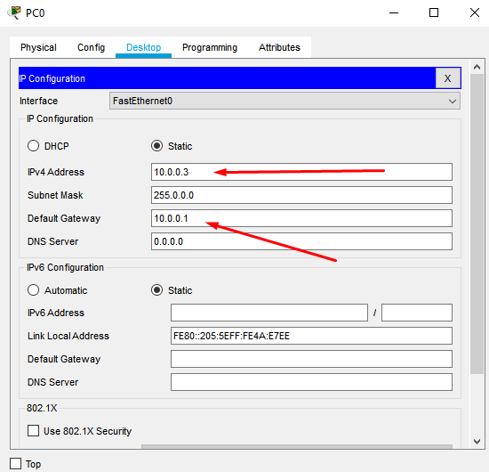

Router 1:

Router>en

Router#conf t

Enter configuration commands, one per line. End with CNTL/Z.

Router(config)#host R1

R1(config)#Int gig0/0

R1(config-if)#ip add 10.0.0.1 255.0.0.0

R1(config-if)#no shut

R1(config-if)#

%LINK-5-CHANGED: Interface GigabitEthernet0/0, changed state to up

%LINEPROTO-5-UPDOWN: Line protocol on Interface GigabitEthernet0/0, changed state to up

R1(config-if)#exit

R1(config)#int se0/0/0

R1(config-if)#ip add 15.0.0.1 255.0.0.0

R1(config-if)#clock rate 64000

R1(config-if)#no shut

R1(config-if)#

%LINK-5-CHANGED: Interface Serial0/0/0, changed state to up

R1(config-if)#exit

R1(config)#

%LINEPROTO-5-UPDOWN: Line protocol on Interface Serial0/0/0, changed state to up

R1(config)#

Router2:

Router>en

Router#conf t

Enter configuration commands, one per line. End with CNTL/Z.

Router(config)#hostname R2

R2(config)#INT se0/0/0

R2(config-if)#ip add 15.0.0.2 255.0.0.0

R2(config-if)#no shut

R2(config-if)#exit

R2(config)#int se0/0/1

R2(config-if)#clock rate 64000

R2(config-if)#ip add 16.0.0.2 255.0.0.0

R2(config-if)#no shut

R2(config-if)#

R2(config-if)#exit

R2(config)#

Router3:

Router>en

Router#conf t

Enter configuration commands, one per line. End with CNTL/Z.

Router(config)#hostname R3

R3(config)#int gig0/0

R3(config-if)#ip address 20.0.0.1 255.0.0.0

R3(config-if)#no shut

R3(config-if)#

%LINK-5-CHANGED: Interface GigabitEthernet0/0, changed state to up

%LINEPROTO-5-UPDOWN: Line protocol on Interface GigabitEthernet0/0, changed state to up

R3(config-if)#ex

R3(config)#

R3>en

R3#config t

Enter configuration commands, one per line. End with CNTL/Z.

R3(config)#int se0/0/1

R3(config-if)#ip ad 16.0.0.1 255.0.0.0

R3(config-if)#no shut

R3(config-if)#

%LINK-5-CHANGED: Interface Serial0/0/1, changed state to up

%LINEPROTO-5-UPDOWN: Line protocol on Interface Serial0/0/1, changed state to up

**Configuration as per now:**

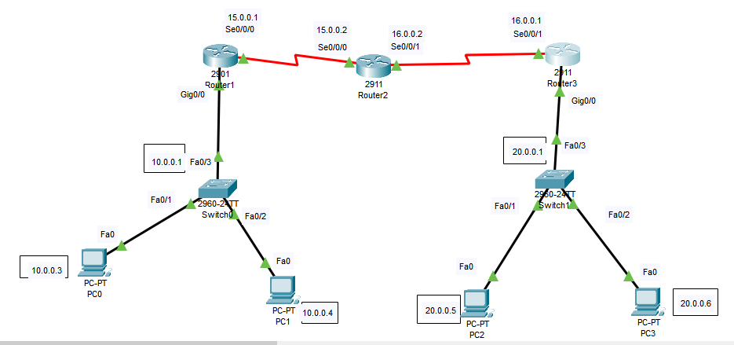

**Configuring OSPF routing on router 1:**

R1(config)#router ospf 1

R1(config-router)#network 10.0.0.0 0.255.255.255 area 1

R1(config-router)#network 15.0.0.0 0.255.255.255 area 1

R1(config-router)#exit

R1(config)#

**Configuring OSPF routing on router 2:**

R2(config)#

R2(config)#router ospf 2

R2(config-router)#network 15.0.0.0 0.255.255.255 area 1

R2(config-router)#

00:16:57: %OSPF-5-ADJCHG: Process 2, Nbr 15.0.0.1 on Serial0/0/0 from LOADING to FULL, Loading Done

R2(config-router)#network 16.0.0.0 0.255.255.255 area 2

R2(config-router)#

R2(config-router)#exit

**Configuring OSPF routing on router 3:**

R3>en

R3#conf t

Enter configuration commands, one per line. End with CNTL/Z.

R3(config)#router ospf 1

R3(config-router)#network 20.0.0.0 0.255.255.255 area 2

R3(config-router)#network 16.0.0.0 0.255.255.255 area 2

R3(config-router)#exit

R3(config)#

**Digital Ping test:**

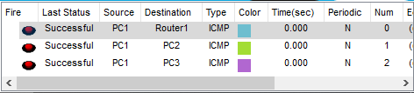

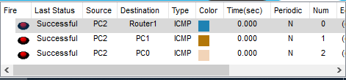

**Pinging from PC 0 to PC 2:**

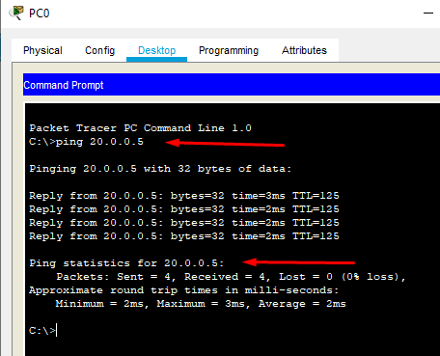

**Pinging Pc 1 from PC 3:**

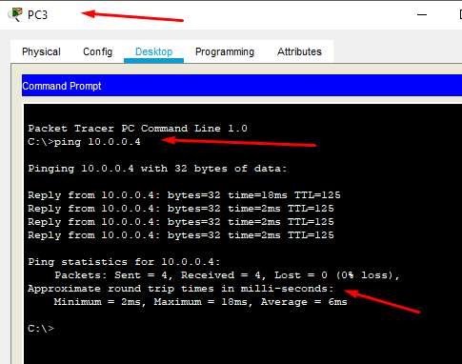

**Pinging Router 3 from Pc1:**

