**TASK 1:**

**What is the Internet address of your computer?**

**Solution:**

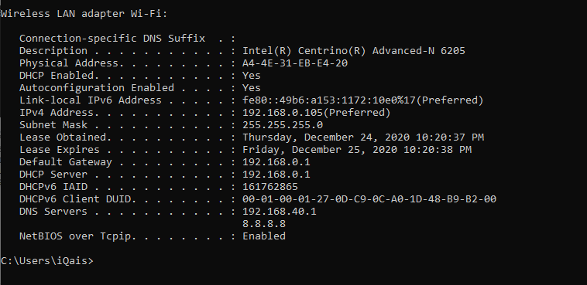

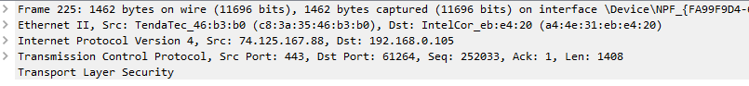

**TASK 2:**

**Access your university website and list DNS records.**

**Solution:**

