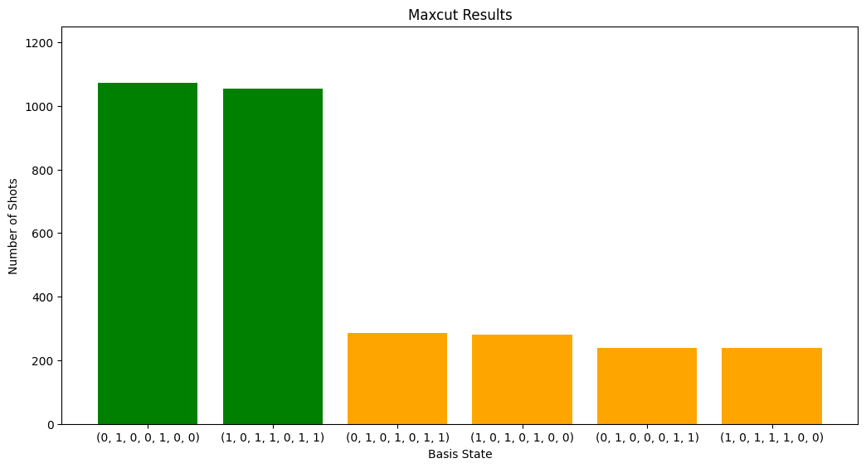
new highest energy found: 3.1432
new highest energy found: 3.283599999999999
new highest energy found: 4.361
new highest energy found: 4.925600000000001
new highest energy found: 4.941999999999999
highest energy: 4.941999999999999
best guess mixer angles: [0.392 0.247 0.138]
best guess cost angles: [0.592 0.738 0.608]
CPU times: total: 1min 36s
Wall time: 1min 37s
Success ratio 0.4252

