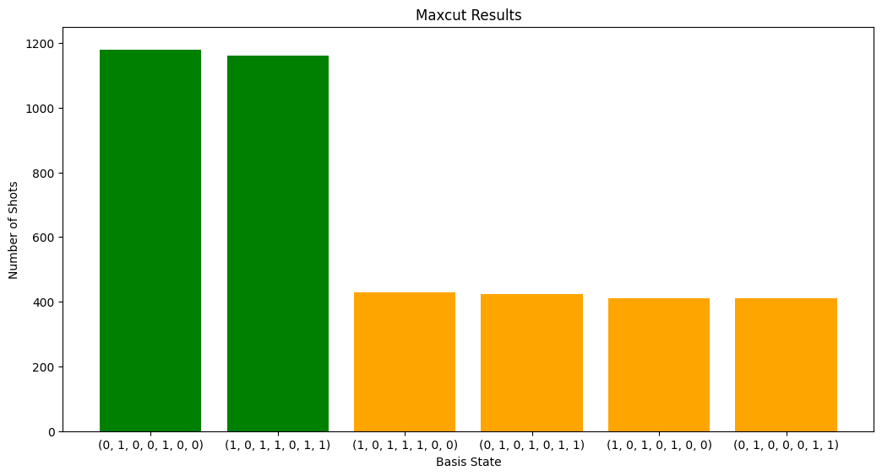
new highest energy found: 5.273599999999999
new highest energy found: 5.342399999999999
highest energy: 5.342399999999999
best guess mixer angles: [0.917 0.254 0.15 ]
best guess cost angles: [-0.581 1.094 0.735]
CPU times: total: 1min 27s
Wall time: 1min 28s
Success ratio 0.468

