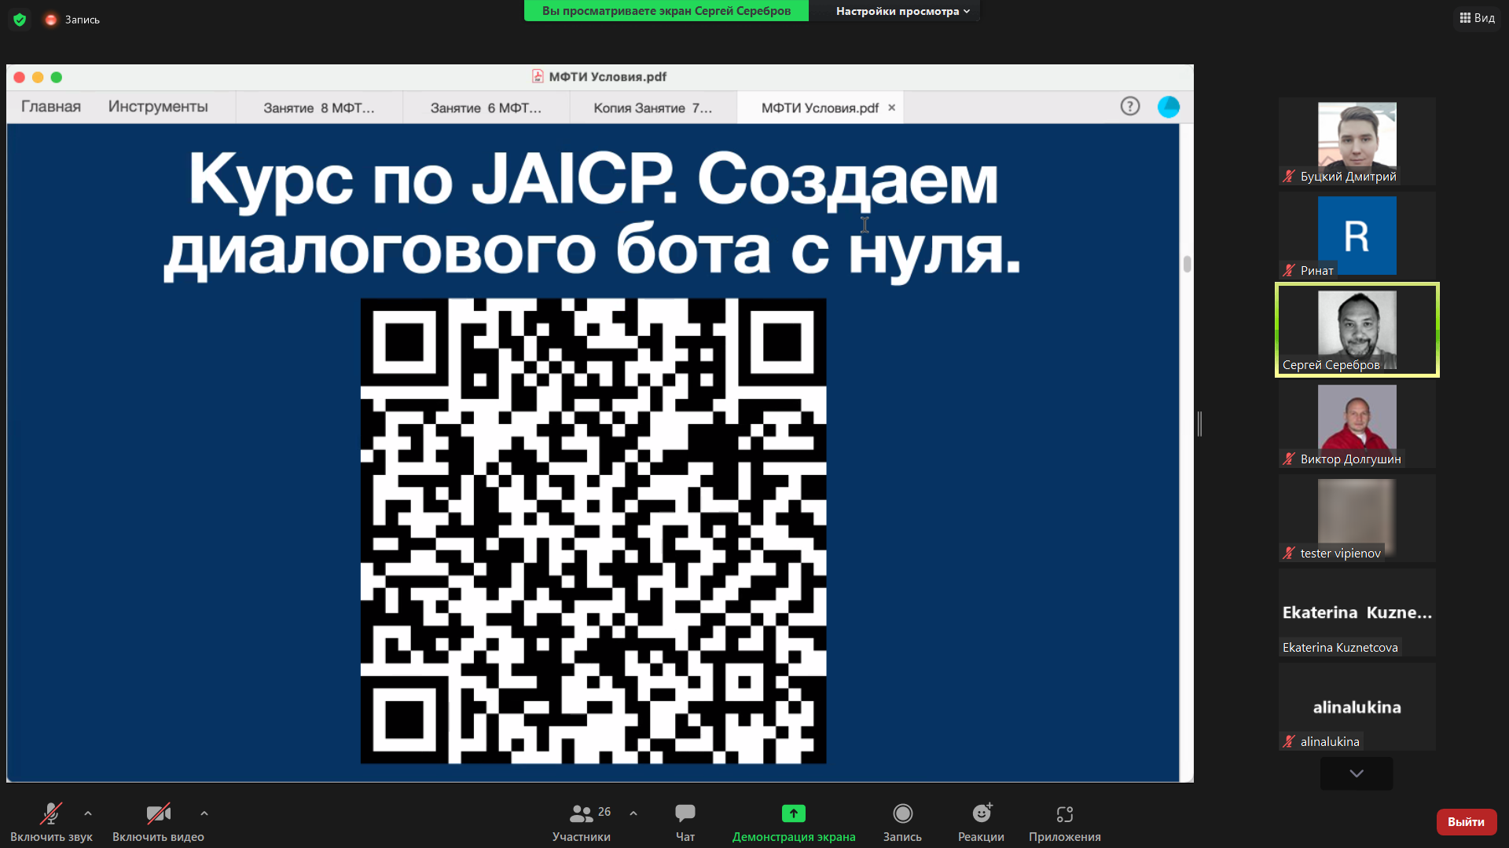

help.just-ai.com/docs/ru