Conspiracy Detection by Real Time Email Analysis

Md. Ikramul Hoque
Department of Computer Science and Engineering, CUET
Chittagong-4349,Bangladesh
ikramulhaqsagor@gmail.com
.

Abu Hasnat Mohammad Ashfak Habib
Department of Computer Schience and Engineering,CUET
Chittagong-4349,,Bangladesh

Abstract—Text classification by sentiment analysis has become a common field of research. Supervised vector-based method of sentiment has a rich lexical meanings. To detect a psychological concept “CONSPIRACY” by a machine automatically is a new dimension here. We analyze email data to predict the conspiracy related sentiment in any working place. We have used logistic regression as a predicting classifier to determine the sentiment in real time email exchanging environment. And if out prediction go to the infected class it will alert the management of the company in real time. So it can monitor the email data automatically.
Keywords—Sentiment Analysis, Conspiracy, Logistic regression, TFIDF

Introduction
We live in the era of modern technology where almost every things are dependent on the technology. And today’s technology is mostly an advancement of old technology. Email is such a form of advance technology that is broadly used in an effective way of communication. It is the most popular communication tools thorough out the world. Statistics indicate that’s the number of email user is growing day by day. In the working place, it is the most common way of communication throughout the employees. Almost every company uses their customized email id for their employees. And thus the importance and significance of these email has become beyond imagine.
As email has become the most popular way of communication in working place thus it has some significance in the profit and overall outcome of any working place. So it could be a big medium of doing harm to any company. There is a company named Enron in America that had been bankrupted due to the internal conspiracy in between the company employees. And these conspiracy was occurred by communicating through the email. So email is a sensitive issue of concern.
Conspiracy is a pure psychological concept of human insight. It means a secret plan by a group of powerful people for doing something unlawful and harmful. According to conspiracy theory it is the conviction that a group of actors meets in secret agreement with the purpose of attaining some malevolent goal []. These theory has some aspect of thinking. It reflects how the people are interconnected as hypothesized pattern. It reflects the intentionality to the actions. It also means the coalition of the people, threat and secrecy and therefore difficult to invalidate.
Conspiracy in working place is a popular conspiracy theory where some outcome of conspiracy has been proposed and studied. The most common outcome of a working place conspiracy is that the turnover of the employees. In any conspiracy infected working place the working environment will not be proper. And the management will be intended to appoint employees of their own choice without measuring the quality of these employees. And make the good resources fired without any legal way or notice. The overall empowerment of the company will be in a changing shape day by day.
We like to draw the shape of conspiracy among the employees during these period of conspiracy in the working place. And tried to convert this concept into the machine and learn it for predicting the conspiracy in future automatically without monitoring the mail data manually. We uses logistic regression. In this paper we proposed the framework for using our algorithm.
The outline of this paper is epitomized as follows. Section two reviews the previous related works on Email classification. Section three defines the flow of work in the methodology. Section four displays the experimental results and finally section five summarizes the future directions.

Relarted work
The most common way to text sentiment analysis is to detect the frequency of features of any given positive and negative semantic value. It has a similarity in classical text classification and mining. Pang and Lee uses standard machine learning techniques Bayesian classifiers, maximum entropy and SVM.
There are some works on analyzing email data. Some of these tried to analysis the large data of email. They use sentiment analysis to detect positive and negative sentiment. Sisi Liu has proposed a framework for sentiment analysis in Email using a hybrid scheme of process combined with Kmeans clustering and a classifier, support vector machine. The measurement for the design is conducted through the correlation among three labeling methods. Combination of clustering approach with SWN lexicon for sentiment analysis in blog was proposed by Feng Wang, Yu, and Yang. Li and Wu proposed kmenas clustering for hotspot indication and SVM sentiment prediction.
Moreover Balasubramanyan, Routledge and Smith proposed an algorithm for the prediction for poll results by using public opinion. As in email data classification, most studies focus on the identification of spam emails, the study of social networking among email. Mohammad and Yang analyzes the gender classification of sentiment axis among set of labeled mail data. Hangal, Lam and Heen proposed a system for visualizing archived mail data with sentiment words.
So there have been a lot of works in the sentiment analysis for text data classification for too many years. And there also been so many works on email data for sentiment analysis, spam detection, networking in the email users. Other than these studies, a systematic and structural design for conspiracy detection from Email data has not been invented yet.

Framework and Methodology
For detecting conspiracy we are proposing a method here. Fig 1 shows the overall flow graph of the architecture. It shows the workflow in short
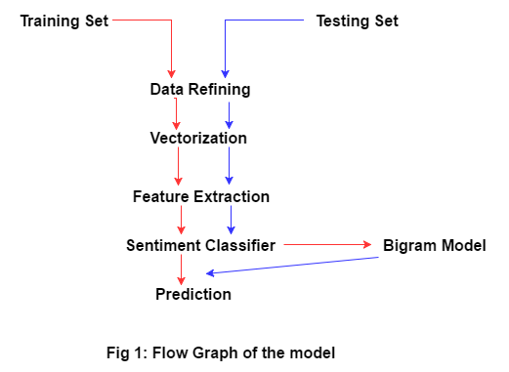
Here we are going to describe the overall system architecture of our module. This system architecture is shown in the figures. It displays the proposed architecture of sentiment analysis that is composed of four different modules. They are Data Acquisition and Refining module, Data Processing module, Training module, testing in Real Time module. These modules are not independent, they are interdependent and works sequentially one after another.

Data Acquisition and Refining
In this module we have labeled our data with green and red tag. This tagged data is separated into two values sentiment and body. These data is stored as form of csv file. Our comma separated file is categorized with 0 for green data and 1 for red data. Fig 2 will display the architecture of the module.
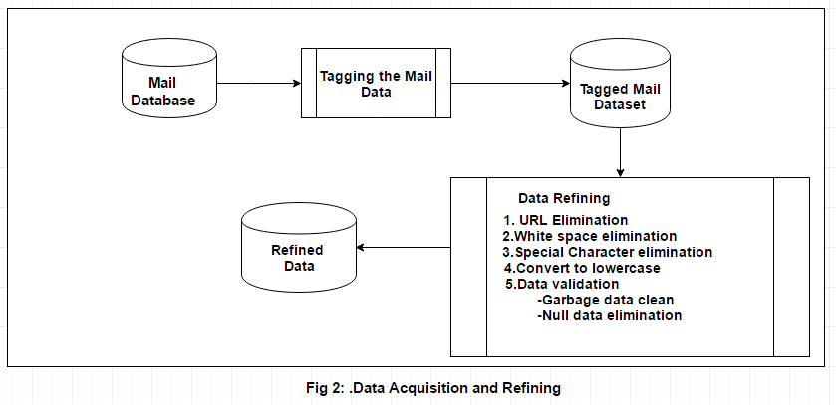
This data is now ready for refining. As the email data is mixed with words of emotions, symbols, URL and references and attachments.
Data Refining
To remove the noise in the email body we have to remove the link, URL, emotions. Thus the following steps are taken:
- Convert every words into lowercase
- Remove duplication of space
- Remove quotes, extra dots and extra space
- Null data elimination
- Spelling correction
- Contracted word handling

Data Processing Model
In this module the refined data is used. The clean data is further processed here for using in the algorithm for predicting the class of the email data. Fig 3 will show us the modular architecture.

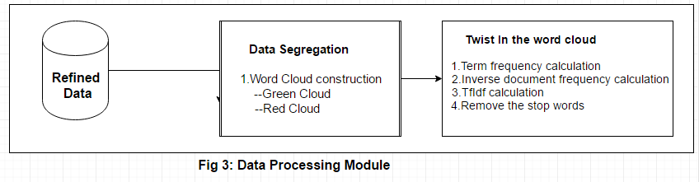
There are some common steps-

- Tokenization: Tokenization means the chopping sentences into pieces. Every sentences will be split into individual words.
- Stop Words Remove: Stop words means the most common words that are too common to reflect any particular sentiment. In every class these words are common. Such as preposition, pronouns etc.
- Feature Vector: We have produced our features based on the conspiracy theory in work place, its outcomes and symptoms. We have used style metric feature vectorization process in here. Mainly TFIDF, Count Vector. Here term frequency and inverse document frequency refers as:
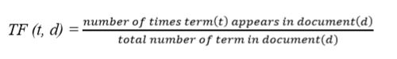
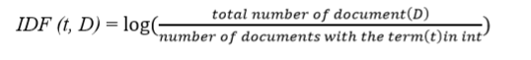And the TFIDF is the multiplication of tf and idf.
Identify applicable funding agency here. If none, delete this text box.

Teaining Module
In this module the tfidf matrix is used in our classifier for every features in the mail data. This matrix is used in the independent axis of the classifier. Fig 4 will show the Training module architecture.
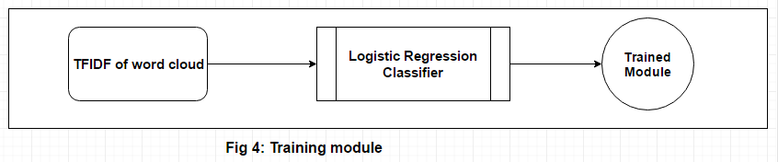
As we have used Logistic Regression classifier for the prediction of the class, we will use the tfidf matrix in the X axis. Logistic regression uses a sigmoid function to predict the class
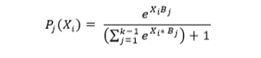
Here, B: parameter matrix
K: number of classes
The last class has probability
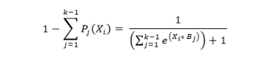

Testing in Real Time Module
Fig 5 will show the architectural model of this module.
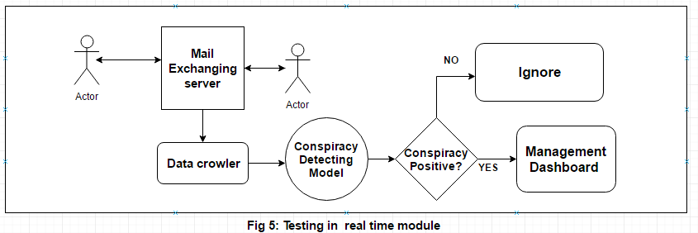
In this module the training model is worked for predicting the conspiracy from the user’s mail data. Here we have some client those can communicate with email by a mail server. A data crawling method is set to crawl the email data and stored it in a database. Then the trained model analyze the data and predict a probability of conspiracy or not.
If the model has the higher probability of conspiracy positive in the body of the email, then the model give alert to the monitoring body of the company and the data and those who exchange the mail between them. Thus the verdict of every email is monitored automatically.

Complexity
Our system has three parts keeping the issue of time in concern. The time complexity of our system may be described in some few steps. The email cleaning process requires O(nm) time. Here n is the number of letter in a email and m is the number of email in the dataset.
And the complexity for storing the database of Email is O(n) where n is the number of email in the email database. And the last concern is predicting email time complexity is O(nC) where n is the number of word in a email and C is the number of words in the feature vector.

Experimenta Reuslt
We have experiment our model result in different ways. It was a challenging tast to test the performance of the model in proper way as it is a model for real time prediction. And a big challenge was to collect the dataset as mail data with conspiracy classified is not available now.
Green Database Collection:
We have tested our system with extensive experiment. We had collected our green data from the Enron Email corpus data. This data is adapted for the majority scientific task. It contains more than .5 million message retrieved from about 150 users. As the fundamental purpose of the research is to classify the body thus we only use the body and remove the ‘to’ and ‘from’ parts and also the attachment things.
Here we collect the official email like office affair, work related email, deal related, client related, gratitude related, personal email, internal component operation, legal advice, humor, forwarding email, logistic arrangement etc. We have use the data with perfectly classified with these sort of classes. We have labeled the data with 0(zero) or the green data.
Red Database Collection:
It was not so easy to collect the red data. As we are designing a model that can easily detect or predict the conspiracy in the email data. We have to teach the machine about the sentiment and psychology behind the concept of conspiracy. We have to frame the related word and concept clear about the theory.
As conspiracy is a psychological concept in human life, first we had to study through the concept of the conspiracy theory and about the working place conspiracy theory. There are too many conspiracy theory over the world. But we have just look through the working place conspiracy theory and the study over the theory. We have collected the consequences of conspiracy theory and the reason behind it. After all that study we made a list of situation based on the theory. We have come to the concept that there could be three possible angle of conspiracy in a working place that may causes the after effect that we have mentioned earlier. So we have sorted some point in which we will give our focus to create the real time environment and find the email with the concept of conspiracy.
Here we came out with the three angles of conspiracy, there are:
- Financial conspiracy
- Organizational conspiracy
- Reputational conspiracy

Evalution of the System
Our system is evaluated in two different ways.

Evaluation by the main dataset: It gives us the result from the main dataset. We have splited our dataset into 85% in training set and 15% as testing dataset. And after training the model, the model can successfully predict 72% correctly. So the accuracy of the model for main dataset is 72%

Evaluation by the real time dataset: In here we have evaluate our model by realtime environment. At first we set up the main environment with some users. And the user sends 100 mixed mails to each other. These mails were contaminated with conspiracy and also some green mail. And the had predicted the mail 68% accurately. Then we have visualize the result in form of four groups. These are true positive, true negative, false positive, false negative. The table 1 will show the result of these four forms during the evaluation.

- REal time evaluation
Table Head | Evaluation
Table Head | True positive | True negative | False positive | False negative
100 | 42 | 18 | 26 | 14

So the overall real time accuracy of this system is = (42+26)*100/100 = 68. Now we can say the accuracy is 68%.

Conclusion
Our primary aim was to develop a system that can automatically detect conspiracy in the mail data of the employees of a company. We have designed and train the module that can predict the possibility of conspiracy in the user’s conversation. This can automatically monitor the user’s mail body. We have used prediction process to make this psychological concept machine detectable in real time. In this model, those mails are detected as a conspiracy related mail are then send to the management for further monitoring manually. If the model predict anything wrong, then the management can discard the mail from the infected list easily. So it is quite a dynamic way of predicting both automatically and manually.
Future works: As we model the system based on the data that are collected from the real field and we are analyzing the text data to predict, there are a common opportunity to improve the accuracy by training the model with a large amount of data.
And during preprocessing and refining data, we usually remove the link of any email data and also remove the attachment file from the mail. So the future improvement would be extracting the sentiment of that link and the attachment. Because sometime the attachment and the link could be a huge way of conspiracy.

References

- G. Eason, B. Noble, and I. N. Sneddon, “On certain integrals of Lipschitz-Hankel type involving products of Bessel functions,” Phil. Trans. Roy. Soc. London, vol. A247, pp. 529–551, April 1955. (references)
- J. Clerk Maxwell, A Treatise on Electricity and Magnetism, 3rd ed., vol. 2. Oxford: Clarendon, 1892, pp.68–73.
- I. S. Jacobs and C. P. Bean, “Fine particles, thin films and exchange anisotropy,” in Magnetism, vol. III, G. T. Rado and H. Suhl, Eds. New York: Academic, 1963, pp. 271–350.
- K. Elissa, “Title of paper if known,” unpublished.
- R. Nicole, “Title of paper with only first word capitalized,” J. Name Stand. Abbrev., in press.
- Y. Yorozu, M. Hirano, K. Oka, and Y. Tagawa, “Electron spectroscopy studies on magneto-optical media and plastic substrate interface,” IEEE Transl. J. Magn. Japan, vol. 2, pp. 740–741, August 1987 [Digests 9th Annual Conf. Magnetics Japan, p. 301, 1982].
- M. Young, The Technical Writer’s Handbook. Mill Valley, CA: University Science, 1989.

IEEE conference templates contain guidance text for composing and formatting conference papers. Please ensure that all template text is removed from your conference paper prior to submission to the conference. Failure to remove template text from your paper may result in your paper not being published.

