**Chapter 4:**

**Implementation of Conspiracy Detection Framework**

In this chapter of implementation of conspiracy detection module, we will discuss about the overall implementation procedure of the project. It is a challenging task to implement this module. In the first chapter 4.1 we will describe our experimental setup. In the next section 4.2 shows the system that can be used to exchange the email data among the employee of the company. Section 4.3 shows the detection and exchanging email procedure. And in the last one section 4.4 we will conclude the chapter of implementation.

**4.1 Experimental Setup**

An Email Conspiracy Detection Framework has been developed on a machine having the Windows 10, core i5 processor with 8GB RAM. The system has been developed in Python and Php in the backend and javascript is used in the front end. Mysql is used for storing related data in this framework.

For coding in python, we have used the latest version of PyCharm which is 2018.2.4 with python version 3.6. For coding in php, we have used the latest version of phpstorm which is 2018.2.2 with php version 7. The system architecture following illustrates the internal and external structure of system modules integrated together in one package to form one system. The following subsections provide a brief background overview of the tools used and the implementation details of the different modules of the developed system starting from the back-end to the front-end. The whole system was developed on Windows Operating System and using pycharm and phpstorm IDE.

**4.2 Email Exchanging System**

In this section we will discuss about the mail server that can exchange the mail between the employees of the company. Here we build a system that can show us an interface to login to the mail server and check the inbox, outbox, sent box and logout. In this system we build the process to compose the mail to any other individual of the company. In this system anyone can exchange the mail to anyone of this company. This system can be used from anywhere of this world using internet. This system is hosted with a Public IP. Thus anyone in anywhere can exchange the mail with having the Id and Password of this system.

We have named the system as “CUET Mail”. And hosted it in a public IP with classified user id and password.

Fig 4.1 shows the snapshot of the system of exchanging the email. In here we will give the snapshot of the login Page of the mail system interface:



Fig 4.1: Login interface of CUET Mail.

Now we will give the inbox interface of our system that will show the mails that are sent to the individual of this account. This page will be seen after the authorized login

Fig 4.2 will show the figure below:

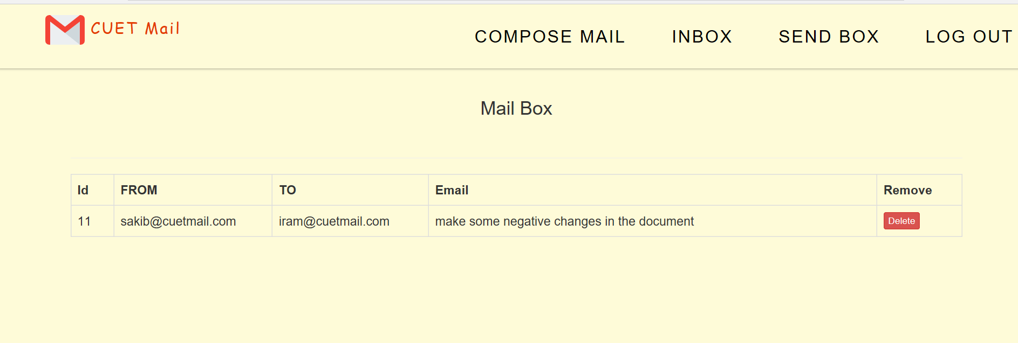

Fig 4.2: Inbox of the System

Here we will give the necessary interface of the Send box of the system.

Fig 4.3 will show the interface:

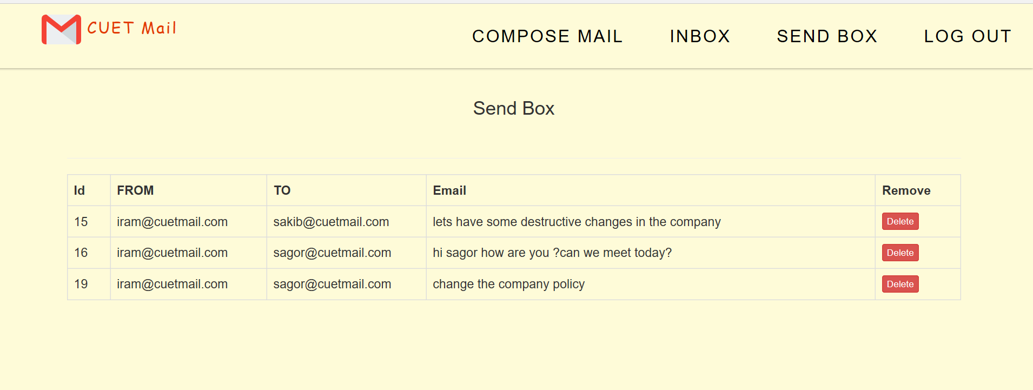

Fig 4.3: Send Box Interface

Now the last one is the composing mail interface, in where we can compose the new mail to another end user.

Fig 4.4 will show the figure below:

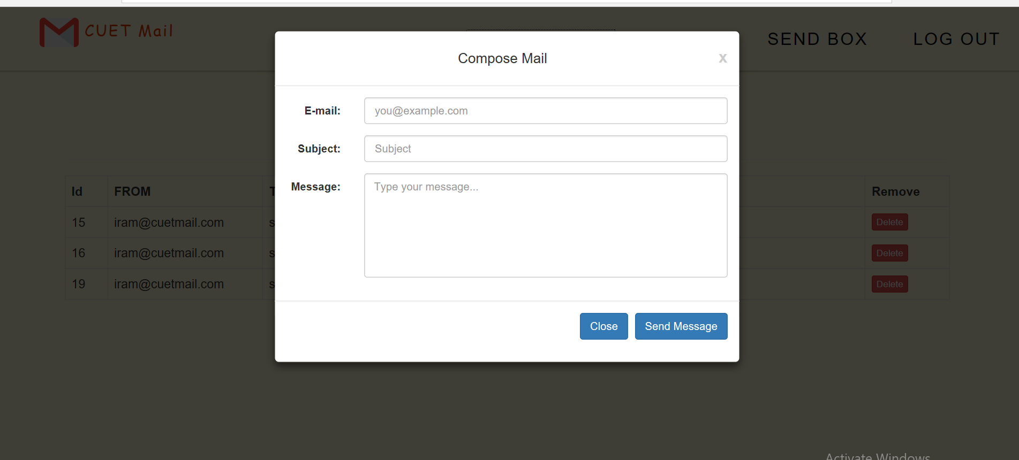

Fig 4.4: Compose Mail Interface

In this every section we use three database table to store the email data and for analyzing the data. The two database looks like:

Fig 4.5 shows the email_data database table for analyzing the email data:

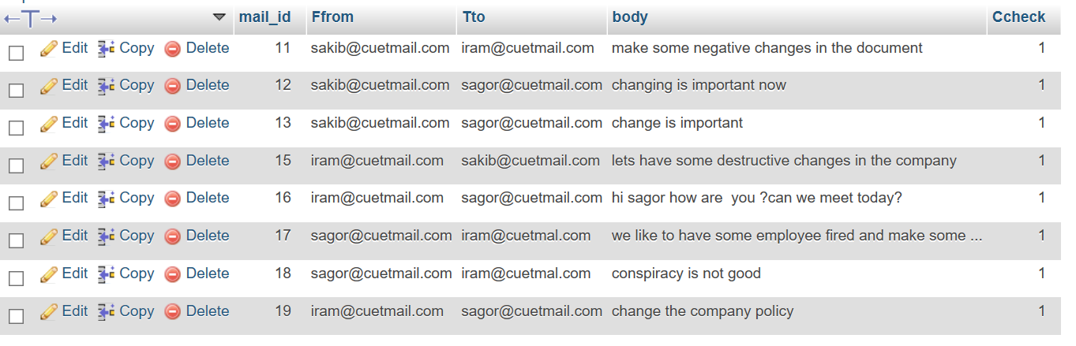

Fig 4.5: ‘Email Data’ Table Interface

Then the next figure will show the interface for the infected email that are analyzed to show the governing body of the company

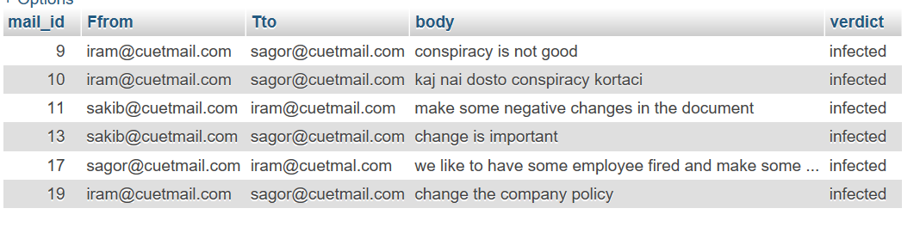

Fig 4.6: Infected ‘Result’ Database Table

Now we will show the user of the company database. It means the employee who has the authorized id and password to enter into the mail server:

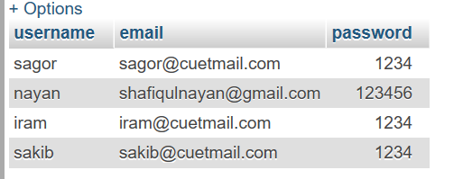

Fig 4.7: User Verification Table Interface

**4.3 Detection System Implementation**

In this section we will discuss about the interface of the detection model. Here the company management can have the alert and got the verdict about the mail had exchanged between the employees in real time. If any employee delete the data from his inbox or send box, still the system can monitor the email in real time. It stores the email after analyzing in a new database and will give the proof of the email.

In this section we will show the system as a whole in the figure 4.8:

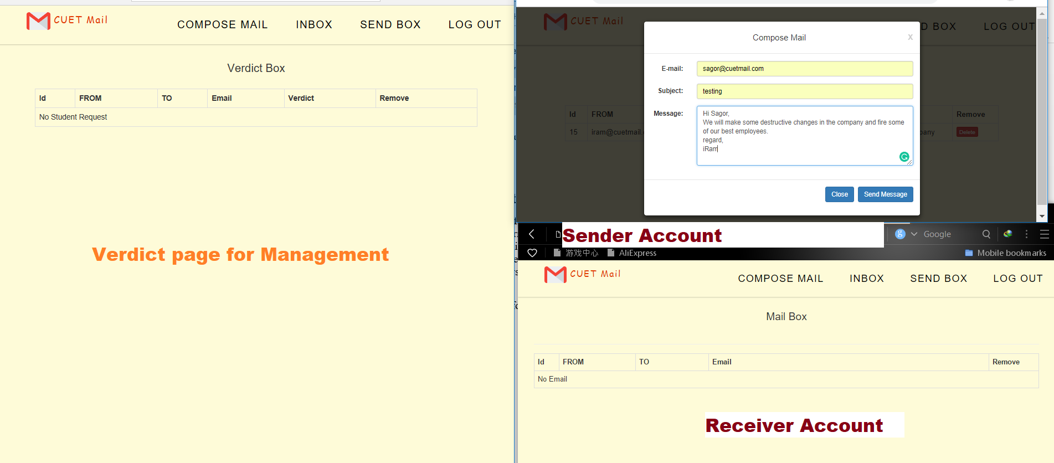

Fig 4.8: Email Sending System

In the next one we will show detection in the verdict page for any mail exchanged through this server.

Fig 4.9 will show the interface of this affair:

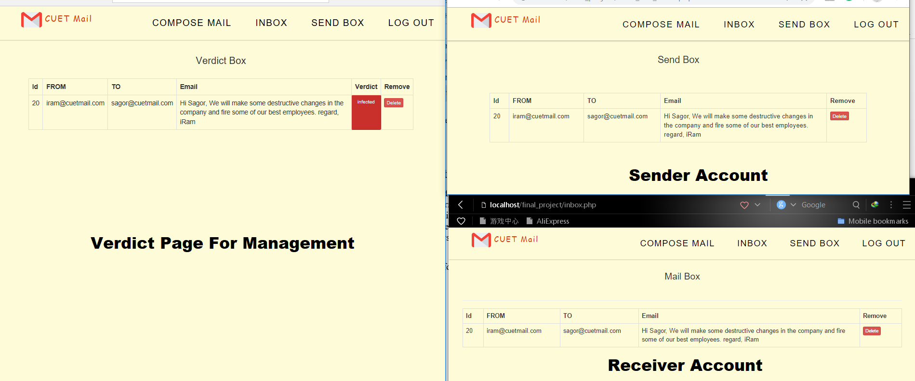

Fig 4.9: Detection Illustration

**4.4 Conclusion**

In this chapter we have tried to give an overview about our system’s implementation. Specifically, we have described the experimental set up, system layout and output generation.