Word Count using Map Reduce

Setup Hadoop along with Java 1.8
1) Setup Hadoop 3.3.0 as in pseudo distributed cluster mode as a single cluster
ref - https://hadoop.apache.org/docs/current/hadoop-project-dist/hadoop-common/ClusterSetup.html

2) Setup done on root user on Linux distro Ubuntu
Commands ::

configure localhost session for hadoop cluster for user ::
ssh localhost
ssh-keygen -t rsa -P '' -f ~/.ssh/id_rsa
cat ~/.ssh/id_rsa.pub >> ~/.ssh/authorized_keys
chmod 0600 ~/.ssh/authorized_keys

Format HDFS ::
bin/hdfs namenode -format

Start Service ::
sbin/start-all.sh
Stop Service ::
sbin/stop-all.sh

Check Service ::
http://localhost:9000/
HDFS Access via Browser at ::
http://localhost:9870/dfshealth.html#tab-overview
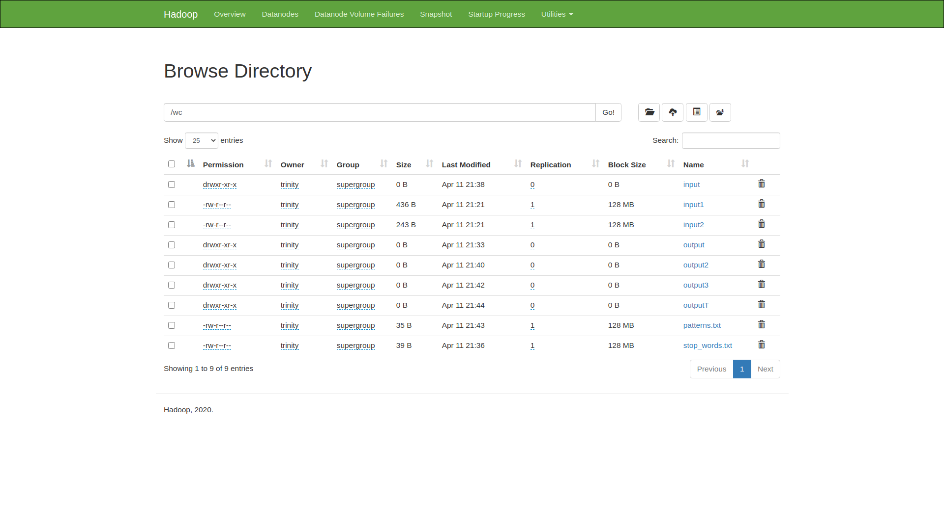

--exec
export HADOOP_CLASSPATH=${JAVA_HOME}/lib/tools.jar
bin/hadoop com.sun.tools.javac.Main WordCount.java
jar cf wc.jar WordCount*.class

--assumption
/wc/input - input directory in HDFS with input files
/wc/output - output directory in HDFS where output will be stored

--add dir and files to hdfs
hadoop fs -mkdir /wc/
hadoop fs -mkdir /wc/input/
hadoop fs -put input1 /wc/input/
hadoop fs -put input2 /wc/input/

#Simple Word Count
--Exec
bin/hadoop jar wc.jar WordCount /wc/input/ /wc/output

--Results
bin/hadoop fs -cat /wc/output/part-r-00000

#Word Count with Stop Words
hadoop fs -put patterns.txt /wc/
bin/hadoop jar wc.jar WordCount /wc/input /wc/output2 -skip /wc/patterns.txt

WordCount class is the main driver class which defines the configuration for mapper and reducer and takes input and generates output file.

WordCountMapper extends Mapper and implements map function.

WordCountReducer extends Reducer and implements the reduce function.

