**Assignment 1**

|  |  |  |  |
| --- | --- | --- | --- |
| **Course Title:** | Fundamentals of AI | **Course Code:** | CCAI-221 |
| **Weightage:** | 5% | **Due Date** | 25-04-2022 |
| **Remarks:** | The submission is online, and system will not allow submission after due date. | | |

Raneem Alomari / 2006352

**Question 1: (2 marks)**

1. Given the following search tree, apply the Minmax algorithm to it and show the search tree that would be built by this algorithm. Orange is for max, Green stand for min.

PATH: H,D,B,A Time O(bm)= 23=8 Space O(bm)=2*3=6

**6**

**A**

**D**

**E**

**F**

**G**

**6**

**5**

**8**

**2**

**1**

**10**

**15**

**18**

**C**

**B**

**p**

**O**

**M**

**K**

**J**

**H**

**I**

**L**

**2**

**6**

**189**

**2**

**6**

**10**

1. Apply the alpha-beta pruning algorithm to it and show the search tree that would be built by this algorithm pruning is DOUBLE LINES.

PATH: H, D, B, A.

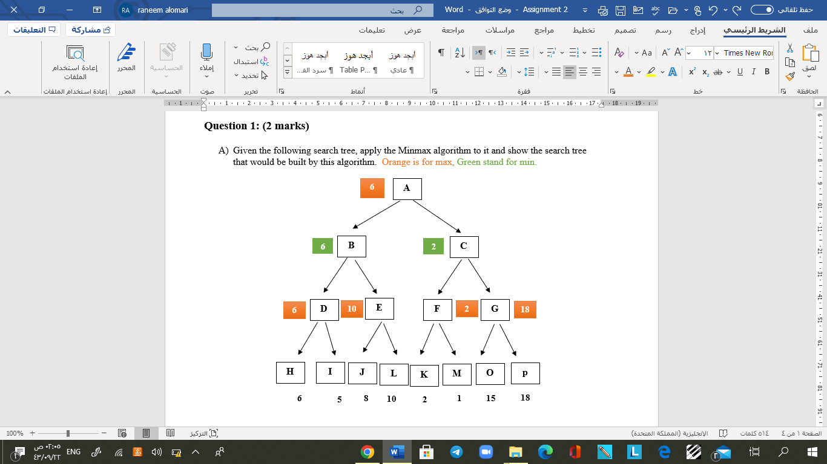

8

1. Given the following search tree, apply the Expected Minmax algorithm to it and show the search tree that would be built by this algorithm.

0.7

0.3

0.2

0.8

0.2

0.8

0.8

0.2

0.8

**-50**

**+90**

**+60**

**+80**

**-40**

**+70**

**+30**

**-20**

**+80**

**+50**

**+60**

**-20**

**-40**

**-30**

**+20**

**-20**

-8.5

-8.5

-12

-30

30

5

-22

5

-30

30

58

40

75

10

-22

1. Who is the winner player and what is his final utility value?

**Min** wins over max bc max has negative sign with -8,5 utility

**Question 2: (3 marks)**

We have five planes: A, B, C, D, and E. We would like to schedule a time slot for each aircraft to land. We have four time slots: 1*,* 2*,* 3*,* 4, during which we can schedule a landing of a plane. We must find an assignment that meets the following constraints:

* + Plane B has lost an engine and must land in time slot 1.
  + Plane D can only arrive at the airport to land during or after time slot 3.
  + Plane A is running low on fuel but can last until at most time slot 2.
  + Plane D must land before plane C takes off, because some passengers must transfer from D to C.
  + Planes A, B and C cannot land at the same time
  + Plane D and E cannot land at the same time

1. Complete the formulation of this problem as a CSP in terms of variables, domains, and constraints (both unary and binary). Constraints should be expressed implicitly using mathematical or logical notation rather than with words.

Variable (Plane): A,B,C,D,E.

Domain (Timeslot) €{1,2,3,4}

Constraints :

|  |  |  |
| --- | --- | --- |
| unary | binary | Higher order |
| B=1 | C>D | A≠B≠C |
| D>=3 | D≠E |
| A<=2 | A≠B |
| B≠C |
| C≠A |

b) Draw the constraint graph for the above problem.

B

C

A

E

D

c)What are the domains of the variables after enforcing node-consistency(UNARY)?

A->{1,2},

B->{1},

C->{1,2,3,4},

D->{3,4},

E->{1,2,3,4}.

d)What are the domains of the variables after enforcing arc-consistency? (Cross out values that are no longer in the domain.)

B=1

|  |  |  |  |  |
| --- | --- | --- | --- | --- |
| A | 1 | 2 | 3 | 4 |
| B | 1 | 2 | 3 | 4 |
| C | 1 | 2 | 3 | 4 |
| D | 1 | 2 | 3 | 4 |
| E | 1 | 2 | 3 | 4 |

A <=2

|  |  |  |  |  |
| --- | --- | --- | --- | --- |
| A | 1 | 2 | 3 | 4 |
| B | 1 | 2 | 3 | 4 |
| C | 1 | 2 | 3 | 4 |
| D | 1 | 2 | 3 | 4 |
| E | 1 | 2 | 3 | 4 |

D>=3

|  |  |  |  |  |
| --- | --- | --- | --- | --- |
| A | 1 | 2 | 3 | 4 |
| B | 1 | 2 | 3 | 4 |
| C | 1 | 2 | 3 | 4 |
| D | 1 | 2 | 3 | 4 |
| E | 1 | 2 | 3 | 4 |

C>D

|  |  |  |  |  |
| --- | --- | --- | --- | --- |
| A | 1 | 2 | 3 | 4 |
| B | 1 | 2 | 3 | 4 |
| C | 1 | 2 | 3 | 4 |
| D | 1 | 2 | 3 | 4 |
| E | 1 | 2 | 3 | 4 |

A≠B≠C

|  |  |  |  |  |
| --- | --- | --- | --- | --- |
| A | 1 | 2 | 3 | 4 |
| B | 1 | 2 | 3 | 4 |
| C | 1 | 2 | 3 | 4 |
| D | 1 | 2 | 3 | 4 |
| E | 1 | 2 | 3 | 4 |

D≠E

|  |  |  |  |  |
| --- | --- | --- | --- | --- |
| A | 1 | 2 | 3 | 4 |
| B | 1 | 2 | 3 | 4 |
| C | 1 | 2 | 3 | 4 |
| D | 1 | 2 | 3 | 4 |
| E | 1 | 2 | 3 | 4 |

FINAL RESULT.

1. Arc-consistency can be rather expensive to enforce, and we believe that we can obtain faster solutions using only **forward-checking** (Keep track of remaining legal values for unassigned variables) on our variable assignments. Using the Minimum Remaining Values heuristic, perform backtracking search on the graph, breaking ties by picking lower values and characters first. List the (*variable, assignment*) pairs in the order they occur. If you mean according to the time slots by "in the order they occur."

(B,1), (E,1), (A,2), (D,3), (C,4)

If you mean according to the solving steps by "in the order they occur."

(B,1), (A,2), (D,3), (C,4), (E,1)

|  |  |  |  |  |
| --- | --- | --- | --- | --- |
| A | 1 | 2 | 3 | 4 |
| B | 1 | 2 | 3 | 4 |
| C | 1 | 2 | 3 | 4 |
| D | 1 | 2 | 3 | 4 |
| E | 1 | 2 | 3 | 4 |
|  |  |  |  |  |

We remove the value assigned to B from the connected node(A,C)

|  |  |  |  |  |
| --- | --- | --- | --- | --- |
| A | 1 | 2 | 3 | 4 |
| B | 1 | 2 | 3 | 4 |
| C | 1 | 2 | 3 | 4 |
| D | 1 | 2 | 3 | 4 |
| E | 1 | 2 | 3 | 4 |

We remove the value assigned to A from the connected node(B,C)

|  |  |  |  |  |
| --- | --- | --- | --- | --- |
| A | 1 | 2 | 3 | 4 |
| B | 1 | 2 | 3 | 4 |
| C | 1 | 2 | 3 | 4 |
| D | 1 | 2 | 3 | 4 |
| E | 1 | 2 | 3 | 4 |

We remove the value assigned to D from the connected node(C,E)

|  |  |  |  |  |
| --- | --- | --- | --- | --- |
| A | 1 | 2 | 3 | 4 |
| B | 1 | 2 | 3 | 4 |
| C | 1 | 2 | 3 | 4 |
| D | 1 | 2 | 3 | 4 |
| E | 1 | 2 | 3 | 4 |

Nothing to do here all constraint already applied

|  |  |  |  |  |
| --- | --- | --- | --- | --- |
| A | 1 | 2 | 3 | 4 |
| B | 1 | 2 | 3 | 4 |
| C | 1 | 2 | 3 | 4 |
| D | 1 | 2 | 3 | 4 |
| E | 1 | 2 | 3 | 4 |

all constraint already applied. Randomly choose a time slot from the options (1,2,4)

|  |  |  |  |  |
| --- | --- | --- | --- | --- |
| A | 1 | 2 | 3 | 4 |
| B | 1 | 2 | 3 | 4 |
| C | 1 | 2 | 3 | 4 |
| D | 1 | 2 | 3 | 4 |
| E | 1 | 2 | 3 | 4 |

CONCLUSIN **forward-checking is faster way to solve CSPs as we solve it in 3 steps unlike paragraph d which cost us 6 steps.**